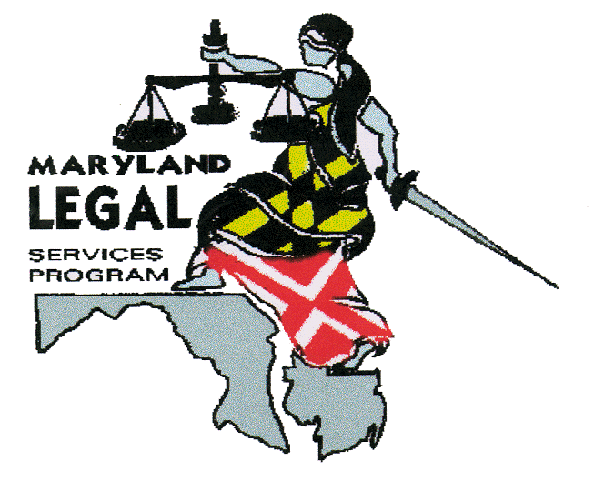
OFFICE OF THE SECRETARY

Maryland Legal Services Program

CINA / TPR - Training Verification Form

Firm Name:

I certify that (print name) attended

hours of the following training:

Name of Training | Sponsor | Date
 |  | MM/DD/YY
 |  | MM/DD/YY
 |  | MM/DD/YY

I understand that all attorneys representing children under the Department’s legal services contracts are required to have 12 hours of continuing legal education and training annually according to the provision of representation under the Contract.

Project Manager, Signature: _______________________________________________

Project Manager, Printed Name:

Date Signed: ________________________________

I certify that the above information is true and accurate to the best of my knowledge.

Attorney Signature: ______________________________________________________

Attorney, Printed Name:

Date Signed: __________________________________

Witness, Signature: ______________________________________________________

Witness, Printed Name:

Date Signed: ___________________________________

Rev. 2/28/2013

