

Maryland’s Human Services Agency

DEPARTMENT OF HUMAN RESOURCES

FAMILY INVESTMENT ADMINISTRATION

SMALL PROCUREMENT INVITATION FOR BIDS (IFB) FOR

ASSET VERIFICATION SYSTEM SERVICES

DHR AGENCY CONTROL NUMBER: FIA/AVS-17-002-S

Issue Date: September 26, 2016

- SUMMARY STATEMENT

The Department of Human Resources (DHR or the Department), Family Investment Administration (FIA) seeks to acquire an Asset Verification System (AVS) service for the purpose of obtaining data on the liquid and real property assets of applicants for Medicaid benefits for long-term care. DHR intends that the services shall comply with the verification method proscribed by Section 1940 of the Social Security Act (codified at 42 U.S.C. § 1396w). The AVS services shall provide verifications for assets held by Financial Institutions and Real Property Assets.

DHR is the State’s social services provider and Maryland’s fourth largest agency. Its critical mission is to assist people in economic need, provide prevention services, and protect vulnerable children and adults. To serve this critical mission, DHR coordinates with Department of Health and Mental Hygiene (DHMH) in the administration of medical assistance programs that serve two populations: (1) the aged, blind, and disabled, and (2) long-term care patients. This solicitation relates to DHR’s administration of medical assistance programs for residents of long-term care facilities.

The Contract resulting from this solicitation will be for a period of approximately six (6) months.

- ABBREVIATIONS AND DEFINITIONS:

- Applicant – A person who has submitted a signed application for Medicaid benefits for long-term care.

- Authorized Representative is the person designated to assist or handle affairs related to an Applicant’s health care services. This may be someone designated as a Power of Attorney, a family member, friend, caregiver, or an advocate assigned to assist with an exception, appeal or grievance.

- Business Day(s) – The official working days of the week to include Monday through Friday. Official working days exclude State Holidays (see definition of “Normal State Business Hours” below).

- Financial Institution – any institution, including, but not limited to, any bank, savings association, credit union, security broker or dealer, or insurance company, established and regulated under the laws of the United States or any State, territory, or possession of the United States, the District of Columbia, Commonwealth of Puerto Rico, Commonwealth of Northern Mariana Islands, Guam, American Samoa, or the United States Virgin Islands, and having significant operations in the United States.

- Medicaid (MA) – Also called Medical Assistance. This is a joint federal and State program that pays the medical bills of people who have low income and cannot afford medical care. Each State establishes its own eligibility standards, benefit package, provider requirements, payment rates, and program administration under broad federal guidelines. There are four categories of eligibility of Medicaid: community care, long-term care, Supplement Security Income (SSI), and Maryland Children’s Health Program (MCHP). The DHMH runs Maryland’s Medicaid program for policy and payments; DHR, through its Local Departments of Social Services and the Bureau of Long Term Care, process applications and ongoing cases.

- Normal Operating Hours – Normal Operating Hours are 7:30 AM – 7:30 PM Monday through Saturday except State Holidays, which can be found at www.dbm.maryland.gov – keyword: State Holidays. When a State Holiday occurs on a Saturday, the program will not have Normal Operating Hours on either that Saturday or the date the State Holiday is observed.

- Normal State Business Hours – Normal State Business hours are 8:00 AM – 5:00 PM, Monday through Friday except State Holidays, which can be found at: www.dbm.maryland.gov – keyword: State Holidays.

- Responsible Party – Any person whose capacity to contribute towards payment of the Applicant’s medical expenses is considered by the Department in determining the Applicant’s eligibility for Medicaid benefits. The spouse of a married Applicant and each parent of a child Applicant are Responsible Parties.

- State – The State of Maryland.

- BIDDER MINIMUM QUALIFICATIONS

The Bidder shall provide proof with its Bid that the following Minimum Qualifications have been met:

The Bidder shall have a minimum of one (1) year of experience providing verification of financial and/or real property asset verification services to at least three separate corporate, federal, state, or local governmental entities within the last three (3) years.

As proof of meeting this qualification, the Bidder shall provide a list of three (3) references from corporate, federal, state, or local governmental entities to which the Bidder has provided financial and/or real property asset verification services within the last three (3) years prior to the date of issue of this IFB. For each reference, provide the entity’s name, a description of the scope of work provided, the term of the services that have been provided, and the name, mailing address, telephone number, and email address of a person with knowledge of the work provided.

- SCOPE OF THE PROJECT

In order to ensure that the medical assistance programs serve the designated populations, DHR determines the eligibility of Applicants based, in part, on the total assets available to the Applicants for purposes of paying their medical expenses. Those assets include financial assets such as checking, savings, money market, retirement, and annuity accounts as well as real property owned by the Applicant or any Responsible Party.

DHR receives, in an average month, approximately 800 new applications for long-term care Medicaid. In order to process new applications for long-term care Medicaid, DHR is required by federal law to verify the assets of Applicants, and Responsible Parties for Applicants, for an approximate total of 1,600 asset requests each month.

- CONTRACTOR RESPONSIBILITIES

A. Network of Financial Institutions

The Contractor shall establish and maintain relationships with Financial Institutions that will participate in its AVS system. Those relationships shall include at least 300 Financial Institutions, including at least 10 of the banks listed in Attachment G, and at least 10 credit unions with significant operations in the State of Maryland. A Financial Institution is deemed to participate in the AVS system if it is contractually bound to provide to the Contractor account data sufficient to serve the purposes of the AVS.

B. Financial Asset Verification System:

The Contractor shall provide a Financial AVS that meets the following functional requirements:

(1) The AVS shall provide a user interface from which an active user may electronically request a Financial Asset Verification Report for an Applicant or a Responsible Party that will identify accounts, whether an account is open or closed, in which the Applicant or a Responsible Party held an ownership interest and that had a positive account balance within a specified date range (the specified date range will not exceed a 60-month period within the 63 months immediately preceding the date of request. The date range will generally include the 60 months immediately preceding the first date of the month in which the Applicant applied for program benefits). The user interface shall request the following information from the active user:

- The name of an individual Applicant and/or Responsible Party;
- The Social Security Number of the named individual;
- The addresses at which the named individual has resided in the five (5) years prior to the date of the application, if available;
- The specified date range to be searched; and
- The user ID of the requestor.

(2) The AVS shall generate a Financial Asset Verification Report (substantially in the form provided as Attachment C) that includes, at a minimum, the following specific information regarding each such account described in paragraph 5(B)(1) above:

- the name of the financial institution holding the account along with the branch location address and telephone number where the account is serviced;
- the type of account (checking, saving, annuity, retirement, etc.) and the last four digits of the account numbers;
- the full legal name of each individual or entity with any ownership interest in the account, any known aliases used by an individual, any known residence or mailing addresses of the individual during the specified date range, and the nature by which ownership interests are shared, if applicable (e.g., joint tenant account);
- the date the account was opened and, if closed, the date closed;
- the account balance in the account at 12:01 AM on the first date of each month in which the account was open during the specified date range;
- The requestor’s user name and ID;
- The requestor’s supervisor’s name and ID; and,
- The requestor’s district office number.

(3) The Financial Asset Verification Report must be prepared in Adobe PDF format, and it must be available for download on the AVS no later than ten (10) Business Days following the Department’s request. If the AVS does not identify any financial asset accounts for the named individual(s), the Financial Asset Verification Report must so state.

(4) In generating each Financial Asset Verification Report, the AVS shall submit electronic requests to, and receive all relevant account data from, at least 200 participating Financial Institutions, including at least 10 of the banks listed in Attachment G, and at least 10 credit unions with significant operations in the State of Maryland. The AVS shall select the target Financial Institutions from its network of participating Financial Institutions using some logic such as geographic proximity to the named individual’s home address, or other reasonable factors, to insure that it identifies accounts not previously identified on the application for long-term care.

C. Real Property Asset Verification System:

The Contractor shall provide a Real Property AVS that meets the following functional requirements:

(1) The AVS shall provide a user interface from which an active user may electronically request a Real Property Asset Verification Report for an Applicant or a Responsible Party that will identify real property owned in whole or in part by the Applicant or the Responsible Party at any point in time within a specified date range (the specified date range will not exceed a 60-month period within the 63 months immediately preceding the date of request. The date range will generally include the 60 months immediately preceding the first date of the month in which the Applicant applied for program benefits. The user interface shall request the following information from the active user:

- The name of an individual Applicant and/or Responsible Party;
- The Social Security Number of the named individual(s);
- The addresses at which the named individual(s) has resided in the five (5) years prior to the date of the application, if available;
- The specified date range to be searched; and
- The user ID of the requestor.

(2) The AVS shall generate a Real Property Asset Verification Report (substantially in the form provided as Attachment D) that includes, at a minimum, the following specific information for each such piece of real property identified pursuant to paragraph 5(C)(1) above:

- sufficient information to identify the property, including but not limited to its address location, any plat or tax identification number assigned to the property, the governing jurisdiction where title is registered, etc.;
- the assessed value of the property by the relevant taxing authority and the name of the taxing authority;
- the names of any co-owners of the property; and,
- the transaction history of the property, if available, including the dates, prices, and parties involved in the most recent sale or transfer of the property involving the Applicant or Responsible party, and the type of transaction;
- The requestor’s user name and ID;
- The requestor’s supervisor’s name and ID; and,
- The requestor’s district office number.

(3) The Real Property Asset Verification Report must be prepared in Adobe PDF format, and it must be available for download on the AVS no later than ten (10) Business Days following the Department’s request. If the AVS does not identify any real property assets for the named individual, the Real Property Asset Verification Report must so state.

(4) In generating the Real Property Asset Verification Report, the Contractor must conduct electronic or manual queries to identify real property held in title interest in whole or in part by the target individual(s), including:

- Real property title records in each state in which the target individual resided in the five years prior to the date of the application, if provided in Section 5(C)(1) above;
- Real property title records in the State of Maryland; and,
- Real property title records in the District of Columbia (D.C.), Delaware, North Carolina, Virginia, West Virginia and Pennsylvania, if the target individual holds any title interest to real property in Maryland.

D. General Requirements

The Contractor shall provide a Financial and Real Property AVS with the following requirements:

- The AVS shall provide secure web-based access to approximately 120 users (approximately 50 concurrent users) over the Internet. The Contractor shall maintain records of each active user, including the user’s name, the user ID, the user’s supervisor’s name, the supervisor’s user ID, and the user’s District Office number, based on information that the State Project Manager shall provide to the Contractor. Upon request, the Contractor shall provide the Department with a list of active users.

- The AVS shall be available for users to access over the internet Monday through Saturday from 7:30 AM – 7:30 PM, except that the Contractor may schedule periodic, planned service outages outside Normal State Business Hours for purposes of system maintenance and upgrades.

- The AVS shall make all completed Financial and Real Property Asset Verification Reports available for download on the AVS throughout the duration of the contract resulting from this solicitation, and the download method must adhere to the security requirements/encryption standards identified in Section 5(D)(3b).

- The AVS must provide users with search tools to locate the status of, and to download completed Asset Verification Reports within the AVS using the Social Security Number of the Applicant or Responsible Party and the name of the Applicant or Responsible Party.

C. Technical Support and Training

The Contractor shall provide a Help Desk that allows users to obtain technical assistance from the Contractor, during Normal Operating Hours, for all users.

The Contractor shall provide a printable, online user manual that assists users in navigating and using the system. The manual shall be updated whenever changes are made to the system.

- Technical Requirements

The Contractor shall provide a secure web-based system for AVS requests. The system shall utilize established technical and security protocols recognized in the industry for secure transmission of the highly sensitive financial information identified in this scope of work, including but not limited to the U.S. Commerce Department’s National Institute of Standards and Technology (NIST). The Contractor shall ensure the system complies with the following minimum requirements:

- Authorization

- An automated process to ensure that individual user sessions time out or request users to re-enter their password after a period of fifteen (15) minutes of inactivity;
- An automated process to disable user accounts after three (3) failed attempts of logging on;
- An automated process to ensure that the user access rights are revoked within twenty-four (24) hours of receiving notification from the State Project Manager.
- An automated process to ensure that user IDs are disabled after sixty (60) days of inactivity unless they are extended through a written request by the State Project Manager;
- A system to ensure that access privileges are traceable to a unique user ID;
- An automated display, after a successful logon, showing the date and time of last successful logon and the number of unsuccessful logon attempts since the last successful logon; and,
- An automated mechanism to permit access to the system only from state authorized network IP addresses.

- Password Requirements

The Contractor shall require a secured login and password to access the system. The system shall force users to change temporary passwords at the first logon and shall prohibit password reuse by not allowing the last ten (10) passwords to be reused with a minimum password age of at least two (2) days. After three failed attempts per user to log on, password tables or security devices shall lock out the user account.

- Passwords shall not:
    - Be the same as the User ID;
    - Be stored in clear text;
    - Be displayed on the screen; or,
    - Contain leading or trailing blanks

- Passwords shall:
- Be a minimum of eight characters;
- Consist of mixed alphabetic, special character and numeric characters;
- Not consist of all numbers, all special characters, or all alphabetic characters; and
- Be changed every ninety (90) days. Automatic mechanisms shall prompt users of this requirement.

- Confidential Information Security Requirements

The Contractor shall keep confidential information from public disclosure. Confidential information is non-public information that if disclosed could result in a high negative impact to the State of Maryland, its employees or citizens and may include information or records deemed as Private, Privileged or Sensitive. This includes but is not limited to information that contains Personally Identifiable Information (PII), Social Security Numbers (SSN), Names, Phone Numbers, Addresses, and/or Dates of Birth.
The Contractor shall safeguard confidential information by incorporating, at a minimum, the following security measures:
- The Contractor shall not place confidential or sensitive data on any application servers, database servers, or infrastructure components that require direct access from the Internet. Components that meet these criteria must be placed behind a de-militarized zone (DMZ) where they are not accessible from the Internet and can interact with DMZ components only through a firewall.

- Encryption – All data transmissions for operations shall use an SSL Encryption algorithm to encode data transmissions that is Federal Information Processing Standard (FIPS) 140-2 compliant. The details can be found at www.nist.gov.

The Contractor shall establish appropriate procedures to protect documents, computer media, information/data, and system documentation from unauthorized disclosure, modification, removal, and destruction, including suitable measures to properly dispose of media when it is no longer needed.

- 508 Compliance

The Contractor shall ensure that the system complies with the Federal Guidelines for Web Accessibility, available at www.section508.gov.

- Auditing

  - The system shall require all identification and authentication activities be logged and maintained. The audit trails shall include at least the following information at a minimum:
- Date and time of event;
- User ID;
- Type of event;
- Success or failure of event; and,
- Source (terminal, port, location, IP address) where technically feasible.

- Retain the aforementioned logs for (45) Business Days and review them at least daily to identify suspicious or questionable activity for investigation and documentation as to their cause and perform remediation, if required. The Department shall have the right to inspect these policies and procedures and the Contractor’s or subcontractor’s performance upon request to confirm the effectiveness of these measures for the services being provided under this Contract.

- Security Incidents

The Contractor shall thoroughly investigate and document all security incidents. The Contractor shall notify the State Project Manager via telephone within twenty-four (24) hours upon initial detection of an incident, followed up in writing via email by close of the first Business Day after the initial detection. The Contractor shall follow published and accepted procedures available online at www.us-cert.gov until complete containment of the security breach. At a minimum, the following events shall be reviewed:

  - Three failed attempts per a single user per calendar day to log into the system. Three (3) failed attempts shall lock the user account;
  - Disabled logging or attempts to disable logging;
  - Two (2) or more failed attempts to log into the system within a week, five (5) Business Days from unusual network sources; or,
  - Any unauthorized attempts to modify software or to disable hardware configurations.

E. Reporting Requirements

In addition to the Financial Asset Verification Reports and the Real Property Asset Verification Reports identified in Sections 5(B)(1) and 5(C)(1) above, the Contractor shall submit the following reports to the State Project Manager, by e-mail, in Microsoft Excel format, with a signed, paper copy to be sent by regular U.S. mail:

(1) Bi-Weekly Status Reports for Financial Asset Verification Services (see illustrative sample report at Attachment E) that provide statistics regarding the status of all requested financial asset verification activity in the prior two-week period. This report should include all asset verification searches conducted regardless of whether any assets were located. This report is due to the State Project Manager on the first (1st) Business Day of alternate weeks, and shall report statistics from the two-week period ending at 12:01 am on the prior Saturday.

(2) The Monthly Financial Asset Verification Report (see illustrative sample report at Attachment F) provides a monthly summary of all financial asset verification reports completed in the calendar month. This report should include all asset verification reports that were completed regardless of whether any assets were located. This report is due to the State Project Manager on the fifth (5th) day of the month following the reporting month.

(3) Bi-Weekly Status Reports for Real Property Asset Verification Services (see illustrative sample report at Attachment E-1) that provide statistics regarding the status of all requested real property asset verification activity in the prior two week period. This report should include all asset verification searches conducted regardless of whether any assets were located. This report is due to the State Project Manager on the first (1st) Business Day of alternate weeks, and shall report statistics from the two-week period ending at 12:01 am on the prior Saturday.

(4) The Monthly Real Property Asset Verification Report (see illustrative sample report at Attachment F-1) provides a monthly summary of all real property asset verification reports completed in the calendar month. This report should include all real property asset verification reports that were completed regardless of whether any assets were located. This report is due to the State Project Manager on the fifth (5th) day of the month following the reporting month.

(5) Each report shall contain at a minimum the following information:

  - Applicant’s Name and the last four digits of the Applicant’s Social Security Number (SSN);
  - District office number;
  - User’s name and ID;
  - User’s supervisor’s name and ID;
  - Date the request was submitted;
  - Date the completed asset verification report was posted on the AVS;
  - Number of accounts discovered, for the Bi Weekly Status Report for Financial Asset Verification Services and Monthly Financial Asset Verification Reports; and
  - Number of real properties identified, for the Bi Weekly Status Report for Real Property Asset Verification Services and Monthly Real Property Asset Verification Reports.

F. Insurance Requirements

(1) The Contractor shall maintain Commercial General Liability Insurance to cover losses resulting from, or arising out of, Contractor action or inaction in the performance of the Contract by the Contractor, its agents, servants, employees, or subcontractors, with a limit of $1,000,000 per occurrence and $2,000,000 aggregate.

(2) The Contractor shall maintain Professional Liability/Cyber Liability insurance with a minimum limit of $2,500,000 per claim and annual aggregate.

(3) Within five (5) Business Days of recommendation for Contract award, and before any work begins, the Contractor shall provide the Procurement Officer with current certificates of insurance, and shall update such certificates periodically, but no less than annually in multi-year contracts, as directed by the State Project Manager. Such copy of the Contractor’s current certificate of insurance shall contain at minimum the following:

- Workers’ Compensation – The Contractor shall maintain such insurance as necessary and/or as required under Workers’ Compensation Acts, the Longshore and Harbor Workers’ Compensation Act, and the Federal Employers’ Liability Act.

- Commercial General Liability as required in Section 5(F)(1).

- Professional Liability/Cyber Liability as required in Section 5(F)(2).

(4) The “State of Maryland, its officers, employees and agents” shall be listed as an additional insured on any Commercial General Liability, Professional Liability/Cyber Liability, and excess liability or umbrella policies with the exception of Worker’s Compensation Insurance, which is currently handled by the Chesapeake Employer’s Insurance Company (formerly Injured Worker’s Insurance Fund). All insurance policies shall be endorsed to include a clause that requires that the insurance carrier provide the State Project Manager, by certified mail, not less than 30 days’ advance notice of any non-renewal, cancellation, or expiration. In the event the State Project Manager receives a notice of non-renewal, the Contractor shall provide the State Project Manager with an insurance policy from another carrier at least 15 days prior to the expiration of the insurance policy then in effect. All insurance policies shall be with a company licensed by the State to do business and to provide such policies.

(5) The Contractor shall require that any subcontractors providing primary services (as opposed to non-critical, ancillary services) under this Contract obtain and maintain the same levels of insurance and shall provide the State Project Manager with the same documentation as is required of the Contractor.

G. END OF CONTRACT TRANSITION

The Contractor shall cooperate in the orderly transition of services from the Contract awarded under this solicitation and any subsequent contract for similar services. The Department will stop requesting reports fifteen (15) Business Days before the end of the Contract. The Contractor shall work toward a prompt and timely transition, proceeding in accordance with directions from the State Project Manager. The State Project Manager may provide the Contractor with additional instructions to meet specific transition requirements prior to the end of Contract.

- CONTRACT TERM

The Contract resulting from this solicitation will be for a period of approximately six (6) months period beginning on or about October 14, 2016 and ending on or about March 31, 2017.

- STATE PROJECT MANAGER

The State Project Manager for this Contract is:

Virginia Johnson
Director
Bureau of Long Term Care
Family Investment Administration 746 Frederick Road
Baltimore, MD 21228
Phone: (410) 455-7511 Fax: (410) 744-2432
Email: virginia.johnson@maryland.gov

After Contract award, the State Project Manager will serve as the primary point of contact for the Contractor in regards to the Contract resulting from this IFB. However, for certain contract-related actions, the Procurement Officer may communicate with the Contractor.

- SUBMISSION INFORMATION

An original, to be so identified, and two (2) copies of the Bid must be received by the Procurement Officer by Friday, September 30, 2016 at 1:00 PM in order to be considered. Requests for extension of this date or time shall not be granted. Bidders mailing Bids should allow sufficient mail delivery time to insure timely receipt by the Procurement Officer. Bids or unsolicited modifications to Bids arriving after the closing time and date will not be considered, except under the conditions identified in COMAR 21.05.02.10 B and 21.05.03.02 F.

A public Bid opening will be held on Friday, September 30, 2016 at 2:00 PM at the following location:

Maryland State Department of Human Resources
311 West Saratoga Street, Room 748
Baltimore, Maryland 21201

Upon receipt, each Bid and any timely modifications (s) to a Bid shall be stored in a secure place until the time and date set for bid opening. Before Bid opening, the State may not disclose the identity of any Bidder.

Bids will be opened publicly in accordance with the provisions of COMAR 21.05.02.11B. The name of each Bidder, the Bid price, and such other information as is deemed appropriate shall be read aloud or otherwise conveyed at the time of Bid opening. The Bids shall be tabulated or a Bid abstract made.

Bids will be made available for public inspection at or within a reasonable time after Bid opening. Any material deemed confidential or proprietary by the Bidder must be clearly marked and shall be readily separable from the Bid to facilitate public inspection of the non-confidential portion of the Bid. A blanket statement declaring the entire Bid confidential is not acceptable.

Oral, electronic mail, and facsimile Bids will not be accepted.

Bids are to be delivered to:

Nneka Willis-Gray
Department of Human Resources
Procurement Division
311 West Saratoga Street, Room 946
Baltimore, MD 21201
Phone: (410) 767-7418 Fax: (410) 333-0258
Email: nneka.willis-gray@maryland.gov

Inquiries must be directed to the Department at the above telephone number and address.

Bid Submission shall include:

A. Transmittal Letter

A Transmittal Letter, printed on the Bidder’s letterhead. The purpose of this letter is to transmit the Bid. The letter shall include the following:

- Title of the solicitation
- Bidder’s name and address
- Name, title, email address, and telephone number of the primary contact for the Bidder;
- Signature, typed, and title of an individual authorized to commit the Bidder to its Bid;
- Federal tax identification or social security number,
- eMaryland Marketplace number;
- Acknowledgement of Bidder’s receipt of any amendments issued on the solicitation. Failure to acknowledge receipt of amendments does not relieve the Bidder from complying with all terms of any such amendment;
- Acceptance of all State IFB and Contract terms and conditions.
- Identify any information considered confidential by specific sections, pages, or portions of pages of the IFB.

B. Location of Services

The Bidder shall identify the location(s) from which it proposes to provide the services, including, if applicable, any current facilities that it operates, and any required construction to satisfy the State’s requirements as outlined in this Solicitation.

C. Experience and Qualification of Proposed Staff

The Bidder shall include individual resumes for the Key Personnel (to include the Contractor’s Project Manager), including Key Personnel for any proposed subcontractor(s), who are to be assigned to the project if the Bidder is awarded the Contract. Each resume should include the amount of experience the individual has had relative to the Scope of Work set forth in this solicitation.

The Bidder shall also include the name, address, fax, telephone number, and email address of the individual who has been designated to be the proposed Contractor’s Project Manager. The Contractor’s Project Manager shall coordinate with the State’s Project Manager and be responsible for assuring the quality and completion of the projects. The Contractor’s Project Manager shall be readily available to discuss and/or meet with the Department’s designated representatives.

D. Bidder Qualifications and Capabilities

The Bidder shall include information on past experience with similar projects and/or services. The Bidder shall describe how its organization can meet the requirements of this solicitation and shall also include the following information:

(1) The number of years the Bidder has provided similar services;
(2) The number of clients/customers and geographic locations that the Bidder currently serves; and
(3) The names and titles of headquarters or regional management personnel who supervisory authority of the personnel assigned to perform services under this Contract;
E. References

At least three (3) references are requested from customers who are capable of documenting the Bidder’s ability to provide the services specified in this solicitation. References used to meet any Bidder Minimum Qualifications (see Section 3) may be used to meet this request. Each reference shall be listed and shall be from a client or organization for whom or which the Bidder has provided services within the past three (3) years and shall include the following information:

(1) Name of client or organization;
(2) Name, title, telephone number, and e-mail address of a point of contact for client organization; and
(3) Value, type, duration, and description of services provided.

The Department reserves the right to request additional references or utilize references not provided by a Bidder.

F. Certificate of Insurance

The Bidder shall provide a copy of its current certificate of insurance showing the types and limits of insurance in effect as of the Bid submission date. The current insurance types and limits do not have to be the same as described in Section 5(F). Upon notification of Contract Award, a copy of the certificate of insurance showing the type and limits as described in Section 5(F) shall be submitted within five (5) Business Days.

G. Pricing Sheet

The Bidder shall submit an original unbound copy and two (2) copies of the Pricing Sheet. The Pricing Sheet (Attachment B) shall contain all price information in the format specified in Attachment B. The Bidder shall complete the Price Sheet only as provided in the Price Sheet Instructions and the Pricing Sheet itself.

9. BASIS FOR AWARD

The Contract will be awarded to the responsible Bidder submitting the Bid that meets the specifications set forth in the Small Procurement Solicitation, and provides the Most Favorable Bid Price.

In the event of tie bids, the provisions of COMAR 21.05.02.14 shall determine the successful bidder.

10. DEPARTMENT CONTRACT

The successful Bidder will be expected to sign a contract with the Department, sample enclosed as ATTACHMENT A. Upon receipt of Contract Award, three (3) original Contracts (ATTACHMENT A) shall be completed, signed and submitted within five (5) Business Days.

11. CANCELLATION OF BIDS

The State may cancel this Solicitation, in whole or in part, whenever this action is determined to be fiscally advantageous to the State or otherwise in the State’s best interest. If the Solicitation is canceled, a notice of cancellation will be provided to all prospective Bidders who were sent this Solicitation or otherwise are known by the Procurement Officer to have obtained this Solicitation.

12. ACCEPTANCE OF BIDS

The State reserves the right to accept or reject any and all Bids, in whole or in part, received in response to this Solicitation, or to waive or permit cure of minor irregularities to serve the best interests of the State of Maryland.

13. TIME OF BID ACCEPTANCE

The content of this Solicitation and the Bid of the successful Bidder will be included by reference in any resulting Contract. All prices, terms and conditions in the Bid are irrevocable for 90 days after the closing date for receipt of Bids. This period may be extended by written mutual agreement between the Bidder and the requesting State organization.

14. PAYMENT

The successful vendor shall bill the Department monthly.

Invoices must be addressed to the State Project Manager, with a copy to:

Accounts Payable
Division of Budget and Finance
Maryland Department of Human Resources
311 West Saratoga Street, 9th Floor
Baltimore, MD 21201

All invoices must (at a minimum) be signed and dated in addition to including the Contractor’s mailing address, the Contractor’s Social Security number or Federal Tax ID number, the State’s assigned Contract control number, the goods/services provided, the time period covered by the invoice, and the amount of requested payment.

The Department reserves the right to reduce or withhold payment in the event the Contractor does not provide the Department with all required deliverables within the time frame specified in the Contract or in the event that the Contractor otherwise materially breaches the terms and conditions of the Contract until such time as the Contractor brings itself into full compliance with the Contract. Any action on the part of the Department, or dispute or action by the Contractor, shall be in accordance with the provisions of Md. Code Ann., State Finance and Procurement Article §§ 15-215 through 15-223 and with COMAR 21.10.02.

Invoices are due by the 10th of the month following the month in which services were performed.

Payment will be made based upon the Bidder’s Fully Loaded Fixed Unit Price (FLFUP) for each Financial Asset Verification Report and each Real Property Asset Verification Report completed on a specific Applicant or Responsible Person.

15. PROCUREMENT METHOD

This award will be made in accordance with Code of Maryland Regulations (COMAR) 21.05.07, Small Procurement Regulations. Small procurement is defined as the use of procedures to obtain items reasonably expected by the Procurement Officer to cost $25,000 or less.

Minority Business Enterprises are strongly encouraged to respond to this solicitation.

ATTACHMENT A – CONTRACT “SAMPLE”

AGENCY CONTROL NUMBER

SMALL PROCUREMENT STANDARD SERVICES CONTRACT
BETWEEN
MARYLAND STATE DEPARTMENT OF HUMAN RESOURCES
Family Investment Administration
311 West Saratoga Street
Baltimore, Maryland 21201

AND

FOR

Asset Verification System Services

THIS CONTRACT, effective as of , by and between the Maryland State Department of Human Resources Family Investment Administration, hereinafter abbreviated as the "DHR/FIA" and a hereinafter referred to as the "CONTRACTOR".

The DHR/FIA and the CONTRACTOR do mutually agree as follows:

I.

PROGRAM AND SERVICES TO BE PROVIDED

Subject to the continuing availability of the State and /or federal funds, the DHR/FIA shall purchase the CONTRACTOR'S services and the CONTRACTOR shall provide asset verification system services. These services shall be provided in accordance with the terms and conditions of this Agreement, the DHR/FIA’s Scope of Work, the CONTRACTOR’S budget dated , attached as the Appendix and incorporated as part of this Agreement.

II.

TERM OF AGREEMENT

Performance under this Agreement shall commence on and shall continue until agreed upon services are completed, but in any case no later than . The PARTIES, however, may mutually agree in writing to an earlier termination, or, the DHR/FIA, in its sole discretion, may serve upon the CONTRACTOR a written notification of an intention to terminate the Agreement pursuant to either Section IV (e) or (f) of this contract.

III.

COSTS AND EFFICIENCY

- The cost to the DHR/FIA for the services to be provided by the CONTRACTOR under the Agreement shall not exceed: Dollars ( ).

(b) METHOD OF PAYMENT: Payments by the Fiscal Services Division shall be made upon submission of an invoice from the CONTRACTOR.

(c) Payment of these funds is conditional upon the DHR/FIA receiving funds as specified to pay for the total costs of the services set forth in the Appendix from .

If funds are not appropriated or otherwise made available to support continuation of the services hereunder in any succeeding fiscal year, the DHR/FIA shall have the right to terminate this Agreement and the CONTRACTOR is not entitled to recover any profits or costs not incurred before termination. This agreement shall be terminated automatically as of the beginning of the fiscal year for which funds are not available.

If the General Assembly fails to appropriate sufficient funds or if sufficient funds are not otherwise made available for performance of this contract, the DHR/FIA reserves the right in its sole discretion to reduce the total amount of funding under the contract.

(d) The CONTRACTOR'S Federal Tax identification Number is .

The CONTRACTOR agrees to include this number on all invoices billed to the DHR/FIA. The DHR/FIA may withhold payment for failure to comply with this provision.

The CONTRACTOR'S Social Security Number is (individual contractor only). This number will be used for disbursement and tax purposes only.

IV.

GENERAL PROVISIONS AND CONDITIONS

(a) State Laws and Regulations: The terms of this Agreement and its execution are subject to all applicable Maryland Laws and Regulations and approval of other agencies of the State of Maryland as required under said laws and regulations.

(b) The DEPARTMENT designates, or designee, to serve as State Project Manager for this Agreement. The CONTRACTOR shall designate INSERT NAME, ADDRESS, TELEPHONE #, FAX # and EMAIL ADDRESS, or designee, to serve as Title for this Agreement. All contact between the DHR/FIA and the CONTRACTOR regarding all matters relative to this Agreement shall be coordinated through the DHR/FIA's designated Title.

(c) Amendment of Agreement: This Agreement may be amended as the DHR/FIA and the CONTRACTOR mutually agree in writing. Amendments may not significantly change the scope of the contract (including the contract price). Except for the specific provision of the Agreement which is thereby amended, the Agreement shall remain in full force and effect after such amendment subject to the same laws, obligations, provisions, rules and regulations, as it was prior to said amendment.

(d) Termination for Convenience: The performance of work under this Agreement may be terminated by the DHR/FIA in accordance with this clause in whole, or from time to time in part, whenever the State Project Manager shall determine that such termination is in the best interest of the State. The DHR/FIA will pay all reasonable costs associated with this Agreement that the CONTRACTOR has incurred up to the date of termination and all reasonable costs associated with termination of the Agreement. However, the CONTRACTOR shall not be reimbursed for any anticipatory profits which have not been earned up to the date of termination. Termination hereunder, including the determination of the rights and obligations of the parties, shall be governed by the provisions of COMAR 21.07.01.12A (2).

(e) Termination for Default: If the CONTRACTOR fails to fulfill its obligations under this Agreement properly and on time or otherwise violates any provision of the Agreement, the DHR/FIA may terminate the Agreement. Prior to terminating this Agreement, the DHR/FIA shall give the CONTRACTOR thirty (30) days prior written notice of such default and if the CONTRACTOR has not cured such default within the thirty (30) day period, the DHR/FIA may, by written notice, within five (5) days after expiration of this period, terminate the contract. The notice shall specify the acts or omissions relied on as cause for termination. All finished or unfinished supplies and services provided by the CONTRACTOR shall, at the DHR/FIA’s option, become the State's property. The DHR/FIA shall pay the CONTRACTOR fair and equitable compensation for satisfactory performance prior to receipt of notice of termination, less the amount of damages caused by the CONTRACTOR'S breach. If the damages are more than the compensation payable to the CONTRACTOR, the CONTRACTOR will remain liable after termination and the DHR/FIA can affirmatively collect damages. Termination hereunder, including the determination of the right and obligations of the parties, shall be governed by the provisions of COMAR 21.07.01.11 B.

(f) Disputes: This Agreement shall be subject to the provisions of State Finance and Procurement Article, Title 15, Subtitle 2, Annotated Code of Maryland and COMAR 21.10. Pending resolution of a claim, the CONTRACTOR shall proceed diligently with the performance of the Agreement in accordance with the State Project Manager's decision.

(g) Document Retention and Inspection: The CONTRACTOR shall retain all books, records, and other documents relevant to this Agreement for a period of no less than three years after the date of final payment, a resolution of audit findings, or disposition of non-expendable property, whichever is later, and upon receipt of reasonable written notice thereof, full access thereto and the right to examine any of said materials shall be afforded Federal and/or State auditors who shall have substantiated in writing a need therefore in the performance of their official duties and such other persons as are authorized by the DHR/FIA.

(h) Anti-Bribery: The CONTRACTOR certifies that, to the best of its knowledge, neither the CONTRACTOR nor (if the CONTRACTOR is a corporation or a partnership) any of its officers, directors, or partners, nor any employee of the CONTRACTOR who is directly involved in obtaining contracts with the State or with any county, city, or other subdivision of the State, has been convicted of bribery attempted bribery, or conspiracy to bribe under the laws of any state or of the United States.

(i) Subject to the Maryland Public Information Act and any other applicable laws including, without limitation, the Fair Credit Reporting Act, the Health Insurance Portability and Accountability Act (HIPAA), the HI-TECH ACT, and the Maryland Medical Records Act, and the implementation of regulations promulgated pursuant thereto, all confidential or proprietary information and documentation relating to either party (including without limitation, any information or data stored within the Contractor’s computer systems) shall be held in absolute confidence by the other party. Each party shall, however, be permitted to disclose relevant confidential information to its officers, agents, and employees to the extent that such disclosure is necessary for the performance of their duties under this Contract, provided that the data may be collected, used, disclosed, stored, and disseminated only as provided by and consistent with the law. The provisions of this section shall not apply to information that: (a) is lawfully in the public domain; (b) has been independently developed by the other party without violation of this Contract; (c) was already in the possession of such party; (d) was supplied to such party by a third party lawfully in possession thereof and legally permitted to further disclose the information; or (e) which such party is required to disclose by law. This section (i) shall survive expiration or termination of this Contract.

(j) Non-liability of the DHR/FIA: It is understood and agreed that the DHR/FIA shall not be liable in any action of tort, contract, or otherwise for any actions of the CONTRACTOR arising out of this Agreement.

(k) Nondiscrimination: The CONTRACTOR shall comply with the nondiscrimination provisions of federal and Maryland law.

(l) Nondiscrimination in Programs: The CONTRACTOR agrees that, in providing any aid, benefit, service, program, or activity, under this contract on behalf of the DHR/FIA, it will not: (1) deny any individual the opportunity to participate in or benefit from the aid, or service equal to that provided others; (2) provide a qualified individual with a disability with any aid, benefit, or service that is not as effective in affording equal opportunity to obtain the same result, to gain the same benefit, or to reach the same level of achievement as that provided to others: (3) provide different or separate aid, benefits, or services to individuals or classes of individuals with disabilities than is provided to others unless such action is necessary to provide qualified individuals with disabilities with aid, benefits, or services that are as effective as those provided to others; (4) deny a qualified individual with a disability the opportunity to participate as a member of any planning or advisory boards; or (5) otherwise limit a qualified individual with a disability in the enjoyment of any right, privilege, advantage or opportunity enjoyed by others receiving the aid, benefit, or service.

The CONTRACTOR agrees further to not utilize criteria or methods of administration that have the effect of subjecting anyone to discrimination on the basis of disability, or have the purpose or effect of defeating or substantially impairing accomplishment of the objectives of the DHR/FIA’s program with respect to individuals with disabilities.

(m) The laws of the State of Maryland shall govern the interpretation and enforcement of this Contract.

THIS AGREEMENT, together with the Appendix attached hereto and incorporated herein by reference, represents the complete, total and final understanding of the PARTIES and no other understanding or representations, oral or written, regarding the subject matter of this Agreement, shall be deemed to exist or to bind the PARTIES hereto at the time of execution.

The remainder of this page is left intentionally blank.
Signatures appear on the next page.

IN WITNESS WHEREOF, the PARTIES have executed this Agreement and have caused their respective seals to be affixed hereto on or before the date first set forth herein.

FOR THE CONTRACTOR: |  | FOR THE DHR/FIA:
_____________________________________________ |  | ___________________________________________
Signature |  | Signature
Type Name Here |  | Tracey Paliath
Name |  | Name
Type Title Here |  | Executive Director
Title |  | Title
_____________________________________________ |  | ___________________________________________
Date Signed |  | Date Signed

THIS AGREEMENT APPROVED AS TO FORM AND LEGAL SUFFICIENCY BY THE OFFICE OF THE ATTORNEY GENERAL.

ATTACHMENT B – PRICING SHEET

The Pricing Sheet (Attachments B) is an Excel files; and is included as separate attachments to this solicitation.

ATTACHMENT C – FINANCIAL ASSET VERIFICATION REPORT “SAMPLE”

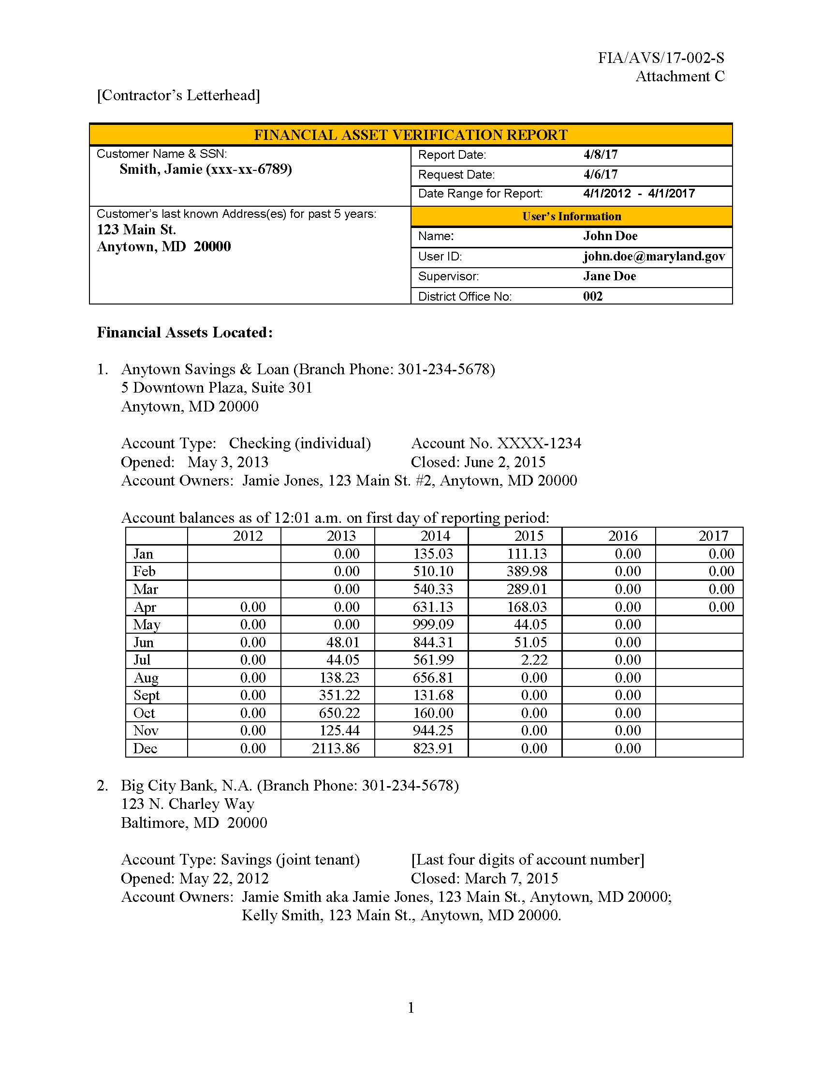

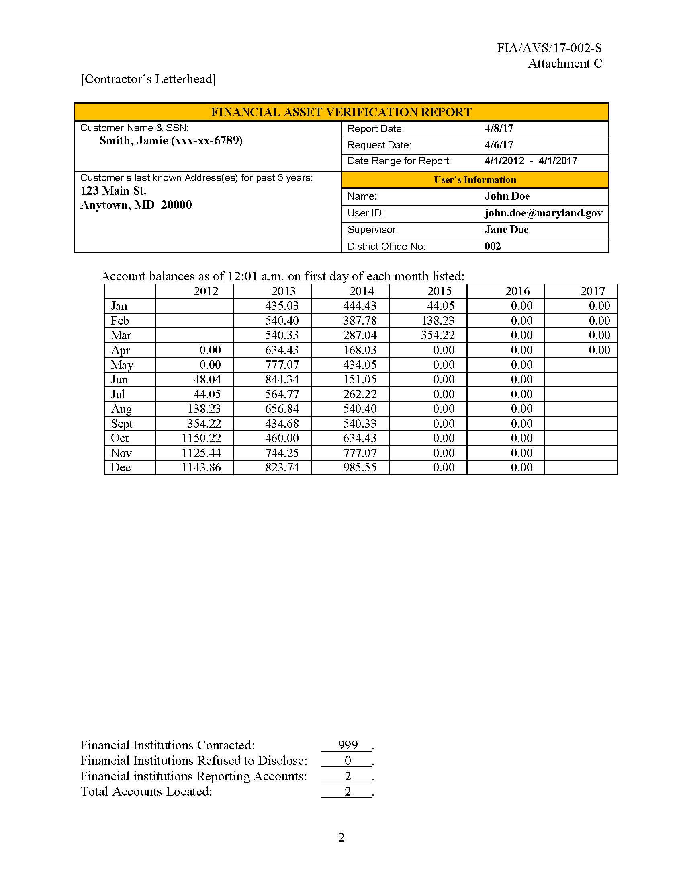

ATTACHMENT D – REAL PROPERTY ASSET VERIFICATION REPORT “SAMPLE”

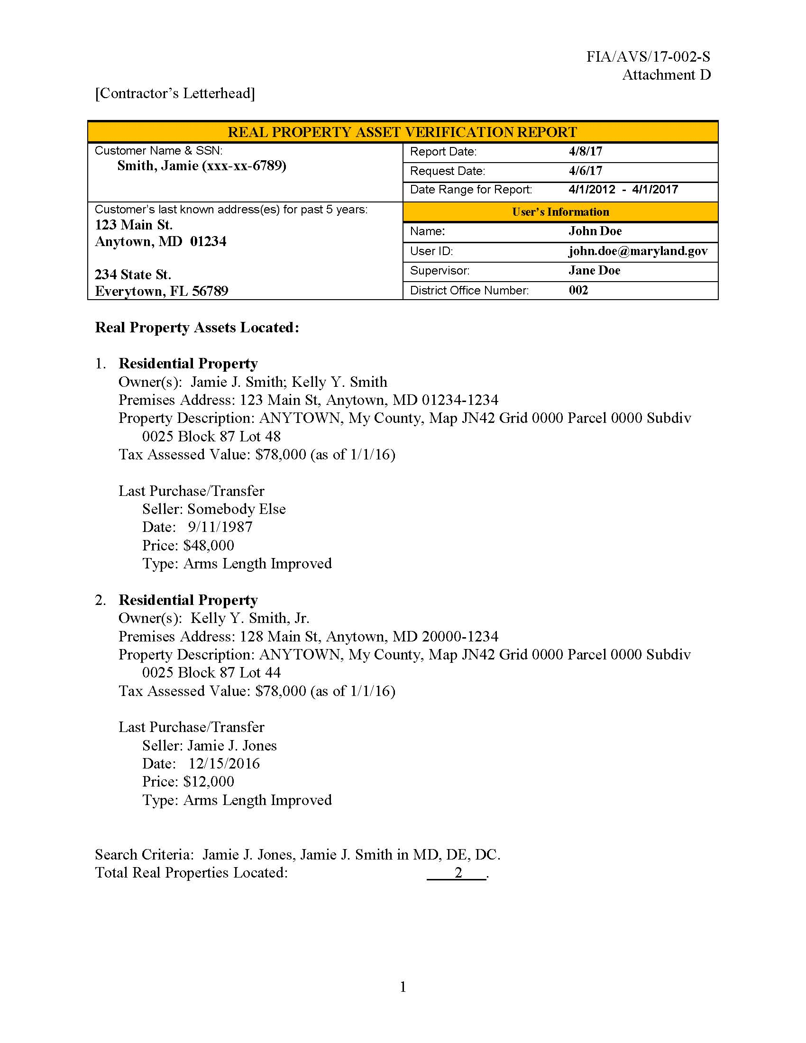

ATTACHMENT E - BI- WEEKLY STATUS REPORT FOR FINANICAL ASSET VERIFICATION SERVICES

The Bi-Weekly Status Report for Financial Asset Verification Services is an Excel Spreadsheet and is included as a separate attachment to the solicitation.

ATTACHMENT E-1 – BI-WEEKLY STATUS REPORT FOR REAL PROPERTY ASSET VERIFICATION SERVICES

The Bi-Weekly Status Report for Real Property Asset Verification Services is an Excel Spreadsheet and is included as a separate attachment to the solicitation.

ATTACHMENT F – MONTHLY FINANCIAL ASSET VERIFICATION REPORT

The Monthly Financial Asset Verification Report is an Excel Spreadsheet and is included as a separate attachment to the solicitation.

ATTACHMENT F-1 – MONTHLY REAL PROPERTY ASSET VERFICATION REPORT

The Monthly Real Property Asset Verification Report is an Excel Spreadsheet and is included as a separate attachment to the solicitation.

ATTACHMENT G – MARYLAND BANKS

- Bank of America
- Bay Bank, FSB
- Branch Banking and Trust Company
- Capital One
- Citibank
- Community Bank of the Chesapeake
- First Mariner Bank
- First National Bank of Pennsylvania
- First United Bank & Trust
- Hebron Savings Bank
- Howard Bank
- Manufacturers and Traders Trust Company
- Old Line Bank
- PNC Bank
- Sandy Spring Bank
- Sun Trust Bank
- TD Bank
- The Columbia Bank
- Wells Fargo Bank
- Woodforest National Bank

