Federal Parent Locator Service
National Directory of New Hires
Guide for Data Submission
Version 12.0
August 12, 2011
Administration for Children and Families
Office of Child Support Enforcement
370 L’Enfant Promenade S.W.
Washington, DC 20447
DCN: C8-2021.82.06
This document was prepared for the United States Department of Health and Human Services, Office of Child Support Enforcement under Contract Number NIH CIOSP 263-01-D-0054 by Lockheed Martin, Information Systems and Global Systems, Incorporated (LM IS&GS). The work was authorized in compliance with the following specific prime task order:
Delivery Order Number: HHS-ACF-2006-C2500M
Delivery Order Title: National Directory of New Hires
Document Date: August 2011
Table of Contents
1. Federal Parent Locator Service Background 1-1
1.1 Purpose of the National Directory of New Hires 1-1
1.2 System Functionality 1-2
2. Security 2-1
2.1 Controlling Authority for Security Legislation 2-1
2.1.1 Social Security Act, Section 453 (42 U.S.C. 653) 2-1
2.1.2 The Privacy Act of 1974 (P.L. 93-579) 2-2
2.1.3 The Computer Security Act of 1987 (P.L. 100-235) 2-2
2.1.4 OMB Bulletins And Circulars 2-3
2.1.5 FIPS Publications 2-3
2.1.6 HHS Information Security Program Policy 2-3
2.2 NDNH FPLS Federal and State Level Security 2-3
2.2.1 Federal Level Security 2-4
2.2.2 State Level Security 2-5
3. Technical Support 3-1
4. Application 4-1
4.1 Strategic Issues 4-1
4.1.1 Oversight Initiatives 4-1
4.1.2 State System Integration Strategies 4-2
4.2 System Configuration 4-3
4.2.1 Federal Agency System Configuration Example 4-3
4.2.2 State System Configuration Examples 4-5
5. Social Security Number Verification 5-1
5.1 Rejected SSNs 5-1
5.2 Non-Matching SSN/Name Combinations 5-2
5.3 Corrected SSNs (W-4 [and UI] Only) 5-2
5.4 Non-Verifiable SSNs 5-3
5.5 Name Transposition 5-4
5.6 Minimal Name Requirements 5-4
5.7 Using the NameSearch Software 5-4
6. CFI Transmission 6-1
6.1 CFI Strategic Issues 6-1
6.2 CFI Technical Support 6-2
6.3 CFI Summary, Conclusion and Recommendation 6-2
7. Data Retention 7-1
8. New Hire Component 8-1
8.1 Legislation 8-1
8.2 Timeframes 8-2
8.3 State Directory of New Hires 8-3
9. W-4 Data Requirements 9-1
9.1 Data Requirements 9-1
9.2 SDNH Collection Methods and Processes 9-3
9.3 Multistate Employer 9-5
10. W-4 Transmission 10-1
10.1 Federal Agency Alternate Transmission Method 10-1
10.2 W-4 Record Layouts 10-1
10.3 Frequency of Transmission 10-12
11. W-4 Data Validation and Verification 11-1
11.1 Pre-Processing Level Editing 11-1
11.2 Transmission Level Editing 11-1
11.2.1 Transmission Errors 11-1
11.3 Batch Level Editing 11-3
11.4 Record Level Editing 11-4
11.4.1 SSN/Name Verification 11-4
11.4.2 Minimal Data Validation 11-5
11.4.3 General Validation 11-5
11.4.4 W-4 Record Codes and Explanations 11-8
11.5 Resubmittal Process 11-10
12. W-4 NDNH Update 12-1
12.1 Duplicates 12-1
13. W-4 Output to Submitters 13-1
13.1 Output Record Layouts 13-1
13.2 Output Mode 13-7
13.3 Output Control Matrix 13-7
14. W-4 Management Information 14-1
14.1 General Information 14-1
14.2 MI Report and Explanation 14-1
15. W-4 Conclusion and Recommendations 15-1
16. Quarterly Wage Component 16-1
16.1 Legislation 16-1
16.2 Timeframes 16-2
16.3 More Frequent Submissions 16-3
17. QW Data Requirements 17-1
17.1 Data Requirements 17-1
17.2 QW Data Source 17-2
18. QW Transmission 18-1
18.1 Transmission Method 18-1
18.2 QW Record Layouts 18-1
19. QW Data Validation and Verification 19-1
19.1 Pre-Processing Level Editing 19-1
19.2 Transmission Level Editing 19-1
19.2.1 Transmission Errors 19-1
19.3 NDNH Pre-Processing Level Editing 19-3
19.3.1 Duplicates 19-3
19.3.2 Submission Limits 19-3
19.4 Batch Level Editing 19-4
19.5 Record Level Editing 19-5
19.5.1 SSN/Name Verification 19-5
19.5.2 Minimal Data Validation 19-6
19.5.3 General Validation 19-7
19.5.4 QW Record Codes and Explanations 19-9
19.6 Resubmittal Process 19-10
20. QW NDNH Update 20-1
20.1 Non-verifiable File 20-1
20.2 Duplicates 20-1
21. QW Output to Submitters 21-1
21.1 Output Record Layouts 21-1
21.2 Output Mode 21-6
21.3 Output Control Matrix 21-6
22. QW Management Information 22-1
22.1 General Information 22-1
22.2 MI Report and Explanation 22-1
23. QW Conclusion and Recommendations 23-1
24. Unemployment Insurance Component 24-1
24.1 Legislation 24-1
24.2 Timeframes 24-2
25. UI Data Requirements 25-1
25.1 Data Requirements 25-1
25.2 UI Data Source 25-2
26. UI Transmission 26-1
26.1 Transmission Method 26-1
26.2 UI Record Layouts 26-1
26.2.1 UI Data Record 26-4
27. UI Data Validation and Verification 27-1
27.1 Pre-Processing Level Editing 27-1
27.2 Transmission Level Editing 27-1
27.2.1 Transmission Errors 27-1
27.3 NDNH Pre-Processing Level Editing 27-2
27.3.1 Duplicates 27-3
27.3.2 Submission Limits 27-3
27.4 Batch Level Editing 27-3
27.5 Record Level Editing 27-5
27.5.1 SSN/Name Verification 27-5
27.5.2 Minimal Data Validation 27-6
27.5.3 General Validation 27-6
27.6 Error Codes and Explanations 27-8
27.6.1 Incomplete Records 27-8
27.6.2 Rejected Records 27-8
27.6.3 Other Errors 27-8
27.7 UI Record Codes and Explanations 27-8
27.8 Resubmittal Process 27-10
28. UI NDNH Update 28-1
28.1 Duplicates 28-1
29. UI Output to Submitters 29-1
29.1 Output Record Layouts 29-1
29.2 Output Mode 29-5
29.3 Output Control Matrix 29-5
30. UI Management Information 30-1
30.1 General Information 30-1
30.2 MI Report and Explanation 30-1
31. UI Conclusion and Recommendations 31-1
A. Acronyms List A-1
B. Federal Information B-1
B.1 Federal Law B-1
B.2 Federal Regulations B-10
B.3 Federal Agency Listing B-10
B.4 PRWORA Sections 313 and 316 B-10
B.5 W-4 Form B-10
C. State Information C-1
C.1 State Legislation C-1
D. Foreign Country FIPS Codes D-1
E. State and Territory Information E-1
F. Transmission Recommendations F-1
F.1 New Hire (W-4) F-1
F.2 Quarterly Wage (QW) F-4
F.3 Unemployment Insurance (UI) F-8
G. References G-1
H. Organizations H-1
I. [Summary of Changes I-1
]
List of Figures and Charts
Figure 1-1: NDNH Functionality Diagram 1-3
Figure 4-1: Federal Agency Configuration Example 4-4
Figure 4-2: State System Configuration Example 1, Part 1 4-6
Figure 4-3: State System Configuration Example 1, Part 2 4-7
Figure 4-4: State System Configuration Example 2, Part 1 4-8
Figure 4-5: State System Configuration Example 2, Part 2 4-9
Figure 4-6: State System Configuration Example 3, Part 1 4-10
Figure 4-7: State System Configuration Example 3, Part 2 4-11
Figure 4-8: State System Configuration Example 4, Part 1 4-12
Figure 4-9: State System Configuration Example 4, Part 2 4-13
Figure 13-1: W-4 Output Control Matrix Registration Form 13-8
Figure 13-2: W-4 Output Control Matrix Registration Form 13-9
Figure 14-1: W-4 MI Report Sample 14-2
Figure 21-1: QW Output Control Matrix Registration Form 21-8
Figure 21-2: QW Output Control Matrix Registration Form 21-9
Figure 22-1: QW MI Report Sample 22-2
Figure 29-1: UI Output Control Matrix Registration Form 29-6
Figure 30-1: UI MI Report Sample 30-2
Figure B-1: Sample W-4 Form B-11

Chart 3-1: Technical Support Resources 3-1
Chart 6-1: CFI Technical Support 6-2
Chart 8-1: W-4 Timeframes 8-2
Chart 9-1: Description of W-4 Data Elements 9-2
Chart 10-1: W-4 Transmitter Header Record 10-3
Chart 10-2: W-4 Data Record 10-5
Chart 10-3: W-4 Total Record 10-11
Chart 11-1: W-4 Transmission Error and Warning Codes 11-2
Chart 11-2: W-4 Batch Editing 11-3
Chart 11-3: W-4 SSN/Name Verification 11-4
Chart 11-4: W-4 General Validation 11-6
Chart 11-5: W-4 Error And Warning Codes 11-8
Chart 13-1: W-4 Transmission Control Record 13-2
Chart 13-2: W-4 Response Data Record 13-4
Chart 14-1: W-4 MI Report Field Descriptions 14-3
Chart 16-1: QW Timeframes 16-2
Chart 17-1: Description of QW Data Elements 17-2
Chart 18-1: QW Transmitter Header Record 18-3
Chart 18-2: QW Data Record 18-6
Chart 18-3: QW Total Record 18-11
Chart 19-1: QW Transmission Error and Warning Codes 19-2
Chart 19-2: QW Batch Editing 19-4
Chart 19-3: QW SSN/Name Verification 19-6
Chart 19-4: QW General Validation 19-7
Chart 19-5: QW Error and Warning Codes 19-9
Chart 21-1: QW Transmission Control Record 21-2
Chart 21-2: QW Response Data Record 21-3
Chart 22-1: QW MI Report Field Descriptions 22-3
Chart 24-1: UI Timeframes 24-2
Chart 25-1: Description OF UI Data Elements 25-1
Chart 26-1: UI Transmitter Header Record 26-2
Chart 26-2: UI Data Record 26-5
Chart 26-3: UI Total Record 26-8
Chart 27-1: UI Transmission Error and Warning Codes 27-2
Chart 27-2: UI Batch Editing 27-4
Chart 27-3: UI SSN/Name Verification 27-5
Chart 27-4: UI General Validation 27-7
Chart 27-5: UI Error and Warning Codes 27-9
Chart 29-1: UI Transmission Control Record 29-2
Chart 29-2: UI Response Data Record 29-3
Chart 30-1: UI MI Field Descriptions 30-3
Chart 31-1: Foreign Country FIPS Codes D-1
Chart 31-2: State and Territory Names, Abbreviations and FIPS Codes E-1
Chart 31-3: NDNH-Related Documents G-1
Chart 31-4: Amendments to the Social Security Act that Affect NDNH G-2
[Chart I-1: Version 12.0 Revisions I-1]

Purpose of This Document
The purpose of the National Directory of New Hires (NDNH) Guide for Data Submission (the Guide) is to provide all submitters of NDNH data with a means to easily locate information regarding their specific use of the NDNH system. The Guide provides general information concerning the NDNH and its purpose, as well as broad technical information for data submission.
The Guide is written in a manner to make locating information as easy as possible. This document is divided into five parts.
Part 1 (Sections 1 through 7) provides general information about the NDNH portion of the Federal Parent Locator Service (FPLS), including an introduction, an overview and the purpose of the NDNH. This part has information about the environment in which the system operates, technical support, system functionality, security and privacy. Technical information about the application, the Social Security Number (SSN) verification processing, the data transmission software (CyberFusion), and data retention complete this part of the Guide.
Part 2 (Sections 8 through 15) covers New Hire (W-4) reporting and includes a description of, and requirements for, processing W-4 data. This part provides information about transmitting data, W-4 records and their validation, updating W-4 data, data being returned to submitters, and management information (MI). This part ends with a section that includes a summary, conclusions and recommendations.
Part 3 (Sections 16 through 23) covers Quarterly Wage (QW) reporting and includes a description of, and requirements for, processing QW data. This part provides information about transmitting data, QW records and their validation, updating QW data, data being returned to submitters, and MI. This part ends with a section that includes a summary, conclusions and recommendations.
Part 4 (Sections 24 through 31) covers Unemployment Insurance (UI) reporting and includes a description of, and requirements for, processing UI data. This part provides information about transmitting data, UI records and their validation, updating UI data, data being returned to submitters, and MI. This part ends with a section that includes a summary, conclusions and recommendations.
Part 5 (Appendices A through I) includes a number of appendices. These include sections about the federal law, state, territory and foreign country abbreviations and codes, form copies and a list of acronyms.
Updates to the Guide are provided when changes are made to the NDNH system.

Federal Parent Locator Service Background
The Personal Responsibility and Work Opportunity Reconciliation Act (PRWORA) of 1996 mandated the establishment of new resources at the federal and state levels to assist State Child Support Enforcement (CSE) (IV-D) agencies to:
- establish paternity
- establish, setting the amount of, or modifying child support obligations
- enforce child support obligations
Some provisions of PRWORA require the establishment of State Directories of New Hires (SDNH), State Case Registries (SCR), and, within the FPLS, an NDNH and a Federal Case Registry of Child Support Orders (FCR). The implementation date for the NDNH was October 1, 1997, and October 1, 1998 for the FCR.
An SDNH is a registry of all newly hired employees in that state, and the SCR is a registry of all of the state’s IV-D child support cases and all of the support orders that have been established or modified in the state on or after October 1, 1998. Each SDNH and SCR transmits data to the NDNH and the FCR components of the FPLS respectively. In addition, each state also transmits QW and UI data to the NDNH.
In order to have a comprehensive database with information from all employers, PRWORA also requires every federal agency to transmit W-4 and QW information to the NDNH. Federal agencies transmit their data directly to the NDNH.

Purpose of the National Directory of New Hires
The purpose of the NDNH is to provide a national repository of employment and unemployment insurance information that enables state IV-D agencies to be more effective in:
- locating noncustodial parents
- establishing child support orders
- enforcing child support orders
The information in the NDNH, as a part of the FPLS, alleviates many of the difficult issues that are inherent in interstate child support enforcement.
Custodial parties (CPs), noncustodial parents (NCPs) and putative fathers (PFs) in IV-D child support cases, as reported by the SCRs, are compared against the QW, UI and W-4 data that the federal agencies and states submit. Any matching information is made available to the state IV-D agencies. This information, combined with other available Locate and enforcement remedies, enables the agencies to be more effective in enforcing and collecting child support.
In addition to the information that is accessible to state IV-D agencies, the following authorized users may access NDNH data:
- the Internal Revenue Service (IRS)
- the Social Security Administration (SSA)
- authorized persons investigating parental kidnapping
- persons authorized to obtain information to locate a parent or child for the purpose of making or enforcing child custody and child visitation determinations
- state IV-B and IV-E agencies in order to locate persons for the purposes of adoption
- the Department of Education (DoEd)
- the Department of Housing and Urban Development (HUD)
- state IV-A agencies for IV-A program purposes
- State Workforce Agencies (SWA)
- the Office of Policy, Research and Evaluation (OPRE)
- the Veteran Affairs Administration (VA)

System Functionality
Figure 1-1, “NDNH Functionality Diagram,” is a representation of NDNH functionality. This diagram shows the types of information that flow into, and out of, the system. The following is a description of the processing of NDNH information for each agency that is shown on the diagram.
Federal Agencies – Each federal agency, or its payroll department, submits W-4 and QW data directly to the NDNH for processing and inclusion on the NDNH database. Each federal submitter receives a Notification Report that provides information about the submitted data, such as the total number of W-4 or QW records received and processed, data errors, and SSN verification information. They also receive a regularly scheduled MI report to assist in monitoring the W-4 and QW reporting.
State Agencies – There are various state agencies that receive and transmit W-4, QW and UI data to the NDNH. They include SDNHs in CSE IV-D agencies, SWAs, state departments of revenue, and any other agency a state may designate as the responsible agency for receiving and transmitting the W-4, QW or UI data. Each submitting state agency receives a Notification Report that provides information about the submitted data, such as the total number of records received and processed by the NDNH, data errors, and SSN verification information. They also receive a regularly scheduled MI report to assist in monitoring the data reporting.
Social Security Administration – When the NDNH receives a record that contains an SSN and name, the NDNH transmits the data to SSA, which attempts to verify the SSN by matching the information against SSA records. The NDNH catalogs the results of SSN verification attempts. In addition, if the NDNH receives a record that contains a Federal Employer Identification Number (FEIN), but not an employer address, the NDNH attempts to match the FEIN against SSA’s Employer Identification File (EIF) to obtain the employer’s address.
OCSE – the federal Office of Child Support Enforcement (OCSE) automatically receives regularly scheduled MI reports, and requests special MI information to assist in the monitoring of the NDNH system and state and federal agency compliance. In addition, the NDNH receives requests for Locate information for individuals through the FPLS. When the NDNH receives a Locate Request, it attempts to match the incoming record against W-4, QW and UI data, and reports matches to the FPLS, which then reports the information to the requesting agency.
Figure 1-1: NDNH Functionality Diagram

Security
Security and privacy are crucial components, which have been, and will continue to be, considered throughout the development, enhancement and operation of the FPLS.

Controlling Authority for Security Legislation
Various applicable statutes, Office of Management and Budget (OMB) Bulletins, Federal Information Processing Standard (FIPS) Publications, and Health and Human Services (HHS) policies establish specific requirements for confidentiality, integrity and availability of information in the FPLS, and address and provide guidance on these issues. Safeguards that support these directives are in place to ensure the accuracy of the FPLS information, as well as, to restrict access to authorized persons and only for authorized purposes. The FPLS Security Plan addresses these safeguards in more detail.

Social Security Act, Section 453 (42 U.S.C. 653)
Section 453(m) of the Social Security Act states that the Secretary shall establish and implement safeguards that are designed to ensure the accuracy and completeness of the information in the FPLS, and to restrict access of confidential information to authorized persons and for authorized purposes.
The Social Security Act limits access to the NDNH data to:
- state agencies that administer the Child Support program, the Temporary Assistance for Needy Families (TANF) program, the UI program and the Foster Care and Child Welfare programs
- the Secretary of the Treasury for purposes of administering the tax laws
- the Commissioner of the SSA for purposes of verifying SSNs and other purposes
- researchers who are pursuing projects that are likely to contribute to achieving the purposes of the Child Support and TANF programs, but without personal identifiers
- authorized persons, as defined by Section 453(c) and Section 463(d) of the Social Security Act
- courts with authority to issue child support orders
- DoEd for collection of debts
- HUD for determination of eligibility for selected housing programs
- the VA for verifying benefit eligibility
- SWAs for fraud detection and recovery of overpayments

The Privacy Act of 1974 (P.L. 93-579)
The Privacy Act provides standards for, and restrictions on, records that are maintained by federal agencies on individuals.
Section 552a(d) - Access to Records. - Each agency that maintains a system of records shall
- upon request by any individual to gain access to his record or to any information pertaining to him which is contained in the system, permit him and upon his request, a person of his own choosing to accompany him, to review the record and have a copy made of all or any portion thereof in a form comprehensible to him, except that the agency may require the individual to furnish a written Statement authorizing discussion of that individual's record in the accompanying person's presence;
- permit the individual to request amendment of a record pertaining to him and -
- not later than 10 days (excluding Saturdays, Sundays, and legal public holidays) after the date of receipt of such request, acknowledge in writing such receipt; and
- promptly, either -
- make any correction of any portion thereof which the individual believes is not accurate, relevant, timely, or complete; or
- inform the individual of its refusal to amend the record in accordance with his request, the reason for the refusal, the procedures established by the agency for the individual to request a review of that refusal by the head of the agency or an officer designated by the head of the agency, and the name and business address of that official;
- permit the individual who disagrees with the refusal of the agency to amend his record to request a review of such refusal, and not later than 30 days (excluding Saturdays, Sundays, and legal public holidays) from the date on which the individual requests such review, complete such review and make a final determination unless, for good cause shown, the head of the agency extends such 30-day period; and if, after his review, the reviewing official also refuses to amend the record in accordance with the request, permit the individual to file with the agency a concise Statement setting forth the reasons for his disagreement with the refusal of the agency, and notify the individual of the provisions for judicial review of the reviewing official's determination under subsection (g)(1)(A) of this section;
- in any disclosure, containing information about which the individual has filed a Statement of disagreement, occurring after the filing of the Statement under paragraph (3) of this subsection, clearly note any portion of the record which is disputed and provide copies of the Statement and, if the agency deems it appropriate, copies of a concise Statement of the reasons of the agency for not making the amendments requested, to persons or other agencies to whom the disputed record has been disclosed; and
- nothing in this section shall allow an individual access to any information compiled in reasonable anticipation of a civil action or proceeding.

The Computer Security Act of 1987 (P.L. 100-235)
The Computer Security Act of 1987 mandates the improvement of privacy for unclassified, sensitive information in federal computer systems. It requires federal agencies to prepare, and periodically update, security plans for their computers that process sensitive information. It also requires federal agencies to provide for the mandatory periodic training in computer security awareness and accepted computer practices of all federal and contractor employees who are involved with the management, use, and operation of each federal computer system within, or under, the supervision of that agency.

OMB Bulletins And Circulars
OMB Bulletin No. 90-08, Guidance for Preparation of Security Plans for Federal Computer Systems that Contain Sensitive Information
The purpose of this Bulletin is to provide guidance to federal agencies about computer security planning activities that are required by the Computer Security Act of 1987. Based on the criteria in the Bulletin, the FPLS is defined as a major application under development.
OMB Circular No. A-130, Security of Federal Automated Information Resources
Appendix III of this Circular establishes a minimum set of controls to be included in federal automated information security programs. It assigns federal agency responsibilities for the security of automated information, and links agency automated information security programs and agency management control systems. It also incorporates requirements of the Computer Security Act of 1987 and responsibilities assigned in applicable national security directives.

FIPS Publications
FIPS Pub 73, Guidelines for Security of Computer Applications
This document focuses on controls for use with computer applications and provides guidance to address and prevent inadequacies in the design and operation of computer applications.
FIPS Pub 102, Guidelines for Computer Security Certification and Accreditation
This publication describes how to establish and implement a computer security certification and accreditation program.

HHS Information Security Program Policy
The HHS Information Security Program Policy establishes departmental policies, procedures and responsibilities for the implementation and administration of security. It provides references to other security requirements.

NDNH FPLS Federal and State Level Security
The NDNH system contains sensitive information (W-4, UI and QW), which requires protection from unauthorized disclosure. Due to the sensitivity of the information, the confidentiality protection requirement level is considered high. FPLS information is categorized as Level 3 (high sensitivity designation) as specified in the HHS Automated Information Systems Security Program (AISSP) Handbook. Level 3 data must be protected from unauthorized disclosure, fraud, waste and abuse. The misuse, unauthorized access to, or modification of FPLS information could result in exceptionally grave damage to the program, or the privacy to which individuals are entitled under the Privacy Act. To ensure the privacy of NDNH data and to prevent unauthorized access to this data, there are safeguards in place at the federal level. In addition to the federal level security, each state agency must have safeguards to ensure security of data, as described by the above-referenced sources.

Federal Level Security
Section 453(l) – Restrictions on Disclosure and Use
Information in the FPLS, and information resulting from comparisons using such information, shall not be used or disclosed except as expressly provided in Section 453 (1) and subject to Section 6103 of the Internal Revenue Code of 1986.
Section 453(m) – Information Integrity and Security
The Secretary shall establish and implement safeguards with respect to the entities established under this section designed to –
- ensure the accuracy and completeness of information in the FPLS; and restrict access to confidential information in the FPLS to authorized persons, and
- restrict use of such information to authorized purposes.
Security for the FPLS at the federal level includes management controls (such as conducting background investigations on personnel), development/implementation controls (such as design review and testing), operational controls (such as emergency backup, disaster recovery, business continuity and contingency planning), security awareness training, and technical controls (such as user identification and authentication). The development of these various controls is evolutionary over the life of the system.
The FPLS central processing and data storage are physically located at the SSA’s National Computer Center (NCC) in Baltimore, Maryland. Physical and perimeter security safeguards exist to protect personnel, hardware, software, data and other components of the NCC. All agency and contractor personnel are subject to the security awareness and training provisions of the Computer Security Act.
All of the SSA mainframes at the NCC operate under the TOP SECRET Control System. TOP SECRET provides security to protect computer data from destruction, modification, disclosure and misuse. It controls access of the computer resources, and automatically denies and logs unauthorized attempts to access resources. TOP SECRET has the ability to log authorized use of sensitive resources for subsequent review. The SSA/OCSE administrator controls access privileges under TOP SECRET.
Data transmissions from the states to the NCC are via data transmission software, known as CyberFusion (CFI), using dedicated lines within SSA’s closed network. The Network Control Center, within the NCC, employs sophisticated network monitoring software that assists in identifying unauthorized access. In order to comply with the required privacy safeguards, agreements on privacy, security and the use of FPLS data have been developed between OCSE and the Department of the Treasury (DoT), the SSA, and other entities as appropriate. Their use of the data is restricted, as provided by legislation.
Within OCSE, access to the data is limited to those in the FPLS branch, and the Associate Commissioner of the Office of Automation and Program Operations (OAPO). A locking door controls access to the room in which the FPLS is located, with limited key access. A list of staff with approved access is maintained by the FPLS Security Team, and is reviewed on a regular basis by management. Visitors to the room must sign in and be escorted at all times by a staff member with approved access.

State Level Security
SWA systems are responsible to comply with privacy and security safeguards established by the Department of Labor (DoL) and their own respective state laws. Each SWA should ensure compliance with its own requirements. Please refer to the DoL for clarification on specific requirements.
In addition, Section 454A of the Social Security Act requires the state agency that administers the IV-D program to have in place safeguards for the integrity, accuracy and completeness of, access to, and use of data in the statewide-automated system, which shall include:
- written policies concerning access to data by state agency personnel and sharing of data with other people
- system controls, such as passwords or blocking of fields
- routine monitoring of access to, and use of, the automated system by audit trails feedback mechanisms, to guard against and promptly identify unauthorized access or use
- procedures to ensure that all personnel, including state and local agency staff and contractors, who have access to confidential program data are informed of applicable requirements and penalties, including those in Section 6103 of the Internal Revenue Code of 1986, and are adequately trained in security procedures
- administrative penalties, up to and including dismissal from employment for unauthorized access to, disclosure or use of confidential data
It is a requirement in Section 454(26) of the Social Security Act that states have in effect safeguards that are applicable to all confidential information. The safeguards must be designed to protect the privacy rights of the parties involved and should include:
- safeguards against unauthorized use or disclosure of information relating to proceedings to establish paternity or to establish, modify or enforce support orders
- prohibitions against the release of information about the location of one party to another party against whom a protective order has been entered
- prohibitions against the release of information about the location of one party to another if the state has reason to believe the release of the information may result in physical or emotional harm to the former party
The state agency is also required to establish safeguards as the Secretary of Labor may determine necessary to ensure information on wages and claims is used only for the purposes that are specified in Section 453(i)(1) of the Social Security Act.

Technical Support
The OCSE provides technical and functional support to the submitters of NDNH data. These resources include a telephone number to receive assistance for technical or operational problems, and the OCSE website.
Chart 3-1: Technical Support Resources
Resource | How to Contact Resource
FPLS Information Line | 202-401-9267
OCSE FPLS website | http://www.acf.hhs.gov/programs/cse/newhire

Application
As part of the federal requirements for reporting W-4 data, every state must establish an SDNH that receives, transcribes into automated format, conducts automated data matches against IV-D cases in the SCR, and transmits W-4 data to the NDNH. States must also report QW and UI data to the NDNH. Federal requirements specify that federal agencies must format and transmit W-4 and QW data directly to the NDNH.
For W-4, UI, federal agency QW data, and QW data that are submitted by a state that stores and transmits employee names, the NDNH first transmits the data to SSA to verify the accuracy of the SSN and its related name against information that is resident in the SSA database. When the NDNH receives notification that the SSN is verified, the system then adds the data to the NDNH database.
For further information about SSN processing, refer to Section 5, “Social Security Number Verification.”

Strategic Issues
Reporting of NDNH information requires the coordination and cooperation of multiple public and private organizations and businesses at the federal, state and local levels. Organizational structures and processing capabilities vary significantly from one federal agency to another and from one state to another. The Social Security Act allows federal agencies and states the flexibility to design their new hire programs in a manner most compatible with the strengths and capabilities of each particular federal agency or state. These variations create challenges in building an effective network that supports the operational aspects of on-going new hire reporting.

Oversight Initiatives
Because responsibility for the reporting of W-4, QW and UI data may reside in different agencies (e.g., SWAs, CSE IV-D agencies, contractor organizations, data processing centers), states may want to consider forming a committee that develops and recommends operational guidelines under which the reporting of data to the NDNH occurs. Some of the strategic issues to consider are:
- the development and maintenance of interagency agreements that specify responsibilities of the different parties that are involved in reporting to the NDNH
- the establishment of frameworks under which the programs operate
- the coordination and direction of:
- employer outreach, compliance, and accuracy for W-4 reporting
- initiatives for improvement of reporting of data
- staff training, including customer service, data preparation, data processing, and technical support
- fraud detection for UI benefits and Workers’ Compensation
- system components review to ensure goals and objectives are being met
- information dissemination about progress of the NDNH to interested parties (employers, participating agencies, etc.), and to inform the general public of the program’s impact on child support enforcement and fraud detection

State System Integration Strategies
Each state’s integration strategy must take into account the state’s existing structure, organizational arrangement and level of automation. Business processes of data gathering, information processing and communication with the NDNH depend on the locale of the SDNH, automated system capabilities and communication links between the system(s) that process the QW, UI and W-4 data. A system may be a composite of records that contain all of the information (QW, W-4 and UI) for transmission to the NDNH, or a data transfer configuration that collects data from different points of origin, maps them to the appropriate format and transmits the files to the NDNH. Regardless of the system configuration, there are basic common factors. The list below contains some of the factors that states should address in program operations. While these are not all-inclusive, they offer material for consideration by state planners.
- Establishment of procedures for data entry functions:
- Employers may transmit W-4 data to the SDNH via many different means, such as by paper, telephone, magnetic or electronic processes. Transcription of the data to a single automated format will be necessary for transmission to the NDNH.
- Methods for error resolution at the point of data entry, or through automated editing at system entry
- Scheduling of processing steps to ensure that federal timeframes are met, particularly during peak processing periods, such as transmission of QW and UI data
- Modification of existing systems or development of new systems:
- Procedural and business requirements for the interface with the NDNH that reflect the needs of all of the agencies/entities that participate in the state’s program
- Procedural and business requirements that support the automated reporting of data to ensure all of the federal programmatic requirements are met
- Modification of existing systems or development of new systems to meet prescribed requirements
- Development of communication links that will support file transfers between hardware components (e.g., data centers) when W-4, QW and UI data reside in different systems or agencies that transport the data to the CFI site
- Establishment of policies and procedures for periodic system validation to ensure continuing optimal operation:
- Measuring and analyzing user satisfaction and the perceived validity of the data
- Measuring and assessing system availability and timely delivery of scheduled outputs and activities
- Control of data access to ensure that adequate safeguards are in place for data security and confidentiality
- Measuring and assessing employer compliance

System Configuration
This section describes the possible arrangements of NDNH data transmission for states and federal agencies.

Federal Agency System Configuration Example
Figure 4-1 is an example of a typical federal agency configuration.

Figure 4-2: Federal Agency Configuration Example
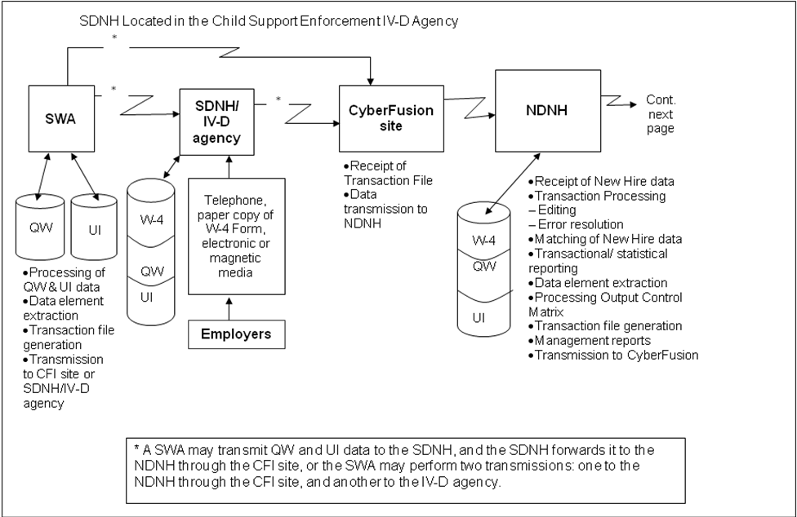

State System Configuration Examples
The following diagrams provide examples of typical state configurations.

Figure 4-3: State System Configuration Example 1, Part 1
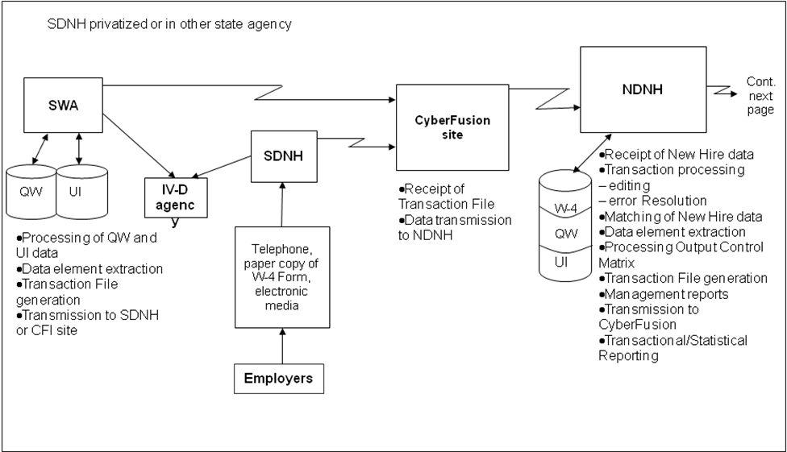
Figure 4-4: State System Configuration Example 1, Part 2
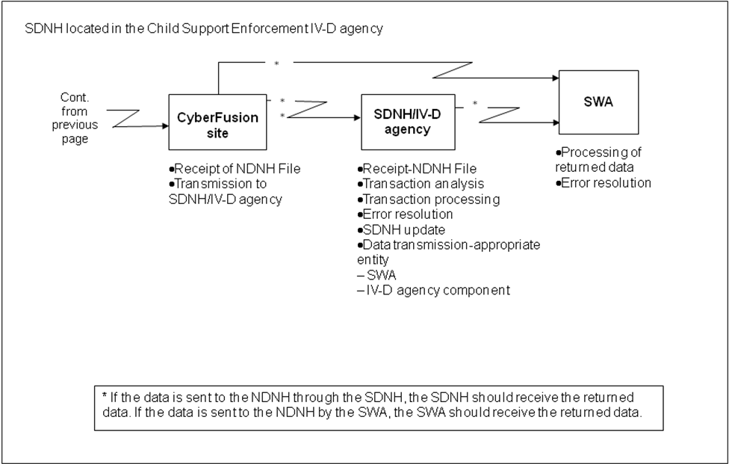
Figure 4-5: State System Configuration Example 2, Part 1
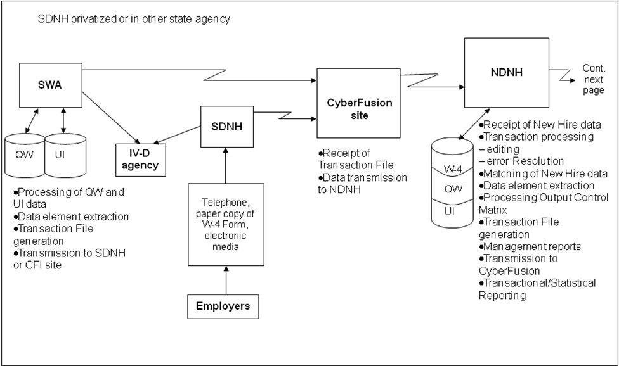
Figure 4-6: State System Configuration Example 2, Part 2
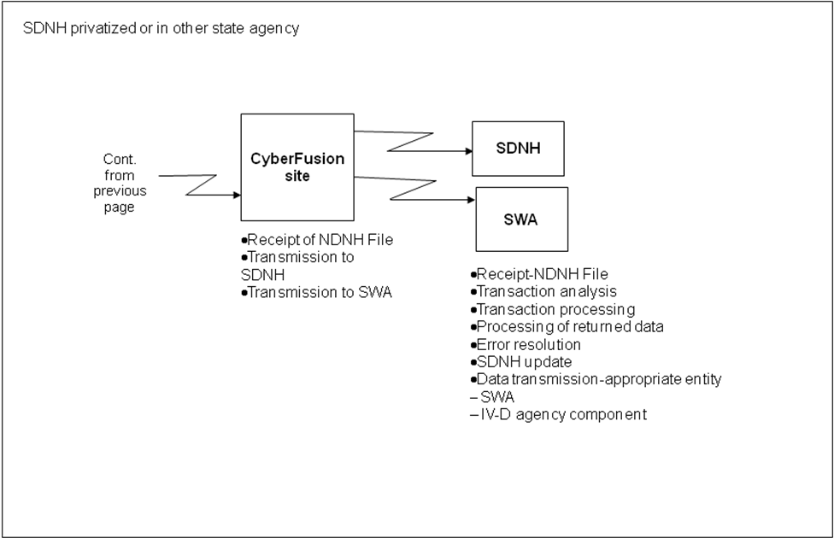
Figure 4-7: State System Configuration Example 3, Part 1
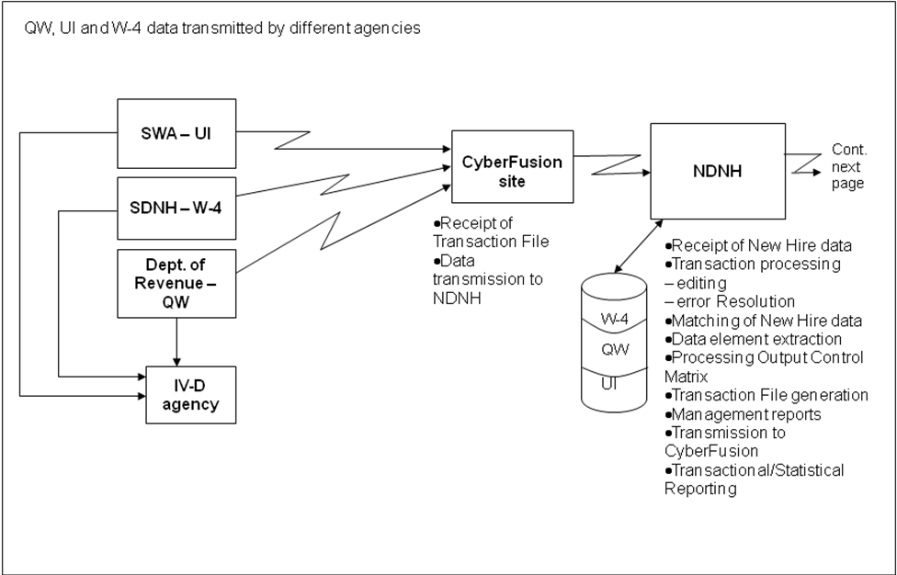
Figure 4-8: State System Configuration Example 3, Part 2
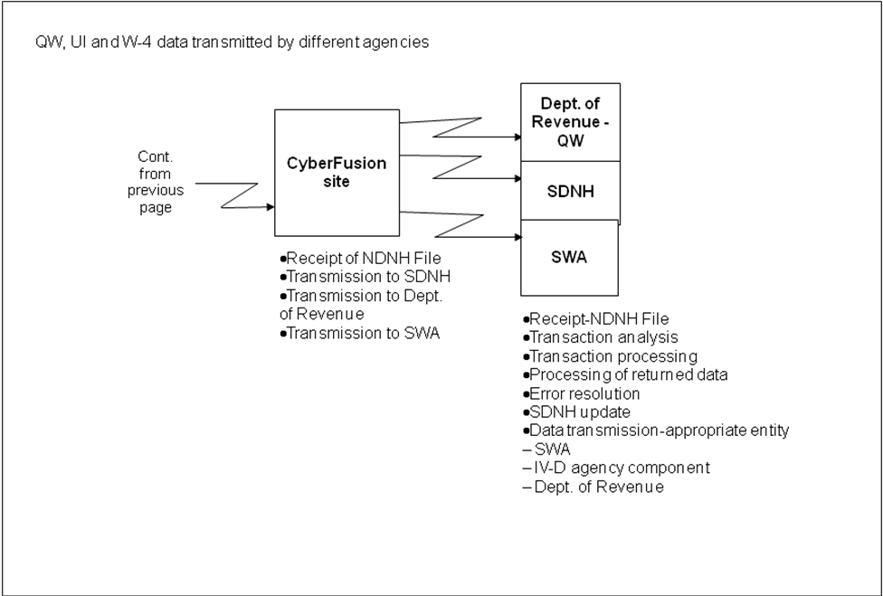
Figure 4-9: State System Configuration Example 4, Part 1
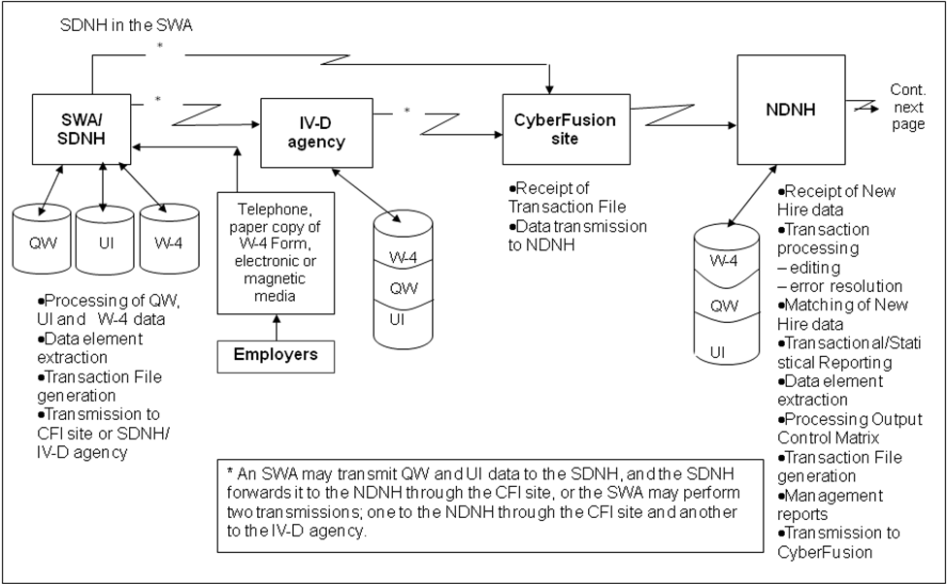
Figure 4-10: State System Configuration Example 4, Part 2
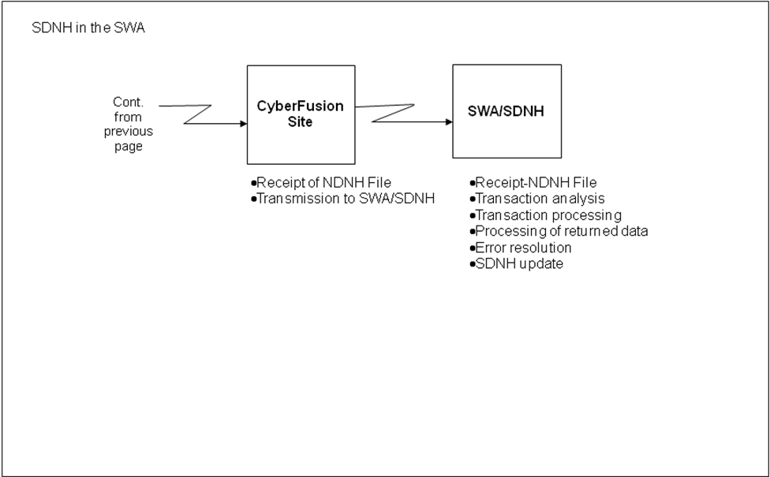

Social Security Number Verification
Note: [Opening and closing brackets] surrounding text signify changed material.
Upon receipt of W-4, QW and UI data from states, or W-4 and QW data from federal agencies, the NDNH system transmits the SSN and name to SSA, which attempts to verify the SSN and its related name against information that is resident in the SSA database. There are several outcomes of this verification process and the submitting agency receives notification of the results, as requested in the NDNH Output Control Matrix Registration. Refer to Sections 13 (W-4), 21 (QW) or 29 (UI), “Output to Submitters,” for additional information regarding the matrix and the data that is available for return to submitting agencies.
The submitting agency receives information about the SSN verification results and may choose to receive the errors, warnings and corrections on individual records. The SSN process checks the submitted SSN and name for:
- Is the SSN a possible number issued by SSA? (W-4, QW and UI)
- Do the SSN and name that were submitted on the record match the SSN and name on SSA’s records? (W-4, QW and UI)?
- Does the SSN have a number transposition and need correction? (W-4 only)?
- Does the SSN have incorrect digits and need correction? (W-4 only)?
- Is the submitted name in the correct fields and is transposition needed? (W-4 and QW)?
If SSA verifies an SSN on a W-4, QW or UI record, or corrects an SSN on a W-4 record, the NDNH system posts the record to the NDNH database. If SSA processing corrects the SSN, the record posts to the NDNH database with the corrected SSN.
Note: SSNs are shown in format ###-XX-####.

Rejected SSNs
Several conditions cause SSNs to be rejected. SSN errors may be due to general edits, or errors found during the SSN verification process. Listed below are conditions that generate rejected SSNs:
- The SSN is non-numeric.
- The SSN is missing.
- The SSN is invalid or out of range.
- The SSN and name on the record does not match with SSA.
- The SSN is not found.
The submitter of the W-4, QW or UI data receives notification of these errors in the transmission acknowledgement. Federal agencies must correct the errors and resubmit the records. State agencies are encouraged to correct the errors and resubmit the records, but are not required to do so. Refer to the Sections 11 (W-4), 18 (QW), or 29 (UI), “Data Validation and Verification,” for the error and warning codes that are associated with the above SSN errors.
SSNs that contain invalid characters and spaces are rejected, as well as those SSNs that have not been assigned through SSA. W-4, QW and UI records must contain SSNs that are properly formatted in order to successfully pass the SSN verification process.
If an SSN is invalid, the system rejects the record and notifies the submitting agency that the SSN is invalid.
EXAMPLE: The SSN that was submitted on the record is 888-XX-8888.
- The system identifies 888-XX-8888 as a number that has not been issued by SSA.
- The system rejects the record.
- The system generates a notification to the submitting agency that 888-XX-8888 is not an SSN issued by SSA.

Non-Matching SSN/Name Combinations
Non-matching SSN/Name combinations are defined as those that do not correspond to SSA’s assigned SSN/Name combinations. W-4, QW and UI records must contain SSNs and names that match SSA’s records, in order to successfully pass the SSN verification and identification process.
If an SSN/Name combination does not match SSA’s SSN/Name combination, the system rejects the record, and notifies the submitting agency that the SSN and name do not match.
EXAMPLE: The SSN and name that were submitted on a record are 333-XX-9911 and Dave Jones.
- The system verifies that the name assigned to 333-XX-9911 is not Dave Jones.
- The system rejects the record.
- The system performs Name Transposition (see Section 5.5, “Name Transposition”).
- The system verifies that the transposed name assigned to 333-XX-9911 is not Jones Dave.
- The system generates a notification to the submitting agency that the SSN and name for this record do not match.

Corrected SSNs (W-4 [and UI] Only)
The W-4 [and UI] validation routines have the capability to identify SSNs that have transposed digits or that have minor numerical errors, such as those that contain one incorrect digit in the SSN. The system selects a corrected SSN only if it can identify one, and only one, corrected SSN/Name combination for the person. This is known as the Single Select Process. The system stores the corrected SSN on the NDNH database with an indicator that shows that the SSN has been corrected, and notifies the submitting agency of the correction. Do not resubmit SSNs that are corrected as a result of the NDNH SSN processing.
EXAMPLE: The SSN and name that were submitted on a W-4 record are 285-XX-9999 and Linda Kay.
- The system verifies that the correct SSN for Linda Kay is 258-XX-9999.
- The system stores Linda Kay with the correct SSN, 258-XX-9999, with an indicator that the SSN has been corrected.
- The system generates a notification, warning code 0005, to the submitting agency that Linda Kay’s correct SSN is 258-XX-9999.
EXAMPLE: The SSN and name that were submitted on a W-4 record are 383-XX-7633 and Don Campbell.
- The system verifies that the correct SSN for Don Campbell is 383-XX-6633.
- The system stores Don Campbell with the correct SSN, 383-XX-6633, with an indicator that the SSN has been corrected.
- The system generates a notification, warning code 0005, to the submitting agency that Don Campbell’s correct SSN is 383-XX-6633.

Non-Verifiable SSNs
Some states’ QW records include only a partial set of letters, or no letters, in the employee’s name(s). When these states send their records to the NDNH, the system checks the SSN to determine if it is within the range of SSNs that have been issued to date by SSA (known as the High-Group check). Records with SSNs outside the issued range are rejected. If the SSN is within the range, the system attempts verification. If the SSN/Name combination does not verify, the system accepts the record and stores it on the QW Non-Verifiable file.
EXAMPLE: A state that only stores a partial set of letters for employee names submitted a QW record with an SSN/Name combination of 274-XX-0154 and ‘Ge’ and ‘McD’ in the first and last name fields.
- The system verifies that 274-XX-0154 is within the range of SSNs issued to date by SSA.
- The system is unable to verify the SSN/Name combination, so it accepts the record and stores the SSN 274-XX-0154 and the partial employee name “Ge McD” on the QW Non-Verifiable file.
- If the SSN passes SSA’s High-Group check, but has one character or a blank in both first and last name fields, the record is saved on the Non-Verifiable file.
- If an SSN passes SSA’s High-Group check, but has a one-character first name and a two- or three-character last name and it fails verification, the record is saved on the QW Non-Verifiable file.
- If an SSN passes SSA’s High-Group check and has the minimal name characters (refer to Section 5.6, “Minimal Name Requirements”), but fails verification, the record is saved on the QW Unverified file.

Name Transposition
If an NDNH record contains an SSN/Name combination that passes SSA’s High-Group check, but does not verify with SSA, the NDNH will reverse the order of the first name and last name and resubmit the transposed name with the SSN to determine if this new SSN/Name combination verifies. If the SSN does verify with the transposed names, the NDNH will accept and store the record with the names transposed, and return warning code 0004 and the corrected name to the submitter. If the transposed name and SSN do not verify, the originally submitted name and the SSN are returned with error code 0001.

Minimal Name Requirements
A minimum number of characters are required to perform the SSN and name verification at SSA. The minimum requirements are:
- First name must contain at least one character, middle name must contain at least one character, and last name must contain at least four characters, or
- First name must contain at least one character and last name must contain at least seven characters.
For any W-4 or UI records that contain less than these name requirements, the system will:
- Not verify the name and SSN
- Reject the record
- Generate a notification to the submitting agency that the name and SSN do not verify
For any QW records that do not meet the minimal name requirements, refer to Section 5.4, “Non-Verifiable SSNs.”

Using the NameSearch Software
After all attempts to find a valid SSN/Name combination have failed, name matching software is utilized to evaluate the extent to which an employee or claimant name with that SSN on a received W4, QW or UI record matches a name in the SSA database. This software provides matching confidence scores at 12 comparison levels. For records that exceed a predetermined confidence level, the comparison results of the name matching software are stored on the W-4, QW or UI Unverified NDNH files, and are used in FCR Locate and Proactive Matching routines.

CFI Transmission
Federal and state agencies transmit W-4, QW and UI data using SSA’s network and the CFI protocol. CFI is a data transfer software product that allows data centers within and across networks to send and receive large amounts of data. The W-4, QW and UI records that are transmitted to the NDNH via CFI must be in the appropriate record format. Refer to the Sections 10 (W-4), 18 (QW), or 26 (UI), “Transmission,” for data requirements, data format rules, record layouts and field descriptions.

CFI Strategic Issues
Currently, a network exists and is operated through SSA that connects each state, and some federal agencies, to SSA. Each state has a copy of the CFI product for data submission via the SSA network. Each state has a site where the CFI transmission is performed. In addition, many federal agencies have been issued a copy of the CFI product for data submission to the SSA.
The Administration for Children and Families (ACF) has a formal agreement with SSA, which allows federal agencies and states to send and receive data through SSA’s existing network.
The basic element of CFI is a file transfer process. Transfers are initiated by submitting predefined processes that consist of a single ‘COPY’ statement, or combinations of multiple statements separated by conditional logic. Processes can trigger transfers at a requested time under predetermined criteria. Six different activities may be specified in a process:
- Move files among systems.
- Submit jobs.
- Execute programs.
- Submit other processes.
- Build and resolve symbolic values.
- Alter the sequence of process execution through conditional logic.
CFI has a checkpoint/restart feature. It eliminates the need to retransmit an entire file in the event of a transmission failure. If a transfer error occurs, the CFI software automatically restarts the transmission at the most recent checkpoint. The CFI software also automatically generates statistics for security, auditing and accounting purposes. This allows federal agencies and states to determine usage of network resources and to determine how to improve network efficiency.
The following steps must be taken to begin using the CFI network to transmit NDNH data:
- Identify the data center that is connected to the SSA CFI network.
- Identify the person who is responsible for creating the CFI process to transmit data.
- Create the CFI processes that are necessary to submit data to the NDNH.
- Create the necessary CFI security profiles.
- Contact the Federal Data Transmission technical liaison to schedule a test to determine the success of submitting and receiving data from the NDNH. A list of the Federal Data Transmission technical liaisons is available through the Technical Support Customer Service Hotline, or from the OCSE website (refer to Chart 6-1).

CFI Technical Support
Federal and state agencies can receive technical support regarding the CFI process and protocols. Chart 6-1 contains the resource and contact information that is available.
Chart 6-2: CFI Technical Support
Resource | How to Contact Resource
FPLS Information Line | 202-401-9267
Data Transmission Team | http://www.acf.hhs.gov/programs/cse/newhire/contacts/dttcontacts.htm

CFI Summary, Conclusion and Recommendation
CFI is the most expedient and secure method of transmitting NDNH data. After each federal agency and state establishes their CFI protocols, data transmission becomes faster and more reliable. CFI ensures that the NDNH system receives W-4, QW and UI data in the most timely, secure manner, which enables the CSE IV-D agencies to use the data quickly and efficiently in child support enforcement efforts.

Data Retention
The SSA imposes restrictions on access to, and retention of, NDNH data. The SSA requires that all NDNH data be deleted from the database 24 months after the date of entry into the NDNH. The SSA does allow the Secretary of HHS to retain such samples of data entered into the NDNH as the Secretary finds necessary to assist in performing research, as specified in section 453(j)(5) of the Social Security Act.

FOREWORD
The OCSE, HHS, promulgated regulations at 45 Code of Federal Regulations (CFR) section 303.108 regarding “Quarterly Wage and Unemployment Compensation Claims Reporting to the National Directory of New Hires.”
The regulations specifically address the dates, format and data elements that are necessary for states to furnish the QW and unemployment compensation data to the NDNH. In developing the regulation, OCSE consulted representatives from state child support agencies, SWAs, the DoL, SSA, Interstate Conference of State Workforce Agencies, and employer groups.
This Guide contains requirements that are contained in the regulation.
The regulations address requirements for state submissions of W-4 reports, QW and UI claims data to the NDNH. The regulations are not applicable to federal agencies. The requirements set forth in this document for federal agencies to submit QW data to the NDNH were determined based on provisions in the PRWORA of 1996 and Executive Order 12953 (February 27, 1995).
Note: [Opening and closing brackets] surrounding text signify changed material.

New Hire Component
The W-4 component of the NDNH is a database of all newly hired employees, as reported from the SDNHs and directly from federal agencies. This data consists of [seven] data elements that are found on the IRS W-4 form, “Employee’s Withholding Allowance Certificate,” in addition to other optional information that SDNHs and federal agencies may submit.

Legislation
Section 453A(a)(1) of the Social Security Act (the Act) required states to develop an SDNH that meets federal requirements by either October 1, 1997 or October 1, 1998, depending on whether a state had a new hire reporting law in effect on August 22, 1996. Section 453(i) of the Act required the HHS to develop an NDNH by October 1, 1997.
Section 453(n) of the Act required federal agencies to report W-4 and QW data as of October 1, 1997. In addition, Section 453A(b)(1)(B) of the Act requires maintenance at the national level of information about multistate employers who choose to report W-4 data to one state in which the employer has employees. Refer to Section 9.3, “Multistate Employer,” for detailed information regarding W-4 reporting options for multistate employers.
Appendix B, “Federal Information,” contains the portions of the Act that are specific to the NDNH.

Timeframes
There are timeframes associated with the reporting of W-4 data, the performance of matches, and reporting by the NDNH. Some of the timeframes are required by the Act and other timeframes are functions of the NDNH system processing. Chart 8-1 shows the activities that are associated with W-4 reporting, and the corresponding timeframes.
Chart 8-3: W-4 Timeframes
Activity | Timeframe
Employers report W-4 data to the SDNH | Employers must report W-4 data no later than 20 days after the date that the employer hires the employee. In the case of an employer that transmits reports magnetically or electronically, the transmitted reports must be separated by two monthly transmissions (if necessary), not less than 12 days nor more than 16 days apart.
Enter W-4 data received from employers into the SDNH | W-4 data must be entered into the SDNH within five business days of the SDNH receiving reports.
SDNHs transmit W-4 data to the NDNH | SDNHs must transmit W-4 data to the NDNH within three business days after the W-4 data are entered into the SDNH.
Federal agencies transmit W-4 data to the NDNH | Federal agencies must report W-4 data no later than 20 days after the date that the employer hires the employee.
Enter W-4 data from federal agencies and SDNHs into the NDNH | W-4 data must be entered into the NDNH within two business days of the NDNH receiving the data.
Return summary and transmittal data, including error reporting, to the submitter | The NDNH must send transmittal, summary, and error data to the submitting federal agency and SDNH within four business days of the NDNH receiving the data.
MI that delineates and summarizes each federal agency’s and SDNH’s submittal data | The NDNH produces reports on a periodic basis.
Compare NDNH and FCR data | NDNH data and FCR data must be cross-matched not less than every two business days.
Report matches from the NDNH and FCR comparison to the CSE IV-D agency | The FCR must report NDNH and FCR matching information to the IV-D agency within two business days of the match.

State Directory of New Hires
The provisions of PRWORA require each state to establish an SDNH. States that did not have a new hire reporting law as of the date of the PRWORA (August 22, 1996) must have established an SDNH, and been able to receive and transmit data to the NDNH as of October 1, 1997.
Those states that had a law for new hire reporting as of the enactment of PRWORA must have reported this data to the NDNH as of October 1, 1997. These states had until October 1, 1998 to comply with the remaining requirements of Section 453A of the Act.
Section 453A of the Act does not specify that the state house the SDNH in a specific agency. Each state decides where to house its SDNH, based on the advantages and disadvantages of each location, and selects the place that best meets its operational needs, such as:
- CSE IV-D agency
- SWA
- Revenue department
- Private vendor under contract with the state
- Local CSE agency
Although there are various options for where to house the SDNH, each state must have only one site for the collection of W-4 data, and only one transmission point of connection to the SSA’s transmission system and the NDNH.

W-4 Data Requirements
Note: [Opening and closing brackets] surrounding text signify changed material.
The federal agencies and SDNHs collect W-4 data and forward this information to the NDNH. Federal law requires the collection and submission of W-4 data, by such dates, in such format, and containing such information as the Secretary of HHS specifies in regulations.
Although additional data is optional under federal law, a state may require information that is more extensive. However, any state requirement that employers report information beyond the [seven] federally mandated data elements must be made under the authority of state law. The federal law gives employers the option of complying with the federally mandated requirements by submitting a W-4 form or, at the option of the employer, an equivalent form. Employers are given the choice to define an “equivalent form.”
In addition to the collection and submission of mandated data, the NDNH system stores optional information that is not on a W-4 form.
These optional data fields can:
- improve states’ fraud detection efforts
- assist with the administration of programs
- increase the effectiveness of identifying the location of persons in CSE IV-D cases
- assist in the prompt implementation of wage withholding for NCPs who owe child support

Data Requirements
Federal agencies and SDNHs collect and transmit information regarding employees and employers to the NDNH. With the exception of the four optional data elements, this information is found on the W-4 form that is completed by an employee at the time of hire. Refer to the Appendix B, “Federal Information,” for a copy of the W-4 form. Refer to Section 10, “W-4 Transmission,” for record layouts and specifications.
Mandatory Data Elements
Federal law requires collection of the following data elements from the W-4 form:
- Employee Name
- Employee SSN
- Employee Address
- Employer Name
- Employer Address
- FEIN
- [Date of Hire]
States without new hire laws in existence on August 22, 1996 must have complied with the mandatory data elements by October 1, 1997.
States with existing new hire laws prior to August 22, 1996 had until October 1, 1998 to fully comply with the mandatory data requirements. As of October 1, 1998, all W-4 records that are submitted must contain the mandatory data elements.
Optional Data Elements
Federal law does not require the collection of the following elements. However, SDNHs may choose to require employers to transmit these data elements to the SDNH, which then transmits the data to the NDNH. The following data elements are optional:
- Employer Optional Address (for income withholding purposes)
- Employee Date of Birth
- Employee State of Hire
To determine what optional fields an SDNH requires, go to:
www.acf.hhs.gov/programs/cse/newhire/employer/contacts/nh_matrix.htm
Chart 9-1 contains descriptions of the W-4 data elements that can be submitted to the NDNH.
Chart 9-4: Description of W-4 Data Elements
Data Element | Description
Employee Name | This element is in box #1 of the W-4 form. This is the employee’s first name, middle name or initial, and last name.
Employee SSN | This element is in box #2 of the W-4 form. SSA assigns this nine-digit number to an individual.
Employee Address | This element is in the un-numbered box below box #1 on the W-4 form. This is the number, street name, PO box, or rural route, city, state, and Zip code where an individual resides. This may be a foreign address.
Employer Name | This element is in box #8 of the W-4 form. This is the name of the entity that employs the individual.
Employer Address | This element is in box #8 of the W-4 form. This is the number, street name, post office box, or rural route, city, state, and Zip code of the entity that employs the individual. This should be the address that the employer reports to the IRS. This may be a foreign address.
FEIN | This element is in box #10 of the W-4 form. The IRS assigns this nine-digit number to an employer.
Employee Date of Birth | The W-4 form does not contain this element. This is the date (in the format CCYYMMDD) that the employee was born.
Employee Date of Hire | The W-4 form does not contain this element. This is the date (in the format CCYYMMDD) that the individual was hired.  The date of hire is the first day in which a person performs services for pay (that is, the first day of work). This is also the date that the employer recognizes as the first day for income tax withholding.  For an additional description of how to determine the employee date of hire, consult OCSE’s “Frequently Asked Questions,” at:  http://www.acf.hhs.gov/programs/cse/newhire/faq/faq.htm
Employee State of Hire | The W-4 form does not contain this element. This is the two-letter state abbreviation where an individual’s wages are reported to the SWA.
Employer Optional Address | This is the number, street name, post office box, or rural route, city, state, and Zip code of an entity that hires an individual. This is the address where an employer receives child support income withholding orders.

SDNH Collection Methods and Processes
Federal law requires that each state have an SDNH that receives reports from employers on either on a W-4 form or, at the option of the employer, an equivalent form. The SDNH must be able to accept W-4 data electronically, magnetically or by first class mail. The SDNH can significantly increase the likelihood of employer compliance by offering employers other methods for submitting W-4 data, in addition to the methods mandated by federal law. The following are examples of methods for W-4 data collection.
ELECTRONICALLY AND MAGNETICALLY
Federal law permits employers to submit data by electronic and magnetic means. The following are some of the methods an SDNH may use to collect data electronically or magnetically:
- An SDNH establishes and disseminates an Internet email address that allows an employer to submit data, either by creating and sending an email, or by scanning and sending a W-4 or equivalent form.
- Many SDNHs provide a website where W-4s can be reported. This provides a fast and easy method of reporting. To determine if an SDNH provides web-based reporting, go to:
http://www.acf.hhs.gov/programs/cse/newhire/employer/contacts/nh_matrix.htm
- An employer sends an SDNH a magnetic tape, cartridge cassette tape, compact disk, digital video disc (DVD), file transfer protocol (FTP), or electronic funds transfer (EFT) that contains the data.
Employers are not required by federal law to transmit W-4 data electronically or magnetically in the same record layout format as required of SDNHs for transmission to the NDNH. However, a state may choose to make that layout a requirement for the employers that report electronically to their SDNH.
PAPER
Federal law requires that an SDNH accept data from the United States Postal Service (USPS) first class mail. The SDNH can implement additional paper submission methods for an employer to submit information. The following are some of the other methods of collecting data on paper:
- An employer mails a copy of the W-4 or equivalent form to the SDNH by private mail service (such as FedEx).
- An employer sends a copy of the W-4 or equivalent form to the SDNH using a facsimile machine.
- An employer hand delivers a copy of the W-4 or equivalent form to the SDNH.
TELEPHONE
An SDNH can establish a process for an employer to use the telephone to submit data for newly hired employees. This accommodates small employers who may not have an electronic means to forward the information. There are several ways to collect data by telephone:
- An operator receives the call from an employer and records the data.
- A voice mail system receives the call and allows the employer to leave a verbal message containing the data.
- A voice response system receives the call and prompts the employer to verbally input the data at certain points in the program.
- A touch-tone data input system receives the call and prompts the employer to key in the data using the telephone’s keypad.
When an employer submits W-4 data, the SDNH can process the information into the system using different means. Some methods of collection, such as receipt of paper copies, require manual entry of data by keying or scanning. Other methods, such as magnetic submission, may only require that an SDNH establish a prescribed format for the records, and then process the data directly into its system.

Multistate Employer
Multistate employers (MSEs) are employers that have employees in two or more states. Federal law allows multistate employers two options for reporting their W-4 data:
- An MSE may choose to report data for each newly hired employee to the state in which the employee works. This option allows the employer to submit data via any of the methods that are accepted by the state. The employer must comply with each state’s W-4 reporting requirements in which its employees work.
- An MSE may choose to report data for all of its newly hired employees to one of the states in which the employer has employees. If an MSE chooses this option, the employer must comply with two requirements of the federal law:
- MSEs must transmit W-4 data electronically or magnetically.
- MSEs must notify the Secretary of HHS in writing indicating to which state they are reporting all of its newly hired employees.
When submitting written notification to the Secretary of HHS about the designation of the single state for W-4 reporting, an employer should include:
- FEIN
- Employer’s name, address, telephone number that are related to the FEIN
- The state selected for reporting purposes
- Other states in which the company has employees (including the subsidiary states)
- Information about subsidiaries (if any), including FEIN, name, state, and Zip code
- Corporate point of contact information, including name, phone number, fax and email
The Multistate Employer Notification form can be found at:
http://www.acf.hhs.gov/programs/cse/newhire/employer/publication/forms/mseform6.pdf
An employer can notify the Secretary of HHS in one of three ways:
- Notify the Secretary of HHS in writing via the MSE Notification form at:
Department of Health and Human Services
Administration for Children and Families
Office of Child Support Enforcement
Multistate Employer Notification
P.O. Box 509
Randallstown, MD 21133
- Notify the Secretary of HHS in writing via the MSE Notification form by facsimile:
Department of Health and Human Services
Administration for Children and Families
Office of Child Support Enforcement
Multistate Employer Notification
Phone: 410-277-9325
- Notify the Secretary of HHS via online Internet registration by accessing the MSE Notification form for New Hire Reporting on the OCSE FPLS website. The Internet address is:
http://www.acf.hhs.gov/programs/cse/newhire/employer/home.htm
The MSE can complete the Notification form on the Internet and send it electronically to the Secretary of HHS; they may send it by USPS mail; or send a facsimile to the Secretary of HHS.
If an MSE has questions regarding the reporting of new hires to one state, they can contact the Multistate Employer Help Desk at 410-277-9470, or by email at MSEdb@acf.hhs.gov
Federal law requires the Secretary of HHS to maintain, within the NDNH, a list of employers who have chosen to report new hires to one state and the state that each employer has designated to receive their W-4 data. OCSE maintains this list to assist in identifying employer compliance with W-4 reporting requirements.
INTERNET USERS ONLY:
1. To register your company via the Internet, sign on to:
http://151.196.108.21/ocse/
- Follow the instructions at the Internet website.
- If you have any questions or if you experience problems, call the Multistate Employer Help Desk at 410-277-9470.

W-4 Transmission
Designated federal agencies and the SDNHs transmit W-4 records via SSA’s closed-line CFI protocol. Each transmission must contain three types of records in the following order:
- W-4 Transmitter Header Record – This record precedes the W-4 data records and contains information about the submitter.
- W-4 Data Records – These records contain the actual W-4 data.
- W-4 Total Record – This record follows the W-4 data records and is a summary of the transmission.

Federal Agency Alternate Transmission Method
Federal agencies that do not have CFI access may send their data via an alternative transmission method. The transmission method is via Government Services Online (GSO). Information about GSO can be accessed at: http://www.socialsecurity.gov/gso/gsowelcome.htm

W-4 Record Layouts
Federal agencies and SDNHs must transmit the W-4 information according to the specified record layouts. The general rules that apply to all of the record formats are shown below:
- All data must be in Extended Binary Coded Decimal Interface Coding (EBCDIC) format.
- All alphabetic data must be uppercase.
- All alphabetic and alphanumeric data must be left justified.
- All numeric data must be right justified with leading zeros.
- All dates must be in CCYYMMDD format:
- CC represents the century
- YY represents the year
- MM represents the month, and must be a number greater than 00, but less than 13
- DD represents the day of the month, and must be a valid number for the designated month (e.g., 01-31 for months 01, 03, 05, 07, 08, 10 or 12; 01-30 for months 04, 06, 09, or 11; and 01-29 for the month 02)
- Name fields cannot include suffixes, such as ‘Jr.’, ‘Sr.’, or ‘III’.
- With the exception of the Employer Name, Employee First Name, Employee Last Name and City fields, all data must consist of the characters A-Z and numbers 0-9. The hyphen is the only special character allowed, and is only allowed in the Employer Name, Employee Name and City fields.
- All state and territory abbreviations in addresses must be valid USPS abbreviations. Refer to Appendix E, “State and Territory Names, Abbreviations and FIPS Codes,” for a complete list.
- All foreign country codes in addresses must be the two-letter FIPS codes assigned to foreign countries. Refer to Appendix D, “Foreign Country FIPS Codes,” or to the U.S. Department of Commerce FIPS Code Manual, National Institute of Standards and Technology, FIPS PUB 10-4 (April 1995) to derive this code. In addition, FIPS codes may be found on the Internet at:
http://earth-info.nga.mil/gns/html/fips10-4.html
- If an address is less than 40 characters per line, do not concatenate into one line.
W-4 Transmitter Header Record
NDNH system processing requires the completion of all of the fields in the W-4 Transmitter Header record.
Chart 10-5: W-4 Transmitter Header Record
OMB Control nO: 0970-0166 expiration date: 06/30/2013
Field Name | Location | Length | A/N | Comments
Record Identifier | 1-2 | 2 | A/N | Required  This field must contain the characters ‘H4’.
Transmitter State Code | 3-4 | 2 | A/N | Required for states and territories  This field must contain the two-digit numeric FIPS code of the state or territory that is transmitting data to the NDNH. Refer to Appendix E, “State and Territory Names, Abbreviations and FIPS Codes” or to the Department of Commerce FIPS Code Manual, National Institute of Standards and Technology, FIPS PUB 5-2 (April 1995) for a list of these codes. In addition, FIPS codes may be found on the Internet at:  http://www.itl.nist.gov/fipspubs/fip5-2.htm  Federal agencies leave this field blank.
Transmitter Agency Code | 5-13 | 9 | A/N | Required for federal agencies  This field must contain the nine-character FEIN, or the letter ‘A’ followed by the FIPS code of the federal agency.  SDNHs leave this field blank.
Transmission Type | 14-15 | 2 | A/N | Required  This field must contain the characters ‘W4’.
Department of Defense Code | 16 | 1 | A | Required for DoD only  This field must contain one of the following characters:  A – Active duty employees  C – Civilian employees  R – Reserve employees  SDNHs and federal agencies, other than the DoD, leave this field blank.
Version Control Number | 17-18 | 2 | A/N | Required  This field must contain the numbers ‘01’. OCSE will notify the SDNHs and federal agencies when this field changes.
Date Stamp | 19-26 | 8 | N | Required  This field must contain the transmission date of the W-4 data to the NDNH. This must be in CCYYMMDD format.
Batch Number | 27-32 | 6 | N | Required  The transmitting federal agency or SDNH generates this number. Do not repeat batch numbers.
Filler | 33-801 | 769 | A/N | Required  This field should be all spaces. States, territories and federal agencies should not use the Filler field. The Filler field is strictly reserved for OCSE. Anything submitted in the field is not returned to the submitter and is overlaid with spaces.
W-4 Data Record
Although it is desirable to include all of the data elements in the W-4 Data record, it is recognized that this may not be possible. The intent of the system is to provide information to locate persons in response to requests from CSE IV-D agencies. A W-4 Data record must include an the Employee First Name, Employee Last Name, Employee SSN, Employee address, Employer Name, Employer address and FEIN fields.
NDNH system processing requires the completion of the required fields of the W-4 Data record.
Note: [Opening and closing brackets] surrounding text signify changed material.

Chart 10-6: W-4 Data Record
OMB Control nO: 0970-0166 expiration date: 06/30/2013
Field Name | Location | Length | A/N | Comments
Record Identifier | 1-2 | 2 | A/N | Required  This field must contain the characters ‘W4’.
Employee SSN | 3-11 | 9 | N | Required  This field must contain a nine-digit SSN.  If this field is blank or contains any alphabetic characters, the system rejects the record.
Employee Name  First Name  Middle Name  Last Name | 12-27  28-43  44-73 | 16  16  30 | A  A  A | Required  If either the First or Last Name field is blank, the system rejects the record.  No special characters, except hyphens, are allowed.  The first and last name cannot begin with a space or a hyphen.
Employee Street Address  Line 1  Line 2  Line 3 | 74-113  114-153  154-193 | 40  40  40 | A/N  A/N  A/N | Required  This field must be at least two characters.  If an address is less than 40 characters per line, do not concatenate into one line.  Use Line 3 for a military designation or Canadian province code.
Employee City | 194-218 | 25 | A | Required  This field must have at least two characters. No special characters, except hyphens, are allowed.
Employee State | 219-220 | 2 | A | Required  This field must be a valid two-letter USPS abbreviation of a state or territory. Refer to Appendix E, “State and Territory Names, Abbreviations and FIPS Codes.”
Employee Zip Code  Zip Code (1)  Zip Code (2) | 221-225  226-229 | 5  4 | A/N  A/N | Required: First five-digits  This field is the five-digit USPS Zip code that is associated with the employee’s address.  The Zip Code (2) field must be either all spaces or the four-digit additional numeric code, but not all zeros.
Employee Foreign Address  Foreign Country Code  Foreign Country Name  Foreign Zip Code | 230-231  232-256  257-271 | 2  25  15 | A/N  A/N  A/N | Optional  Refer to Appendix D, “Foreign Country FIPS Codes,” or to the U.S. Department of Commerce FIPS Code Manual, National Institute of Standards and Technology, FIPS PUB 10-4 (April 1995) to derive this code. In addition, FIPS codes may be found on the Internet at:  http://earth-info.nga.mil/gns/html/fips10-4.html  The foreign country name, if present, must be at least two characters.  Include military designation or Canadian province code.
Employee Date of Birth | 272-279 | 8 | A/N | Optional  This field must be in the format of CCYYMMDD, if present.  This must be either all spaces or a valid date.
Employee Date of Hire | 280-287 | 8 | A/N | [Required]  This field must be in the format of CCYYMMDD, if present.  This field must be either all spaces or a valid date.  The date of hire is the first day in which a person performs services for pay (that is, the first day of work). This is also the date the employer recognizes as the first day for income tax withholding.  For additional description of how to determine the Employee Date of Hire, consult OCSE’s “Frequently Asked Questions,” at:  http://www.acf.hhs.gov/programs/cse/newhire/faq/faq.htm
Employee State of Hire | 288-289 | 2 | A | Optional  This field must be a valid two-letter USPS abbreviation of a state or territory, if present. Refer to Appendix E, “State and Territory Names, Abbreviations and FIPS Codes.”
Federal EIN | 290-298 | 9 | N | Required  This field is the Federal Employer Identification Number (FEIN) that the IRS assigns to an employer.
State EIN | 299-310 | 12 | A/N | Optional  This field is a number a state may assign an employer.
Employer Name | 311-355 | 45 | A/N | Required  This field must be at least two characters.  No special characters, except hyphens, are allowed.
Employer Street Address  Line 1  Line 2  Line 3 | 356-395  396-435  436-475 | 40  40  40 | A/N  A/N  A/N | Required  This field must be at least two characters.  If an address is less than 40 characters per line, do not concatenate into one line.  Use Line 3 for a military designation or Canadian province code.
Employer City | 476-500 | 25 | A | Required  This field must be at least two characters.  No special characters, except hyphens, are allowed.
Employer State | 501-502 | 2 | A | Required  This field must be a valid two-letter USPS abbreviation of a state or territory. Refer to Appendix E, “State and Territory Names, Abbreviations and FIPS Codes.”
Employer Zip Code  Zip Code (1)  Zip Code (2) | 503-507  508-511 | 5  4 | A/N  A/N | Required: First five-digits  This field is the five-digit USPS zip code that is associated with the employer’s address.  The Zip Code (2) field must be either all spaces or the four-digit additional numeric code, but not all zeros.
Employer Foreign Address  Foreign Country Code  Foreign Country Name  Foreign Zip Code | 512-513  514-538  539-553 | 2  25  15 | A/N  A/N  A/N | Optional  Refer to Appendix D, “Foreign Country FIPS Codes,” or to the U.S. Department of Commerce FIPS Code Manual, National Institute of Standards and Technology, FIPS PUB 10-4 (April 1995) to derive this code. In addition, FIPS codes may be found on the Internet at:  http://earth-info.nga.mil/gns/html/fips10-4.html  The foreign country name, if present, must be at least two characters.  Include military designation or Canadian province code.
Employer Optional Street Address  Line 1  Line 2  Line 3 | 554-593  594-633  634-673 | 40  40  40 | A/N  A/N  A/N | Optional  This field is the employer’s street address where a child support income withholding order should be sent.  If an address is less than 40 characters per line, do not concatenate into one line.  Use Line 3 for a military designation or Canadian province code.
Employer Optional City | 674-698 | 25 | A | Optional  This field must have at least two characters, if present.  No special characters, except hyphens, are allowed.
Employer Optional State | 699-700 | 2 | A | Optional  This field must be a valid two-letter USPS abbreviation of a state or territory, if present. Refer to Appendix E, “State and Territory Names, Abbreviations and FIPS Codes.”
Employer Optional Zip Code  Zip Code 1  Zip Code 2 | 701-705  706-709 | 5  4 | A/N  A/N | Optional  Each Zip code field must be either all spaces or all numeric, but not all zeros.
Employer Optional Foreign Address  Foreign Country Code  Foreign Country Name  Foreign Zip Code | 710-711  712-736  737-751 | 2  25  15 | A/N  A/N  A/N | Optional  Foreign Country Code: Refer to Appendix D, “Foreign Country FIPS Codes,” or to the U.S. Department of Commerce FIPS Code Manual, National Institute of Standards and Technology, FIPS PUB 10-4 (April 1995) to derive this code. In addition, FIPS codes may be found on the Internet at:  http://earth-info.nga.mil/gns/html/fips10-4.html.  The foreign country name, if present, must be at least two characters.  Include military designation or Canadian province code.
Filler | 752-801 | 50 | A/N | This field should be all spaces. States, territories and federal agencies should not use the Filler field. The Filler field is strictly reserved for OCSE. Anything submitted in the field is not returned to the submitter and is overlaid with spaces.
W-4 Total Record
System processing requires the completion of all of the fields in the W-4 Total record.
Chart 10-7: W-4 Total Record
OMB Control nO: 0970-0166 expiration date: 06/30/2013
Field Name | Location | Length | A/N | Comments
Record Identifier | 1-2 | 2 | A/N | Required  This field must contain the characters ‘T4’.
Data Record Count | 3-13 | 11 | N | Required  This field must be the number of records in the transmission, including the Header and Total records.
Filler | 14-801 | 788 | A/N | Required  This field should be all spaces. States, territories and federal agencies should not use the Filler field. The Filler field is strictly reserved for OCSE. Anything submitted in the field is not returned to the submitter and is overlaid with spaces.

Frequency of Transmission
Federal law requires SDNHs to enter W-4 data into their system within five business days of receipt of the data from employers. The SDNHs must then transmit the data to the NDNH within three business days from entry into their system.
Federal agencies transmit W-4 data directly to the NDNH. Such reporting shall be made no later than 20 days after the date the agency hires the employee; or in the case of an agency transmitting reports magnetically or electronically, by two monthly transmissions (if necessary), not less than 12 days nor more than 16 days apart.

W-4 Data Validation and Verification
Accurate data is essential to ensure the integrity of the NDNH database. W-4 data that are transmitted by a federal agency or SDNH undergoes various validation and verification processes. Submitters receive information regarding validation and verification within four business days. Refer to Section 13, “W-4 Output to Submitters,” for additional detail regarding returned data. Some of the validation is done by the SDNH/federal agency, and the NDNH edits the incoming data at the various levels from file transmission to the individual record.
There are four levels of validation; the first by the SDNH/federal agency, the rest by the NDNH:
- SDNH/Federal Agency Pre-Processing
- Transmission
- Batch
- Record

Pre-Processing Level Editing
Prior to submitting W-4 data to the NDNH, federal agencies and SDNHs should perform edits on the data to ensure compliance with the requirements, as outlined in the record layouts. This ensures that the data meets the requirements for acceptance by the NDNH, and that the NDNH has accurate and complete information.

Transmission Level Editing
When a file is received by the NDNH, the Node ID in the dataset name for the SDNH and federal agency is verified to determine if the submission is from a valid user. If the Node ID is not valid the file is suspended, and the submitter is contacted.
After the Node ID has been validated, the Submitter ID in the Header record is evaluated against a Master Table to determine the authenticity of the submission. If the Submitter ID is not registered in the Master Table the batch is suspended, and the submitter is contacted.

Transmission Errors
When transmitting W-4 data, there are errors that can occur at the transmission level. Depending upon the type of error, the system:
- Rejects the entire transmission
- Rejects part of the transmission
- Suspends the file and notifies the transmitter to determine whether to process the file
- Accepts the transmission, but returns a warning code to the submitting agency
If a federal agency or SDNH receives a notice of rejection due to transmission error (#1 and #2 above), they must correct the information and resubmit the data.
The following chart contains a list of the error and warning codes at the transmission level.
Chart 11-8: W-4 Transmission Error and Warning Codes
Code | Error Message and Description
TRANSMISSION ERROR CODES – Full Transmission Rejected
5000 | The Transmitter Header record is required.  The Transmitter Header record must be present at the beginning of each transmission file.
5001 | The Transmitter Header record does not contain the transmitter state code or transmitter agency code.
5002 | The Transmitter Header record does not contain the version control number, or has an invalid version control number. The version control number must equal ‘01’.
5003 | The Transmitter Header record contains a non-numeric batch number. The Transmission Header record must contain a numeric batch number.
5004 | The Transmitter Header record contains a batch number that is a duplicate of a previously received batch number. The Transmitter Header record must not contain a batch number that is a duplicate of a batch number received in a previous transmission from the SDNH or federal agency within the same calendar year.
TRANSMISSION ERROR CODES – Part of the Transmission Rejected
5005 | The Transmitter Header record is not the first record in the file. All records are rejected until a Transmitter Header record is found.
TRANSMISSION WARNING CODES – Transmission Accepted, Warnings Issued
5006 | The Transmission Type is missing or invalid. The transmission type must be equal to ‘W4’.
5007 | The Transmitter Header record does not contain a date stamp, or the date stamp is an invalid date.
5008 | The Total record is missing.
5009 | The data record count is non-numeric.
5010 | The data record count does not equal the number of the records received.

Batch Level Editing
All files that pass the transmission level editing are evaluated to ensure that the required records and data values in the Header record, Data records and Trailer record are present. If the required elements or records are missing, the transmission is rejected. The edits allow part of, or the entire, transmission to be processed if minor errors occur. Chart 11-2 describes the types of edits that are performed, and the output at the batch level editing.
Chart 11-9: W-4 Batch Editing
Edit | Processing
The Transmitter Header record is missing. | The transmission is rejected, and an error code is returned to the submitter.
The Transmitter Header record does not contain a valid transmitter state or federal agency code. | The transmission is rejected, and an error code is returned to the submitter.
The Transmitter Header record does not contain a version number, or has an invalid version number. | The transmission is rejected, and an error code is returned to the submitter.
The Transmitter Header record contains a non-numeric batch number. | The transmission is rejected, and an error code is returned to the submitter.
The Transmitter Header record contains a batch number that is a duplicate of a batch number previously received from the submitter within the calendar year. | The transmission is rejected, and an error code is returned to the submitter.
The Transmitter Header record is not the first record in the file. | All records prior to the Header record are rejected, and all of the records after the Header record are processed. A warning code is returned to the submitter.
The transmission type is not equal to  ‘W-4’. | All records are processed, and a warning code is returned to the submitter.
The date stamp is missing or invalid in the Transmitter Header record. | All records are processed, and a warning code is returned to the submitter.
The Total Record is missing. | All records are processed, and a warning code is returned to the submitter.
The data record count is non-numeric. | All records are processed, and a warning code is returned to the submitter.
The data record count does not equal the number of the records received. | All records are processed, and a warning code is returned to the submitter.
If a W-4 submitter receives a notice of rejection, the submitter must correct the information and resubmit the data via C:D, or the designated alternative transmission method. If the submitter receives a warning notification, they should investigate the warning. If records were not processed because of the warning, the submitter should correct the issue and resubmit the data.

Record Level Editing
The NDNH edits each record to ensure that all of the required data elements are present, key values are valid, and the data conforms to the system standards before it is accepted.

SSN/Name Verification
The NDNH system performs edits on the SSN and name entries, and sends the SSN/Name combinations that appear to be valid to SSA for verification. Section 5, “Social Security Number Verification,” outlines the SSN verification processes and errors. Chart 11-3 contains the types of SSN/Name edits that are performed on each W-4 record.
Chart 11-10: W-4 SSN/Name Verification
Edit | Processing
The SSN is spaces. | The record is rejected, and an error code is returned to the submitter.
The SSN is non-numeric. | The record is rejected, and an error code is returned to the submitter.
The SSN is not greater than zeros. | The record is rejected, and an error code is returned to the submitter.
The first five digits of the SSN have not been issued by SSA. | The record is rejected, and an error code is returned to the submitter.
The employee name is missing. | The record is rejected, and an error code is returned to the submitter.
The SSN and name do not match with SSA’s records, or the SSN is not found at SSA. | The record is rejected, and an error code is returned to the submitter. This is returned after all attempts to verify the SSN and name fail.
Verification of SSN and name failed, the first name and last name were transposed, and the SSN and transposed name combination was verified. | The record is passed to the next level of verification. The record is assigned a warning code, and is returned to the submitter with the corrected name.
Verification of SSN and name failed. The transposition of the name failed. The digits of the SSN were transposed and verified with the name. | The record is passed to the next level of verification. The record is assigned a warning code, and the new SSN is returned to the submitter.
After all attempts to find a valid SSN/Name combination have failed, name-matching software is utilized to evaluate the extent to which an employee name on a W-4 record matches a name with the same SSN in the SSA database. This software provides matching confidence scores at 12 comparison levels. For records that exceed a predetermined confidence level, the results of the name match software processing are stored on the W-4 Unverified NDNH file and are used in FCR Locate and Proactive Matching routines.
Any records that do not pass the SSN or SSN/Name verification process are dropped from the system. All records that pass the SSN or SSN/Name verification continue through the record edits.

Minimal Data Validation
Each W-4 record is validated to ensure that it contains an:
- Employee SSN
- Employee Name
- Employee Address
- Employer Name
- Employer Address
- FEIN
If a record does not contain the six required data elements listed above, it is rejected with an error code, and is returned to the submitter.

General Validation
General Validation edits are performed on all records that pass the SSN/Name and Minimal Data Validation. These edits determine the validity of the data that are provided, or identify missing data that would be beneficial to NDNH users. General Validation only creates warning codes for the W-4 record. These warning codes do not prevent records from being posted to the NDNH.
The employee data is checked for a first and last name. If the first or last name is missing, a warning code is returned to the submitter.
The Date of Birth and Date of Hire fields are checked to ensure that they are numeric and contain valid dates. If the dates contain an invalid day, month or year, a warning code is returned to the submitter. If the date of hire is a year old or a future date, a warning code is returned to the submitter.
The employee and employer address data are analyzed to determine the validity of the data provided. The NDNH uses the commercial software product FINALIST® to improve the quality of employee, employer and employer optional domestic addresses that are received on validated W-4 records. By using this software, the received address data undergoes verification and correction processes, and then are formatted in the standard USPS format. The verified or corrected address data is stored on the NDNH W-4 files. The corrected addresses and warning codes are returned to the submitter.
Chart 11-4 contains a description of the address validation. If the address is incomplete or invalid, a warning code is generated, and returned to the submitter. If the address was corrected, a warning code and corrected address are returned to the submitter.

Chart 11-11: W-4 General Validation
Edit | Processing
The employee or employer Zip code is missing or non-numeric, and cannot be corrected. | A warning code is returned to the submitter.
The employee or employer Zip code does not match the city, and cannot be corrected. | A warning code is returned to the submitter.
The FEIN is non-numeric. | A warning code is returned to the submitter.
The FEIN is blank or zeros. | A warning code is returned to the submitter.
The employee state or employer state is missing, and cannot be corrected. | A warning code is returned to the submitter.
The employee state or employer state is invalid (not a valid two-letter USPS abbreviation), and cannot be corrected. | A warning code is returned to the submitter.
The employee name or employer name is spaces. | A warning code is returned to the submitter.
The employee address or employer address lines 1, 2 and 3 are all spaces. | A warning code is returned to the submitter.
The employee city or employer city is all spaces, and cannot be corrected. | A warning code is returned to the submitter.
The employee city or employer foreign city is field is all spaces, and the employee zip code or employer Zip code is all spaces. | A warning code is returned to the submitter.
The employee date of hire is a future date, is more than a year old, or is invalid. | A warning code is returned to the submitter.
The employee or employer street was corrected. | A warning code and the corrected employee, or employer, street is returned to the submitter.
The employee or employer city was corrected. | A warning code and the corrected employee, or employer, city is returned to the submitter.
The employee or employer state was corrected. | A warning code and the corrected employee, or employer, state is returned to the submitter.
The employee or employer Zip code was corrected. | A warning code and the corrected employee, or employer, Zip code is returned to the submitter.
The employer optional address was corrected | A warning code and the corrected employer optional address are returned to the submitter.
The employee address, employer address, or employer optional address could not be corrected. | A warning code is returned to the submitter.

W-4 Record Codes and Explanations
Chart 11-5 contains a list of the W-4 record error and warning codes.
Chart 11-12: W-4 Error And Warning Codes
Code | Code Explanation
ERROR CODES – RECORD REJECTED AND NOT ADDED TO NDNH
0001 | SSN and name do not match.
0002 | SSN is invalid or out of range.
0011 | SSN is non-numeric.
0015 | SSN is missing or is not greater than zeroes.
0016 | Employee name is missing.
0017 | Employee address and employer address are missing, and the employer address cannot be determined from FEIN.
WARNING CODES – RECORD ACCEPTED AND ADDED TO NDNH
0004 | W-4 SSN verified by transposing the first name and last name.
0005 | W-4 SSN has been corrected.
0020 | Employee Zip code is missing or non-numeric; format must be a five-digit USPS zip code.
0021 | Employee Zip code does not match the city.
0022 | Employee state abbreviation is missing.
0023 | Employee state abbreviation is invalid; format should be two-letter state or territory abbreviation.
0024 | Employee first name is missing.
0025 | Employee last name is missing.
0027 | Employee street address lines are missing.
0028 | Employee city is missing.
0029 | Employee date of birth is an invalid date (format is CCYYMMDD).
0030 | Employee date of hire is an invalid date (format is CCYYMMDD).
0031 | Employee state of hire is invalid; should be a valid two-letter state or territory abbreviation or spaces.
0032 | Employee address is incomplete.
0036 | Employee date of hire is more than a year old.
0037 | Employee date of hire is in the future.
0040 | Employer Zip code is missing or non-numeric; format must be a five-digit USPS zip code.
0041 | Employer Zip code does not match city.
0042 | FEIN is non-numeric.
0043 | FEIN is missing or is zero.
0044 | Employer state abbreviation is missing.
0045 | Employer state abbreviation is invalid; format should be two-letter state or territory abbreviation.
0046 | Employer name is missing.
0047 | Employer street address lines are missing.
0048 | Employer city is missing.
0049 | Employer foreign address is incomplete.
0060 | Employee street address has been corrected.
0061 | Employee city has been corrected.
0062 | Employee state has been corrected.
0063 | Employee Zip code (five-digits) has been corrected.
0065 | Employer street address has been corrected.
0066 | Employer city has been corrected.
0067 | Employer state has been corrected.
0068 | Employer Zip code (five-digits) has been corrected.
0069 | Employer optional address has been corrected.
0070 | Employee address cannot be corrected.
0071 | Employer address cannot be corrected.
0072 | Employer optional address cannot be corrected.

Resubmittal Process
The resubmittal process is identical to the standard submittal process. Federal agencies and SDNHs resubmit corrected records and transmissions in the standard formats via C:D, or the designated alternative transmission method. When resubmitting a corrected transmission, submit the entire corrected transmission. When resubmitting corrected records, submit only the corrected records. When resubmitting a corrected transmission or record, ensure the batch number has not been previously submitted. Submitters that are unable to correct the records, or to identify the transmission problems, can contact technical support for assistance. Refer to Section 3, “Technical Support,” for a list of the available technical support options.

W-4 NDNH Update
The NDNH system stores verified records in the NDNH W-4 files. Records with corrected SSNs (corrected using the Single Select process) and records with corrected name (corrected using the Name Transposition process) are stored on the Verified files. The corrected address (corrected using FINALIST®) is stored on the NDNH database. The W-4 records in the NDNH W-4 file are used:
- for proactive matching with the FCR
- for Locate searches in response to a Locate Request
- by data matching partners
The NDNH system scrubs the employer and the employer optional address data, and stores them on the Employer Address File (EAF).

Duplicates
If a federal agency or SDNH submits a duplicate record within a transmission, the NDNH system processes the first of such records and ignores the duplicate W-4 record. Two W-4 records are considered duplicates of each other only if the content of each field matches the contents of the corresponding field on the other W-4 record.
The NDNH also compares records in incoming transmissions against the NDNH database. If a duplicate record [that was submitted during the same quarter] is found, the record in the incoming transmission is rejected. If that occurs, the number of the rejected records is included in the Records Rejected field, positions 44-54, of the W-4 Transmission Control record.

W-4 Output to Submitters
Within four business days, the NDNH system returns information regarding W-4 data to the submitter. The NDNH system returns:
- the number of records that were received in a transmission, including the Transmitter Header record and Total record
- the number of rejected records
- the number of records in a transmission with errors or warnings, regardless of the return error suppression matrix choices
- the number of records accepted and written to the NDNH file
- transmission error codes generated
- each W-4 record that has errors or warnings with up to five error or warning codes
- each W-4 record that has a corrected SSN with the correct SSN
- each W-4 record that has a corrected employee, employer and/or employer optional addresses
In addition to receiving returned data about W-4 records, SDNHs receive a MI summary report on a regular-basis. Refer to Section 14, “W-4 Management Information,” for information about MI reports.

Output Record Layouts
The NDNH returns W-4 record transmission and error information via SSA’s closed-line CFI system to:
- All SDNHs
- Federal agencies that submit data by CFI
Federal agencies that submit data via GSO, obtain their W-4 transmission and error information via GSO.
A trailer or total record is not returned to the submitting SDNH or federal agency in response to W-4 transmissions. Each returned transmission contains two types of records in the following order:
- W-4 Transmission Control Record: This record precedes the returning W-4 records, and contains information about the submitter’s transmission. It contains data that were submitted by SDNHs and federal agencies, record counts, and error/warning codes.
- W-4 Response Data Record: These records contain the actual W-4 data, associated errors or warnings, the corrected SSN (when applicable), and the corrected employee, employer and/or employer optional address.
The NDNH transmits the returning W-4 information according to specified record layouts. Each response record contains submitted data, corrected data and error/warning codes as appropriate. There are general rules that apply to the record formats. Refer to Section 10,
“W-4 Transmission,” for specific information about transmission general rules.
Chart 13-1 contains the data elements in the W-4 Transmission Control record.
Chart 13-13: W-4 Transmission Control Record
OMB Control nO: 0970-0166 expiration date: 06/30/2013
Field Name | Location | Length | Comments | A/N
Record Identifier | 1-2 | 2 | This field contains the characters ‘R4’. | A/N
Transmitter State Code | 3-4 | 2 | For SDNHs, this field is the two-digit code that was submitted.  For federal agencies, this field is spaces. | A/N
Transmitter Agency Code | 5-13 | 9 | For federal agencies, this field is the two-digit code that was submitted.  For SDNHs, this field is spaces. | A/N
Transmission Type | 14-15 | 2 | This field contains the value (‘W4’) that was provided in the submission. | A/N
DoD Code | 16 | 1 | For DoD, this field contains the value that was submitted.  For all other SDNHs and agencies, this field is spaces. | A
Version Control Number | 17-18 | 2 | This field contains the value (‘01’) that was provided in the submission. | A/N
Date Stamp | 19-26 | 8 | This contains the date that was provided in the submission. | N
Batch Number | 27-32 | 6 | This field contains the value that was provided in the submission. | N
Records Received | 33-43 | 11 | This field is the count of the records that were received in the submission, including the Header and Total records. | N
Records Rejected | 44-54 | 11 | This field is the count of the records that were rejected in the submission. | N
Error Records Returned | 55-65 | 11 | This field is the total number of records with errors or warnings that were returned in the transmission, not those excluded due to the Output Control Matrix. | N
Records Posted to NDNH | 66-76 | 11 | This field is the total number of the records that were written to the NDNH W-4 file. | N
Filler | 77-87 | 11 | This field contains all spaces. | A/N
Error Code 1* | 88-91 | 4 | This field contains the transmission error code (if any) that was generated during the processing of the submission. | A/N
Error Code 2* | 92-95 | 4 | This field contains the transmission error code (if any) that was generated during the processing of the submission. | A/N
Error Code 3* | 96-99 | 4 | This field contains the transmission error code (if any) that was generated during the processing of the submission. | A/N
Error Code 4* | 100-103 | 4 | This field contains the transmission error code (if any) that was generated during the processing of the submission. | A/N
Error Code 5* | 104-107 | 4 | This field contains the transmission error code (if any) that was generated during the processing of the submission. | A/N
Filler | 108-831 | 724 | This field contains all spaces | A/N

*Refer to Chart 11-1, “W-4 Transmission Error and Warning Codes,” for the transmission level error and warning codes and their explanation.
For each W-4 record that is submitted and generates an error or warning code, a Response Data record is created and returned to the submitter. Each Response Data record contains submitted data, corrected data and address information, and error/warning codes as appropriate.
Chart 13-2 contains the detail information of the W-4 Response Data record.
Chart 13-14: W-4 Response Data Record
OMB Control nO: 0970-0166 expiration date: 06/30/2013
Field Name | Location | Length | Comments | A/N
Record Identifier | 1-2 | 2 | This field contains the characters ‘WO’. | A/N
Employee SSN | 3-11 | 9 | This field contains the data that were provided in the submission. | N
Employee Name  First Name  Middle Name  Last Name | 12-27  28-43  44-73 | 16  16  30 | This field contains the data that were provided in the submission. | A  A  A
Employee Street Address  Line 1  Line 2  Line 3 | 74-113  114-153  154-193 | 40  40  40 | This field contains the data that were provided or the corrected street address. | A/N  A/N  A/N
Employee City | 194-218 | 25 | This field contains the data that were provided or the corrected city. | A
Employee State | 219-220 | 2 | This field contains the data that were provided or the corrected state. | A
Employee Zip Code  Zip Code 1  Zip Code 2 | 221-225  226-229 | 5  4 | This field contains the data that were provided or the corrected Zip code (five digits). | A/N  A/N
Employee Foreign Address  Foreign Country Code  Foreign Country Name  Foreign Zip Code | 230-231  232-256  257-271 | 2  25  15 | This field contains the data that were provided in the submission. | A/N  A/N  A/N
Employee Date of Birth | 272-279 | 8 | This field contains the data that were provided in the submission. | A/N
Employee Date of Hire | 280-287 | 8 | This field contains the data that were provided in the submission. | A/N
Employee State of Hire | 288-289 | 2 | This field contains the data that were provided in the submission. | A
Federal EIN | 290-298 | 9 | This field contains the data that were provided in the submission. | N
State EIN | 299-310 | 12 | This field contains the data that were provided in the submission. | A/N
Employer Name | 311-355 | 45 | This field contains the data that were provided in the submission. | A/N
Employer Street Address  Line 1  Line 2  Line 3 | 356-395  396-435  436-475 | 40  40  40 | This field contains the data that were provided or the corrected street address. | A/N  A/N  A/N
Employer City | 476-500 | 25 | This field contains the data that were provided or the corrected city. | A
Employer State | 501-502 | 2 | This field contains the data that were provided or the corrected state. | A
Employer Zip Code  Zip Code 1  Zip Code 2 | 503-507  508-511 | 5  4 | This field contains the data that were provided or the corrected Zip code (five digits). | A/N  A/N
Employer Foreign Address  Foreign Country Code  Foreign Country Name  Foreign Zip Code | 512-513  514-538  539-553 | 2  25  15 | This field contains the data that were provided or the corrected address. | A/N  A/N  A/N
Employer Optional Street Address  Line 1  Line 2  Line 3 | 554-593  594-633  634-673 | 40  40  40 | This field contains the data that were provided or the corrected street address. | A/N  A/N  A/N
Employer Optional City | 674-698 | 25 | This field contains the data that were provided or the corrected city. | A
Employer Optional State | 699-700 | 2 | This field contains the data that were provided or the corrected state. | A
Employer Optional Zip Code  Zip Code 1  Zip Code 2 | 701-705  706-709 | 5  4 | This field contains the data that were provided or the corrected Zip code (five digits). | A/N  A/N
Employer Optional Foreign Address  Foreign Country Code  Foreign Country Name  Foreign Zip Code | 710-711  712-736  737-751 | 2  25  15 | This field contains the data that were provided in the submission. | A/N  A/N  A/N
Filler | 752-801 | 50 | This field contains all spaces | A/N
Error Code 1* | 802-805 | 4 | This field contains the generated error or warning code that is associated with the  W-4 record. | A/N
Error Code 2* | 806-809 | 4 | This field contains the generated error or warning code that is associated with the  W-4 record. | A/N
Error Code 3* | 810-813 | 4 | This field contains the generated error or warning code that is associated with the  W-4 record. | A/N
Error Code 4* | 814-817 | 4 | This field contains the generated error or warning code that is associated with the  W-4 record. | A/N
Error Code 5* | 818-821 | 4 | This field contains the generated error or warning code that is associated with the  W-4 record. | A/N
SSN Correction Indicator | 822 | 1 | This field contains a code that describes how the SSN or Name was corrected. | A/N
Corrected SSN | 823-831 | 9 | This field contains the Corrected SSN. | A/N

*Refer to Chart 11-5, “W-4 Error and Warning Codes,” for the record level error and warning codes and their descriptions.

Output Mode
The NDNH returns W-4 data via SSA’s closed-line CFI system, or via the alternate transmission method if used by a federal agency. Each federal agency or SDNH receives returned data on a daily basis, as scheduled by SSA. The NDNH does not return any data as hardcopy.

Output Control Matrix
During the processing of W-4 records, the system may detect errors, correct the data or identify abnormal conditions that can cause the return of a record to the submitter with error or warning codes. The NDNH Output Control Matrix determines which W-4 records with errors, warnings, or information codes are returned to each submitter.
Each SDNH or federal agency can set report parameters of the Output Control Matrix, based on their requirements and needs for returned information, by completing the W-4 Output Control Matrix Registration form. This gives the submitter the ability to restrict some of the data they receive from the NDNH system.
If an SDNH or federal agency chooses to set the parameters, they must complete the W-4 Output Control Matrix Registration form and send it to OCSE. An SDNH or a federal agency can change the parameters by notifying OCSE at the address that appears on the form.
The W-4 Output Control Matrix Registration form cannot be used to suppress transmission- or submission-level errors. Submission of the form is optional; the default is to return all records with error or warning codes.
Federal agencies may not use the Output Control Matrix to suppress the output of response records that have SSN verification codes.
For a complete description of W-4 errors and warnings, refer to Section 11.4.4, “W-4 Record Codes and Explanations.”
A copy of the W-4 Output Control Matrix Registration form is shown in Figure 13-1.
Figure 13-11: W-4 Output Control Matrix Registration Form
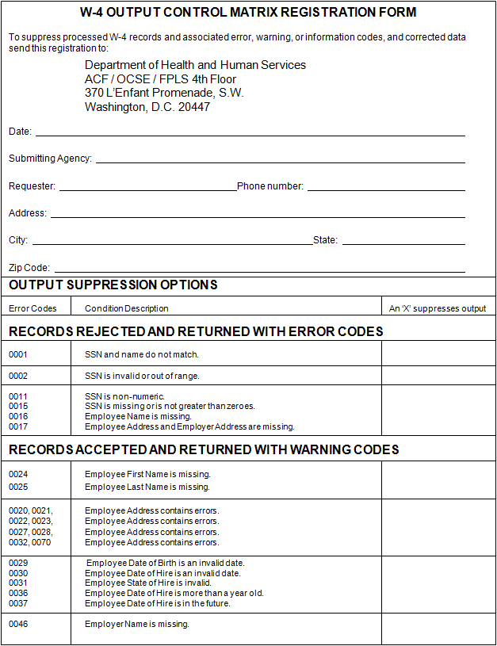

Figure 13-12: W-4 Output Control Matrix Registration Form
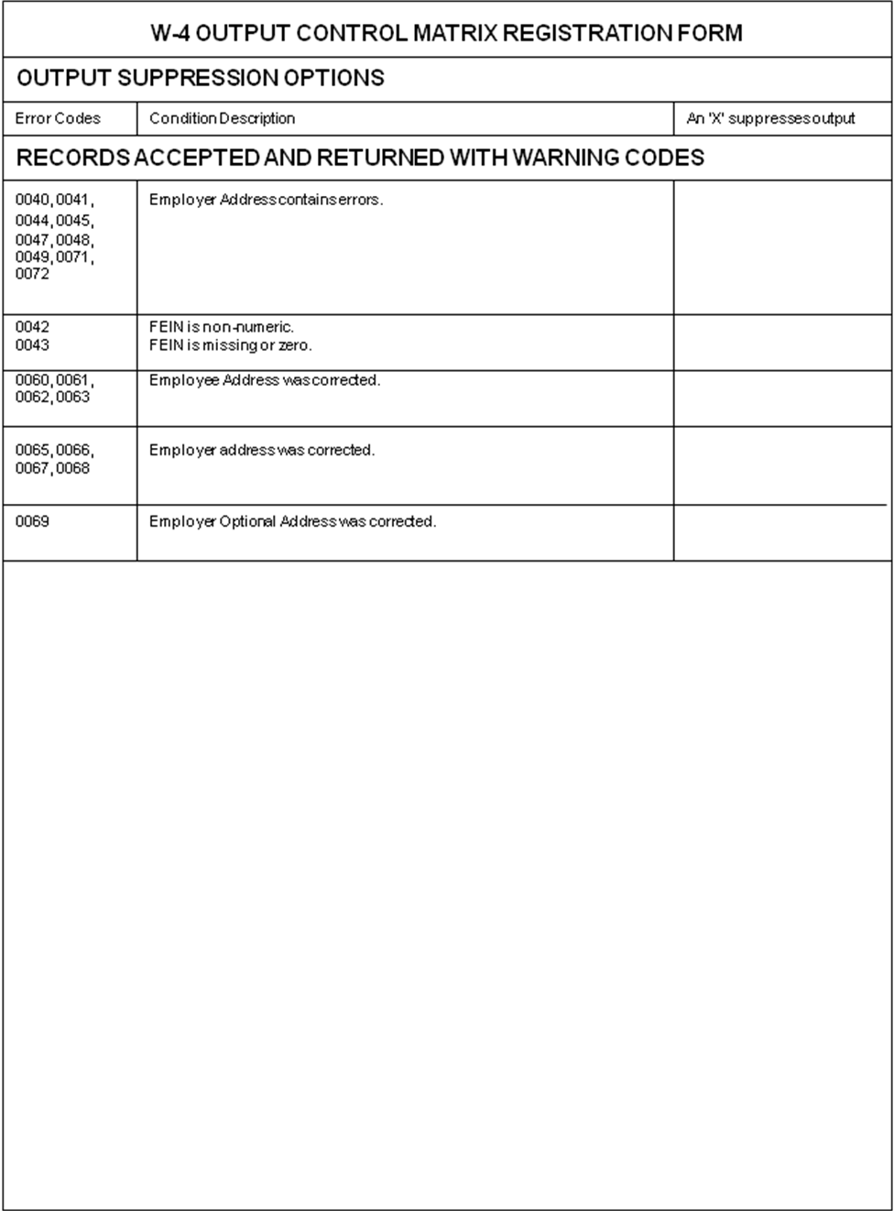

W-4 Management Information

General Information
The NDNH produces an MI report to assist the SDNHs and federal agencies in performing statistical analysis, tracking data, and analyzing trends.

MI Report and Explanation
Figure 14-1 is a sample of an MI report. This sample report contains contrived data to clarify the data that is present in an actual report.
Summary for SDNH/Agency of W-4 Data processed
The NDNH produces an MI report for each SDNH and federal agency submitter. For each batch in a given report period (e.g., week, month, quarter or year), the report displays:
- Header date
- Process date
- Batch number
- Total Number of records in that batch
- Number and percent of those records that were:
- posted to the W-4 NDNH file
- rejected with an unverified SSN
- rejected, including the records that are rejected because of unverified SSNs
- duplicate within a batch
The report displays the totals of all the above counts for the report period. In addition, the report includes these totals for a pre-set prior period, and sums these numbers to create cumulative totals.
The W-4 MI reports are available online through the State Statistical Reporting System, which is located at:
https://extranet.acf.hhs.gov/ssrs/
The reports are provided to assist SDNHs manage their new hire submissions, to compare several months of submission, and to provide the ability to track trends in submissions. There are six monthly reports for each state, consisting of the current month and five previous months. Access to the reports requires a user ID and password. If you need assistance accessing the reports, please use the following contact methods:
Email: kristen.david@acf.hhs.gov
Phone: 202-401-9267, option 3
Figure 14-13: W-4 MI Report Sample
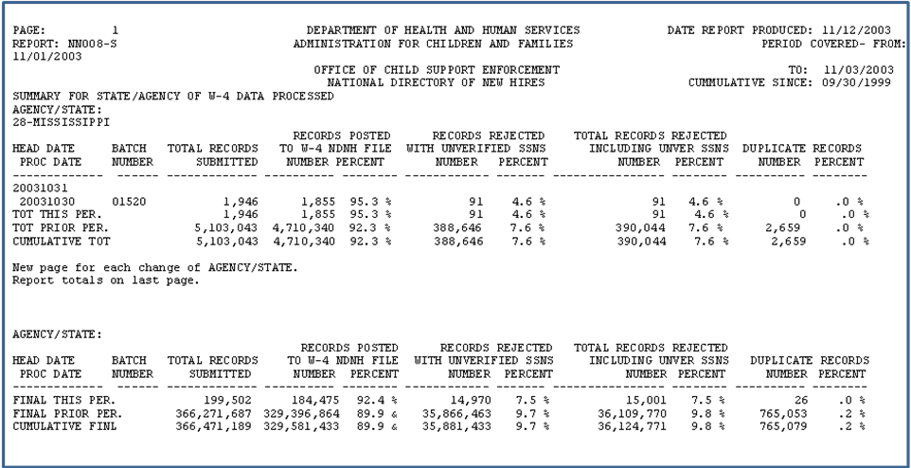

Chart 14-15: W-4 MI Report Field Descriptions
Field | Description
Page Number | This is the page number(s) within the total report (which includes all federal agencies and SDNHs) on which a federal agency’s or SDNH’s report data is located. The page number on an individual federal agency or SDNH report may not begin with the number one.
Report Number | This number is ‘NN008’. The first ‘N’ identifies the report as an NDNH report. The second ‘N’ indicates that the report contains summary data of submitted W-4 data. The numbers distinguish this report from other W-4 reports.
Agency/State | This field contains the name of the federal agency or SDNH that submitted the W-4 data.
Date Report Produced | This is the date of the report run.
Period Covered | These are the inclusive dates for the W-4 data that are presented in this report. This period is the day, week, month, or quarter of submission being reported.
Cumulative Since | This is the beginning date of the prior period.
Head Date | This is the date in the Date Stamp field for a specific W-4 batch.
Proc Date | This is the date that a specific W-4 batch was processed.
Batch Number | This is the unique batch number that was submitted with each W-4 submission.
Total Records Submitted | This is the total number of W-4 data records that were submitted. Header and Total records are not counted. This is expressed for each specific batch in the report period, and as:  - a total for the report period  - a total for the prior report period  - cumulative from the “Cumulative Since” date
Records Posted to W-4 NDNH File | This is the total number and percent of W-4 records that met validation and SSA verification criteria, and were added to the NDNH W-4 file. This is expressed for each specific batch in the report period, and as:  - a total for the report period  - a total for the prior report period  - cumulative from the “Cumulative Since” date
Records Rejected With Unverified SSNs | This is the total number and percent of W-4 records that have unverified SSNs and are rejected by the NDNH. This is expressed for each specific batch in the report period, and as:  - a total for the report period  - a total for the prior report period  - cumulative from the “Cumulative Since” date
Total Records Rejected Including Unverified SSNs | This is the total number and percent of W-4 records that did not meet the minimum information requirements, or contain an unverified SSN. These records were rejected, and individually returned to the submitter at the time of transmission. This information is expressed for each specific batch in the report period, and as:  - a total for the report period  - a total for the prior report period  - cumulative from the “Cumulative Since” date
Duplicate Records | This is the number and percent of duplicate W-4 data records that were received within each batch. Duplicate records are rejected, and individually returned to the submitter at the time of transmission. This information is expressed for each specific batch in the report period, and as:  - a total for the report period  - a total for the prior report period  - cumulative from the “Cumulative Since” date
Percentages | The percentages are derived by dividing each ‘number’ by the “Total Number of Records Submitted” for that row.
Total for This Period | This sum is for the report period that is specified in the “Period Covered” in the report header and include:  - posted to the W-4 NDNH file  - rejected with unverified SSNs  - total rejected records, including unverified SSNs  - duplicate records
Total for Prior Period | This sum is for the period from the “Cumulative Since” date to the day prior to the “Period Covered” in the report header and include:  - posted to the W-4 NDNH file  - rejected with unverified SSNs  - total rejected records, including unverified SSNs  - duplicate records
Cumulative Total | This sum is for the period from the “Cumulative Since” date up to and including the “Period Covered” in the report header and include:  - posted to the W-4 NDNH file  - rejected with unverified SSNs  - total rejected records including unverified SSNs  - duplicate records

W-4 Conclusion and Recommendations
SDNHs and federal agencies submit information on newly hired employees to the New Hire (W-4) portion of the NDNH. Technical support and help are available to each submitter. SDNHs and federal agencies should use the support that is available to ensure the successful transmission of the required information. Refer to the Section 3, “Technical Support,” for information to obtain assistance with W-4 reporting.
W-4 data is critical for enforcement of child support, identification of fraud, establishment of benefits and the recovery of debts. To support these activities, SDNHs and federal agencies should:
- Submit all W-4 data to the NDNH
- Submit all required data elements
- Submit accurate and valid names and SSNs
- Submit W-4 data on a timely basis
There will be changes made to the NDNH as new needs and requirements are identified, and as users’ recommendations are received. Future releases of the NDNH will include updates to this Guide.

FOREWORD
OCSE, HHS, promulgated regulations at 45 CFR section 303.108 regarding “Quarterly Wage and Unemployment Compensation Claims Reporting to the National Directory of New Hires.”
The regulations specifically address the dates, format and data elements that are necessary for states to furnish the QW and unemployment compensation data to the NDNH. In developing the regulation, OCSE consulted representatives from state child support agencies, SWAs, the DoL, SSA, the National Association of State Workforce Agencies, and employer groups.
This Guide contains requirements that are contained in the regulation.
The regulations address requirements for state submissions of QW, W-4 and UI claims data to the NDNH. The regulations are not applicable to federal agencies. The requirements set forth in this document for federal agencies to submit QW data to the NDNH were determined based on provisions in the PRWORA of 1996 and Executive Order 12953 (February 27, 1995).

Quarterly Wage Component
The QW component of the NDNH maintains QW information on individual employees, as received from federal agencies and SWAs. The purpose of including QW data in the NDNH is to provide states with the ability to quickly locate information about the address of, employment of, and compensation being paid to, parents with child support obligations. It is also used by data matching partners to detect fraud, determine benefits and reduce debts.

Legislation
Section 453A(g)(2)(B) of the Social Security Act (the Act) requires states “on a quarterly basis, furnish to the NDNH information concerning the wages … paid to individuals, by such dates, in such format, and containing such information as the Secretary of HHS shall specify in regulations.”
Section 3304(a)(16) of the Internal Revenue Code of 1986 requires states to furnish wage information contained in the records of the state agency that administers the unemployment compensation program to the Secretary of HHS, in accordance with regulations that have been promulgated by the Secretary, as may be necessary for the purposes of the National Directory of New Hires under section 453(i)(1) of the Act.
Section 303(h)(1)(A) of the Act requires the state agency that is charged with the administration of the unemployment compensation program, on a reimbursable basis, to disclose quarterly, to the Secretary of HHS, wage information, as required pursuant to section 453(i)(1) of the Act, that is contained in the records of such agency.
Section 303(h)(3)(A) of the Act defines “wage information” as “information regarding wages paid to an individual, the social security account number of such individual, and the name, address, State, and the Federal employer identification number of the employer paying such wages to such individual.”
Section 453(n) of the Act requires federal agencies to furnish data to the NDNH. The Act States that “Each department, agency, and instrumentality of the United States shall on a quarterly basis report to the FPLS the name and SSN of each employee and the wages paid to the employee during the previous quarter, except that such a report shall not be filed with respect to an employee of a department, agency, or instrumentality performing intelligence or counterintelligence functions, if the head of such department, agency, or instrumentality has determined that filing such a report could endanger the safety of the employee or compromise an ongoing investigation or intelligence mission.”
Appendix B, “Federal Information,” contains portions of the Act that that are specific to the NDNH.

Timeframes
There are timeframes associated with the reporting of QW data, the performance of matches, and reporting by the NDNH. Some of the timeframes are requirements of the Act and other timeframes are functions of NDNH System processing. Chart 16-1 shows the activities that are associated with QW reporting and their corresponding timeframes.
Chart 16-16: QW Timeframes
Activity | Timeframe
SWA transmittal of QW data to the NDNH | SWAs must transmit QW data within four months after the end of the reporting period:  - January through March data is due no later than July 31  - April through June data is due no later than October 31  - July through September is due no later than January 31  - October through December data is due no later than April 30
*Federal agency transmittal of QW data to the NDNH | Federal agencies must transmit QW data no later than one month after the end of the reporting quarter:  - January through March data is due no later than April 30  - April through June data is due no later than July 31  - July through September data is due no later than October 31  - October through December data is due no later than January 31
Enter QW data from federal agencies and SWAs into the NDNH | QW data must be entered into the NDNH within two business days of the NDNH’s receipt of the data.
Return summary and transmittal data, including error reporting, to the submitter | The NDNH must send transmittal, summary and error data to the submitting federal agency or SWA within four business days of the NDNH’s receipt of the data.
Management information delineating and summarizing each federal agency’s and SWA’s submittal data | The NDNH produces reports on a periodic basis.
Compare NDNH and FCR data | NDNH data and FCR data must be cross-matched not less than every two business days.
Report matches from the NDNH and FCR comparison back to the CSE IV-D agency | The FCR must report NDNH and FCR matching information to the IV-D agency within two business days of the match.

* Federal agencies are required to report QW data earlier than states. Because states must collect QW data from employers, states are given more time to prepare and send the data to the NDNH.

More Frequent Submissions
Several states and territories have asked that they be allowed to submit QW data more frequently than quarterly. The OCSE receives QW files daily, weekly or monthly from SWAs. The OCSE encourages states and territories to submit QW data more frequently than quarterly, because this allows employment data to be provided to the child support agency in a more timely manner. Instead of waiting up to three months, the child support agency would only need to wait up to seven or 30 days. This would increase the likelihood of obtaining child support collections.
If a state or territory would like to submit more frequently than quarterly, please contact the NDNH Technical Support staff at: http://www.acf.hhs.gov/programs/cse/newhire/contacts/ndnh_contacts.htm

QW Data Requirements
Federal agencies and SWAs collect QW data and forward this information to the NDNH. Federal law requires the collection and submission of QW data, by such dates, in such format, and containing such information as the Secretary of HHS specifies in regulations.

Data Requirements
SWAs and federal agencies should transmit the following data elements to the NDNH:
- Employee Name
- Employee SSN
- Employee Wage Amount
- Reporting Period
- Federal Employer Identification Number (FEIN)
- Employer Name
- Employer Address
- Employer Optional Address (Optional)
SWAs are required to supply QW information that is contained in the records of the state. The data element, Employee Name is being requested in order to meet the requirement that information in the NDNH be transmitted to the SSA to verify the accuracy of names and SSNs pursuant to section 453(j)(1) of the Act.
In the event that an individual is working more than one job, the state must transmit separate QW records that contain the information for each job that an individual has held during the reporting period.
Refer to Section 18.2, “QW Record Layouts,” for the specifications for transmitting QW data to the NDNH.
Description of the QW Data Elements

Chart 17-17: Description of QW Data Elements
Data Element | Description
Employee Name | This is the employee’s first name, middle name or initial, and last name.
Employee SSN | This is the nine-digit number that the SSA assigns to an individual.
Employee Wage Amount | This is the aggregate wages that were paid to an employee during the reporting period.
Reporting Period | This is the calendar quarter and year during which the employee’s wages were paid. The calendar quarters are:  1 – January 1 through March 31  2 – April 1 through June 30  3 – July 1 through September 30  4 – October 1 through December 31
Employer Name | This is the name of the entity that employs the individual.
FEIN | This is the nine-digit number that the IRS assigns to an employer.
Employer Address | This is the number, street name, rural route or PO box, city, state, and Zip code of the entity that employs the individual. This should be the address that the employer reports to the IRS. This may be a foreign address.
Employer Optional Address (Optional) | This is the address where an employer receives child support income withholding orders. This is a number, street name, rural route or PO box, city, state, and Zip code of the entity that employs an individual.

QW Data Source
Federal agencies, or their payroll providers, report the QW information to the NDNH.
Within a state, the source of QW information is employers. Employers report the QW information to the SWA, as required by state law. The agency to which an employer reports varies by state.

QW Transmission
A transmission from a federal agency may contain submissions from more than one federal agency. Each SWA submits all of the QW records that were processed during the quarter, regardless of reporting period. Each submission must contain three types of records in the following order:
- QW Transmitter Header Record – This record precedes the QW data records and contains information about the submitter.
- QW Data Records – These records contain the actual QW data.
- QW Total Record – This record follows the QW data records and is a summary of the submission.

Transmission Method
Designated federal agencies, and each SWA, transmits QW records via SSA’s closed-line CFI protocol. An alternative transmission method, Government Services Online (GSO), is available for federal agencies that do not have access to CFI. All transmissions must be sent electronically with the data encrypted.
All files must be sent through secure transmission via CFI or GSO.

QW Record Layouts
Federal agencies and SWAs must transmit the QW information according to the specified record layouts. The general rules that apply to all the record formats are shown below:
- All data must be in EBCDIC format.
- All alphabetic data must be uppercase.
- All alphabetic and alphanumeric data must be left justified.
- All numeric data must be right justified with leading zeros.
- All dates must be in CCYYMMDD format.
- CC represents the century
- YY represents the year
- MM represents the month and must be a number greater than 00, but less than 13.
- DD represents the day of the month and must be a valid number for the designated month (e.g., 01-31 for months 01, 03, 05, 07, 08, 10 or 12; 01-30 for months 04, 06, 09, or 11; and 01-29 for the month 02)
- Name fields cannot include suffixes, such as ‘Jr.’, ‘Sr.’, or ‘III’.
- The hyphen is the only special character allowed in the Employee Name, Employer Name and City fields.
- All state and territory abbreviations in addresses must be valid USPS abbreviations. See Appendix E, “State and Territory Names, Abbreviations and FIPS Codes,” for a complete list.
- All foreign country codes in addresses must be the two-letter Federal Information Processing Standard (FIPS) codes that are assigned to foreign countries. Refer to Appendix D, “Foreign Country FIPS Codes,” or to the U.S. Department of Commerce FIPS Code Manual, National Institute of Standards and Technology, FIPS PUB 10-4 (April 1995) to derive this code. In addition, FIPS codes may be found on the Internet at:
http://earth-info.nga.mil/gns/html/fips10-4.html
- If an address is less than 40 characters per line, do not concatenate into one line.

QW Transmitter Header Record
NDNH system processing requires the completion of all fields in the QW Transmitter Header record.
Chart 18-18: QW Transmitter Header Record
OMB Control nO: 0970-0166 expiration date: 06/30/2013
Field Name | Location | Length | A/N | Comments
Record Identifier | 1-2 | 2 | A/N | Required  This field must contain the characters ‘HQ’.
Transmitter State Code | 3-4 | 2 | A/N | Required for states and territories only  This field must contain the two-digit numeric FIPS code of the state or territory that is transmitting data to the NDNH. Refer to Appendix E, “State and Territory Names, Abbreviations and FIPS Codes,” or to the Department of Commerce FIPS Code Manual, National Institute of Standards and Technology, FIPS PUB 5-2 (April 1995) for a list of these codes. In addition, FIPS codes may be found on the Internet at: http://www.itl.nist.gov/fipspubs/fip5-2.htm  Federal agencies leave this field blank.
Transmitter Agency Code | 5-13 | 9 | A/N | Required for federal agencies  This field must contain the nine-character FEIN, or the letter ‘A’ followed by the FIPS code of the federal agency.  SWAs leave this field blank.
Transmission Type | 14-15 | 2 | A/N | Required  This field must contain the characters ‘QW’.
Department of Defense Code | 16 | 1 | A | Required for DoD only  This field must contain one of the following characters:  A – Active duty employees  C – Civilian employees  P – Pension/retired employees  R – Reserve employees  SWAs and federal agencies, other than the DoD, leave this field blank.
Version Control Number | 17-18 | 2 | A/N | Required  This field must contain the numbers ‘01’. OCSE will notify the SWAs and federal agencies when this field changes.
Date Stamp | 19-26 | 8 | N | Required  This field must contain the transmission date of the QW data to the NDNH. This must be in CCYYMMDD format.
Batch Number | 27-32 | 6 | N | Required  The transmitting federal agency or SWA generates this number. Do not repeat batch numbers.
Filler | 33-601 | 569 | A/N | Required  This field should be all spaces. States, territories and federal agencies should not use the Filler field. The Filler field is strictly reserved for OCSE. Anything submitted in the field is not returned to the submitter and is overlaid with spaces.

QW Data Record
Although it is desirable to include all of the data elements in the QW Data record, it is recognized that this may not be possible. The intent of the system is to provide information for locating persons in response to requests from CSE IV-D agencies. A QW Data record must include:
- Employee First Name
- Employee Last Name
- Employee SSN
- Employee Wage Amount
- Reporting Period
- Employer Name
- FEIN
- Employer Address
SWAs are only required to supply wage information that is already contained in the records of the state.
If an employer is late in reporting QW data to the SWA, the SWA should submit the QW data in the next quarter’s transmission.
OCSE is aware that some SWAs’ records include only a partial set of letters, or no letters, in the employee’s name(s). Therefore, SWAs should send as much information for employee names as exists in their QW records. The system accepts these records. If the SSN passes the “High-Group” SSN test (that is, if the SSN is valid), the NDNH attempts to verify the SSN/Name combination. For those states that send only a partial name, or no name, in the QW record, if the SSN/Name combination does not verify, the NDNH stores the record on the QW Non-Verifiable file. For any QW record that does not meet the minimal name requirements, refer to Section 5.4, “Non-Verifiable SSNs.”

QW Data Record
NDNH system processing requires the completion of the required fields of the QW Data record.
Chart 18-19: QW Data Record
OMB Control nO: 0970-0166 expiration date: 06/30/2013
Field Name | Location | Length | A/N | Comments
Record Identifier | 1-2 | 2 | A/N | Required  This field must contain the characters ‘QW’.
Employee SSN | 3-11 | 9 | N | Required  This field must contain a nine-digit SSN.  If this field is blank, or contains any alphabetic characters, the system rejects the record.
Employee Name  First Name  Middle Name  Last Name | 12-27  28-43  44-73 | 16  16  30 | A  A  A | Required  There must be at least one character in the First and Last Name fields.  If the Employee Middle Name field is non-blank, it must contain at least one character.  - No special characters, except hyphens, are allowed  - The First and Last Name cannot begin with a space or hyphen  If a state only collects a partial name, or does not collect any name information, the record is NOT rejected. These states must transmit as much information for employee names as exists in their QW records.
Employee Wage Amount | 74-84 | 11 | N | Required  This field is the gross amount of wages an employer reports as paid to an employee during the reporting quarter. If the QW data are reported late by an employer, the SWA should submit the data with their next quarterly transmission.  The last two positions are decimal places. Do not include a decimal point as part of this field.  Negative values are not allowed.
Reporting Period | 85-89 | 5 | N | Required  The format is QCCYY.  Q – Reporting quarter:  1 – January 1 through March 31  2 – April 1 through June 30  3 – July 1 through September 30  4 – October 1 through December 31  CC – Century  YY – Year
Federal EIN | 90-98 | 9 | N | Required  This field is the Federal Employer Identification Number (FEIN) that the IRS assigns to an employer.
State EIN | 99-110 | 12 | A/N | Optional  This field is a number a state may assign an employer.
Employer Name | 111-155 | 45 | A/N | Required  This field must be at least two characters. No special characters, except hyphens, are allowed.
Employer Street Address  Line 1  Line 2  Line 3 | 156-195  196-235  236-275 | 40  40  40 | A/N  A/N  A/N | Required  This field must be at least two characters.  If an address is less than 40 characters per line, do not concatenate into one line.  Use Line 3 for a military designation or Canadian province code.
Employer City | 276-300 | 25 | A | Required  This field must be at least two characters. No special characters, except hyphens, are allowed.
Employer State | 301-302 | 2 | A | Required  This field must be a valid two-letter USPS abbreviation of a state or territory. Refer to Appendix E, “State and Territory Names, Abbreviations and FIPS Codes.”
Employer Zip Code  Zip Code (1)  Zip Code (2) | 303-307  308-311 | 5  4 | A/N  A/N | Required: First five-digits  This field is the five-digit USPS Zip code that is associated with the employer’s address.  The Zip Code (2) field must be either all spaces, or the four-digit additional numeric code, but not all zeros.
Employer Foreign Address  Foreign Country Code  Foreign Country Name  Foreign Zip Code | 312-313  314-338  339-353 | 2  25  15 | A/N  A/N  A/N | Optional  Refer to Appendix D, “Foreign Country FIPS Codes,” or to the U.S. Department of Commerce FIPS Code Manual, National Institute of Standards and Technology, FIPS PUB 10-4 (April 1995) to derive this code. In addition, FIPS codes may be found on the Internet at:  http://earth-info.nga.mil/gns/html/fips10-4.html  The foreign country name, if present, must be at least two characters.  Include military designation or Canadian province code.
Employer Optional Street Address  Line 1  Line 2  Line 3 | 354-393  394-433  434-473 | 40  40  40 | A/N  A/N  A/N | Optional  This field is the employer’s street address where a child support income withholding order should be sent.  If an address is less than 40 characters per line, do not concatenate into one line.  Use Line 3 for a military designation or Canadian province code.
Employer Optional City | 474-498 | 25 | A | Optional  This field must be at least two characters, if present. No special characters, except hyphens, are allowed.
Employer Optional State | 499-500 | 2 | A | Optional  This field must be a valid two-letter USPS abbreviation of a state or territory, if present. Refer to Appendix E, “State and Territory Names, Abbreviations and FIPS Codes.”
Employer Optional Zip Code  Zip Code (1)  Zip Code (2) | 501-505  506-509 | 5  4 | A/N  A/N | Optional  Each zip code must be either all spaces or all numeric, but not all zeros.
Employer Optional Foreign Address  Foreign Country Code  Foreign Country Name  Foreign Zip Code | 510-511  512-536  537-551 | 2  25  15 | A/N  A/N  A/N | Optional  Refer to Appendix D, “Foreign Country FIPS Codes,” or to the U.S. Department of Commerce FIPS Code Manual, National Institute of Standards and Technology, FIPS PUB 10-4 (April 1995) to derive this code. In addition, FIPS codes may be found on the Internet at:  http://earth-info.nga.mil/gns/html/fips10-4.html  The foreign country name must be at least two characters, if present. Include military designation or Canadian province code.
Filler | 552-601 | 50 | A/N | This field should be all spaces. States, territories and federal agencies should not use the Filler field. The Filler field is strictly reserved for OCSE. Anything submitted in the field is not returned to the submitter and is overlaid with spaces.
QW Total Record
System processing requires the completion of all fields in the QW Total record.
Chart 18-20: QW Total Record
OMB Control nO: 0970-0166 expiration date: 06/30/2013
Field Name | Location | Length | A/N | Comments
Record Identifier | 1-2 | 2 | A/N | Required  This field must contain the characters ‘TQ’.
Data Record Count | 3-13 | 11 | N | Required  This field must be the number of records in the transmission, including the Header and Total records.
Filler | 14-601 | 588 | A/N | Required  This field should be all spaces. States, territories and federal agencies should not use the Filler field. The Filler field is strictly reserved for OCSE. Anything submitted in the field is not returned to the submitter and is overlaid with spaces.

QW Data Validation and Verification
Note: [Opening and closing brackets] surrounding text signify changed material.
Accurate data is essential to ensure the integrity of the NDNH database. QW data that is transmitted by a federal agency or state undergoes various validation and verification processes. Submitters receive information regarding validation and verification within four business days. Refer to Section 21, “QW Output to Submitters,” for more information regarding return data. NDNH edits incoming data at the various levels from file transmission to the individual record.
There are five levels of validation. The first by the SWA, and the rest by the NDNH:
- SWA/federal agency pre-processing
- Transmission
- NDNH pre-processing
- Batch
- Record

Pre-Processing Level Editing
Prior to submitting QW data to the NDNH, federal agencies and SWAs should perform edits on the data, to ensure compliance with the requirements as outlined in the record layouts. This ensures that the data meets the requirements for acceptance to the NDNH, and that the NDNH has accurate and complete information.

Transmission Level Editing
When a file is received by the NDNH, the Node ID in the dataset name for SWAs and federal agencies is verified to determine if the submission is from a valid user. If the Node ID is not valid, the file is suspended and the submitter is contacted.
After the Node ID is validated, the Submitter ID in the Header record is evaluated against a Master Table to determine the authenticity of the submission. If the Submitter ID is not registered in the Master Table, the batch is suspended and the submitter is contacted.

Transmission Errors
When transmitting QW data, there are errors that can occur at the transmission level. Depending upon the type of error, the system:
- rejects the entire transmission
- rejects part of the transmission
- suspends the file and notifies the transmitter to determine whether to process the file, or
- accepts the transmission, but returns a warning code to the submitting agency
A federal agency or SWA that receives notice of rejection due to transmission error (#1 or #2 above), must correct the information and resubmit the data via CFI, or the designated alternative transmission method. The following chart is a list of error and warning codes at the transmission level.
QW Transmission Error and Warning Codes

Chart 19-21: QW Transmission Error and Warning Codes
Error Code | Error Message and Description
TRANSMISSION ERROR CODES – Full Transmission Rejected
5000 | The Transmitter Header record is required.  The Transmitter Header record must be present at the beginning of each transmission file.
5001 | The Transmitter Header record does not contain the transmitter state code or transmitter agency code.
5002 | The Transmitter Header record does not contain the version control number, or has an invalid version control number. The version control number must equal ‘01’.
5003 | The Transmitter Header record contains a non-numeric batch number. The Transmission Header record must contain a numeric batch number.
5004 | The Transmitter Header record contains a batch number that is a duplicate of a previously received batch number. The Transmitter Header record must not contain a batch number that is a duplicate of a batch number received in a previous transmission from the SWA or federal agency within the same calendar year.
TRANSMISSION ERROR CODES – Part of Transmission Rejected
5005 | The Transmitter Header record is not the first record in the file. All of the records are rejected until a Transmitter Header record is found.
TRANSMISSION WARNING CODES – Transmission Accepted
5006 | The Transmission Type is missing or invalid. The transmission type must equal ‘QW’.
5007 | The Transmitter Header record does not contain a date stamp or the date stamp is an invalid date.
5008 | The Total record is missing.
5009 | The data record count is non-numeric.
5010 | The data record count does not equal the number of the records received.

NDNH Pre-Processing Level Editing
The NDNH system performs several edits to determine if the data is acceptable. These edits determine whether batch processing can proceed. If a submission does not pass the NDNH pre-process, the submission is suspended and the submitter is contacted.

Duplicates
If the NDNH receives a QW file that contains a threshold number of duplicate records, the NDNH suspends the file, and the submitter is notified by phone. The submitter has the option to request that the suspended file be processed. In order to determine whether a file is a duplicate, the records of the received file are sampled methodically, and compared against the NDNH database for matching records in the current and previous quarter. The NDNH system considers two QW records to be duplicates if the content of the following fields of the incoming QW record are identical to the corresponding fields on a record from the NDNH database:
- Employee SSN
- Submitting State/Agency Code
- Employee Name
- Employee Wage Amount
- Reporting Period
- FEIN

Submission Limits
NDNH processing edits examine certain key characteristics of each file to determine if these characteristics are within expected limits. The limits are based on experience of the data received from each submitter, as well as standards set by OCSE. If one or more of these limits is exceeded, the file is suspended. The NDNH processing edits that result in suspension are:
- A large percentage of the records contain a Reporting Quarter that is not the current or expected Reporting Quarter at the time the file is processed.
- The number of records that were submitted is below or above the expected volume range for that submitter.
- A large percentage of the records contain a wage amount that is excessively low (under $251) or high (over $10 million) or all nines.
If a QW file is suspended, the submitter is notified. The submitter has the option to request that the suspended file be processed or to correct the data and submit another file.
Each quarter, the NDNH expects to receive QW records for a particular (current) reporting quarter. OCSE establishes a standard for the percentage of records that should contain the current reporting quarter. The NDNH tallies the number of records that are submitted in the file for each reporting quarter. If a submission has too few records with the expected reporting quarter, the file is suspended and the submitter is contacted.
For each SWA and federal agency, a minimum and maximum volume of records to be received has been established based on previous submissions. If a submission is received with too few or too many records, the file is suspended and the submitter is contacted. If the volume of records received is determined to be correct, the file is processed and the expected minimum/maximum volume for the submitter is adjusted, if needed.
The wage amount on each QW record is evaluated to determine if the wage amount is less than $251. The number and percentage of wages under $251 are evaluated against a pre-set threshold. If the file contains excessive amounts of records with wages under $251, the file is suspended and the submitter is contacted. If the wages are determined to be correct, the file is processed.
The wage amount on each QW record is evaluated to determine if the wage amount is $10 million or greater. If the number of high wage amounts exceeds an established limit, the records with excessively high wage amounts are analyzed to determine if there is a submission issue. If the wage amounts appear erroneous, the submitter is contacted.
The wage amount on each QW record is also evaluated to determine if the dollar amount is all nines. For example, the wage amounts $9, $99, and $99999 are identified as all nines. If the wage amount is all nines, a warning code is returned to the submitter. All records that are identified as all nines are written to a report file for further analysis.

Batch Level Editing
All files that pass the transmission level editing are evaluated to ensure that the required records and data values in the header record, data records and trailer record are present. If the required elements or records are missing, the transmission is rejected. The edits allow part of, or the entire, transmission to be processed if minor errors occur. Chart 19-2 describes the types of edits that are performed, and the output at the batch level editing.
Chart 19-22: QW Batch Editing
Edit | Processing
The Transmitter Header record is missing. | The transmission is rejected, and an error code is returned to the submitter.
The Transmitter Header record does not contain a valid transmitter state or federal agency code. | The transmission is rejected, and an error code is returned to the submitter.
The Transmitter Header record does not contain the version number, or has an invalid version number. | The transmission is rejected, and an error code is returned to the submitter.
The Transmitter Header record contains a non-numeric batch number. | The transmission is rejected, and an error code is returned to the submitter.
The Transmitter Header record contains a batch number that is a duplicate of a batch number that was previously received from the submitter within the calendar year. | The transmission is rejected, and an error code is returned to the submitter.
The Transmitter Header record is not the first record in the file. | All records prior to the Header record are rejected, and all records after the Header record are processed. A warning code is returned to the submitter.
The transmission type is not equal to ‘QW’. | All records are processed, and a warning code is returned to the submitter.
The date stamp is missing or invalid in the Transmitter Header record. | All records are processed, and a warning code is returned to the submitter.
The Total record is missing. | All records are processed, and a warning code is returned to the submitter.
The data record count is non-numeric. | All records are processed, and a warning code is returned to the submitter.
The data record count does not equal the number of the records received. | All records are processed, and a warning code is returned to the submitter.
If a QW submitter receives notice of rejection, the submitter must correct the information and resubmit the data via CFI, or the designated alternative transmission method. If the submitter receives a warning notification, they should investigate the warning. If records were not processed because of the warning, the submitter should correct the issue and resubmit the data.

Record Level Editing
The NDNH edits each record to ensure that all of the required data elements are present, key values are valid, and data conforms to the system standards before it is accepted.

SSN/Name Verification
The NDNH system performs edits on the SSN and name entries and sends SSN/Name combinations that appear to be valid to SSA for verification. Section 5, “Social Security Number Verification,” outlines the SSN verification processes and errors. Note that not all SWAs submit name information, or enough name information, to complete a full SSN/Name verification. Chart 19-3 contains the types of SSN/Name edits that are performed on each QW record.

Chart 19-23: QW SSN/Name Verification
Edit | Processing
The SSN is spaces. | The record is rejected, and an error code is returned to the submitter.
The SSN is non-numeric. | The record is rejected, and an error code is returned to the submitter.
The SSN is not greater than zeros. | The record is rejected, and an error code is returned to the submitter.
The first five digits of the SSN have not been issued by SSA. | The record is rejected, and an error code is returned to the submitter.
The employee name is missing. | The record is rejected, and an error code is returned to the submitter.
The SSN and name do not match with SSA’s records, or the SSN is not found at SSA. | The record is rejected, and an error code is returned to the submitter. This is returned after all attempts to verify the SSN and name fail.
Verification of SSN and name failed, the first name and last name were transposed, and the SSN and transposed name combination was verified. | The record is passed to the next level of verification. The record is assigned a warning code, and is returned to the submitter with the corrected name.
After all attempts to find a valid SSN/Name combination have failed, name matching software is utilized to evaluate the extent to which an employee name on a received QW record matches a name in the SSA database. This software provides matching confidence scores at 12 comparison levels. For records that exceed a predetermined confidence level, the results of the name match software processing are stored on the QW Unverified NDNH file and used in FCR Locate and Proactive Matching routines.
Any records that do not pass the SSN or SSN/Name verification process are dropped from the system. All records that pass the SSN or SSN/Name verification process continue through the record edits.

Minimal Data Validation
Each QW data record is validated to ensure that it contains an:
- Employee Name
- Employee SSN
- Employer Name
- FEIN
- Employer Address
If the record does not contain the five required data elements listed above, it is rejected with an error code, and is returned to the submitter.

General Validation
General Validation edits are performed on all of the records that pass the SSN/Name and Minimal Data Validation. These edits determine the validity of the data that is provided, or identify missing data that would be beneficial to NDNH users. General validation only creates warning codes for the QW record. These warning codes do not prevent records from being posted to the NDNH.
The employee data is checked for a first and last name. This edit is only performed for those SWAs that send name information. If the first or last name is missing, a warning code is returned to the submitter.
The employee wage amount is analyzed to determine if it is numeric. If the wage amount is non-numeric, a warning code is returned to the submitter.
The reporting quarter is checked to ensure that it is numeric. If the reporting quarter is numeric, the quarter is validated for a ‘1’, ‘2’, ‘3’ or ‘4’. The year is also validated to ensure that it is a valid year. If the reporting quarter is non-numeric, or does not contain a valid quarter and year [or if the reporting period is older than the last eight reporting quarters], a warning code is returned to the submitter.
The employer address data is analyzed to determine the validity of the data that were provided. The NDNH uses the commercial software product FINALIST® to improve the quality of employer and employer optional domestic addresses that are received on validated QW records. By using this software, the received address data undergoes verification and correction processes, and then is formatted in the standard USPS format. The verified, or corrected, address data is stored on the QW NDNH files.
Chart 19-4 contains a description of the address validation. If the address is incomplete or invalid, a warning code is generated, and is returned to the submitter. If the address was corrected, a warning code and corrected address are returned to the submitter.
Chart 19-24: QW General Validation
Edit | Processing
The employer Zip code is missing or non-numeric and cannot be corrected. | A warning code is returned to the submitter.
The employer Zip code does not match the city and cannot be corrected. | A warning code is returned to the submitter.
The FEIN is non-numeric. | A warning code is returned to the submitter.
The FEIN is blank or zeros. | A warning code is returned to the submitter.
The employer state is missing and cannot be corrected. | A warning code is returned to the submitter.
The employer state is invalid (not a valid two-character USPS abbreviation) and cannot be corrected. | A warning code is returned to the submitter.
The employer name is blank. | A warning code is returned to the submitter.
The employer address lines (1, 2 and 3) are all blanks and cannot be corrected. | A warning code is returned to the submitter.
The employer city is blank and cannot be corrected. | A warning code is returned to the submitter.
The employer foreign city is blank and the employer Zip code is blank. | A warning code is returned to the submitter.
The employer street was corrected. | A warning code and corrected employee street or employer street is returned to the submitter.
The employer city was corrected. | A warning code and corrected employee city or employer city is returned to the submitter.
The employer state was corrected. | A warning code and corrected employee state or employer state is returned to the submitter.
The employer Zip code was corrected. | A warning code and corrected employee Zip code or employer Zip code is returned to the submitter.
The employer address, or employer optional address could not be corrected. | A warning code is returned to the submitter.
[The reporting period is older than the last eight reporting quarters. | A warning code is returned to the submitter.]

QW Record Codes and Explanations
Chart 19-5 contains a list of the QW record error and warning codes.
Chart 19-25: QW Error and Warning Codes
Code | Code Explanation
ERROR CODES – RECORD REJECTED AND NOT ADDED TO NDNH
0001 | SSN and name do not match.
0002 | SSN is invalid or out of range.
0011 | SSN is non-numeric.
0015 | SSN is missing or is not greater than zeroes.
0016 | *Employee name is missing.
0017 | Employer address is missing and cannot be determined from the FEIN.
[0018 | Reporting period is older than the last eight reporting quarters.]
WARNING CODES – RECORD ACCEPTED AND ADDED TO NDNH
0004 | QW SSN verified by transposing first name and last name.
0024 | *Employee first name is missing.
0025 | *Employee last name is missing.
0034 | Employee wage amount is non-numeric.
0035 | Employee wage amount is all nines.
0040 | Employer Zip code is missing or non-numeric; format must be a five-digit USPS Zip code.
0041 | Employer Zip code does not match city.
0042 | FEIN is non-numeric.
0043 | FEIN is missing or is zero.
0044 | Employer state abbreviation is missing.
0045 | Employer state abbreviation is invalid; format should be two-letter state or territory abbreviation.
0046 | Employer name is missing.
0047 | Employer street address lines are missing.
0048 | Employer city is missing.
0049 | Employer foreign address is incomplete
0051 | Reporting period is invalid.
0065 | Employer street address has been corrected.
0066 | Employer city has been corrected.
0067 | Employer state has been corrected.
0068 | Employer Zip code (five-digits) has been corrected.
0069 | Employer optional address has been corrected.
0071 | Employer address cannot be corrected.
0072 | Employer optional address cannot be corrected.

* These errors apply only to federal agencies and SWAs that have the ability to send employee names.

Resubmittal Process
The resubmittal process is identical to the standard submittal process. Federal agencies and SWAs resubmit corrected records and corrected transmissions in the standard formats via CFI, or the designated alternate transmission method. When resubmitting a corrected transmission, submit the corrected full transmission. When resubmitting corrected records, submit only the corrected records. Submitters that are unable to correct the records, or identify the transmission problems, can contact technical support for assistance. Refer to Section 3, “Technical Support,” for a list of the available technical support.

QW NDNH Update
The NDNH system posts QW records that (a) meet the critical edits, and (b) either pass the SSN verification process, or come from a state that is unable to send full employee names to the NDNH. The QW records in the NDNH QW file are used for proactive matching with the FCR, Locate searches in response to a Locate Request, and by data matching partners.
The following explains how the process uses the name fields to determine to which NDNH file the record is written.
- If a QW SSN passes SSA’s High-Group check, but has one character or blank in both the First and Last Name fields, the record is saved as Non-Verifiable.
- If a QW SSN passes SSA’s High Group check, but has a one-character first name, and a two- or three-character last name, and if it fails the Enumeration Verification System (EVS) verification, the record is saved as Non-Verifiable.
- If a QW SSN passes SSA’s High Group check, but has a one-character first name, a one-character middle name, and a four- or more character last name, or has a one-character first name and seven- or more character last name, and if it fails the EVS verification, the record is saved as Unverified.
The NDNH system scrubs the employer optional address and the employer optional address data, and stores them on the Employer Address File (EAF).

Non-verifiable File
The QW Non-Verifiable file contains the records from SWAs that pass critical edits but for which the SWA is unable to send full employee names that pass the other critical edits. The NDNH attempts to verify the SSN/Name combination on these records, even though they may have incomplete names. The records may contain valuable Locate information regarding persons involved in child support cases. Therefore, even if the SSN/Name combination does not verify, the NDNH accepts and store the record on the QW Non-Verifiable file. QW Non-verifiable data is used for proactive matching with the FCR and is released to CSE IV-D agencies or other authorized data matching partners.

Duplicates
At the record level, if a federal agency or SWA submits a duplicate record or records within a transmission, the NDNH processes the first of those records and ignores the duplicate QW record(s). Refer to Section 19.3, “NDNH Processing Level Editing,” for details. During comparison of two QW records within a batch, they are considered to be duplicates of each other if the contents of the following fields are the same:
- SSN
- State
- Node-ID
- Employee Name
- Wage Amount
- Reporting Period
- FEIN
- State Employer Identification Number (SEIN)
- DoD Code
The NDNH also compares records of incoming transmissions against the NDNH database. If a duplicate record [that was submitted during the same quarter] is found, the record in the incoming transmission is rejected. If that occurs, the number of the rejected records is included in the Records Rejected field, positions 44-54, of the QW Transmission Control record.

QW Output to Submitters
Within four business days, the NDNH system returns information regarding QW data to the submitter. The NDNH system returns:
- The number of records that were received in a transmission, including the Transmitter Header record and Total record.
- The number of rejected records.
- The number of records in a transmission with errors or warnings, regardless of the return error suppression matrix choices.
- The number of records accepted and written to the NDNH QW file.
- Transmission error codes generated.
- Each QW data record that has errors or warnings with up to five error or warning codes. Currently, SWAs or federal agencies receive 15,000 QW Acknowledgement records. SWAs or federal agencies have the option to bypass the limit and receive all the QW Acknowledgement records.
- Each QW record that has a corrected employee name with the corrected name.
- Each QW record that has a corrected employer address and/or employer optional address.
In addition to receiving returned data about QW records, federal agencies and SWAs receive an MI summary report on a regular basis. Refer to Section 22, “QW Management Information,” for information about MI reports.

Output Record Layouts
The NDNH returns QW record transmission and error information via SSA’s closed-line CFI system to:
- All SWAs
- Federal agencies that submit data via CFI
Federal agencies that submit data via GSO obtain their QW transmission and error information via GSO.
A trailer or total record is not returned to the submitting federal agency or SWA in response to QW transmissions. Each returned transmission contains two types of records in the following order:
- QW Transmission Control Record: This record precedes the returning QW data records, and contains information about the submitter’s transmission. It contains data that were submitted by SWAs and federal agencies, record counts, and error/warning codes.
- QW Response Data Records: These records contain the actual QW data, any associated errors or warnings, the corrected name, and corrected employer address and/or employer optional address.
The NDNH transmits the returning QW information according to specified record layouts. Each response record contains the submitted data, corrected data, and error/warning codes as appropriate. The general rules are identical to the requirements for data transmission. Refer to the Section 18, “QW Transmission,” for specific information on transmission general rules.
Chart 21-1 contains the data elements in the QW Transmission Control record.
Chart 21-26: QW Transmission Control Record
OMB Control nO: 0970-0166 expiration date: 06/30/2013
Field Name | Location | Length | Comments | A/N
Record Identifier | 1-2 | 2 | This field contains ‘RQ’. | A/N
Transmitter State Code | 3-4 | 2 | For SWAs, this is the two-digit code that was submitted.  For federal agencies, it is spaces. | A/N
Transmitter Agency Code | 5-13 | 9 | For federal agencies, this is the two-digit code that was submitted.  For SWAs, it is spaces. | A/N
Transmission Type | 14-15 | 2 | This field contains the value that was provided in the submission: ‘QW’. | A/N
DoD Code | 16 | 1 | For DoD, this field contains the value that was submitted.  For all other SDNHs and agencies, it is spaces. | A
Version Control Number | 17-18 | 2 | This field contains the value that was provided in the submission: ‘01’. | A/N
Date Stamp | 19-26 | 8 | This field contains the date that was provided in the submission. | N
Batch Number | 27-32 | 6 | This field contains the value that was provided in the submission. | N
Records Received | 33-43 | 11 | This field contains the count of the records that were received in the submission, including the Header and Total records. | N
Records Rejected | 44-54 | 11 | This field contains the count of the records that were rejected in the submission. | N
Error Records Returned | 55-65 | 11 | This field contains the total number of records with errors or warnings that were returned in the transmission, not those excluded due to the Output Control Matrix. | N
Records Posted to NDNH | 66-76 | 11 | This field contains the total number of records that were posted to the NDNH QW files. | N
Filler | 77-87 | 11 | This field contains all spaces. | A/N
Error Code 1* | 88-91 | 4 | This field contains the transmission error code (if any) that was generated during the processing of the submission. | A/N
Error Code 2* | 92-95 | 4 | This field contains the transmission error code (if any) that was generated during the processing of the submission. | A/N
Error Code 3* | 96-99 | 4 | This field contains the transmission error code (if any) that was generated during the processing of the submission. | A/N
Error Code 4* | 100-103 | 4 | This field contains the transmission error code (if any) that was generated during the processing of the submission. | A/N
Error Code 5* | 104-107 | 4 | This field contains the transmission error code (if any) that was generated during the processing of the submission. | A/N
Filler | 108-631 | 524 | This field contains all spaces. | A/N

*Refer to Chart 19-1, “QW Transmission Error and Warning Codes,” for the transmission level error and warning codes and their explanation.
For each QW record that is submitted and generates an error or warning, a Response Data record is created and returned to the submitter. Each Response Data record contains submitted data, corrected data, address information, and error/warning codes.
Chart 21-27: QW Response Data Record
OMB Control nO: 0970-0166 expiration date: 06/30/2013
Field Name | Location | Length | Comments | A/N
Record Identifier | 1-2 | 2 | This field contains ‘WO’. | A/N
Employee SSN | 3-11 | 9 | This field contains the data that were provided in the submission. | N
Employee Name  First Name  Middle Name  Last Name | 12-27  28-43  44-73 | 16  16  30 | This field contains the data that were provided in the submission, or the corrected first and last name. | A  A  A
Employee Wage Amount | 74-84 | 11 | This field contains the data that were provided in the submission. | N
Reporting Period | 85-89 | 5 | This field contains the data that were provided in the submission. | N
Federal EIN | 90-98 | 9 | This field contains the data that were provided in the submission. | N
State EIN | 99-110 | 12 | This field contains the data that were provided in the submission. | A/N
Employer Name | 111-155 | 45 | This field contains the data that were provided in the submission. | A/N
Employer Street Address  Line 1  Line 2  Line 3 | 156-195  196-235  236-275 | 40  40  40 | This field contains the data that were provided in the submission, or the corrected street address. | A/N  A/N  A/N
Employer City | 276-300 | 25 | This field contains the data that were provided in the submission, or the corrected city. | A
Employer State | 301-302 | 2 | This field contains the data that were provided in the submission, or the corrected state. | A
Employer Zip Code  Zip Code (1)  Zip Code (2) | 303-307  308-311 | 5  4 | This field contains the data that were provided in the submission, or the corrected Zip code (five digits). | A/N  A/N
Employer Foreign Address  Foreign Country Code  Foreign Country Name  Foreign Zip Code | 312-313  314-338  339-353 | 2  25  15 | This field contains the data that were provided in the submission. | A/N  A/N  A/N
Employer Optional Address  Line 1  Line 2  Line 3 | 354-393  394-433  434-473 | 40  40  40 | This field contains the data that were provided in the submission, or the corrected address. | A/N  A/N  A/N
Employer Optional City | 474-498 | 25 | This field contains the data that were provided in the submission, or the corrected city. | A
Employer Optional State | 499-500 | 2 | This field contains the data that were provided in the submission, or the corrected state. | A
Employer Optional Zip Code  Zip Code (1)  Zip Code (2) | 501-505  506-509 | 5  4 | This contains the data that were provided in the submission, or the corrected Zip code field (five digits). | A/N  A/N
Employer Optional Foreign Address  Foreign Country Code  Foreign Country Name  Foreign Zip Code | 510-511  512-536  537-551 | 2  25  15 | This field contains the data that were provided in the submission. | A/N  A/N  A/N
Filler | 552-601 | 50 | This field contains spaces. | A/N
Error Code 1* | 602-605 | 4 | This contains the generated error or warning code associated with the QW record. | A/N
Error Code 2* | 606-609 | 4 | This field contains the generated error or warning code associated with the QW record. | A/N
Error Code 3* | 610-613 | 4 | This field contains the generated error or warning code associated with the QW record. | A/N
Error Code 4* | 614-617 | 4 | This field contains the generated error or warning code associated with the QW record. | A/N
Error Code 5* | 618-621 | 4 | This field contains the generated error or warning code associated with the QW record. | A/N
Filler | 622-631 | 10 | This field contains all spaces. | A/N

*Refer to Chart 19-5, “QW Error and Warning Codes,” for the record level error and warning codes and their descriptions.

Output Mode
The NDNH returns QW data via SSA’s closed-line CFI system, or via the alternate transmission method if used by a federal agency. Each federal agency or SWA receives return data within four business days of transmitting the QW data, as scheduled by SSA. The NDNH does not return any data by hardcopy.

Output Control Matrix
Note: [Opening and closing brackets] surrounding text signify changed material.
During the processing of QW records, the system may detect errors, correct the data or identify abnormal conditions that can cause the return of a record to the submitter with error or warning codes. The NDNH Output Control Matrix determines which QW records with errors, warnings, or information codes are returned to each submitter.
Each SWA or federal agency can set report parameters of the Output Control Matrix, based on their requirements and needs for returned information by completing the QW Output Control Matrix Registration form. This gives the submitter the ability to restrict some of the data they receive from the NDNH system.
If a SWA or federal agency chooses to set the parameters, they must complete the QW Output Control Matrix Registration form and send it to OCSE. A SWA or a federal agency can change the parameters by notifying OCSE at the address that appears on the form.
The QW Output Control Matrix Registration form cannot be used to suppress transmission- or submission-level errors. Submission of the form is optional; the default is to return the first 15,000 records that contain error or warning codes.
Federal agencies may not use the Output Control Matrix to suppress the output of response records that have SSN verification codes.
For a complete description of QW errors and warnings, refer to Section 19.5.4, “QW Record Codes and Explanations.”
A copy of the QW Output Control Matrix Registration form is shown in Figure 21-1.
Figure 21-14: QW Output Control Matrix Registration Form
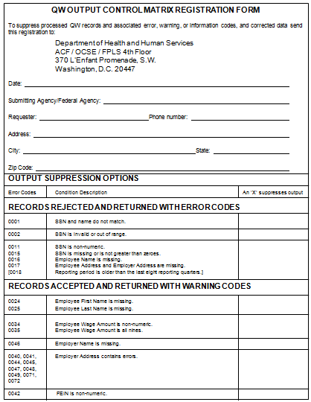
Figure 21-15: QW Output Control Matrix Registration Form
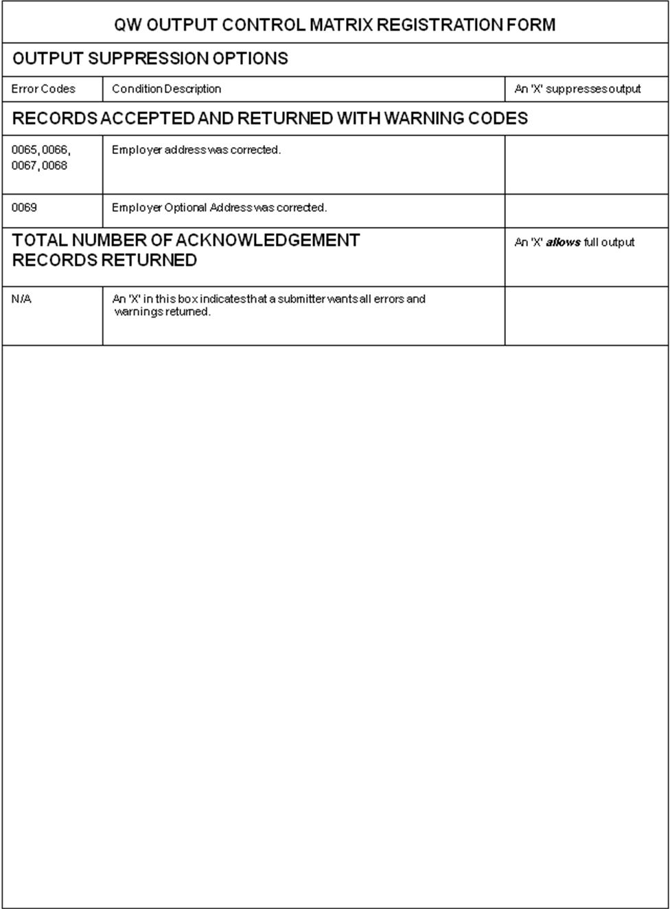

QW Management Information

General Information
The NDNH produces an MI report to assist the federal agencies and SWAs in performing statistical analysis, tracking data, and analyzing trends.

MI Report and Explanation
Figure 22-1 is a sample of an MI report. This sample report contains contrived data to clarify the data that is present in an actual report.
Summary for State/Agency of QW Data Submitted
The NDNH produces an MI report for each federal agency and state submitter. For each batch in a given report period (e.g., week, month, quarter or year), the report displays:
- Header date
- Process date
- Batch number
- Total number of records in each batch
- Number and percent of those records that were:
- posted to the QW NDNH files
- rejected with an unverified SSN
- rejected, including the records that are rejected because of unverified SSNs
- duplicated within a batch
SWAs that do not submit full employee names receive a report that shows the number of records that were accepted and posted to the QW Non-Verifiable file.
The report displays the totals of all of the above counts for the report period. In addition, the report includes these totals for a pre-set prior period, and sums these numbers to create cumulative totals.

Figure 22-16: QW MI Report Sample
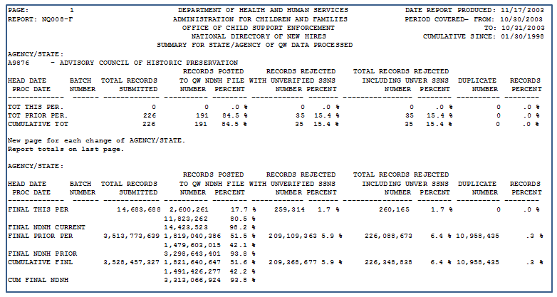

MI Report Field Descriptions

Chart 22-28: QW MI Report Field Descriptions
Field | Description
Page Number | This is the page number within the total report (which includes all federal agencies and SWAs) on which a federal agency’s or state’s report data is located. The page number on an individual federal agency or SWA report may not begin with the number one.
Report Number | This number is ‘NQ008’. The ‘N’ identifies the report as an NDNH report. The ‘Q’ indicates that the report contains summary data of submitted QW data. The numbers distinguish this report from other QW reports.
Agency/State | This field contains the name of the federal agency or SWA that submitted the QW data.
Date Report Produced | This is the date of the report run.
Period Covered | These are the inclusive dates for the QW data presented in this report. This period is the quarter of submission being reported.
Cumulative Since | This is the beginning date of the prior period.
Head Date | This is the date in the Date Stamp field for a specific QW batch.
Proc Date | This is the date a specific QW batch was processed.
Batch Number | This is the unique batch number submitted with each QW submission.
Total Records Submitted | This is the total number of QW Data records submitted. Header and Total records are not counted. This is expressed for each specific batch in the report period, and as:  - A total for the report period  - A total for the prior report period  - Cumulative from the “Cumulative Since” date
Records Posted to QW NDNH File | This is the total number and percent of QW records that met validation and SSA verification criteria, and were added to the NDNH QW file. This column will be present for all federal agencies or if the submission is from a SWA that collects and transmits full employee names. This is expressed for each specific batch in the report period, and as:  - A total for the report period  - A total for the prior report period  - Cumulative from the “Cumulative Since” date
Records Posted to QW Non-Verifiable File | This is the total number and percent of QW records that were posted to the NDNH QW Non-Verifiable file. This column is only present if the submission is from a SWA that does not collect and transmit full employee names. Information regarding QW Non-Verifiable records is expressed for each specific batch in the report period, and as:  - A total for the report period  - A total for the prior report period  - Cumulative from the “Cumulative Since” date
Records Rejected With Unverified SSNs | This is the total number and percent of QW records that have unverified SSNs, and are rejected by the NDNH. This is expressed for each specific batch in the report period, and as:  - A total for the report period  - A total for the prior report period  - Cumulative from the “Cumulative Since” date
Total Records Rejected Including Unverified SSNs | This is the total number and percent of QW data records that did not meet the minimum information requirements, or contain an unverified SSN. These records were rejected, and individually returned to the submitter at the time of transmission. This information is expressed for each specific submission in the report period, and as:  - A total for the report period  - A total for the prior report period  - Cumulative from the “Cumulative Since” date
Duplicate Records | This is the number and percent of duplicate QW data records received within each batch. Duplicate records are rejected, and individually returned to the submitter at the time of transmission. This information is expressed for each specific batch in the report period, and as:  - A total for the report period  - A total for the prior report period  - Cumulative from the “Cumulative Since” date
Percentages | The percentages are derived by dividing each “number” by the “Total Records Submitted” for that row.
Total for This Period | These sums are for the report period that is specified in the “Period Covered” fields in the report heading and include:  - Posted to the QW NDNH file  - Rejected with unverified SSNs  - Posted to the QW Non-Verifiable file  - Total rejected records, including unverified SSNs  - Duplicate records
Total for Prior Period | These sums are for the period from the “Cumulative Since” date to the day prior to the “Period Covered” in the report heading and include:  - Posted to the QW NDNH file  - Rejected with unverified SSNs  - Posted to the QW Non-Verifiable file  - Total rejected records including unverified SSNs  - Duplicate records
Cumulative Total | These sums are for the period from the “Cumulative Since” date up to and including the “Period Covered” in the report heading and include:  - Posted to the QW NDNH file  - Rejected with unverified SSNs  - Posted to the QW Non-Verifiable file  - Total rejected records including unverified SSNs  - Duplicate records

QW Conclusion and Recommendations
Federal agencies and SWAs submit quarterly wage (QW) data to the NDNH. Technical support and help are available to each submitter. Federal agencies and SWAs should use the support that is available to ensure the successful transmission of the required information. Refer to Section 3, “Technical Support,” for information to obtain assistance with QW reporting.
The NDNH returns corrected name and address information. SWAs and federal agencies should use this corrected data to update their systems.
QW data is critical for the enforcement of child support, identification of fraud, establishment of benefits and the recovery of debts. To support these activities, SWAs should:
- Submit QW data more frequently than quarterly, which allows data matching partners to receive the data up to three months sooner.
- Submit all QW data that they process. If an employer is late in submitting their QW data, and it is submitted in a subsequent quarter, the SWA should submit the delinquent data to the NDNH. The NDNH processes both the current QW data, and all delinquent data submitted.
There will be changes made to the NDNH as new needs and requirements are identified and as users’ recommendations are received. Future releases of the NDNH will include updates to this Guide.

FOREWORD
The OCSE, HHS, promulgated regulations at 45 CFR section 303.108 regarding “Quarterly Wage and Unemployment Compensation Claims Reporting to the National Directory of New Hires.”
The regulations address specifically the dates, format and data elements that are necessary for states to furnish the QW and unemployment compensation data to the NDNH. In developing the regulation, OCSE consulted representatives from state child support agencies, SWAs, the DoL, SSA, the National Association of State Workforce Agencies, and employer groups.
This Guide contains various requirements that are contained in the regulation. The regulation addresses requirements for SWAs that submit QW and UI data to the NDNH. The regulation is not applicable to federal agencies.

Unemployment Insurance Component
Note: [Opening and closing brackets] surrounding text signify changed material.
The UI component of the NDNH maintains, on a quarterly basis, UI information for individuals who have received, or made application for, unemployment benefits as reported by the SWAs. For the purposes of this document, UI is defined as Unemployment Insurance claimant data. The purpose of including UI data in the NDNH is to provide states with the ability to quickly locate information about the address of, and UI compensation being paid to, parents with child support obligations.

Legislation
Section 453A(g)(2)(B) of the Social Security Act (the Act) requires States “on a quarterly basis, furnish to the NDNH information concerning … unemployment compensation paid to individuals, by such dates, in such format, and containing such information as the Secretary of HHS shall specify in regulations.”
Section 3304(a)(16) of the Internal Revenue Code of 1986 requires states to furnish unemployment compensation information contained in the records of the state agency that administers the unemployment compensation program to the Secretary of HHS, in accordance with regulations that have been promulgated by the Secretary, as may be necessary for the purposes of the National Directory of New Hires under section 453(i)(1) of the Act.
Section 303(h)(1)(A) of the Act requires the state agency charged with the administration of the unemployment compensation program, on a reimbursable basis, to disclose quarterly, to the Secretary of HHS, unemployment compensation claim information, as required pursuant to section 453(i)(1) of the Act, that is contained in the records of such agency.
Section 303(h)(3)(B) defines “claim information” as “information regarding whether an individual is receiving, has received, or has made application for, unemployment compensation, the amount of any such compensation being received (or to be received by such individual), and the individual’s current (or most recent) home address.”
Refer to Appendix B, “Federal Information,” for a reference to the PRWORA of 1996 law that is specific to the NDNH.

Timeframes
There are timeframes associated with the reporting of UI data, the performance of matches, and reporting by the NDNH. Some of the timeframes are requirements of the Act and others are functions of the NDNH system processing. [UI data transmissions are to be submitted to the NDNH on a quarterly basis, that is, once per quarter.] Chart 24-1 shows the activities that are associated with UI reporting and their corresponding timeframes.

Chart 24-29: UI Timeframes
Activity | Timeframe
SWA transmittal of UI data to the NDNH | States must transmit UI data within one month after the end of the reporting quarter:  - January through March data is due no later than April 30  - April through June data is due no later than July 31  - July through September is due no later than October 31  - October through December data is due no later than January 31
Enter UI data from SWAs into the NDNH | UI data must be entered into the NDNH within two business days of the NDNH receiving the data.
Return summary and transmittal data, including error reporting, to the state | The NDNH must send transmittal, summary and error data to the submitting SWA within four business days of the NDNH system receiving the data.
Management information delineating and summarizing each SWA’s submittal data | The NDNH produces reports on a periodic basis.
Compare NDNH and FCR data | NDNH data and FCR data must be cross-matched not less than every two business days.
Report matches from the NDNH and FCR comparison back to the CSE IV-D agency | The FCR must report NDNH and FCR matching information to the IV-D agency within two business days of the match.

UI Data Requirements
Each SWA collects UI data and forwards this information to the NDNH. Federal law requires that each SWA furnish UI data by such dates, in such format, and containing such information as the Secretary of HHS specifies in regulations. The SWAs supply UI information, which is already contained in the records of the state agency that administers the unemployment compensation program. There is no requirement to collect additional UI information for purposes of the NDNH.

Data Requirements
SWAs should transmit the following data elements to the NDNH:
- Claimant Name
- Claimant SSN
- Claimant Address
- Claimant Benefit Amount
- Reporting Period
Refer to Section 26.1, “UI Record Layouts,” for the specifications for transmitting UI data to the NDNH.
Description of the UI Data Elements

Chart 25-30: Description OF UI Data Elements
Data Element | Description
Claimant Name | This is the claimant’s first name, middle name or initial, and last name.
Claimant SSN | This is the nine-digit number SSA assigns to an individual.
Claimant Address | This is the number, street name, PO box or rural route, city, state, and Zip code where an individual resides.
Benefit Amount | This is the gross amount, prior to any deductions, of benefits paid to a claimant during a reporting quarter. This may be zero if an individual has filed for unemployment insurance benefits, but no amount was paid during the reporting quarter, such as when a claim is pending or denied.
Reporting Period | This is the calendar quarter and year during which the UI benefits were paid or activity was performed:  - – January 1 through March 31  - – April 1 through June 30  - – July 1 through September 30  - – October 1 through December 31

UI Data Source
Within a state, the source of UI information is the agency that is charged with the administration of the unemployment compensation program. The state forwards the claimant information to the NDNH via CFI.

UI Transmission
Each transmission must contain three types of records in the following order:
- UI Transmitter Header Record – This record precedes the UI data records and contains information about the submitter.
- UI Data Records – These records contain the actual UI data.
- UI Total Record – This record follows the UI data records and is a summary of the transmission.

Transmission Method
Each SWA transmits UI records via SSA’s closed-line CFI protocol. All transmissions must be sent electronically, and the data must be encrypted.

UI Record Layouts
States must transmit the UI information according to the specified record layouts. The general rules that apply to all the record formats are shown below:
- All data must be in EBCDIC format.
- All alphabetic data must be uppercase.
- All alphabetic and alphanumeric data must be left justified.
- All numeric data must be right justified with leading zeros.
- All dates must be in CCYYMMDD format.
- CC represents the century
- YY represents the year.
- MM represents the month and must be a number greater than 00, but less than 13
- DD represents the day of the month and must be a valid number for the designated month (e.g., 01-31 for months 01, 03, 05, 07, 08, 10 or 12; 01-30 for months 04, 06, 09, or 11; and 01-29 for the month 02)
- Name fields cannot include suffixes, such as ‘Jr.’, ‘Sr.’ or ‘III’.
- The hyphen is the only special character allowed in the Claimant Name or City.
- All state and territory abbreviations in addresses must be valid USPS abbreviations. See Appendix E, “State and Territory Names, Abbreviations and FIPS Codes,” for a complete list.
- If an address is less than 40 characters per line, do not concatenate into one line.

UI Transmitter Header Record
System processing requires the completion of all of the fields in the UI Transmitter Header record.
Chart 26-31: UI Transmitter Header Record
OMB Control nO: 0970-0166 expiration date: 06/30/2013
Field Name | Location | Length | A/N | Comments
Record Identifier | 1-2 | 2 | A/N | Required  This field must contain the characters ‘HU’.
Transmitter State Code | 3-4 | 2 | A/N | Required  This field must contain the two-digit FIPS code of the state or territory that is transmitting data to the NDNH. Refer to Appendix E, “State and Territory Names, Abbreviations and FIPS Codes,” or to the Department of Commerce FIPS Code Manual, National Institute of Standards and Technology, FIPS PUB 5-2 (April 1995) for a list of these codes. In addition, FIPS codes may be found on the Internet at:  http://www.itl.nist.gov/fipspubs/fip5-2.htm.
Filler | 5-13 | 9 | A/N | Required  This field will be used in future versions. For the current version, this should be all spaces.
Transmission Type | 14-15 | 2 | A/N | Required  This field must contain the characters ‘UI’.
Filler | 16 | 1 | A/N | Required  This field will be used in future versions. For the current version, this should be all spaces.
Version Control Number | 17-18 | 2 | A/N | Required  This field must contain the numbers ‘01’. OCSE will notify the SWAs when this field changes.
Date Stamp | 19-26 | 8 | N | Required  This field must contain the transmission date of the UI data to the NDNH. This must be in CCYYMMDD format.
Batch Number | 27-32 | 6 | N | Required  The field contains a number that is generated by the transmitting SWA. Do not repeat batch numbers.
Filler | 33-295 | 263 | A/N | Required  This field should be all spaces. States and territories should not use the Filler field. The Filler field is strictly reserved for OCSE. Anything submitted in the field is not returned to the submitter and is overlaid with spaces.

UI Data Record
The intent of the system is to provide information to locate persons in response to requests from CSE IV-D agencies. A UI Data record must include these fields:
- Claimant First Name
- Claimant Last Name
- Claimant SSN
- Reporting Period
- Claimant Address

UI Data Record
NDNH system processing requires the completion of the required fields of the UI Data record.
Chart 26-32: UI Data Record
OMB Control nO: 0970-0166 expiration date: 06/30/2013
Field Name | Location | Length | A/N | Comments
Record Identifier | 1-2 | 2 | A/N | Required  This field must contain the characters ‘UI’.
Claimant SSN | 3-11 | 9 | N | Required  This field must contain a nine-digit SSN.  If this field is blank, or contains any alphabetic characters, the system rejects the record.
Claimant Name  First Name  Middle Name  Last Name | 12-27  28-43  44-73 | 16  16  30 | A  A  A | Required  This field must contain least one character in the first name and one character in the last name.  If both the first and last names are blank, the system rejects the record.  If the claimant middle name is non-blank, it must contain at least one character.  The first and last names cannot begin with a space or hyphen.  No special characters, except hyphens, are allowed.
Claimant Street Address  Line 1  Line 2  Line 3 | 74-113  114-153  154-193 | 40  40  40 | A/N  A/N  A/N | Required: Line (1)  This field must be at least two characters.  If an address is less than 40 characters per line, do not concatenate into one line.  Use Line 3 for a military designation or the Canadian province code.
Claimant City | 194-218 | 25 | A | Required  This field must be at least two characters. No special characters, except hyphens, are allowed.
Claimant State | 219-220 | 2 | A | Required  This field must be a valid two-letter USPS abbreviation of a state or territory. Refer to Appendix E, “State and Territory Names, Abbreviations and FIPS Codes.”
Claimant Zip Code  Zip Code (1)  Zip Code (2) | 221-225  226-229 | 5  4 | A/N  A/N | Required: First five-digits  This field must be the five-digit USPS Zip code that is associated with the claimant’s address.  Zip Code 2 must be either all spaces or the four-digit additional numeric code, but not all zeros.
Benefit Amount | 230-240 | 11 | N | Optional  This field contains the gross amount of benefits, prior to any deductions, paid to a claimant during the reporting quarter. For reporting purposes, the date used should be the file (process) date, rather than the week ending date (WED).  The last two positions are decimal places. All zeroes are allowed. Do not include a decimal point as part of this field.  Negative values are not allowed.
Reporting Period | 241-245 | 5 | N | Required  This field contains the time period of the UI data being reported. For reporting purposes, the date used should be the file (process) date, rather than the WED.  The format is QCCYY.  Q – Reporting quarter:  1 – January 1 through March 31  2 – April 1 through June 30  3 – July 1 through September 30  4 – October 1 through December 31  CC – Century  YY – Year
Filler | 246-295 | 50 | A/N | This field should be all spaces. States and territories should not use the Filler field. The Filler field is strictly reserved for OCSE. Anything submitted in the field is not returned to the submitter and is overlaid with spaces.
UI Total Record
System processing requires the completion of all of the fields in the UI Total record.
Chart 26-33: UI Total Record
OMB Control nO: 0970-0166 expiration date: 06/30/2013
Field Name | Location | Length | A/N | Comments
Record Identifier | 1-2 | 2 | A/N | Required  This field must contain the characters ‘TU’.
Data Record Count | 3-13 | 11 | N | Required  This field must be the number of records in the transmission, including the Header and Total records.
Filler | 14-295 | 282 | A/N | Required  This field should be all spaces. States and territories should not use the Filler field. The Filler field is strictly reserved for OCSE. Anything submitted in the field is not returned to the submitter and is overlaid with spaces.

UI Data Validation and Verification
Accurate data is essential to ensure the integrity of the NDNH database. UI data that are transmitted by a state undergoes various validation and verification processes. Submitters receive information regarding validation and verification within four business days. Refer to Section 29, “UI Output to Submitters,” for more information regarding return data. NDNH edits incoming data at the various levels from file transmission to the individual record.
There are five levels of validation: The first by the SWA and the rest by the NDNH:
- SWA-Pre-processing
- Transmission
- NDNH Pre-Processing
- Batch
- Record

Pre-Processing Level Editing
Prior to submitting UI data to the NDNH, SWAs should perform edits on the data to ensure compliance with the requirements as outlined in the record layouts. This ensures that the data meet the requirements for acceptance to the NDNH, and that the NDNH has accurate and complete information.

Transmission Level Editing
When a file is received by the NDNH, the Node ID in the dataset name for SWAs is verified to determine if the submission is from a valid user. If the Node ID is not valid, the file is suspended and the submitter is contacted.
After the Node ID is validated, the Submitter ID in the Header record is evaluated against a Master Table to determine the authenticity of the submission. If the Submitter ID is not registered in the Master Table, the batch is suspended and the submitter is contacted.

Transmission Errors
When transmitting UI data, there are errors that can occur at the transmission level. Depending upon the type of error, the system:
- Rejects the entire transmission,
- Rejects part of the transmission,
- Suspends the file and notifies the transmitter to determine whether to process the file, or
- Accepts the transmission, but returns a warning code to the submitting agency.
An SWA that receives notice of rejection due to transmission errors (#1 or #2) above, must correct the information and resubmit the data via CFI. Chart 27-1, is a list of the error and warning codes at the transmission level.

Chart 27-34: UI Transmission Error and Warning Codes
Code | Error Message and Description
Transmission Error Codes – Full Transmission Rejected
5000 | The Transmitter Header record is required. The Transmitter Header record must be present at the beginning of each transmission file.
5001 | The Transmitter Header record does not contain the transmitter state code.
5002 | The Transmitter Header record does not contain the version control number, or has an invalid version control number. The version control number must be ‘01’.
5003 | The Transmitter Header record contains a non-numeric batch number. The Transmitter Header record must contain a numeric batch number.
5004 | The Transmitter Header record contains a batch number that is a duplicate of a previously received batch number. The Transmitter Header record must not contain a batch number that is a duplicate of a batch number received in a previous transmission from the state or territory within the same calendar year.
Transmission Error Codes – Part of Transmission Rejected
5005 | The Transmitter Header record is not the first record in the file. All records are rejected until a Transmitter Header record is found.
Transmission Warning Codes – Transmission Accepted
5006 | The transmission type is missing or invalid. The transmission type must equal ‘UI’.
5007 | The Transmitter Header record does not contain the date stamp or the date stamp is an invalid date.
5008 | The Total record is missing.
5009 | The data record count is non-numeric.
5010 | The data record count does not equal the count of the records received.

NDNH Pre-Processing Level Editing
The NDNH system performs several edits to determine if the data is acceptable. These edits determine whether batch processing can proceed. If a submission does not pass the NDNH processing level editing, the submission is suspended and the submitter is contacted.

Duplicates
To determine whether a file is a duplicate, samples of the records are compared to the NDNH current and previous quarter databases for matching records. The NDNH system considers two UI records to be duplicates if the contents of the following fields of the incoming UI record are identical to the corresponding fields on the record from the NDNH database:
- Claimant SSN
- Transmitter State Code
- Claimant Name
- Benefit Amount
- Reporting Period

Submission Limits
NDNH processing level edits examine certain key characteristics of each file to determine if these characteristics are within expected limits. The limits are based on experience of the data that has been received from each submitter, as well as standards set by OCSE. If one or more of these limits is exceeded, the file is suspended. The NDNH processing level edits that result in suspension are:
- The number of records that were submitted is below or above the expected volume range for that submitter.
- A large percentage of the records contain a benefit amount that is excessively high (over $25,000).
- The file contains records that are not for the current or expecting Reporting Quarter.
For each SWA a minimum and maximum volume of records to be received has been established, based on previous submissions. If a submission is received with too few or too many records, the file is suspended and the submitter is contacted. If the volume of records received is determined to be correct, the file is processed and the expected minimum/maximum volume for the submitter may be adjusted, if needed.
The benefit amount on each UI record is evaluated to determine if the benefit amount is greater than $25,000. The number and percentage of benefits over $25,000 are evaluated against a pre-set threshold. If the file contains excessive amounts of records with benefit over $25,000, the file is suspended and the submitter is contacted. If the benefits are determined to be correct, the file is processed.

Batch Level Editing
All of the files that pass the transmission level editing are evaluated to ensure that the required records and data values in the header record, data records and trailer record are present. If the required elements or records are missing, the transmission is rejected. The edits allow part of, or the entire, transmission to be processed if minor errors occur. Chart 27-2, describes the types of edits that are performed, and the output at the batch level editing.

Chart 27-35: UI Batch Editing
Edit | Processing
The Transmitter Header record is missing. | The transmission is rejected, and an error code is returned to the submitter.
The Transmitter Header record does not contain a valid transmitter state code. | The transmission is rejected, and an error code is returned to the submitter.
The Transmitter Header record does not contain the version number, or has an invalid version number. | The transmission is rejected, and an error code is returned to the submitter.
The Transmitter Header record contains a non-numeric batch number. | The transmission is rejected, and an error code is returned to the submitter.
The Transmitter Header record contains a batch number that is a duplicate of a batch number previously received from the submitter within the calendar year. | The transmission is rejected, and an error code is returned to the submitter.
The Transmitter Header record is not the first record in the file. | All records prior to the Header record are rejected, and all records after the Header record are processed. A warning code is returned to the submitter.
The transmission type is not equal to ‘UI’. | All records are processed, and a warning code is returned to the submitter.
The date stamp is missing or invalid in the Transmitter Header record. | All records are processed, and a warning code is returned to the submitter.
The Total record is missing. | All records are processed, and a warning code is returned to the submitter.
The data record count is non-numeric. | All records are processed, and a warning code is returned to the submitter.
The data record count does not equal the number of the records received. | All records are processed, and a warning code is returned to the submitter.
If a UI submitter receives notice of rejection, the submitter must correct the information and resubmit the data via CFI. If the submitter receives a warning notification, they should investigate the warning. If records were not processed because of the error, the submitter should correct the issue and resubmit the data.

Record Level Editing
The NDNH edits each record to ensure that all of the required data elements are present, key values are valid, and data conforms to the system standards before it is accepted.

SSN/Name Verification
The NDNH system performs edits on the SSN and name entries and sends SSN/Name combinations that appear to be valid to SSA for verification. Section 5, “Social Security Number Verification,” outlines the SSN verification processes and errors.
Note: Not all States submit name information, or enough name information, to complete a full SSN/Name verification.
Chart 27-3 contains the types of SSN/Name edits that are performed on each UI record.
Chart 27-36: UI SSN/Name Verification
Edit | Processing
The SSN is spaces. | The record is rejected, and an error code is returned to the submitter.
The SSN is non-numeric. | The record is rejected, and an error code is returned to the submitter.
The SSN is not greater than zeros. | The record is rejected, and an error code is returned to the submitter.
The first five digits of the SSN have not been issued by SSA. | The record is rejected, and an error code is returned to the submitter.
The claimant name is missing. | The record is rejected, and an error code is returned to the submitter.
The SSN and name do not match with SSA’s records, or the SSN is not found at SSA. | The record is rejected, and an error code is returned to the submitter. This is returned after all attempts to verify the SSN and name fail.
Verification of SSN and name failed, the first name and last name were transposed, and the SSN and transposed name combination was verified. | The record is passed to the next level of verification. The record is assigned a warning code, and is returned to the submitter with the corrected name.
Verification of SSN and name failed. The transposition of the name failed. The digits of the SSN were transposed and verified with the name. | The record is passed to the next level of verification. The record is assigned a warning code, and the new SSN is returned to the submitter.
After all attempts to find a valid SSN/Name combination have failed, name matching software is utilized to evaluate the extent to which a claimant name on a received UI record matches a name in the SSA database. This software provides matching confidence scores at 12 comparison levels. For records that exceed a predetermined confidence level, the results of the name match software processing are stored on the UI Unverified NDNH file, and are used in FCR Locate and Proactive Matching routines.
Any records that do not pass the SSN or SSN/Name verification process are dropped from the system. All records that pass the SSN or SSN/Name verification process continue through the record edits.

Minimal Data Validation
Each UI data record is validated to ensure that it contains a claimant SSN, claimant name and claimant address. If the record does not contain the three required data elements listed above it is rejected with an error code, and is returned to the submitter.

General Validation
General Validation edits are performed on all of the records that pass the SSN/Name and Minimal Data Validation. These edits determine the validity of the data that are provided, or identify missing data that would be beneficial to NDNH users. General validation only creates warning codes for the UI record. These warning codes do not prevent records from being posted to the NDNH.
The claimant data are checked for a first and last name. If the first or last name is missing, a warning code is returned to the submitter.
The benefit amount is checked to ensure that it is numeric. If the amount is non-numeric, a warning code is returned to the submitter.
The reporting quarter is checked to ensure that it is numeric. If the reporting quarter is numeric, the quarter is validated for a ‘1’, ‘2’, ‘3’ or ’4’. The year is also validated to ensure that it is a valid year. If the reporting quarter is non-numeric, or does not contain a valid quarter and year, a warning code is returned to the submitter.
The claimant address data are analyzed to determine the validity of the data that are provided. The NDNH system uses the commercial software product FINALIST® to improve the quality of claimant addresses that are received on validated UI records. By using this software, the received address data undergoes verification and/or correction processes, and then are formatted in the standard USPS format. Addresses that are corrected by this process are returned to the submitter with a warning code that indicates what part(s) of the address was corrected. The verified or corrected address data are stored on the UI NDNH files.
Chart 27-4 contains a description how the analysis is performed.
Chart 27-37: UI General Validation
Edit | Processing
The claimant Zip code is missing or non-numeric, and cannot be corrected. | A warning code is returned to the submitter.
The claimant Zip code does not match the city, and cannot be corrected. | A warning code is returned to the submitter.
The claimant state is missing, and cannot be corrected. | A warning code is returned to the submitter.
The claimant state is invalid (not a valid 2- character USPS abbreviation), and cannot be corrected. | A warning code is returned to the submitter.
The claimant name is blank. | An error code is returned to the submitter.
The claimant address Line 1, 2 and 3 are all blanks. | A warning code is returned to the submitter.
The claimant city is blank, and cannot be corrected. | A warning code is returned to the submitter.
The claimant street was corrected. | A warning code and the corrected claimant street are returned to the submitter.
The claimant city was corrected. | A warning code and the corrected claimant city are returned to the submitter.
The claimant state was corrected. | A warning code and the corrected claimant state are returned to the submitter.
The claimant Zip code was corrected. | A warning code and the corrected claimant Zip code are returned to the submitter.
The claimant address cannot be corrected. | A warning code is returned to the submitter.

Error Codes and Explanations
There are a variety of data errors that can occur in any submission. The type of error determines the next processing step. In addition to the errors that occur in the SSN verification processes, records may be incomplete or invalid due to other data errors. The following sections discuss these types of errors.

Incomplete Records
Incomplete UI data records are records that are missing one or more of the required data elements, but contain the minimum critical information to make the record useful to users of NDNH data. If a UI data record contains a claimant name, SSN, reporting period and a claimant address, the information is helpful to the users. The NDNH system accepts and stores incomplete UI records, and sends a notification that warns the submitter about the data that are missing from the record.

Rejected Records
Invalid UI data records are those that have not met the critical edits. When the critical edits are not met, the system designates the record as invalid and rejects the record. The NDNH system does not store invalid records, but notifies the submitter of the rejected records and the reason(s) for rejection. Refer to Section 29, “UI Output to Submitters,” for the record formats for data that are returned to submitters. The critical edits that determine the retention or rejection of a UI record are:
- The record contains an SSN that is all numeric.
- The record contains at least one character in the claimant name.
- The record contains a valid reporting period.
- The record contains the claimant address.
- The SSN/name combination is verified.

Other Errors
Other errors that can occur relate to the Transmitter Header record and the Transmitter Total record, rather than to a specific UI data record. These errors may cause the NDNH system to reject the full transmission, reject part of the transmission or accept the transmission and warn the submitter of the error. Section 26, “UI Transmission,” discusses transmission level errors.

UI Record Codes and Explanations
Chart 27-5 contains a list of the UI record error and warning codes.

Chart 27-38: UI Error and Warning Codes
Code | Error Explanation
ERROR CODES – RECORD REJECTED AND NOT ADDED TO NDNH
0001 | SSN and name do not match.
0002 | SSN is invalid or out of range.
0011 | SSN is non-numeric.
0015 | SSN is missing or is not greater than zeroes.
0016 | Claimant name is missing.
0017 | Claimant address is missing.
WARNING CODES – RECORD ACCEPTED AND ADDED TO NDNH
0004 | UI SSN verified by transposing first name and last name.
0005 | UI SSN has been corrected.
0020 | Claimant Zip code is missing or non-numeric; format must be a five-digit USPS zip code.
0021 | Claimant Zip code does not match the city.
0022 | Claimant state abbreviation is missing
0023 | Claimant state abbreviation is invalid; the format should be two letter state or territory abbreviation
0024 | Claimant first name is missing.
0025 | Claimant last name is missing.
0027 | Claimant street address Lines are missing.
0028 | Claimant city is missing.
0034 | Benefit amount is non-numeric.
0051 | Reporting period is invalid.
0060 |  | Claimant street address has been corrected.
0061 |  | Claimant city has been corrected.
0062 |  | Claimant state has been corrected.
0063 |  | Claimant Zip code (five-digits) has been corrected.
0070 |  | Claimant address cannot be corrected.

Resubmittal Process
The resubmittal process is identical to the standard submittal process. SWAs resubmit corrected records and corrected transmissions in the standard formats via C:D. Submitters that are unable to correct the records or identify the transmission problems can contact technical support for assistance. Refer to the Section 3, “Technical Support,” for a list of the available technical support.

UI NDNH Update
The NDNH system stores verified UI records in the NDNH UI file. Records with corrected name (using Name Transposition process) are stored on the Verified file. The corrected address (corrected using FINALIST) is stored on the NDNH database. The UI records in the NDNH UI file are used for proactive matching with the FCR, and Locate searches in response to a Locate request.

Duplicates
At the record level, if a SWA submits a duplicate record(s) within a transmission, the NDNH system processes the first of those records and ignores the duplicate UI record(s). During comparison of two UI records within a batch to determine if they are duplicates, the records are considered to be duplicates of each other if the contents of the following fields are the same:
- SSN
- State Code
- Node ID
- Benefit Amount
- Reporting Period
- Claimant Name
- Claimant Address
The NDNH also compares records in incoming transmissions against the NDNH database. If a duplicate record [that was submitted during the same quarter] is found, the record in the incoming transmission is rejected. If that occurs, the number of the rejected records is included in the Records Rejected field, positions 44-54, of the UI Transmission Control record.

UI Output to Submitters
Within four business days, the NDNH system returns information regarding UI data to the submitter. The NDNH system returns:
- The number of records that were received in a transmission, including the Transmitter Header record and Total record
- The number of rejected records
- The number of records in a transmission with errors or warnings, regardless of the return error suppression matrix choices
- The number of records accepted and written to the NDNH UI file
- Transmission error codes
- Each UI data record that has errors or warnings with up to five error or warning codes
- Each UI record that has a corrected claimant address
In addition to receiving data about UI records, SWAs receive an MI summary report on a regular basis. Refer to Section 30, “UI Management Information,” for information on MI reports.

Output Record Layouts
The NDNH returns UI record transmission and error information via SSA’s closed-line CFI system. A trailer or total record is not returned to the submitting SWA in response to UI transmissions. Each transmission contains two types of records in the following order:
- UI Transmission Control Record: This record precedes the returning UI data records, and contains information about the submitter’s transmission. It contains data that was submitted by the SWA, record counts, and error/warning codes.
- UI Response Data Records: These records contain the actual UI data and their associated errors or warnings, and corrected claimant addresses.
The NDNH transmits the returning UI information according to specified record layouts. Each response record contains submitted data, corrected data, and error/warning codes as appropriate. The general rules are identical to the requirements for data transmission. Refer to Section 26, “UI Transmission,” for specific information on transmission rules.
Chart 29-1 contains the data elements in the UI Transmission Control record.

Chart 29-39: UI Transmission Control Record
OMB Control nO: 0970-0166 expiration date: 06/30/2013
Field Name | Location | Length | Comments | A/N
Record Identifier | 1-2 | 2 | This field contains ‘RU’. | A/N
Transmitter State Code | 3-4 | 2 | This field contains the two-digit code that was submitted. | A/N
Filler | 5-13 | 9 | This field contains all spaces. | A/N
Transmission Type | 14-15 | 2 | This field contains the value that was provided in the submission: ‘UI’. | A/N
Filler | 16 | 1 | This field contains all spaces | A/N
Version Control Number | 17-18 | 2 | This field contains the value that was provided in the submission: ‘01’. | A/N
Date Stamp | 19-26 | 8 | This field contains the date that was provided in the submission. | N
Batch Number | 27-32 | 6 | This field contains the value that was provided in the submission. | N
Records Received | 33-43 | 11 | This field contains the count of the records that were received in the submission, including the Header and Total records. | N
Records Rejected | 44-54 | 11 | This field contains the count of the records that were rejected in the submission. | N
Error Records Returned | 55-65 | 11 | This field contains the total number of records with errors or warnings that were returned in the transmission, not those excluded due to the Output Control Matrix. | N
Records Posted to NDNH | 66-76 | 11 | This field contains the total number of records that were posted to the NDNH UI file. | N
Filler | 77-98 | 22 | This field contains all spaces. | A/N
Error Code 1* | 99-102 | 4 | This field contains the transmission error code (if any) that was generated during the processing of the submission. | A/N
Error Code 2* | 103-106 | 4 | This field contains the transmission error code (if any) that was generated during the processing of the submission. | A/N
Error Code 3* | 107-110 | 4 | This field contains the transmission error code (if any) that was generated during the processing of the submission. | A/N
Error Code 4* | 111-114 | 4 | This field contains the transmission error code (if any) that was generated during the processing of the submission. | A/N
Error Code 5* | 115-118 | 4 | This field contains the transmission error code (if any) that was generated during the processing of the submission. | A/N
Filler | 119-325 | 207 | This field contains all spaces. | A/N

*Refer to Chart 27-1, “UI Transmission Error and Warning Codes,” for the transmission level error and warning codes and their explanation.
For each UI record that is submitted and generates an error or warning code, a Response Data record is created and returned to the submitter. Each Response Data record contains submitted data, corrected data and address information, and error/warning codes as appropriate.
Chart 29-2 contains the information that is returned to the submitter in the UI Response Data record.
Chart 29-40: UI Response Data Record
OMB Control nO: 0970-0166 expiration date: 06/30/2013
Field Name | Location | Length | Comments | A/N
Record Identifier | 1-2 | 2 | This field contains ‘UO’. | A/N
Claimant SSN | 3-11 | 9 | This field contains the data that were provided in the submission. | N
Claimant Name  First Name  Middle Name  Last Name | 12-27  28-43  44-73 | 16  16  30 | This field contains the data that were provided in the submission, or the corrected first and last name. | A  A  A
Claimant Street Address  Line 1  Line 2  Line 3 | 74-113  114-153  154-193 | 40  40  40 | This field contains the data that were provided in the submission, or the corrected street. | A/N  A/N  A/N
Claimant City | 194-218 | 25 | This field contains the data that were provided in the submission, or the corrected city. | A
Claimant State | 219-220 | 2 | This field contains the data that were provided in the submission, or the corrected state. | A
Claimant Zip Code  Zip Code (1)  Zip Code (2) | 221-225  226-229 | 5  4 | This field contains the data that were provided in the submission, or the corrected Zip code (five digits). | N  A/N
Claimant Benefit Amount | 230-240 | 11 | This field contains the data that were provided in the submission. | N
Reporting Period | 241-245 | 5 | This field contains the data that were provided in the submission. | N
Filler | 246-295 | 50 | This field contains all spaces. | A/N
Error Code 1* | 296-299 | 4 | This field contains the generated error or warning code that is associated with the UI record. | A/N
Error Code 2* | 300-303 | 4 | This field contains the generated error or warning code that is associated with the UI record. | A/N
Error Code 3* | 304-307 | 4 | This field contains the generated error or warning code associated with the UI record. | A/N
Error Code 4* | 308-311 | 4 | This field contains the generated error or warning code that is associated with the UI record. | A/N
Error Code 5* | 312-315 | 4 | This field contains the generated error or warning code that is associated with the UI record. | A/N
SSN Correction Indicator | 316 | 1 | This field contains a code that describes how the SSN or Name was corrected. | A/N
Corrected SSN | 317-325 | 9 | This field contains the Corrected SSN. | A/N

*Refer to Chart 27-5, “UI Error and Warning Codes,” for the record level error and warning codes and their explanation.

Output Mode
The NDNH returns UI data via SSA’s closed-line CFI system. Each SWA receives returned data within four business days of transmitting UI data, as scheduled by SSA. The NDNH does not return any data by hardcopy.

Output Control Matrix
During the processing of UI records, the system may detect errors, correct data or identify abnormal conditions that can cause the return of a record to the submitter with error or warning codes. The NDNH Output Control Matrix determines which UI records with errors, warnings, or information codes are returned to each submitter.
Each SWA can set report parameters of the Output Control Matrix, based on their requirements and needs for returned information by completing the UI Output Control Matrix Registration form. This gives the SWA the ability to restrict some of the data they receive from the NDNH system.
If a SWA chooses to set the parameters, they must complete the UI Output Control Matrix Registration form and send it to OCSE. A SWA can change the parameters by notifying OCSE at the address that appears on the form.
The UI Output Control Matrix Registration form cannot be used to suppress transmission- or submission-level errors. Submission of the form is optional; the default is to return all of the records with error or warning codes.
For a complete description of UI errors and warnings, refer to Section 27.7, “UI Record Codes and Explanations.”
A copy of the UI Output Control Matrix Registration form is shown in Figure 29-1.
Figure 29-17: UI Output Control Matrix Registration Form
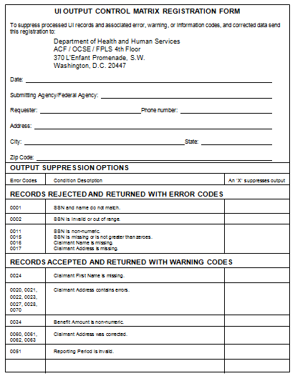

UI Management Information

General Information
The NDNH produces an MI reports to assist the SWAs in performing statistical analysis, tracking data, and analyzing trends.

MI Report and Explanation
Figure 30-1 is a sample of an MI report. This sample report contains contrived data to clarify the data that is present in an actual report.
Summary for State of UI Data Submitted
The NDNH produces an MI report for each SWA submitter. For each batch in a given report period (e.g., week, month, quarter or year), the report displays:
- Header date
- Process date
- Batch number
- Total number of records in each batch
- Number and percent of those records that were:
- posted to the UI NDNH file
- rejected with an unverified SSN
- rejected, including the records that are rejected because of unverified SSNs
- duplicated within a batch
The report displays the totals of all of the above counts for the report period. In addition, the report includes totals for a pre-set prior period and sums these numbers to create cumulative totals.

Figure 30-18: UI MI Report Sample
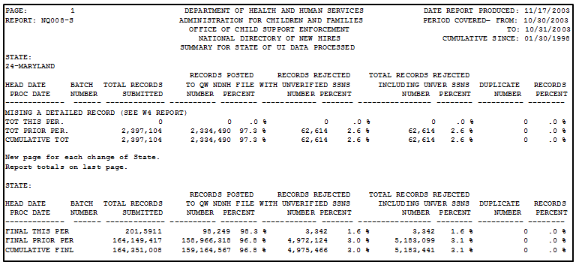

Field Descriptions

Chart 30-41: UI MI Field Descriptions
Field | Description
Page Number | This is the page number within the total report (which includes all SWAs) on which a SWA’s report data is located. The page number on an individual SWA report may not begin with the number one.
Report Number | This number is ‘NU008’. The ‘N’ identifies the report as an NDNH report. The ‘U’ indicates that the report contains summary data of submitted UI data. The numbers distinguish this report from other UI reports.
State | This field contains the name of the SWA that submitted the UI data.
Date Report Produced | This is the date of the report run.
Period Covered | These are the inclusive dates for the UI data presented in this report. This period is the quarter of submission being reported.
Cumulative Since | This is the beginning of the prior period.
Head Date | This is the date in the Date Stamp field for a specific UI batch.
Proc Date | This is the date a specific UI batch was processed.
Batch Number | This is the unique batch number that was submitted with each UI submission.
Total Records Submitted | This is the total number of UI Data records submitted. Header and Total records are not counted. This is expressed for each specific batch in the report period, and as:  - A total for the report period  - A total for the prior report period  - Cumulative from the “Cumulative Since” date
Records Posted to UI NDNH File | This is the total number and percent of UI data records that met validation and SSA verification criteria, and were added to the NDNH UI file. This is expressed for each specific batch in the report period, and as:  - A total for the report period  - A total for the prior report period  - Cumulative from the “Cumulative Since” date
Records Rejected with Unverified SSNs | This is the total number and percent of UI records that have unverified SSNs, and are rejected by the NDNH. This is expressed for each specific batch in the report period, and as:  - A total for the report period  - A total for the prior report period  - Cumulative from the “Cumulative Since” date
Total Records Rejected Including Unverified SSNs | This is the total number and percent of UI Data records that did not meet the minimum information requirements or contain an unverified SSN. These records were rejected and individually returned to the submitter at the time of transmission. This information is expressed for each specific batch in the report period, and as:  - A total for the report period  - A total for the prior report period  - Cumulative from the “Cumulative Since” date
Duplicate Records | This is the number and percent of duplicate UI Data records that were received within each batch. Duplicate records are rejected and individually returned to the submitter at the time of transmission. This information is expressed for each specific batch in the report period, and as:  - A total for the report period  - A total for the prior report period  - Cumulative from the “Cumulative Since” date
Percentages | The percentages are derived by dividing each ‘number’ by the “Total Records Submitted” for that row.
Total for This Period | These sums are for the report period specified in the “Period Covered” fields in the report heading and include:  - Posted to the UI NDNH file  - Rejected with unverified SSNs  - Total records rejected including unverified SSNs  - Duplicate records
Total for Prior Period | These sums are for the period from the “Cumulative Since” date to the day prior to the “Period Covered” in the report heading and include:  - posted to the UI NDNH file  - rejected with unverified SSNs  - total records rejected including unverified SSNs  - duplicate records
Cumulative Total | These sums are for the period from the “Cumulative Since” date up to and including the “Period Covered” in the report heading and include:  - posted to the UI NDNH file  - rejected with unverified SSNs  - total number of rejected records  - duplicate records

UI Conclusion and Recommendations
SWAs submit UI data on a quarterly basis to the NDNH. Technical support and help are available to each submitter. SWAs should use the support that is available to ensure the successful transmission of the required information. Refer to the Section 3, “Technical Support,” for information to obtain assistance with UI reporting.
The NDNH returns corrected name and address information. SWAs should use this corrected data to update their systems.
UI data is critical for the enforcement of child support, identification of fraud, establishment of benefits and the recovery of debts. To support these programs, SWAs should:
- Submit all of the UI data that they process.
- Submit all of the claimant applications, even if it is rejected, denied or suspended.
- Submit all of the claimants that did not receive benefits but had an open claim.
- Use the corrected claimant address that is returned to update data in the SWA databases.

Acronyms List
ACF | Administration for Children and Families
AISSP | Automated Information Systems Security Program
CFR | Code of Federal Regulations
CP | Custodial Party
CSE | Child Support Enforcement
CSPIA | Child Support Performance and Incentives Act of 1998
DCIA | Debt Collection Improvement Act
DoEd | Department of Education
DoD | Department of Defense
DoL | Department of Labor
DoS | Department of the State
DoT | Department of the Treasury
DVD | Digital video disc
EAF | Employer Address File
EBCDIC | Extended Binary Coded Decimal Interface Coding
EFT | Electronic funds transfer
EIF | Employer Identification File used by SSA
EIN | Employer Identification Number
EVS | Enumeration Verification System
FCR | Federal Case Registry
FEIN | Federal Employer Identification Number
FINALIST® | Address validation software
FIPS | Federal Information Processing Standard
FPLS | Federal Parent Locator Service, the system currently in use by OCSE
FTP | File transfer protocol
GSO | Government Services Online
HHS | Health and Human Services (normally shown as DHHS)
HUD | Department of Housing and Urban Development
IRS | Internal Revenue Service
IV-A Agency | The agency that administers the TANF program
IV-B Agency | State Child Protective Services Agency
IV-D Agency | Child Support Enforcement Agency, State or local
IV-E Agency | State Foster Care and Adoption Agency
JCL | Job Control Language
LM | Lockheed Martin Corporation
MI | Management Information
MSE | Multistate Employer
NASWA | National Association of State Workforce Agencies
NCC | National Computer Center at SSA
NCP | Noncustodial Parent
NDNH | National Directory of New Hires
NGC | Northrop Grumman Corporation
NIST | National Institute of Standards and Technology
OAPO | Office of Automation and Program Operations
OCSE | Office of Child Support Enforcement (federal)
OMB | Office of Management and Budget
OPRE | Office of Policy, Research and Evaluation
PF | Putative Father
PL | Public Law
POE | Point of Entry
PRWORA | Personal Responsibility and Work Opportunity Reconciliation Act
QW | Quarterly Wages
R/CD | Requirements/Conceptual Design document
R/DS | Requirements/Design Specifications document
SCR | State Case Registry
SDNH | State Directory of New Hires
SEIN | State Employer Identification Number
SESA | State Employment Security Agency
SRA | SRA International, Inc
SSA | Social Security Administration
SSN | Social Security Number
SWA | State Workforce Agency
TANF | Temporary Assistance to Needy Families (formerly AFDC)
TOP SECRET | Computer resources control system used by SSA
UI | Unemployment Insurance
USC | United States Code
USPS | United States Postal Service
VA | Department of Veterans Affairs
WED | Week Ending Date
WWW | World Wide Web
W-4 | New Hire or IRS employer reporting form (also Form W-4)

Federal Information

Federal Law
TITLE 42 – THE PUBLIC HEALTH AND WELFARE
CHAPTER 7 – SOCIAL SECURITY
SUBCHAPTER IV – GRANTS TO STATES FOR AID AND SERVICES
TO NEEDY FAMILIES WITH CHILDREN AND
FOR CHILD-WELFARE SERVICES
Sec. 653. Federal Parent Locator Service
(a)(1) Establishment; purpose
The Secretary shall establish and conduct a Federal Parent Locator Service, under the direction of the designee of the Secretary referred to in section 652(a) of this title, which shall be used for the purposes specified in paragraphs (2) and (3).
(2) For the purpose of establishing parentage, establishing, setting the amount of, modifying, or enforcing child support obligations, the Federal Parent Locator Service shall obtain and transmit to any authorized person specified in subsection (c) -
(A) information on, or facilitating the discovery of, the location of any individual -
(i) who is under an obligation to pay child support;
(ii) against whom such an obligation is sought; or
(iii) to whom such an obligation is owed, including the individual's social security number (or numbers), most recent address, and the name, address, and employer identification number of the individual's employer;
(B) information on the individual's wages (or other income) from, and benefits of, employment (including rights to or enrollment in group health care coverage); and
(C) information on the type, status, location, and amount of any assets of, or debts owed by or to, any such individual.
(3) For the purpose of enforcing any Federal or state law with respect to the unlawful taking or restraint of a child, or making or enforcing a child custody or visitation determination, as defined in section 663(d)(1), the Federal Parent Locator Service shall be used to obtain and transmit the information specified in section 663(c) to the authorized persons specified in section 663(d)(2).
(b)(1) Upon request, filed in accordance with subsection (d), of any authorized person, as defined in subsection (c) for the information described in subsection (a)(2), or of any authorized person, as defined in section 663(d)(2) for the information described in section 663(c), the Secretary shall, notwithstanding any other provision of law, provide through the Federal Parent Locator Service such information to such person, if such information -
(A) is contained in any files or records maintained by the Secretary or by the Department of Health and Human Services; or
(B) is not contained in such files or records, but can be obtained by the Secretary, under the authority conferred by subsection (e), from any other department, agency, or instrumentality of the United States or of any state, and is not prohibited from disclosure under paragraph (2).
(2) No information shall be disclosed to any person if the disclosure of such information would contravene the national policy or security interests of the United States or the confidentiality of census data. The Secretary shall give priority to requests made by any authorized person described in subsection (c)(1). No information shall be disclosed to any person if the state has notified the Secretary that the state has reasonable evidence of domestic violence or child abuse and the disclosure of such information could be harmful to the custodial parent or the child of such parent, provided that -
(A) in response to a request from an authorized person (as defined in subsection (c) of this section and section 663(d)(2)), the Secretary shall advise the authorized person that the Secretary has been notified that there is reasonable evidence of domestic violence or child abuse and that information can only be disclosed to a court or an agent of a court pursuant to subparagraph (B); and
(B) information may be disclosed to a court or an agent of a court described in subsection (c)(2) of this section or section 663(d)(2)(B), if -
(i) upon receipt of information from the Secretary, the court determines whether disclosure to any other person of that information could be harmful to the parent or the child; and
(ii) if the court determines that disclosure of such information to any other person could be harmful, the court and its agents shall not make any such disclosure.
(3) Information received or transmitted pursuant to this section shall be subject to the safeguard provisions contained in section 654(26).
(c) “Authorized person” defined
As used in subsection (a) of this section, the term “authorized person”' means –
(1) any agent or attorney of any state having in effect a plan approved under this part, who has the duty or authority under such plans to seek to recover any amounts owed as child and spousal (including, when authorized under the state plan, any official of a political subdivision);
(2) the court which has authority to issue an order or to serve as the initiating court in an action to seek an order against a noncustodial parent for the support and maintenance of a child, or any agent of such court;
(3) the resident parent, legal guardian, attorney, or agent of a child (other than a child receiving aid under part A of this subchapter) (as determined by regulations prescribed by the Secretary) without regard to the existence of a court order against a noncustodial parent who has a duty to support and maintain any such child.
(d) Form and manner of request for information
A request for information under this section shall be filed in such manner and form as the Secretary shall by regulation prescribe and shall be accompanied or supported by such documents as the Secretary may determine to be necessary.
(e) Compliance with request; search of files and records by head of any department, etc., of United States; transmittal of information to Secretary; reimbursement for cost of search; fees
(1) Whenever the Secretary receives a request submitted under subsection (b) of this section which he is reasonably satisfied meets the criteria established by subsections (a), (b), and (c) of this section, he shall promptly undertake to provide the information requested from the files and records maintained by any of the departments, agencies, or instrumentalities of the United States or of any state.
(2) Notwithstanding any other provision of law, whenever the individual who is the head of any department, agency, or instrumentality of the United States receives a request from the Secretary for information authorized to be provided by the Secretary under this section, such individual shall promptly cause a search to be made of the files and records maintained by such department, agency, or instrumentality with a view to determining whether the information requested is contained in any such files or records. If such search discloses the information requested, such individual shall immediately transmit such information to the Secretary, except that if any information is obtained the disclosure of which would contravene national policy or security interests of the United States or the confidentiality of census data, such information shall not be transmitted and such individual shall immediately notify the Secretary. If such search fails to disclose the information requested, such individual shall immediately so notify the Secretary. The costs incurred by any such department, agency, or instrumentality of the United States or of any state in providing such information to the Secretary shall be reimbursed by him in an amount which the Secretary determines to be reasonable payment for the information exchange (which amount shall not include payment for the costs of obtaining, compiling, or maintaining the information). Whenever such services are furnished to an individual specified in subsection (c)(3) of this section, a fee shall be charged such individual. The fee so charged shall be used to reimburse the Secretary or his delegate for the expense of providing such services.
(3) The Secretary of Labor shall enter into an agreement with the Secretary to provide prompt access for the Secretary (in accordance with this subsection) to the wage and unemployment compensation claims information and data maintained by or for the Department of Labor or state employment security agencies.
(f) Arrangements and cooperation with state agencies
The Secretary, in carrying out his duties and functions under this section, shall enter into arrangements with state agencies administering state plans approved under this part for such state agencies to accept from resident parents, legal guardians, or agents of a child described in subsection (c)(3) of this section and to transmit to the Secretary requests for information with regard to the whereabouts of noncustodial parents and otherwise to cooperate with the Secretary in carrying out the purposes of this section.
(g) REIMBURSEMENT FOR REPORTS BY STATE AGENCIES .- The Secretary may reimburse Federal and state agencies for the costs incurred by such entities in furnishing information requested by the Secretary under this section in an amount which the Secretary determines to be reasonable payment for the information exchange (which amount shall not include payment for the costs of obtaining, compiling, or maintaining the information).
(h) FEDERAL CASE REGISTRY OF CHILD SUPPORT ORDERS .-
(1) IN GENERAL .- Not later than October 1, 1998, in order to assist states in administering programs under state plans approved under this part and programs funded under part A, and for the other purposes specified in this section, the Secretary shall establish and maintain in the Federal Parent Locator Service an automated registry (which shall be known as the ‘Federal Case Registry of Child Support Orders’), which shall contain abstracts of support orders and other information described in paragraph (2) with respect to each case and order in each state case registry maintained pursuant to section 654A(e), as furnished (and regularly updated), pursuant to section 654A(f), by state agencies administering programs under this part.
(2) CASE AND ORDER INFORMATION. - The information referred to in paragraph (1) with respect to a case or an order shall be such information as the Secretary may specify in regulations (including the names, social security numbers or other uniform identification numbers, and state case identification numbers) to identify the individuals who owe or are owed support (or with respect to or on behalf of whom support obligations are sought to be established), and the state or states which have the case or order.
(i) NATIONAL DIRECTORY OF NEW HIRES .-
(1) IN GENERAL .- In order to assist states in administering programs under state plans approved under this part and programs funded under part A, and for the other purposes specified in this section, the Secretary shall, not later than October 1, 1997, establish and maintain in the Federal Parent Locator Service an automated directory to be known as the National Directory of New Hires, which shall contain the information supplied pursuant to section 653A(g)(2).
(2) ENTRY OF DATA .- Information shall be entered into the data base maintained by the National Directory of New Hires within 2 business days of receipt pursuant to section 653A(g)(2).
(3) ADMINISTRATION OF FEDERAL TAX LAWS .- The Secretary of the Treasury shall have access to the information in the National Directory of New Hires for purposes of administering section 32 of the Internal Revenue Code of 1986, or the advance payment of the earned income tax credit under section 3507 of such Code, and verifying a claim with respect to employment in a tax return.
(4) LIST OF MULTISTATE EMPLOYERS .- The Secretary shall maintain within the National Directory of New Hires a list of multistate employers that report information regarding newly hired employees pursuant to section 653A(b)(1)(B), and the state which each such employer has designated to receive such information.
(j) INFORMATION COMPARISONS AND OTHER DISCLOSURES .-
(1) VERIFICATION BY SOCIAL SECURITY ADMINISTRATION .-
(A) IN GENERAL .- The Secretary shall transmit data in each component of the Federal Parent Locator Service maintained under this section and to information on individuals and employers maintained under this section to the Social Security Administration to the extent necessary for verification in accordance with subparagraph (B).
(B) VERIFICATION BY SSA .- The Social Security Administration shall verify the accuracy of, correct, or supply to the extent possible, and report to the Secretary, the following information supplied by the Secretary pursuant to subparagraph (A):
(i) The name, social security number, and birth date of each such individual.
(ii) The employer identification number of each such employer.
(2) INFORMATION COMPARISONS .- For the purpose of locating individuals in a paternity establishment case or a case involving the establishment, modification, or enforcement of a support order, the Secretary shall -
(A) compare information in the National Directory of New Hires against information in the support case abstracts in the Federal Case Registry of Child Support Orders not less often than every 2 business days; and
(B) within 2 business days after such a comparison reveals a match with respect to an individual, report the information to the state agency responsible for the case.
(3) INFORMATION COMPARISONS AND DISCLOSURES OF INFORMATION IN ALL REGISTRIES FOR TITLE IV PROGRAM PURPOSES. - To the extent and with the frequency that the Secretary determines to be effective in assisting states to carry out their responsibilities under programs operated under this part and programs funded under part A, the Secretary shall -
(A) compare the information in each component of the Federal Parent Locator Service maintained under this section against the information in each other such component (other than the comparison required by paragraph (2)), and report instances in which such a comparison reveals a match with respect to an individual to state agencies operating such programs; and
(B) disclose information in such components to such State agencies.
(4) PROVISION OF NEW HIRE INFORMATION TO THE SOCIAL SECURITY ADMINISTRATION. - The National Directory of New Hires shall provide the Commissioner of Social Security with all information in the National Directory.
(5) RESEARCH .- The Secretary may provide access to data in each component of the Federal Parent Locator Service maintained under this section and to information reported by employers pursuant to section 653A(b) for research purposes found by the Secretary to be likely to contribute to achieving the purposes of part A or this part, but without personal identifiers.
(k) FEES. -
(1) FOR SSA VERIFICATION - The Secretary shall reimburse the Commissioner of Social Security, at a rate negotiated between the Secretary and the Commissioner, for the costs incurred by the Commissioner in performing the verification services described in subsection (j).
(2) FOR INFORMATION FROM STATE DIRECTORIES OF NEW HIRES - The Secretary shall reimburse costs incurred by state directories of new hires in furnishing information as required by section 653A(g)(2), at rates which the Secretary determines to be reasonable (which rates shall not include payment for the costs of obtaining, compiling, or maintaining such information).
(3) FOR INFORMATION FURNISHED TO STATE AND FEDERAL AGENCIES. - A state or Federal agency that receives information from the Secretary pursuant to this section shall reimburse the Secretary for costs incurred by the Secretary in furnishing the information, at rates which the Secretary determines to be reasonable (which rates shall include payment for the costs of obtaining, verifying, maintaining, and comparing the information).
(l) RESTRICTION ON DISCLOSURE AND USE. - Information in the Federal Parent Locator Service, and information resulting from comparisons using such information, shall not be used or disclosed except as expressly provided in this section, subject to section 6103 of the Internal Revenue Code of 1986.
(m) INFORMATION INTEGRITY AND SECURITY. - The Secretary shall establish and implement safeguards with respect to the entities established under this section designed to -
(1) ensure the accuracy and completeness of information in the Federal Parent Locator Service; and
(2) restrict access to confidential information in the Federal Parent Locator Service to authorized persons, and restrict use of such information to authorized purposes.
(n) FEDERAL GOVERNMENT REPORTING .- Each department, agency, and instrumentality of the United States shall on a quarterly basis report to the Federal Parent Locator Service the name and social security number of each employee and the wages paid to the employee during the previous quarter, except that such a report shall not be filed with respect to an employee of a department, agency, or instrumentality performing intelligence or counterintelligence functions, if the head of such department, agency, or instrumentality has determined that filing such a report could endanger the safety of the employee or compromise an ongoing investigation or intelligence mission.
(o) USE OF SET-ASIDE FUNDS .- Out of any money in the Treasury of the United States not otherwise appropriated, there is hereby appropriated to the Secretary for each fiscal year an amount equal to 2 percent of the total amount paid to the Federal Government pursuant to section 657(a) during the immediately preceding fiscal year (as determined on the basis of the most recent reliable data available to the Secretary as of the end of the 3rd calendar quarter following the end of such preceding fiscal year), which shall be available for use by the Secretary, either directly or through grants, contracts, or interagency agreements, for operation of the Federal Parent Locator Service under this section, to the extent such costs are not recovered through user fees. Amounts appropriated under this subsection for each of fiscal years 1997 through 2001 shall remain available until expended.
(p) SUPPORT ORDER DEFINED .- As used in this part, the term `support order' means a judgment, decree, or order, whether temporary, final, or subject to modification, issued by a court or an administrative agency of competent jurisdiction, for the support and maintenance of a child, including a child who has attained the age of majority under the law of the issuing state, or of the parent with whom the child is living, which provides for monetary support, health care, arrearages, or reimbursement, and which may include related costs and fees, interest and penalties, income withholding, attorneys' fees, and other relief.
SEC. 653A. State Directory of New Hires.
(a) ESTABLISHMENT. -
(1) IN GENERAL. -
(A) REQUIREMENT FOR STATES THAT HAVE NO DIRECTORY.- Except as provided in subparagraph (B), not later than October 1, 1997, each state shall establish an automated directory (to be known as the ‘State Directory of New Hires’) which shall contain information supplied in accordance with subsection (b) by employers on each newly hired employee.
(B) STATES WITH NEW HIRE REPORTING IN EXISTENCE. - A state which has a new hire reporting law in existence on the date of the enactment of this section may continue to operate under the state law, but the state must meet the requirements of subsection (g)(2) not later than October 1, 1997, and the requirements of this section (other than subsection (g)(2)) not later than October 1, 1998.
(2) DEFINITIONS - As used in this section:
(A) EMPLOYEE. - The term ‘employee’ -
(i) means an individual who is an employee within the meaning of chapter 24 of the Internal Revenue Code of 1986; and
(ii) does not include an employee of a Federal or state agency performing intelligence or counterintelligence functions, if the head of such agency has determined that reporting pursuant to paragraph (1) with respect to the employee could endanger the safety of the employee or compromise an ongoing investigation or intelligence mission.
(B) EMPLOYER. -
(i) IN GENERAL. - The term ‘employer’ has the meaning given such term in section 3401(d) of the Internal Revenue Code of 1986 and includes any governmental entity and any labor organization.
(ii) LABOR ORGANIZATION .- The term ‘labor organization’ shall have the meaning given such term in section 2(5) of the National Labor Relations Act, and includes any entity (also known as a ‘hiring hall’) which is used by the organization and an employer to carry out requirements described in section 8(f)(3) of such Act of an agreement between the organization and the employer.
(b) EMPLOYER INFORMATION. -
(1) REPORTING REQUIREMENT. -
(A) IN GENERAL .- Except as provided in subparagraphs (B) and (C), each employer shall furnish to the Directory of New Hires of the state in which a newly hired employee works, a report that contains the name, address, and social security number of the employee, and the name and address of, and identifying number assigned under section 6109 of the Internal Revenue Code of 1986 to, the employer.
(B) MULTISTATE EMPLOYERS - An employer that has employees who are employed in 2 or more states and that transmits reports magnetically or electronically may comply with subparagraph (A) by designating 1 state in which such employer has employees to which the employer will transmit the report described in subparagraph (A), and transmitting such report to such state. Any employer that transmits reports pursuant to this subparagraph shall notify the Secretary in writing as to which state such employer designates for the purpose of sending reports.
(C) FEDERAL GOVERNMENT EMPLOYERS. - Any department, agency, or instrumentality of the United States shall comply with subparagraph (A) by transmitting the report described in subparagraph (A) to the National Directory of New Hires established pursuant to section 653.
(2) TIMING OF REPORT. - Each state may provide the time within which the report required by paragraph (1) shall be made with respect to an employee, but such report shall be made -
(A) not later than 20 days after the date the employer hires the employee; or
(B) in the case of an employer transmitting reports magnetically or electronically, by 2 monthly transmissions (if necessary) not less than 12 days nor more than 16 days apart.
(c) REPORTING FORMAT AND METHOD. - Each report required by subsection (b) shall be made on a W-4 form or, at the option of the employer, an equivalent form, and may be transmitted by 1st class mail, magnetically, or electronically.
(d) CIVIL MONEY PENALTIES ON NONCOMPLYING EMPLOYERS. - The state shall have the option to set a state civil money penalty which shall not exceed -
(1) $25 per failure to meet the requirements of this section with respect to a newly hired employee; or
(2) $500 if, under state law, the failure is the result of a conspiracy between the employer and the employee to not supply the required report or to supply a false or incomplete report.
(e) ENTRY OF EMPLOYER INFORMATION .- Information shall be entered into the data base maintained by the State Directory of New Hires within 5 business days of receipt from an employer pursuant to subsection (b).
(f) INFORMATION COMPARISONS .-
(1) IN GENERAL. - Not later than May 1, 1998, an agency designated by the state shall, directly or by contract, conduct automated comparisons of the social security numbers reported by employers pursuant to subsection (b) and the social security numbers appearing in the records of the state case registry for cases being enforced under the state plan.
(2) NOTICE OF MATCH. - When an information comparison conducted under paragraph (1) reveals a match with respect to the social security number of an individual required to provide support under a support order, the State Directory of New Hires shall provide the agency administering the state plan approved under this part of the appropriate state with the name, address, and social security number of the employee to whom the social security number is assigned, and the name and address of, and identifying number assigned under section 6109 of the Internal Revenue Code of 1986 to, the employer.
(g) TRANSMISSION OF INFORMATION .-
(1) TRANSMISSION OF WAGE WITHHOLDING NOTICES TO EMPLOYERS .- Within 2 business days after the date information regarding a newly hired employee is entered into the State Directory of New Hires, the state agency enforcing the employee's child support obligation shall transmit a notice to the employer of the employee directing the employer to withhold from the income of the employee an amount equal to the monthly (or other periodic) child support obligation (including any past due support obligation) of the employee, unless the employee's income is not subject to withholding pursuant to section 666(b)(3).
(2) TRANSMISSIONS TO THE NATIONAL DIRECTORY OF NEW HIRES. -
(A) NEW HIRE INFORMATION - Within 3 business days after the date information regarding a newly hired employee is entered into the State Directory of New Hires, the State Directory of New Hires shall furnish the information to the National Directory of New Hires.
(B) WAGE AND UNEMPLOYMENT COMPENSATION INFORMATION .- The State Directory of New Hires shall, on a quarterly basis, furnish to the National Directory of New information concerning the wages and unemployment compensation paid to individuals, by such dates, in such format, and containing such information as the Secretary of Health and Human Services shall specify in regulations.
(3) BUSINESS DAY DEFINED .- As used in this subsection, the term ‘business day’ means a day on which state offices are open for regular business.
(h) OTHER USES OF NEW HIRE INFORMATION .-
(1) LOCATION OF CHILD SUPPORT OBLIGORS. - The agency administering the state plan approved under this part shall use information received pursuant to subsection (f)(2) to locate individuals for purposes of establishing paternity and establishing, modifying, and enforcing child support obligations, and may disclose such information to any agent of the agency that is under contract with the agency to carry out such purposes.
(2) VERIFICATION OF ELIGIBILITY FOR CERTAIN PROGRAMS .- A state agency responsible for administering a program specified in section 1137(b) shall have access to information reported by employers pursuant to subsection (b) of this section for purposes of verifying eligibility for the program.
(3) ADMINISTRATION OF EMPLOYMENT SECURITY AND WORKERS' COMPENSATION .- State agencies operating employment security and workers' compensation programs shall have access to information reported by employers pursuant to subsection (b) for the purposes of administering such programs.

Federal Regulations
For definitions for quarterly wage and unemployment compensation reporting, refer to 45 CFR 303.108.

Federal Agency Listing
OCSE maintains a list of federal agencies on its website that report to the NDNH. The list contains the agencies’ names and their FEIN or FIPS codes. Refer to the following Internet web address:
http://www.acf.hhs.gov/programs/cse/newhire/contacts/iw_fedcontacts.htm

PRWORA Sections 313 and 316
For the statutory basis for the NDNH and the SDNH, refer to: 42 U.S.C. 653 and 653A.

W-4 Form
Figure B-1 shows a sample W-4 Form.
Figure B-: Sample W-4 Form

State Information

State Legislation
Place a copy of your state’s new hire legislation here.

Foreign Country FIPS Codes
The following chart shows commonly used Federal Information Processing Standard (FIPS) codes for foreign countries. These codes are continually updated. The complete current list may be accessed at:
http://earth-info.nga.mil/gns/html/fips10-4.html

Chart 31-42: Foreign Country FIPS Codes
Country Name | FIPS | Country Name | FIPS
Afghanistan | AF | Botswana | BC
Albania | AL | Bouvet Island | BV
Algeria | AG | Brazil | BR
American Samoa | AQ | British Indian Ocean Territory | IO
Andorra | AN | British Virgin Islands | VI
Angola | AO | Brunei | BX
Anguilla | AV | Bulgaria | BU
Antarctica | AY | Burkina | UV
Antigua and Barbuda | AC | Burma | BM
Argentina | AR | Burundi | BY
Armenia | AM | Cambodia | CB
Aruba | AA | Cameroon | CM
Ashmore and Cartier Islands | AT | Canada | CA
Australia | AS | Cape Verde | CV
Austria | AU | Cayman Islands | CJ
Azerbaijan | AJ | Central African Republic | CT
Bahamas, The | BF | Chad | CD
Bahrain | BA | Chile | CI
Baker Island | FQ | China | CH
Bangladesh | BG | Christmas Island | KT
Barbados | BB | Clipperton Island | IP
Bassas Da India | BS | Cocos (Keeling) Islands | CK
Belarus | BO | Colombia | CO
Belgium | BE | Comoros | CN
Belize | BH | Congo | CF
Benin | BN | Cook Islands | CW
Bermuda | BD | Coral Sea Islands | CR
Bhutan | BT | Costa Rica | CS
Bolivia | BL | Cote D’Ivoire | IV
Bosnia and Herzegovina | BK | Croatia | HR
Cuba | CU | Gibraltar | GI
Cyprus | CY | Glorioso Islands | GO
Czech Republic | EZ | Greece | GR
Denmark | DA | Greenland | GL
Djibouti | DJ | Grenada | GJ
Dominica | DO | Guadeloupe | GP
Dominican Republic | DR | Guam | GQ
Ecuador | EC | Guatemala | GT
Egypt | EG | Guernsey | GK
El Salvador | ES | Guinea | GV
Equatorial Guinea | EK | Guinea-Bissau | PU
Eritrea | ER | Guyana | GY
Estonia | EN | Haiti | HA
Ethiopia | ET | Heard Island and McDonald Islands | HM
Europa Island | EU | Honduras | HO
Falkland Islands (Islas Malvinas) | FK | Hong Kong | HK
Faroe Islands | FO | Howland Island | HQ
Federated States of Micronesia | FM | Hungary | HU
Fiji | FJ | Iceland | IC
Finland | FI | India | IN
France | FR | Indonesia | ID
French Guiana | FG | Iran | IR
French Polynesia | FP | Iraq | IZ
French Southern & Antarctic Lands | FS | Ireland | EI
Gabon | GB | Israel | IS
Gambia | GA | Italy | IT
Gaza Strip | GZ | Jamaica | JM
Georgia | GG | Jan Mayen | JN
Germany | GM | Japan | JA
Ghana | GH | Jarvis Island | DQ
France | FR | Jersey | JE
French Guiana | FG | Johnston Atoll | JQ
Jordan | JO | Mayotte | MF
Juan de Nova Island | JU | Mexico | MX
Kazakhstan | KZ | Midway Islands | MQ
Kenya | KE | Moldova | MD
Kingman Reef | KQ | Monaco | MN
Kiribati | KR | Mongolia | MG
Korea, Democratic People’s Rep. of | KN | Montenegro | MW
Korea, Republic of | KS | Montserrat | MH
Kuwait | KU | Morocco | MO
Kyrgyzstan | KG | Mozambique | MZ
Laos | LA | Namibia | WA
Latvia | LG | Nauru | NR
Lebanon | LE | Navassa Island | BQ
Lesotho | LT | Nepal | NP
Liberia | LI | Netherlands | NL
Libya | LY | Netherlands Antilles | NT
Liechtenstein | LS | New Caledonia | NC
Lithuania | LH | New Zealand | NZ
Luxembourg | LU | Nicaragua | NU
Macau | MC | Niger | NG
Macedonia | MK | Nigeria | NI
Madagascar | MA | Niue | NE
Malawi | MI | Norfolk Island | NF
Malaysia | MY | Northern Mariana Islands | CQ
Maldives | MV | Norway | NO
Mali | ML | Oman | MU
Malta | MT | Pakistan | PK
Man, Isle of | IM | Palmyra Atoll | LQ
Marshall Islands | RM | Panama | PM
Martinique | MB | Papua New Guinea | PP
Mauritania | MR | Paracel Islands | PF
Mauritius | MP | Paraguay | PA
Peru | PE | Spratly Islands | PG
Philippines | RP | Sri Lanka | CE
Pitcairn Islands | PC | Sudan | SU
Poland | PL | Suriname | NS
Portugal | PO | Svalbard | SV
Puerto Rico | RQ | Swaziland | WZ
Qatar | QA | Sweden | SW
Reunion | RE | Switzerland | SZ
Romania | RO | Syria | SY
Russia | RS | Taiwan | TW
Rwanda | RW | Tajikistan | TI
St. Kitts and Nevis | SC | Tanzania | TZ
St. Helena | SH | Thailand | TH
St. Lucia | ST | Togo | TO
St. Pierre and Miquelon | SB | Tokelau | TL
St. Vincent and the Grenadines | VC | Tonga | TN
San Marino | SM | Trinidad and Tobago | TD
Sao Tome and Principe | TP | Tromelin Island | TE
Saudi Arabia | SA | Trust Territory of the Pacific Islands (Palau) | PS
Senegal | SG | Tunisia | TS
Serbia | SR | Turkey | TU
Seychelles | SE | Turkmenistan | TX
Sierra Leone | SL | Turks and Caicos Islands | TK
Singapore | SN | Tuvalu | TV
Slovakia | LO | Uganda | UG
Slovenia | SI | Ukraine | UP
Solomon Islands | BP | United Arab Emirates | TC
Somalia | SO | United Kingdom | UK
South Africa | SF | Uruguay | UY
South Georgia and the South Sandwich Islands | SX | Uzbekistan | UZ
Spain | SP | Vanuatu | NH
Vatican City | VT | Western Sahara | WI
Venezuela | VE | Western Samoa | WS
Vietnam | VM | Yemen | YM
Virgin Islands | VQ | Zaire | CG
Wake Island | WQ | Zambia | ZA
Wallis and Futuna | WF | Zimbabwe | ZI
West Bank | WE

State and Territory Information

Chart 31-43: State and Territory Names, Abbreviations and FIPS Codes
State Name | Abbreviation | FIPS | State Name | Abbreviation | FIPS
Alabama | AL | 01 | Nebraska | NE | 31
Alaska | AK | 02 | Nevada | NV | 32
Arizona | AZ | 04 | New Hampshire | NH | 33
Arkansas | AR | 05 | New Jersey | NJ | 34
California | CA | 06 | New Mexico | NM | 35
Colorado | CO | 08 | New York | NY | 36
Connecticut | CT | 09 | North Carolina | NC | 37
Delaware | DE | 10 | North Dakota | ND | 38
District of Columbia | DC | 11 | Ohio | OH | 39
Florida | FL | 12 | Oklahoma | OK | 40
Georgia | GA | 13 | Oregon | OR | 41
Guam | GU | 66 | Pennsylvania | PA | 42
Hawaii | HI | 15 | Puerto Rico | PR | 72
Idaho | ID | 16 | Rhode Island | RI | 44
Illinois | IL | 17 | South Carolina | SC | 45
Indiana | IN | 18 | South Dakota | SD | 46
Iowa | IA | 19 | Tennessee | TN | 47
Kansas | KS | 20 | Texas | TX | 48
Kentucky | KY | 21 | Utah | UT | 49
Louisiana | LA | 22 | Vermont | VT | 50
Maine | ME | 23 | Virgin Islands | VI8 | 78
Maryland | MD | 24 | Virginia | VA | 51
Massachusetts | MA | 25 | Washington | WA | 53
Michigan | MI | 26 | Washington, DC | DC | 11
Minnesota | MN | 27 | West Virginia | WV | 54
Mississippi | MS | 28 | Wisconsin | WI | 55
Missouri | MO | 29 | Wyoming | WY | 56
Montana | MT | 30

Transmission Recommendations
The following pages are helpful hints for submitting NDNH data for transmission. The recommendations are grouped according to W-4, QW and UI.

New Hire (W-4)
Below are some hints to help with the transmission of W-4 information. For additional information about New Hire Error and Warning Codes, refer to Section 11, “W-4 Data Validation and Verification.”
Transmission File:
- All data must be in EBCDIC format.
- All alphabetic data must be upper case.
- All alphabetic and alphanumeric data must be left justified.
- All numeric data must be right justified with leading zeros.
- All dates must be in format CCYYMMDD.
Transmission Header Record:
- The record identifier, in positions 1-2, must be ‘H4’.
- The Transmission file must contain a Header record.
- The Header record must be the first record in the Transmission file.
- The transmission type, in positions 14-15, must be ‘W4’.
- The version control number, in positions 17-18, must be ‘01’.
- The batch number cannot be repeated within the calendar year.
- The batch number, in positions 27-32, must be numeric.
- Do not send empty files. If there is no data to transfer to the NDNH, no files should be submitted.
W-4 Data Record:
- Name fields cannot include suffixes such as ‘Jr.’, ‘Sr.’ or ‘III’.
- All state and territory abbreviations must be valid USPS abbreviations.
- All foreign country codes must be the valid two-letter FIPS codes.
- SSNs cannot contain blanks, alphabetic characters or all zeros.
- The minimum name requirement is:
- one character in the first name, one character in the middle name and four characters in the last name, or
- one character in the first name and seven characters in the last name.
- The employee name must be alphabetic. A hyphen may be used in the employee last name.
- The employer name must be at least two characters.
- Each record must contain the following:
- FEIN
- Employer address
- Employee address
- The employer street address and the employer city must contain at least two characters.
- If the employee street address, employer street address, or the employer optional street address is less than 40 characters per line, do not concatenate to one line.
- If the last four digits of a Zip code are present, the first five digits are required. The last four digits of the Zip code may be all numeric or all spaces.
- If the employer has a local address and a foreign address, the foreign address may be stored in the third line of the Employer Optional Street Address field.
- The record identifier, located in positions 1-2, must be ‘W4’.
- Do not put anything in the Filler field. It is replaced with spaces.
Total Record:
- The record identifier, in positions 1-2, must be ‘T4’.
- The Transmission file must contain a Total record.
- The Total record should be the last record in the Transmission file.
- The data record count must be equal to the sum of all the Data records, the Header record and the Total record.
- The data record count must be numeric.
- Transmission errors that cause the submission to be rejected:
- no Header record
- no transmitter state code in the Header record
- invalid version control number
- non-numeric batch number
- duplicate batch number
- Transmission error that causes part of the submission to be rejected:
- The Header recorder is not the first record in the submission.
- Transmission errors that do not cause all or part of the submission to be rejected but do cause warning codes to be returned:
- Header record transmission type is missing or invalid.
- Header record date stamp is missing or invalid.
- Total record is missing.
- Data record count on the Total record is non-numeric.
- Data record count on the Total record does not equal the count of record submitted.
W-4 Output Returned to the Submitter:
- The number of records received in the transmission, including the Header and Data records.
- The number of records rejected.
- The number of error records returned.
- The number of records accepted and written to the W-4 file.
- Transmission error codes.
- Each Data record that has errors with up to five error or warning codes.
- The error codes for records rejected are:
- The SSN is non-numeric.
- The SSN is missing or is not greater than zero.
- The employee name is missing.
- The SSN and name do not match.
- The SSN is invalid or out of range.
- The employee name is missing.
- The employee address and employer address are missing.
- The warning codes for records accepted with errors are:
- The employee first name is missing.
- The employee last name is missing.
- The employer address contains errors.
- The FEIN is missing, or is non-numeric or not greater than zero.
- The employee address contains errors.
- The employee date of birth is invalid.
- The employee state of birth is an invalid format.
- The employee state of hire is invalid.
- SSN has been corrected.
- The SSN/Name was verified by transposing first and last name.
- The employee street has been corrected.
- The employee city has been corrected.
- The employee state has been corrected.
- The employee Zip code has been corrected.
- The employer street has been corrected.
- The employer city has been corrected.
- The employer state has been corrected.
- The employer Zip code has been corrected.
- The employer optional address has been corrected.

Quarterly Wage (QW)
Below are hints to help with the transmission of QW information. For additional information about Quarterly Wage Error and Warning Codes, refer to Section 19, “QW Data Validation and Verification.”
Transmission File:
- All data must be in EBCDIC format.
- All alphabetic data must be upper case.
- All alphabetic and alphanumeric data must be left justified.
- All numeric data must be right justified with leading zeros.
- All dates must be in format CCYYMMDD.
Transmission Header Record:
- The Transmission file must contain one, and only one, Header record*.
- The record identifier must be located in positions 1-2 and must contain ‘HQ’.
- The Header record must:
- be the first record in the Transmission file
- contain a two-digit transmitter state code
- contain a date stamp in Y2K format (CCYYMMDD)
- The transmission type, in positions 14-15, and must be equal to ‘QW’.
- The version control number, in positions 17-18, must be equal to ‘01’.
- The batch number, in positions 27-32, cannot be repeated within the calendar year.
- The batch number must be numeric.
QW Data Record:
- The record identifier, in positions 1-2, must be ‘HQ’.
- Name fields cannot include suffixes such as: ‘Jr.’, ‘Sr.’ or ‘III’.
- All state and territory abbreviations must be valid USPS abbreviations.
- All foreign country codes must be the valid two-letter FIPS codes.
- SSNs cannot contain blanks, alphabetic characters or all zeros.
- If the first name does not contain at least one character and the last name contains at least three characters, only a high group check will be performed for the record.
- The minimum name requirement is:
- one character in the first name, one character in the middle name, and four characters in the last name, or
- one character in the first name, and seven characters in the last name.
- The employee name must be alphabetic. A hyphen may be used in the employee last name.
- The reporting period must be equal to one of the following values:
- 1 – January 1 through March 31
- 2 – April 1 through June 30
- 3 – July 1 through September 30
- 4 – October 1 through December 31
- The reporting period format is QCCYY. (Q = quarter).
- The employee wage amount must be a positive number (including zero) and the last two digits must be decimal places. Do not include the decimal point as part of the field.
- The employer name must be at least two characters.
- Each record must contain at least the following:
- Employer FEIN
- Employer address
- The employer street address and city must contain at least two characters.
- If the employer street address is less than 40 characters per line, do not concatenate to one line.
- If the last four digits of a Zip code are present, the first five digits are required. The last four digits of the Zip code may be all numeric or all spaces.
- Do not put anything in the Filler field. It is replaced with spaces.
Total Record:
- The record identifier, in positions 1-2, must be ‘TQ’.
- The Transmission file must contain one, and only one, Total record *.
- The Total record must be the last record in the Transmission file.
- The data record count must be equal to the sum of all the Data records, the Header record and the Total record.
- The data record count must be numeric.
QW Transmission: **
- Transmission errors that cause the submission to be rejected:
- no Header record
- no transmitter state code in the Header record
- invalid version control number
- non-numeric batch number
- duplicate batch number
- Transmission error that causes part of the submission to be rejected:
- The Header recorder is not the first record in the submission.
- Transmission errors that do not cause all or part of the submission to be rejected but do cause warning codes to be returned:
- Header record transmission type is missing or invalid.
- Header record date stamp is missing or invalid.
- Total record is missing.
- Data record count on the Total record is non-numeric.
- Data record count on the Total record does not equal the count of record submitted.
QW Output Returned to the Submitter:
- Information returned to a submitter after a successful transmission:
- The number of records received in the transmission, up to 15,000 names, including the Header and Data records. Submitters may request all of their records be returned.
- The number of records rejected.
- The number of error records returned.
- The number of records accepted and written to the QW file.
- The number of records accepted and written to the QW Non-verifiable file.
- Transmission error codes.
- Each Data record that has errors with up to five error or warning codes.
- Errors that cause a record to be rejected are:
- The SSN is missing or is not greater than zero.
- The employee name is missing. ***
- The SSN and name do not match.
- The SSN is invalid or out of range.
- The employee first name is missing. ***
- The employee last name is missing. ***
- The SSN is non-numeric.
- The employee address is missing.
- Errors that do not cause a record to be rejected (but return warning codes) are:
- The employee wage amount is non-numeric.
- The employer name is missing.
- The employer address contains errors.
- The FEIN is missing or is equal to zero.
- The FEIN is non-numeric.
- The reporting period is invalid.
- The wage amount contains all 9s.
- The SSN/Name was verified by transposing first and last name.
- The employer street has been corrected.
- The employer city has been corrected.
- The employer state has been corrected.
- The employer Zip code has been corrected.
- The employer optional address has been corrected.

* Multiple Header and Total records may be included in a file only if multiple batches are being submitted. There must be a corresponding Total record for each Header record.
** Refer to Chart 19-5, “QW Error and Warning Codes,” for a complete list of Error and Warning Codes.
*** States that have the ability to send employee names that contain at least four characters in the last name and at least one character in the first name will receive these errors.

Unemployment Insurance (UI)
Below are hints to help with the transmission of UI information. For additional information about unemployment insurance error and warning codes, refer to Section 27, “UI Data Validation and Verification.”
Transmission File:
- All data must be in EBCDIC format.
- All alphabetic data must be upper case.
- All alphabetic and alphanumeric data must be left justified.
- All numeric data must be right justified with leading zeros.
- All dates must be in format CCYYMMDD.
Transmission Header Record:
- The Transmission file must contain one, and only* one, Header record.
- The record identifier must be located in positions 1-2, and must contain ‘HU’.
- The Header record must:
- be the first record in the transmission file
- contain a two digit transmitter state code
- contain a date stamp in Y2K format (CCYYMMDD)
- The transmission type, in positions 14-15, must be ‘UI’.
- The version control number, in positions 17-18, must be equal to ‘01’.
- The batch number, in positions 27-32, cannot be repeated within the calendar year.
- The batch number must be numeric.
UI Data Record:
- The record identifier, in positions 1-2, must be ‘HU’.
- Name fields cannot include suffixes such as ‘Jr.’, ‘Sr.’ or ‘III’.
- All state and territory abbreviations must be valid USPS abbreviations.
- All foreign country codes must be the valid two-letter FIPS codes.
- SSNs cannot contain blanks, alphabetic characters or all zeros.
- The minimum name requirement is:
- one character in the first name, one character in the middle name, and four characters in the last name, or
- one character in the first name and seven characters in the last name.
- The claimant name must be alphabetic. A hyphen may be used in the claimant last name.
- If the claimant street address is less than 40 characters per line, do not concatenate to one line.
- If the claimant has a foreign address, place the country and foreign zip code in one of the three claimant street address lines.
- If needed, claimant street address line 3 should be used for military designations or Canadian province codes.
- The claimant city must be at least two characters.
- If the last four digits of a Zip code are present, the first five digits are required. The last four digits of the Zip code may be all numeric or all spaces.
- Benefit amount must be a positive number or zero. The last two digits are decimal places.
- The reporting period must be equal to one of the following values:
- 1 – January 1 through March 31
- 2 – April 1 through June 30
- 3 – July 1 through September 30
- 4 – October 1 through December 31
- The reporting period format is QCCYY. (Q = Quarter, CC = Century, YY = Year).
Total Record:
- The Transmission file must contain one, and only one, Total record *.
- The Total record should be the last record in the Transmission file.
- The Data record count must be equal to the sum of all the Data records, the Header record and the Total record.
- The data record count must be numeric.
UI Transmission: **
- Transmission errors that cause the submission to be rejected:
- no Header record
- no transmitter state code in the Header record
- invalid version control number
- non-numeric batch number
- duplicate batch number
- Transmission error that causes part of the submission to be rejected:
- The Header record is not the first record in the submission.
- Transmission errors that do not cause all or part of the submission to be rejected but do cause warning codes to be returned:
- Header record transmission type is missing or invalid.
- Header record date stamp is missing or invalid.
- Total record is missing.
- Data record count on the Total record is non-numeric.
- Data record count on the Total record does not equal the count of records submitted.
UI Output Returned to the Submitter:
- Information returned to a submitter after a successful transmission:
- The number of records received in the transmission, including the Header and Data records.
- The number of records rejected.
- The number of error records returned.
- The number of records accepted and written to the UI file.
- Each Data record that has errors with up to five error or warning codes.
- Errors that cause a record to be rejected are:
- The SSN is non-numeric.
- The SSN is missing or is not greater than zero.
- The claimant address is missing.
- The SSN and name do not match.
- The SSN is invalid out of range.
- The claimant first name is missing.
- The claimant last name is missing.
- Errors that do not cause a record to be rejected (but return warning codes) are:
- The claimant address contains errors.
- The benefit amount is non-numeric.
- The reporting period is invalid.
- The claimant street has been corrected.
- The claimant city has been corrected.
- The claimant state has been corrected.
- The claimant Zip code has been corrected.

* Multiple Header and Total records may be included in a file only if multiple batches are being submitted. There must be a corresponding Total record for each Header record.
** Refer to Chart 27-5, “UI Error and Warning Codes,” for a complete list of Error and Warning Codes.

References
The following charts list the key documents that relate to the NDNH, and amendments to the Social Security Act that affect NDNH.
Chart 31-44: NDNH-Related Documents
Document | Source | Date
Title 42 -The Public Health and Welfare,  Chapter 7 - Social Security, Sub-chapter IV | U.S. Code
Public Law 104-193 (PRWORA) | 104th Congress | 08/22/96
Code of Federal Regulations 45,  Parts 200-499, Public Welfare | Federal Code
National Directory of New Hires,  Release 1.0, Requirements/Conceptual Design (R/CD) | OCSE | 06/30/97
National Directory of New Hires,  Requirements/Design Specifications (R/DS) | OCSE | 02/28/03
Department of Commerce  FIPS Code Manual  National Institute of Standards and Technology  FIPS PUB 10-4 | Department of Commerce | April 1995
Department of Commerce  FIPS Code Manual  National Institute of Standards and Technology  FIPS PUB 6-4 (State/Country Codes) | Department of Commerce | April 1995

Chart 31-45: Amendments to the Social Security Act that Affect NDNH
Law | Summary of Major Requirements
Debt Collection Improvement Act (DCIA) of 1996  (P.L. 104-134)  (See also Executive Order 13019, September 16, 1998, and 31 CFR 285.1 and 285.3) | Increase the collection of non-tax debt, including past-due child support, through administrative offsets.
Personal Responsibility and Work Opportunity Reconciliation Act (PRWORA) (P.L. 104-193) | - Transmit certifications of child support debts from IV-D agencies to Department of State (DoS) for passport restrictions.  - Reimburse SSA for SSN verification and SDNHs for furnishing information.  - Prohibit disclosure of FPLS information if the state notifies HHS of family violence.
Balanced Budget Reconciliation Act of 1997 (P.L. 105-33) | - 2% of set-aside funds made available for use by the Secretary of HHS for operation of FPLS, to extent costs not recovered through user fees.  - Expand FPLS data available for research.
Adoption and Safe Families Act of 1997 (P.L. 105-89) | Make FPLS available to specified state IV-E and IV-B agencies.
Taxpayer Relief Act of 1997  (P.L. 105-34) | Require that FCR include names and SSNs of children and that data be available to the DoT for tax administration.
Child Support Performance and Incentives Act of 1998 (CSPIA)  (P.L. 105-200) | - Establish a new incentive-funding scheme based upon states’ performance levels.  - Assist states and multistate financial institutions, through the FPLS, in conducting a financial institution data match system.  - Delete information from the NDNH in 24 months, restrict use of NDNH data for child support purposes and permit HHS to retain samples of data for specified research purposes.  - Impose a penalty for misuse of information in the NDNH.
Consolidated Appropriations Act of 1999 (P.L. 106-113) | - Require HHS to match NDNH data against the DoEd data to collect debts on student loans and grant overpayments.  - Expand penalty for misusing NDNH data.
Consolidated Appropriations Act of 2004 (P.L. 108-199) | Adds HUD access.
SUTA Dumping Prevention Act of 2004 (PL 108-295) | Allows for SWAs to match against NDNH for purposes of the Unemployment Compensation program.

Organizations
While OCSE is responsible for the development and operations of the FPLS, several agencies and organizations assisted in the development of the expanded FPLS. The following agencies and organizations constitute the current FPLS project team:
Administration for Children and Families (ACF)
Center for the Support of Children
Department of Labor (DoL)
Employer Community
Federal Parent Locator Service Work Group
Federal agencies
Internal Revenue Service (IRS)
Lockheed Martin (LM) Corporation
National Association of State Workforce Agencies (NASWA)
Northrop Grumman Corporation (NGC)
Office of Child Support Enforcement (Federal OCSE)
Social Security Administration (SSA)
SRA International, Inc. (SRA)
State and Local Child Support Enforcement Agencies
State Workforce Agency (formerly SESA)

[Summary of Changes

Chart I-0: Version 12.0 Revisions
Revision Date | 08/12/11
Implemented By
Approved By
Approval Date
Part/Section/  Chart/Figure | Description of  Change
Section 5.3 | The Single Select process is now done for UI SSNs as well as for W-4 SSNs.
Section 9.1 | The Date of Hire is now legally mandatory,
Chart 10-2 | The Date of Hire is now legally mandatory,
Section 19.5.3  Chart 19-4  Chart 19-5  Figure 21-1 | If the QW reporting period is older than the latest eight reporting quarters a warning code is returned.
Section 24.2 | UI transmissions must be submitted to the NDNH quarterly.]

For the purpose of this document, the term “W-4 reporting” is used to describe the [seven] federally mandated data elements that are required by the new hire reporting provisions pursuant to Section 453A (b)(1)(A) of the Social Security Act. Section 453A (c) of the Act states that “Each [new hire] report shall be made on a W-4 form or, at the option of the employer, an equivalent form, and may be transmitted by first class mail, magnetically, or electronically.”

