Department of Human Services  311 West Saratoga Street  Baltimore MD 21201 | Family Investment Administration  ACTION TRANSMITTAL
Control Number: # 18-02 | Effective Date: 7/31/2017
Control Number: # 18-02 | Issuance Date: 7/28/2017

TO: DIRECTORS, LOCAL DEPARTMENTS OF SOCIAL SERVICES;

DEPUTY/ASSISTANT DIRECTORS FOR FAMILY INVESTMENT
FAMILY INVESTMENT SUPERVISORS AND ELIGIBILITY STAFF;
ELIGIBILITY DETERMINATION DIVISION, OFFICE OF ELIGIBILITY SERVICES, MARYLAND DEPARTMENT OF HEALTH SUPERVISORS AND ELIGIBILITY STAFF


FROM: NICHOLETTE SMITH-BLIGEN, EXECUTIVE DIRECTOR, FIA, DEPARTMENT OF HUMAN SERVICES
DEBBIE RUPPERT, EXECUTIVE DIRECTOR, OES, MARYLAND DEPARTMENT OF HEALTH

RE: TRACKING AND MONITORING LONG-TERM CARE APPLICATIONS USING THE MYDHR LTC MANAGEMENT TOOL (LMT)

PROGRAM AFFECTED: Long-Term Care Medical Assistance

ORIGINATING OFFICE: OFFICE OF OPERATIONS

SUMMARY:

Effective July 31, 2017, all pending Long-Term Care (LTC) Medical Assistance (MA) applications must be tracked and monitored using the myDHR Long-Term Care Management Tool (LMT). The LMT currently has four reports and a data entry tool to capture the LTC MA application status on the 15th of the month and on the last day of month.

Important Note: Pending applications that were date-stamped prior to July 1, 2017 will be migrated to the LMT soon; until then, continue to track and monitor their status in the Excel-based LTC Application Tracker in your office’s PIRAMID folder.

The myDHR LMT must be updated by the business day prior to the 15th of the month and by the last day of the month, or the prior business day should the due date fall on a holiday, weekend, or other day the State is closed.

This AT does not apply to Local Department of Social Services (LDSS) case managers in the following jurisdictions: Baltimore City, Baltimore County, Prince George’s County and Anne Arundel County. LTC applications received in these four jurisdictions are to be forwarded to the DHS Bureau of Long-Term Care (BLTC). At present, the Maryland Department of Health’s Eligibility Determination Division (EDD) will continue to track and monitor their status in the Excel-based LTC Application Tracker.

ACTION REQUIRED

BLTC and all LDSS offices, other than the four listed above in the “Important Note” section, must track and monitor all LTC Medical Assistance applications date stamped July 1, 2017 and later in the myDHR Long-Term Care Management Tool (LMT).

To access the myDHR Long–Term Care Management Tool:
- Type https://mydhrbenefits.dhr.state.md.us/myDHRAdmin/Admin/LMT.aspx URL in your web browser.
- Enter your Login ID and Password and click on the Sign In button.
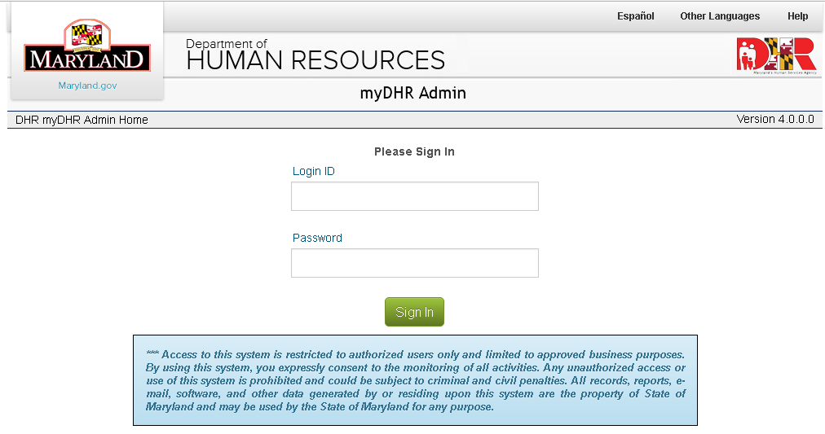

- Click on LMT in the left navigation bar.
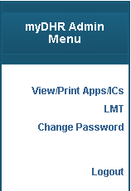

- The page will refresh, displaying the myDHR LTC Management Tool menu page. In order to enter the updated status for each pending application, click on the link for myDHR LTC Data Entry Tool.
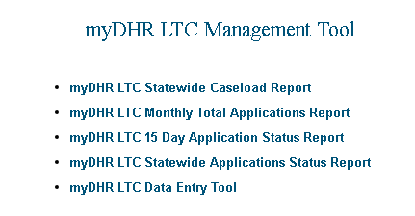

myDHR LTC Data Entry Tool

The Current 15 Day Status or Decision Status must be updated in the myDHR LMT by close of business on the 15th and last day of the month for all pending LTC Medical Assistance applications date stamped July 1, 2017 or later.
NOTE: The LMT must be updated on the business day prior to the 15th or last day of the month should the due date fall on a holiday, weekend, or other day the State is closed.

The list can be filtered by entering a single or combination of the fields listed From and To Date, Control ID, Customer Name, Supervisor, Case Manager, Data Stamp From and To Date. Click on the Search button after you have entered your filter criteria.
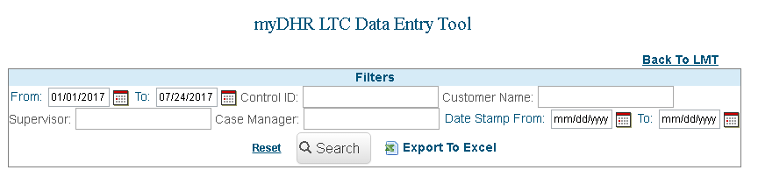

- Click on the in the Current 15-day Status column.

- Select the 15-day Status and 15-day Date from the drop down list in the pop up window. Click on the Save button.
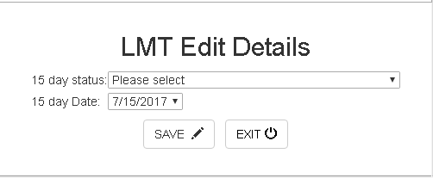

If any updates are needed for the case information, click on the edit ( ) icon in the Action column:

These are the case information fields that you can edit if needed:

- Type of Application – click on the selection that best describes the reason the application was submitted
- Facility – click on the name of the nursing facility the customer resides
- Supervisor Name – click on the name of the supervisor of the assigned case manager
- CM Assigned to Application – click on the name of the case manager that will render an eligibility decision
- Date Assigned to CM – enter the date the case manager was initially assigned
- Date of First of Month – select the first day of the month of the application month
- Delay Code – click on the delay code reason, if an eligibility decision is not rendered by the 27th day of the application month
- Date 1st 1052 was mailed – enter the date the 1st 1052 was mailed
- SSI Indicator – click on Yes or No to indicate if the customer receives SSI
- Good Faith & Reasonable Certainty (GF & RC) Indicator – click on Yes or No to indicate if GF & RC were factored into the eligibility decision
- Decision Type – click on Approved, Denied, or Transferred to indicate the final decision
- Denial Code – if applicable, click on the denial code that represents the reason the application was denied
- Date of Eligibility Decision – enter the date the eligibility decision was rendered
- Date of Extension – if applicable, enter the new application consideration end date if an extension has been granted beyond the 6 month initial consideration period
- 15 – day Increment App Status Date – click on the next 15 day increment month
- 15 – day Increment App Status – click on the 15th day increment month
Click on the Save button to update the customer’s record.
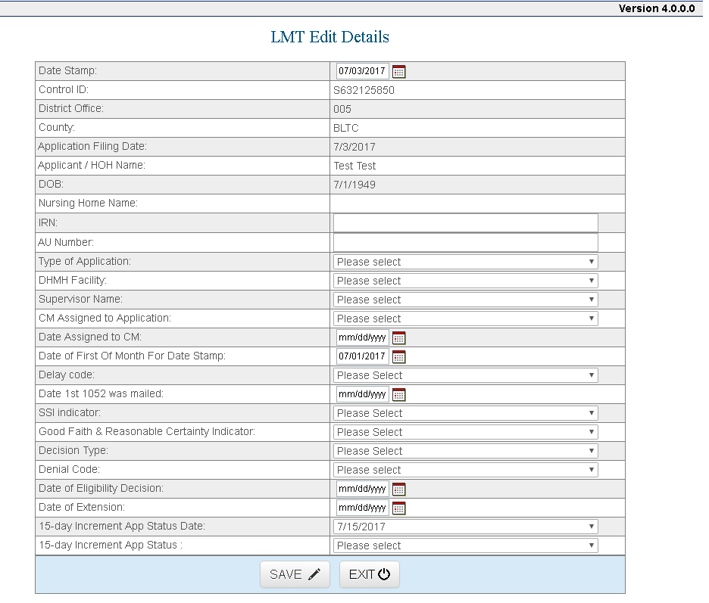

The LMT has several other reports of use to Long-Term Care staff. They are as follows:

myDHR LTC Statewide Caseload Report

Click on the myDHR LTC Statewide Caseload Report link to obtain a listing of customers with applications assigned to your agency within a specific timeframe.

- Enter a From Date and To Date in the text boxes then click on the View Report button.

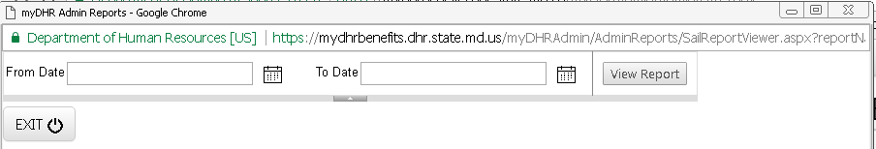

- A pop-up window with the report details will open.
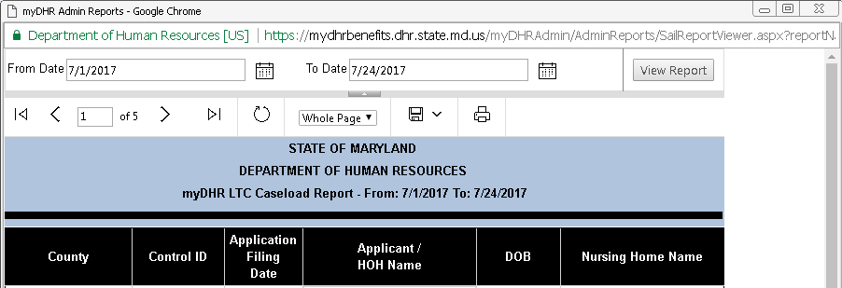

myDHR LTC Monthly Total Applications Report

Click on the myDHR LTC Monthly Total Applications Report link to obtain a listing of customers with applications assigned to your agency within a specific monthly timeframe.

- Enter a From Date and To Date in the text boxes then click on the View Report button.
- A pop-up window with the report details will open.

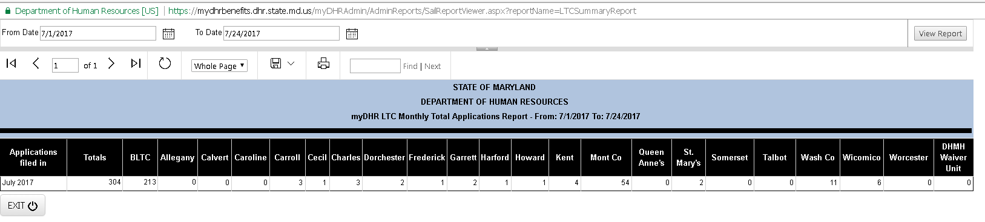

myDHR LTC 15 Day Application Status Report

Click on the myDHR LTC 15 Day Application Status Report link to obtain the 15th and last day of the month Application Status statistics for your agency.

- Select the application Month and Year of interest from the drop-down list then click on the View Report button.

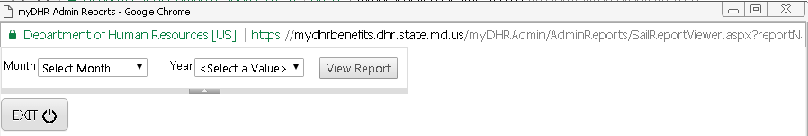

- A pop-up window with the report details will open.
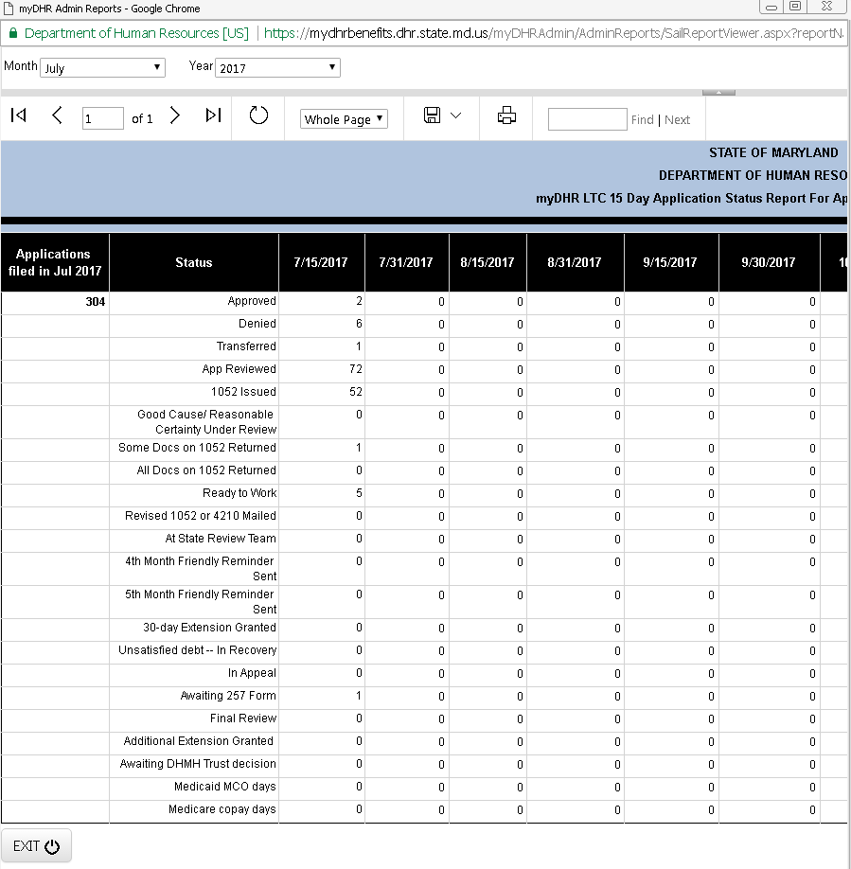

myDHR LTC Statewide Applications Status Report

Click on the myDHR LTC Statewide Application Status Report link to obtain application Status statistics for a specific month and year as of a specific date.

- Select the Application Filed Month, Application Filed Year and Application Type of interest from the drop-down list. Type the As of Date of interest then click on the View Report button.

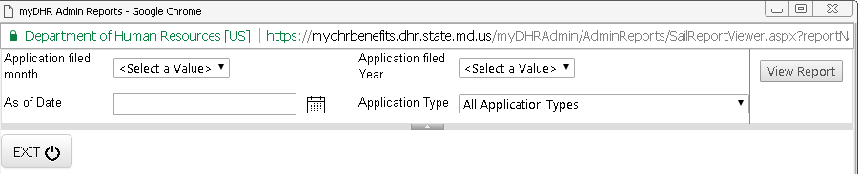
- A pop-up window with the report details will open.

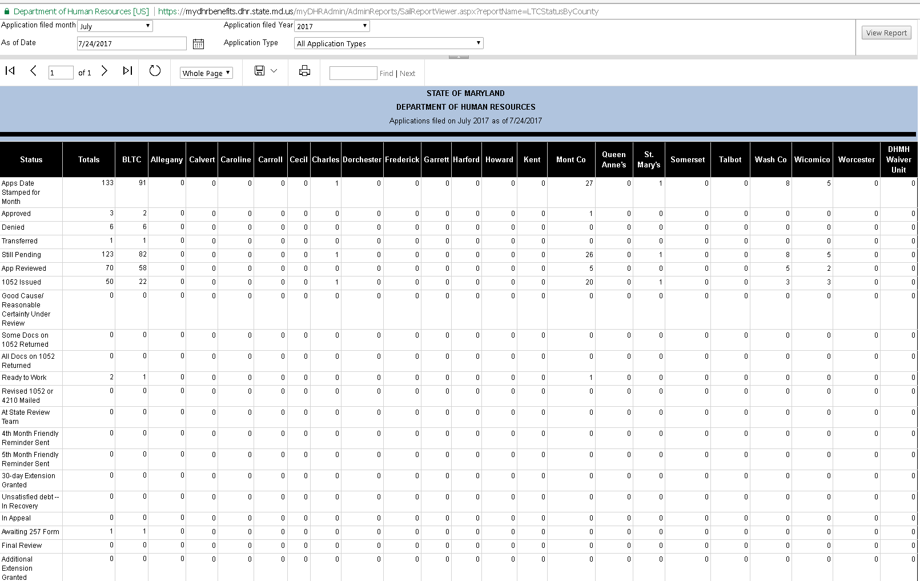

INQUIRIES

Please direct system questions to fia.policy@maryland.gov. Please direct policy questions to the Maryland Department of Health, Division of Eligibility Policy, at 410-767-1463 or 1-800-492-5231 (select option 2 and request extension 1463).

cc: DHS Executive Staff
FIA Management Staff
Constituent Services
Maryland Department of Health OES
Help Desk

