Department of Human Services  311 West Saratoga Street  Baltimore MD 21201 | Family Investment Administration  ACTION TRANSMITTAL
Control Number: # 18-01 | Effective Date: July 1, 2017
Control Number: # 18-01 | Issuance Date: July 26, 2017

TO: DIRECTORS, LOCAL DEPARTMENTS OF SOCIAL SERVICES;

DEPUTY/ASSISTANT DIRECTORS FOR FAMILY INVESTMENT
FAMILY INVESTMENT SUPERVISORS AND ELIGIBILITY STAFF;
ELIGIBILITY DETERMINATION DIVISION, OFFICE OF ELIGIBILITY SERVICES, MARYLAND DEPARTMENT OF HEALTH SUPERVISORS AND ELIGIBILITY STAFF


FROM: NICHOLETTE SMITH-BLIGEN, EXECUTIVE DIRECTOR, FIA, DEPARTMENT OF HUMAN SERVICES
DEBBIE RUPPERT, EXECUTIVE DIRECTOR, OES, MARYLAND DEPARTMENT OF HEALTH

RE: PROCESSING LONG-TERM CARE APPLICATIONS IN myDHR

PROGRAM AFFECTED: Long-Term Care Medical Assistance

ORIGINATING OFFICE: OFFICE OF OPERATIONS

SUMMARY:

Effective July 1, 2017, customers and their authorized representatives will be able to apply for Long-Term Care (LTC) through the myDHR customer portal. In addition, all LTC applications filed in paper, by fax or mail must be data-entered into myDHR and tracked and monitored in the myDHR Long-Term Care Management Tool. As of now, this Action Transmittal (AT) pertains only to the Department of Human Services (DHS). Eventually, the Maryland Department of Health’s Eligibility Determination Division will also use myDHR for LTC applications.

Important Note: This AT does not apply to Local Department of Social Services (LDSS) case managers in the following jurisdictions: Baltimore City, Baltimore County, Prince George’s County and Anne Arundel County. LTC applications received in these four jurisdictions are to be forwarded to the DHS Bureau of Long-Term Care (BLTC).

The steps and images outlined in this document may vary as system enhancements are implemented. You may contact fia.policy@maryland.gov if you have system questions.

ACTION REQUIRED:

BLTC and all LDSS offices, other than the four listed above in the “Important Note” section, must ensure that all LTC Medical Assistance applications that are filed online through myDHR be accepted, brought into CARES via the VMEN immediately, and processed accordingly in CARES.

For applications that are filed by paper (in person, by fax or by mail), staff must data-enter the applications into myDHR as soon as possible, but no later than the second business day after the paper application is date-stamped. All paper applications must be immediately scanned and uploaded to ECMS. Please follow the process as outlined on the instructions job aid below.

The administrative process for handling applications has not changed. Eligibility is determined in CARES.

A separate Action Transmittal will be issued regarding tracking applications through the myDHR Long-Term Care Management Tool. A separate Action Transmittal will also be issued for Maryland Department of Health’s Eligibility Determination Division for LTC cases.

The procedures below provide instructions for entering all paper applications into myDHR, whether entered the same day or after the date received.

NOTE: The date a paper application is received and date-stamped is the application date.

Entering a Paper Application into myDHR

Go to myDHR using this link:
https://mydhrbenefits.dhr.state.md.us
Click on Long Term Care Stand-Alone Application
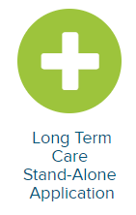

In pop-up window click on:

Answer the 7 guidance questions as indicated below for all LTC paper applications received regardless of the exact answer so that you can move past this section for purposes of registering the paper application in myDHR:

- Is the person applying for Long Term Care Medical Assistance currently in a nursing home?
YES
- How long is the nursing home resident expected to stay in the nursing home?
I DON’T KNOW
- Is the person applying for Long Term Care Medical Assistance receiving federal Medicare through the Social Security Administration?
I DON’T KNOW
- Does the person applying for Long Term Care Medical Assistance need help paying for the federal Medicare co-pays?
I DON’T KNOW
- Was the person applying for Long Term Care Medical Assistance residing in the hospital for at least 3 days immediately before transferring to the nursing home?
I DON’T KNOW
- Is the person applying for Long Term Care Medical Assistance now receiving rehab or skilled services in the nursing home?
I DON’T KNOW
- Does the nursing home resident currently receive Maryland Medicaid (Medical Assistance) or is the resident enrolled in a Maryland Medicaid Managed Care Organization (MCO)?
I DON’T KNOW

Click on


On the myDHR Registration Screen Click on



On the myDHR Account Registration screen:
- Enter applicant’s name in Your Name text boxes.
- Use applicant's first initial and last name as a User Name. (If an error message indicates that the user name is already taken, then use the first initial, middle initial and last name as the user name.)
- Use a simple reusable password as Password (it must contain at least one number).
Enter applicant’s Date of Birth.

 Click on

On the CBO Sign In screen, click NO. Then scroll down to the bottom of the screen to click NEXT.
Write on the paper application:
myDHR Control #

Continue to enter the information from the paper application in the correct sections on all screens. It is important that you enter ALL of the information provided on the paper application.

On the Additional Information screen enter:
LTC application entered by case manager’s initials and District Number. Application signed by the name of the person and relationship of the person that signed the application.

On the Application Summary screen:
- Review what you have entered.
- Beneath the map, click Yes to the question asking if you have reviewed the information.
- Click on the Rights & Responsibilities box.

On the Agreement screen, click the boxes to agree with all of the statements. On the next screen, fill in the information for the person that signed the application. This would be the applicant, spouse and or authorized rep information.

Click the box for I AGREE.

Then click on


On the Application Submitted screen, click on


Now that the application has been entered in myDHR you will enter information for tracking. Log into:

https://mydhrbenefits.dhr.state.md.us/myDHRAdmin/Admin/LMT.aspx

- Click on LMT in the left navigation bar
- Select myDHR LTC Data Entry Tool

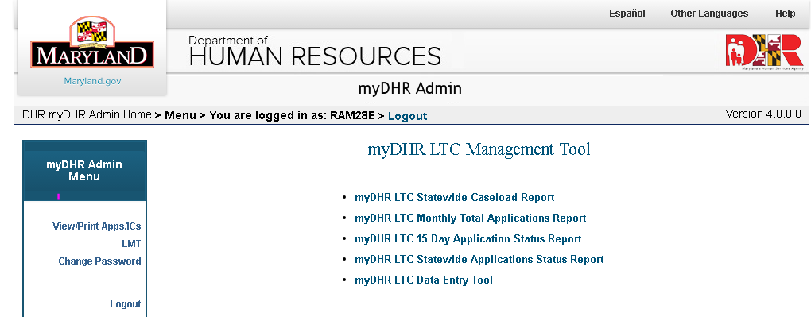

- Search the applications control number
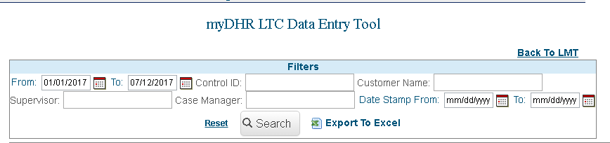

- Enter the Date Stamp date from the paper application. (This is the correct application date.)
- Click on the Save icon in the Action column

Pending the Application in CARES

- Log into CARES and go to the VMEN screen on the CARES Main Menu.

- Enter the control number of the application to be pended.

- Enter “j” next to the control number. This will bring the information entered in myDHR in to CARES.

- Continue the J-screening process as normal.

- At the Informed Choice INCH screen in CARES, verify that the application date is the same as the date stamped on the paper application. If the date stamped on the paper application differs from the date on the INCH screen in CARES, please change the App Date to the date stamped on the paper application.
INQUIRIES

Please direct system questions to fia.policy@maryland.gov. Please direct policy questions to the Maryland Department of Health, Division of Eligibility Policy at 410-767-1463 or 1-800-492-5231 (select option 2 and request extension 1463).

cc: DHS Executive Staff
FIA Management Staff
Constituent Services
Maryland Department of Health OES
Help Desk

