  Department of Human Resources  311 West Saratoga Street  Baltimore MD 21201 | Family Investment Administration  ACTION TRANSMITTAL
Control Number: 17-13 | Effective Date: Immediately
Control Number: 17-13 | Issuance Date: February 14, 2017

TO: DIRECTORS, LOCAL DEPARTMENTS OF SOCIAL SERVICES
DEPUTY/ASSISTANT DIRECTORS FOR FAMILY INVESTMENT
FAMILY INVESTMENT SUPERVISORS AND ELIGIBILITY STAFF
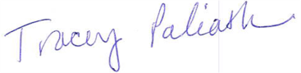
FROM: TRACEY C. PALIATH, EXECUTIVE DIRECTOR

RE: ENSURING CORRECT SYSTEM CODING FOR FOOD SUPPLEMENT PROGRAM WORK REQUIREMENTS

PROGRAM AFFECTED: FOOD SUPPLEMENT PROGRAM (FSP)

ORIGINATING OFFICE: OFFICE OF PROGRAMS

SUMMARY:

On January 1, 2016, the Food Supplement policy waiver on Able-Bodied Adults Without Dependents (ABAWD) ended and ABAWD policy was re-implemented nationwide. ABAWD policy states that in order to receive FSP benefits more than three months in a 36-month period, the customer must be working or participating in an approved activity for 20 or more hours per week. States may request an annual waiver for local jurisdictions that have a high unemployment rate or a labor surplus. In calendar year 2017, the ABAWD policy is waived in the following 13 jurisdictions: Allegany County, Baltimore City, Caroline County, Cecil County, Dorchester County, Garrett County, Harford County, Kent County, Queen Anne’s County, Somerset County, Talbot County, Wicomico County, and Worcester County.

Information on ABAWDs is tracked in CARES, WORKS and ABAWD Direct. While pertinent information coded in CARES is transmitted into WORKS and ABAWD Direct, there is no connectivity between WORKS and ABAWD Direct. Therefore, it is critical that required ABAWD data is coded into CARES to ensure the other two systems are updated appropriately. Proper coding of CARES, WORKS and ABAWD Direct screens for all individuals ensures that appropriate exemptions are allowed and that customers identified as ABAWDs are issued only 3 months of benefits if not complying with the work requirements. Proper coding also helps ensure that our state and federal reporting is accurate.

This Action Transmittal (AT) provides information and guidance for properly coding CARES and WORKS. Please note that while this AT addresses specifically work requirements for FSP, proper coding must be completed for Temporary Cash Assistance (TCA) cases also.

Remember that if the coding is not correct in the systems and verification is not scanned into ECMS, it is the same as if it doesn’t exist.

ACTION REQUIRED:

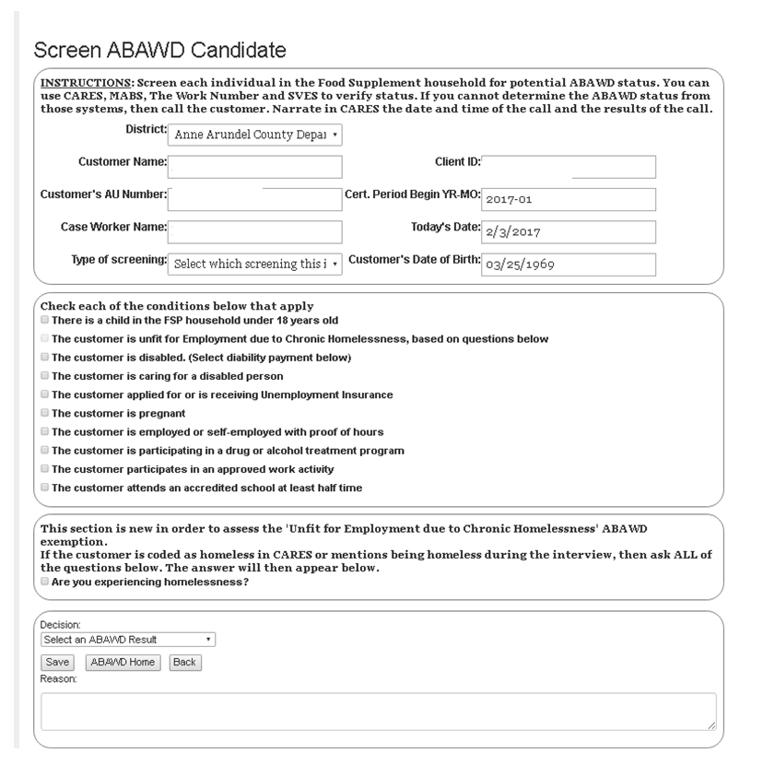
All applicants and recipients who are potential ABAWDs must be screened using the Screening Tool that is located within ABAWD Direct. The screening result must be saved as a .pdf file and uploaded to the Enterprise Content Management Solutions (ECMS).

After screening the customer, case managers must use the correct coding for all fields in CARES. Properly coding CARES screens for exemptions will read over to ABAWD Direct and result in less work in the next month’s status coding.

CARES SCREENS

ADDR

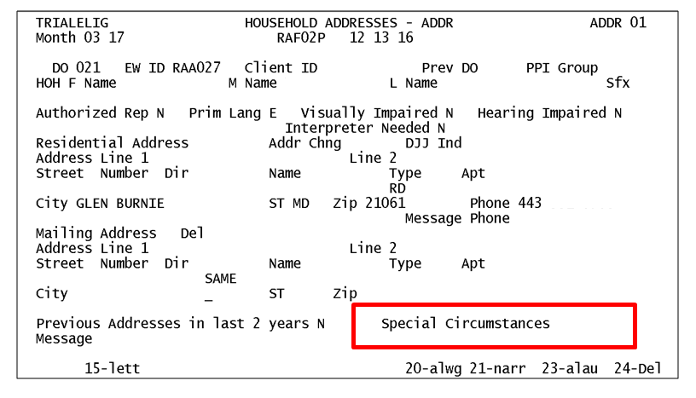
Make sure the customer’s name, address and all other information are entered to match the most recent communication from the customer and coded correctly for: Authorized Representative, Language, and the Interpreter Need. Code the Special Circumstance field. This field can hold up to three separate identifiers and there may be other codes in the field already. Make sure the codes are still accurate.

DEM1

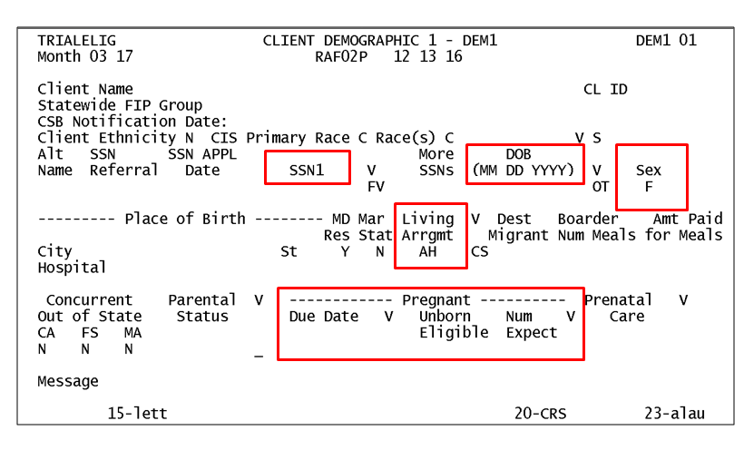
Code all fields on the DEM1 appropriately. To ensure the correct information feeds over to WORKS and ABAWD DIRECT, make sure the social security number, date of birth, sex, and living arrangement are entered correctly.

If the customer is pregnant, code the pregnancy fields because the customer is exempt from ABAWD policy

DEM2

Code the Citizenship, Student Status, and Striker fields. Code the disability fields if your customer is disabled or impaired. Code the DMVIOL if anyone is a victim of domestic violence

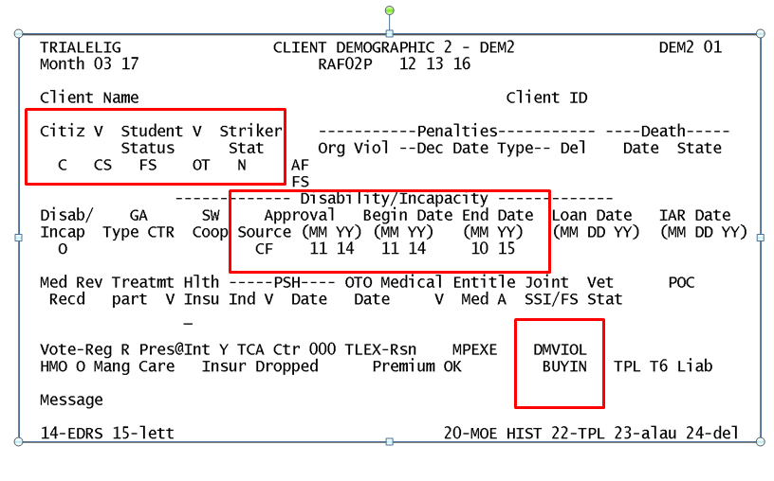

ELIG SCREEN
Code the SYSAB field next to the customer’s name in the following way:

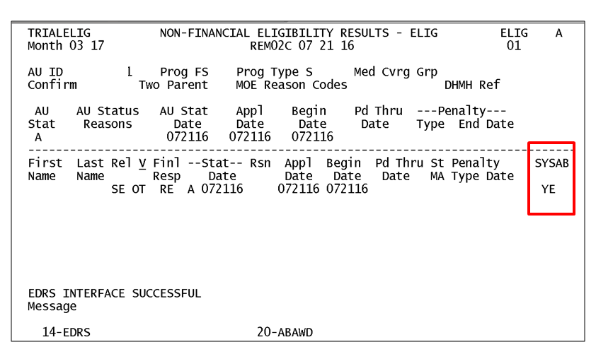

ABAWD MAINTENANCE

At application

During finalization of an application, the ABAWD MAINTENANCE screen appears following the ELIG screen when there is an ABAWD in the assistance unit.

The message BNFT CTR (benefit counter) MUST BE ENTERED WHEN ABAWD STATUS = YE OR OVERRIDE = CY appears on the ELIG screen.

Confirm the case and press ENTER for the ABAWD MAINTENANCE screen to display.

Active Case

On an active FSP case, the FSP AU is accessed via Option R on the AMEN screen.
Fast path to the CARES ELIG screen.

Press ENTER if the YE valid value displays in red in the SYSAB field, otherwise, press PF20.

The ABAWD MAINTENANCE screen will then display.

ABAWD Maintenance Screen

The ABAWD MAINTENANCE screen displays ABAWD identification requirements and ABAWD exemption criteria for each member of the Food Supplement assistance unit. The information displayed here comes from other CARES screens.

There is one screen per assistance unit. The field definitions for the ABAWD MAINTENANCE screen are as follows:

- The MONTH field indicates the benefit month for which information is displayed
- The First Name field indicates the first name of each AU member
- The Last Name field indicates the last name of each AU member
- The Rl Cd field indicates the relationship code of each AU member (comes from STAT screen)
- The Fn Rp field indicates the financial responsibility of each AU member (comes from the STAT screen)
- The ST field indicates the status (Active or Closed) of each AU member (STAT screen)
- The Age field displays the age of each AU member (comes from DEM1 of each customer)

Required Fields-Waiver/Exempt Fields

CARES populates a Y valid value in each field for which the individual meets the selected exemption criteria.

CA - Cash assistance recipient (Comes from STAT screen)
CH - The SE has a child under 18 years of age (comes from DEM1 and STAT)
DI - The individual is disabled (comes from DEM2)
SI - The individual is an applicant or recipient of SSI (Comes from UNIC unearned
income screen)
15 - 15% ABAWD waiver ***This field is not currently working in CARES; 15% exemptions are granted to customers ONLY with the permission of DHR Central***.
EM - ABAWD exemption given due to employment (ERN1 and ERN2) income screen
DA - ABAWD exemption given due to alcohol/drug treatment (DEM2)
ST - ABAWD exemption given due to full time or half time student status (DEM2)
PR – Pregnancy (DEM1)
UC - ABAWD exemption given due to receipt of unemployment compensation (UINC
screen)
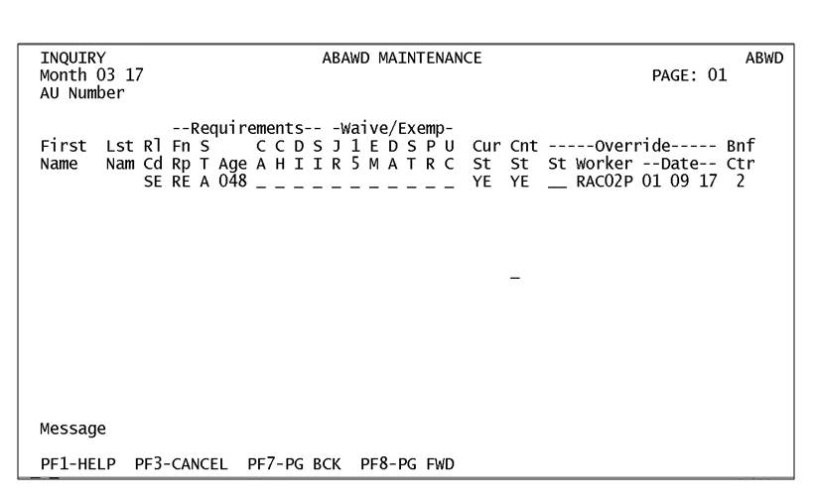

ABAWD Status Fields

Free months are the months the ABAWD can receive without meeting the requirements. This includes the first three months the ABAWD received (which do not have to be consecutive) and an additional three months the ABAWD can receive if he or she meets the requirements and then stops meeting them. Example: Customer receives three months of benefits then gets a job. After six months, the customer loses his job. Because he met requirements, when he lost his job he is eligible for three additional “free” months of benefits.

CARES will populate the YE valid value (individual is ABAWD and the benefit month is a “free” month), or the NO valid value (customer is not ABAWD and the benefit month is not a “free” month) in the fields listed below:

Cur St - Individual's current system generated ABAWD status.
Cnt St - Individual's status for the month “free” or not.

Override Fields

ST -Override status field.

The case manager enters the ST fields associated with the override fields to correct the status that CARES determined.
The valid values are as follows:

CN- Case manager changes from a “free” month to a Non-ABAWD status.
CY- Case manager changes from a Non-ABAWD status to a “free” month.

Worker - LOGON ID of the case manager overriding the ABAWD status. This field is automatically populated by CARES.

Date -The date the most recent action was taken to override or change the status.

Bnf Ctr -This field displays the number of "free” ABAWD months received to date. A number from 0 through 6 may be entered in this field. The number in this field is NOT automatic; it must be entered by the case manager.

NOTE: CARES does not automatically update the counter for the customer’s “free” months. There is no CARES case processing associated with the BNF CTR field. ABAWD tracking must be performed in the ABAWD Direct system.

Monthly Coding

For all active customers who are screened as Not Exempt, a monthly status code must be entered into ABAWD Direct. Refer to the ABAWD Direct Desk Guide for more instructions on the monthly coding.

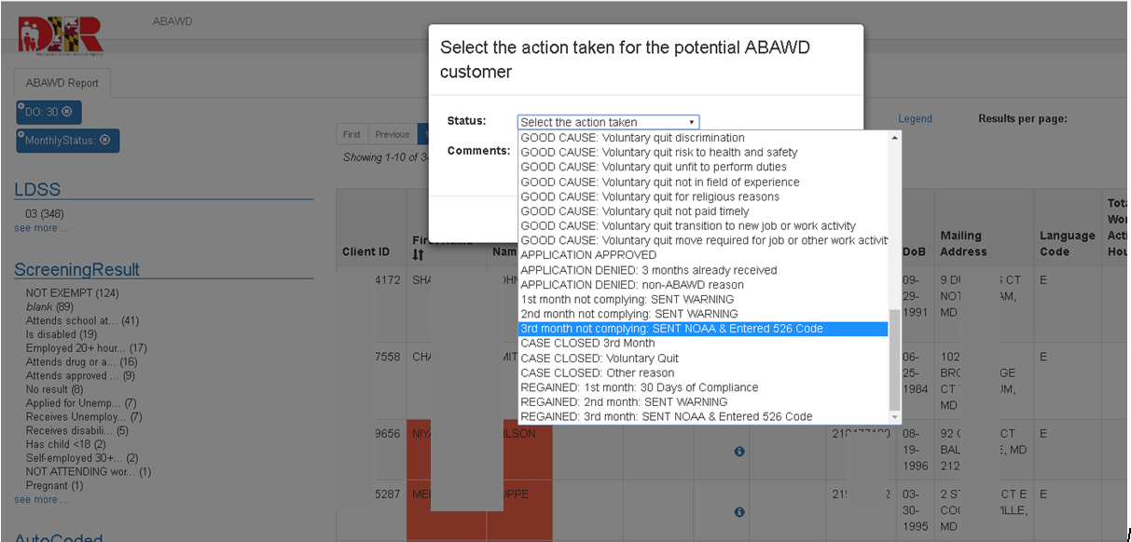

WORK Screen

ABAWD fields on the CARES WORK screen do not require data entry by the case manager. The ABAWD fields appear in the ABAWD information section of the WORK screen. The fields and their valid values are as follows:

Curr Stat – the current ABAWD status. YE indicates the individual is an ABAWD. NO indicates the individual is Non-ABAWD.

Countable Status - indicates whether or not the benefit month is a “free” month. YE displays when the full month is “free.” NO displays when the benefit month is not a “free” month. It will also display NO if the individual is Non-ABAWD for any day of the month or the benefit is prorated in any month.

Work – displays ABAWD work requirement information. The valid values are MP (mandatory), EX (exempt), and WA (waiver or blank if the Curr Stat field is NO).

Override - indicates whether or not the system determined ABAWD status was overridden by the case manager. This field will be blank if an override was not done. CY indicates that the system determined Non-ABAWD status was changed to ABAWD. CN indicates that the system determined ABAWD status was changed to a Non-ABAWD status.

Override Worker – displays the LOGON ID of the case manager entering the
override code or maintaining the benefit counter.

Bnft Ctr – displays the number of "free" ABAWD months.

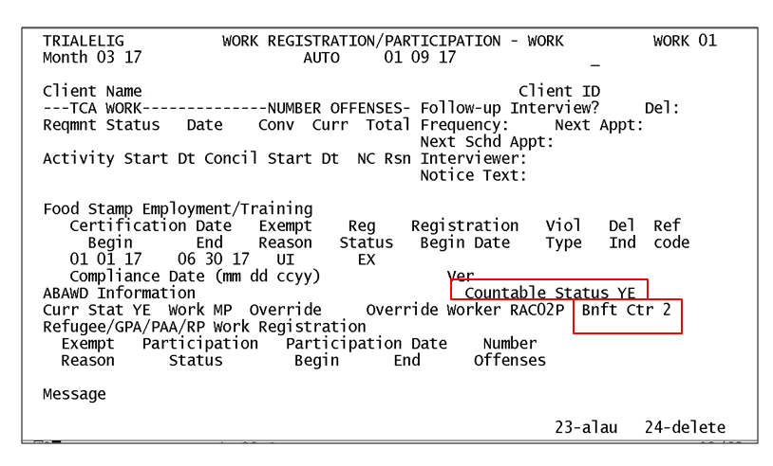
STAT Screen

CASE CLOSURES DUE TO RECEIPT OF THE MAXIMUM NUMBER OF “FREE” MONTHS:

Use CARES closure code 526, when closing either an assistance unit or an individual for receipt of the maximum number of benefits having been received, “DID NOT MEET ABAWD REQUIREMENTS” Notices must be generated from ABAWD Direct or the Word document templates in the PIRAMID folder. The CARES notice must be suppressed. For instructions on how to generate notices, consult the ABAWD Direct Desk Guide.

When an ineligible ABAWD is in a Food Supplement household with other eligible members the following action is required:

- Identify the ineligible ABAWD on the STAT screen by entering code 526 in the Rsn field to the right of the individual’s name (Client Level).
- Determine the prorated share of income off line and enter on the appropriate screen(s) for an eligible household member.
- Determine the assets of the ineligible ABAWD household member offline. Enter the full amount of assets on the appropriate screen(s) for an eligible household member.
- When the ineligible ABAWD is responsible for shelter costs, determine the prorated amount off line. Enter the prorated shelter costs on the SHEL 01 screen.
- Narrate all actions in CARES to explain how the ABAWD’s prorated income and expense amounts were calculated.
- Complete CARES processing as required.

Potential CARES ABAWD Error Message

- Error Message #2307 – OVERRIDE IND CANNOT BE THE SAME AS THE ABAWD STATUS.
  - This message appears on the ABAWD MAINTENANCE screen when the incorrect override valid value is entered.
  - For example, the system has determined an individual to have NO as ABAWD status.
The above error message will display if the case manager enters the CN valid value in the St field of the ABAWD MAINTENANCE screen

- Error Message #2308 – BNFT CTR MUST BE ENTERED WHEN ABAWD STATUS = YE OR OVERRIDE = CY.
  - This message indicates that a value from 0 through 6 must be entered in the Bnf Ctr field on the ABAWD MAINTENANCE screen.

- Error Message #2314 – OVERRIDE IND INVALID – THE CLIENT IS DISABLED OR OUT OF AGE RANGE.
  - This message appears when CY is entered in the St field of the ABAWD MAINTENANCE screen and the individual is disabled or does not meet ABAWD age requirements.

- Error Message #2315 – YOU ARE TURNING A SYSTEM GENERATED ABAWD CLIENT TO NO.
  - This message appears in yellow on the ABAWD MAINTENANCE screen when the CN valid value is entered in the St field and the system has determined an individual to be an ABAWD. Press the PF-4 key to bypass this message.

- Error message #2318 – ABAWD OVERRIDE CLEARED AT REDET, USE PF-20 TO MAINTAIN THE OVERRIDE.
  - This message appears on the ELIG screen when processing an FSP redetermination. The override is maintained by pressing the PF-20 key to access the Bnf Ctr field on the ABAWD MAINTENANCE screen.

- Error message #2334 – ABAWD OVERRIDES CLEARED FOR REDET.
  - This message appears on the ABAWD MAINTENANCE screen and informs the case manager that overrides have been cleared in processing the FSP redetermination.

- Error message #2336 – VERIFY WARNINGS, PRESS PF-4 TO ACCEPT. This message appears on the ABAWD MAINTENANCE screen when finalizing a reapplication.
  - This message prompts the case manager to check the Bnf Ctr field for accuracy.
  - Press the PF-4 key to bypass this message. After checking the Bnt Ctr.

- Error message #2337 – PRESS PF-7/PF-8 TO VERIFY WARNINGS ON OTHER PAGES.
  - This message appears when the size of the assistance unit requires more than one ABAWD MAINTENANCE screen for the assistance unit. This message also refers to checking the accuracy of the Bnf Ctr field on the ABAWD MAINTENANCE screen when finalizing an FSP reapplication on CARES.

- Error message #2339 – REVIEW CLIENT'S ABAWD COUNTER. PRESS PF4.
- This message appears during finalization of subsequent month for a pending Food Supplement case.

WORKS Application

ABAWD customers who are not exempt are required to participate in an appropriate work activity and to be added to the WORKS system. All Food Supplement Program cases coded appropriately in CARES read over to the WORKS and ABAWD Direct systems during the overnight batch process. There is no data exchange between WORKS and ABAWD Direct; therefore, it is critical that the required information be input into CARES so that each of the other systems are populated.

If an ABAWD customer is not working 20 or more hours per week, then he or she must be registered and participating in one or a combination of the following work activities for at least 80 hours per month (averaged 20 weekly) to continue to receive benefits after their initial three “free “months. Activities under Workforce Investment Act (WIOA) and the Trade Act are considered qualifying activities.

The appropriate verification of attendance in work-like activities must be scanned in and stored in the ECMS. The type of activity codes are similar to TCA, but there are additional FSP codes.

WEX Placements at public or private sector employers to target those who lack work experience or recent work experience. WEX hours are subject to Fair Labor Standards Act (FLSA) requirements. This can be a placement at for profit, non-profit or government sites.

WKF Workfare –a placement in the public non-profit sector that is targeted to those who lack work experience or recent work experience. WKF is subject Fair Labor Standard Act (FLSA) requirements.

- FLSA equals the Food Supplement Program benefit (FSP) monthly allotment divided by the highest of the Federal, State or local minimum wage. The result is the number of hours the customer is required to participate.

WEJ Unsubsidized employment the customer does not receive wages subsidized by a Federal, State or local government program.

BEV Vocation Training. In ABAWD counties only, this category also includes self-employment. Also job retention services are included this category.

IGS Job Search in which only 9 contacts per week or 39 hours per month can be countable. The customer must be participating in another activity to fulfill requirements.

GJS Group Job Search (Job Readiness)
Staff assisted job search and readiness training including case management, career and job skills assessment, workplace etiquette, resume and cover letter assistance, motivation and confidence building, job search and job placement assistance, financial literacy and other support activities. This component is offered in conjunction with other components.

WORKS SCREENS

Activities

Enter the customer’s work activity code on the WORKS Activities page
Ensure that the length of the activity coincides with the customer’s submitted documentation. For more details see WORKS User Manual Page 83 – 96.

All of the demographic information on this page feeds over from CARES.

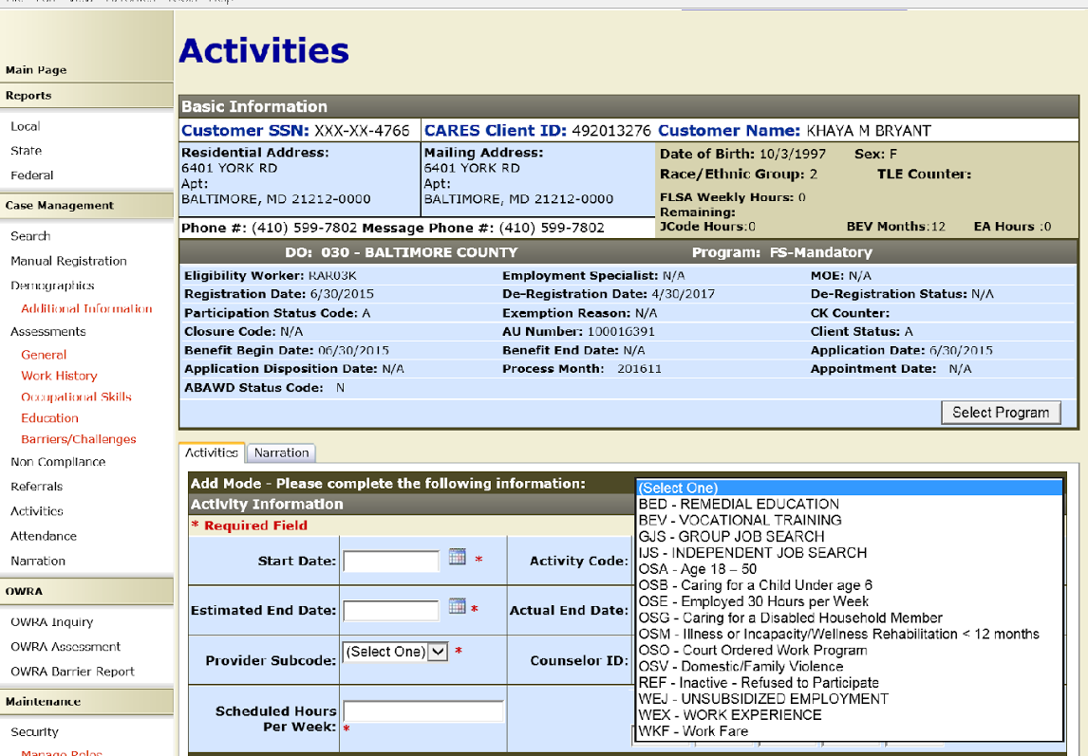

Attendance

Enter attendance for appropriate activities on a weekly basis to ensure compliance.
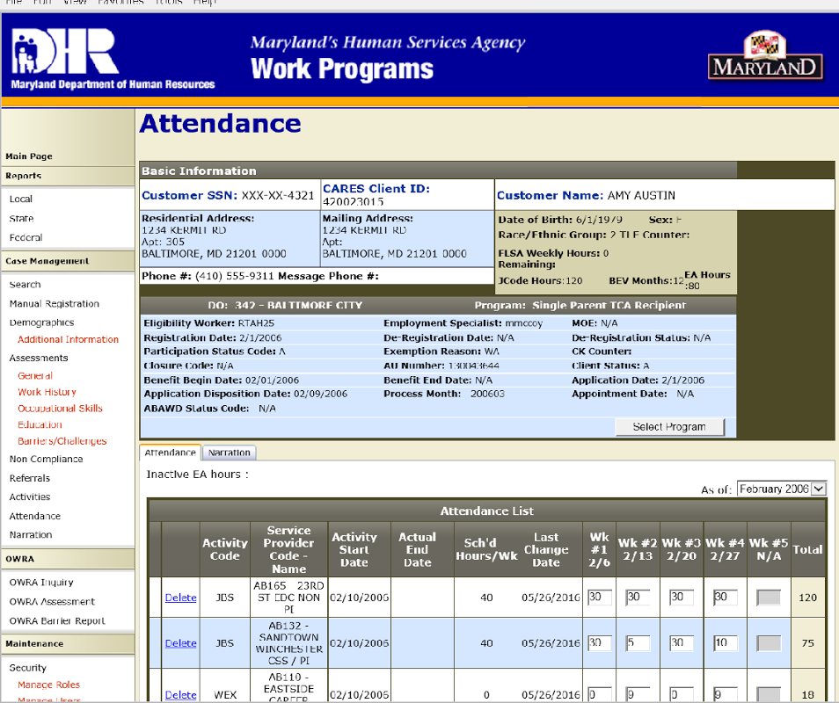

Use the WORKS SNAP/ABAWD Caseload Report to track cases with and without attendance in WORKS. (FYI: Screenshot below is from the training region.)

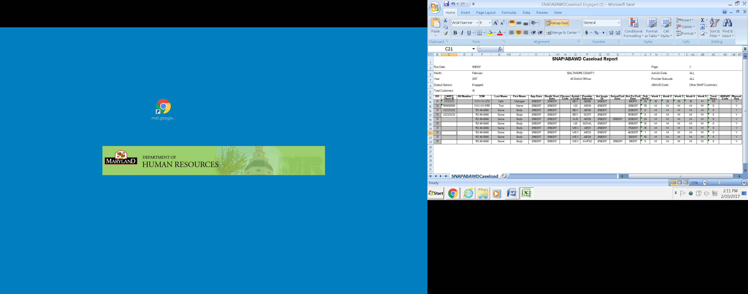

Payment Accuracy

Failing to properly code CARES and WORKS increases the potential for Quality Control (QC) errors, audit findings, and incorrect Federal and State reporting. It increases the potential for customers to be denied access to benefits they are otherwise eligible for or the potential for customers to receive benefits they are ineligible for.

Proper case coding is essential to good case management and customer service.
Accurate, concise and thorough narration of all actions taken helps anyone reviewing the case follow and validate the actions taken.

INQUIRIES:

Please direct policy questions to fia.policy@maryland.gov.
Please direct WORKS questions to Faith Freeman at 410 767-7696 or
faith.freeman @maryland.gov. Please direct CARES and ABAWD Direct systems questions to La Sherra Ayala at 410-238-1285 or Lasherra.ayala@maryland.gov

cc: DHR Executive Staff
FIA Management Staff
Constituent Services
DHR Help Desk

