 | Department of Human Resources  311 West Saratoga Street  Baltimore MD 21201 | Family Investment Administration  ACTION TRANSMITTAL
 | Control Number: 17-10 Revised | Effective Date: UPON RECEIPT
 | Control Number: 17-10 Revised | Issuance Date: November 30, 2016

TO: DIRECTORS, LOCAL DEPARTMENTS OF SOCIAL SERVICES DEPUTY/ASSISTANT DIRECTORS FOR FAMILY INVESTMENT FAMILY INVESTMENT SUPERVISORS AND ELIGIBILITY STAFF

FROM: TRACEY C. PALIATH, EXECUTIVE DIRECTOR

RE: ELDERLY SIMPLIFIED APPLICATION PROJECT (ESAP)

PROGRAMS AFFECTED: FOOD SUPPLEMENT PROGRAM ORIGINATING OFFICE: OFFICE OF PROGRAMS
Background

The previously issued Action Transmittal #17-10 contained some unclear information on ESAP and we have received numerous questions about the process. We are issuing this revised AT-17-10 with attachments to provide additional guidance to staff. AT 17-10 Revised and the attached information clarify that:

- The Rights and Responsibilities must be signed.
- The application has been revised slightly to require the customer’s signature at the end of the Rights and Responsibilities only.
- Customers cannot apply for the Maryland Supplemental Nutrition Assistance Program (MSNAP). That policy and procedure has not changed.
- Customers must return the Change Form at the end of the 12th month and the and 24th months or their FSP case should be closed with 10 days adverse action. DHR Central will send out the Change Form.
Included with 17-10 Revised is an Elderly Simplified Application Project (ESAP) toolkit
including questions and answers that Policy has received. We will post the toolkit on FIPNet and the Q&A on the Google Drive for easy access. As we receive additional information from our federal partners at the USDA, Food and Nutrition Service (FNS) we will provide updates.

Summary

In an effort to be responsive to the needs of local departments and the customers we serve, FIA requested and received approval from the Food and Nutrition Service (FNS) to implement a demonstration project allowing us to waive certain Food Supplement Program (FSP) rules for customers over age 60 who have no earned income.

Anyone with earned income is not eligible for the Elderly Simplified Application Project (ESAP). The primary goal of ESAP is to simplify the application and verification process for eligible seniors. Maryland is the sixth state to implement ESAP.

The project has several key advantages:

● Increased efficiency by using a DHR Central team to process applications filed via
myDHR.
● Increased use of electronic verification sources to improve both efficiency and
accuracy.
● Reduced verification requirements for customers.
● Elimination of the redetermination interview, saving case managers from scheduling and conducting interviews.
● Extended certification to 36 months for the customers’ convenience.

ESAP was implemented statewide effective Tuesday, November 1, 2016.

ACTION REQUIRED

Case manager actions:

A team of staff within FIA’s Bureau of Local Operations will process ESAP applications filed through myDHR. When a customer or a customer’s authorized representative comes to a local department to file an application, encourage them to use myDHR to apply for FSP. The logic within myDHR will automatically screen the customer for ESAP (at least 60 years old with no earned income), and automatically assign the application to district office (DO) 006, which is the FIA Central team.

If the customer opts to fill out a paper application, use the new ESAP application. Customers may also fill out the 9701 application. Using a paper application means that the case manager must process the application in the LDSS. If a customer applies for FSP and another FIA benefit program through myDHR, the application will be routed to the local department for handling.

Case managers should note that the ESAP application signature page is located at the end of the Rights and Responsibilities. Customers must sign the application.

For existing FSP customers, the local departments are responsible for converting customers to ESAP at the next redetermination. The same CARES procedures should be used for this. ESAP cases are maintained in the LDSS.

ESAP

1. Reduced verification requirements for customers. Case managers are responsible for obtaining verifications through computer matches and system clearances. The customer may verify required information that is questionable.

● ESAP-eligible customers are not required to verify unearned income, household size, residency, identity, and shelter expenses, unless questionable.

● Case managers should use computer matches to verify information. Case managers should use systems such as SOLQ, SDX, MABS and the WORK Number to verify income, identity, and social security number.

- Medical expenses must be verified to allow the customer the medical expense deduction.
- When medical expenses are not verified, request verification from the customer.

2. ESAP customers have an extended certification period of 36 months.

• An annual contact with ESAP households is required. The FIA Central team will send out the 12 and 24 month contacts. The contact form must be returned to the Central unit.

• Extending the certification period requires a CARES workaround described in the
CARES Procedures section of this action transmittal.

3. After the initial interview, ESAP customers are not required to be interviewed again.

● Once the customer has an initial interview (whenever possible, this should be a telephone interview), there is no requirement for an interview at redetermination or at the 12 or 24 month contact, unless the ESAP FSP case is being denied.

● No ESAP case can be denied without an attempt to schedule an interview with the customer.

4. If an ESAP customer requests a fair hearing, the hearing can be completed by telephone.

● The customer does not have to appear in person for the hearing.

Case managers must complete and mail approval notices to ESAP customers. The application approval notice and redetermination notice are the only ESAP notices. Existing CARES notices will be issued, if there is a denial, reduction in benefits or case closing.

CARES PROCEDURES

Case managers must code the Special Circumstances field on the CARES ADDR screen with an ‘ES’ for the Elderly Simplified Application Project. At this time that is the only designation in CARES that the case is an ESAP.

After an approved ESAP case is finalized, case managers should immediately extend the
certification period to 36 months or three years and suppress all CARES notices. For
cases that have an initial six-month certification period, the extension is done in CARES by initializing a Redet, completing the Redet, then completing an additional four Redets. The five Redets add 30 months to the certification period to create the 36-month certification.

For cases that have an initial 12-month certification period, such as FSP cases where the
client is an SSI recipient, only two additional Redets are needed, each adding a 12-month, or one-year extension.

A. For cases where the initial certification period starts at 6 months, follow these steps to create the 36-month extension:

1. After finalizing the case, immediately initiate a Redet by selecting option “N” (Initiate
Redet) from the AMEN screen.

2. On the REDE (Initiate Redetermination) screen, type ‘Y’ to the left of the AU
information and press Enter.

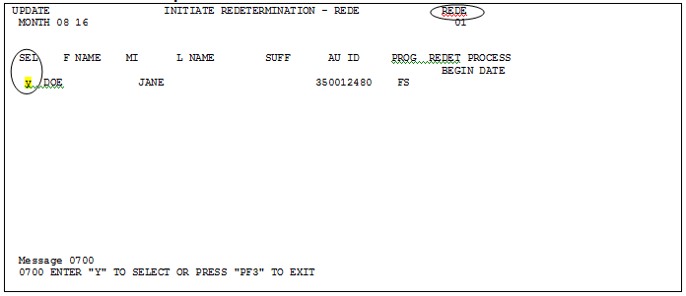

3. From the AMEN screen, select option ‘R’, ‘Interim/Hist Change’, to complete the
Redet.

4. Fast path to the MISC screen and enter a ‘Y’ in the ‘Redet Compl’ field, then press
Enter.

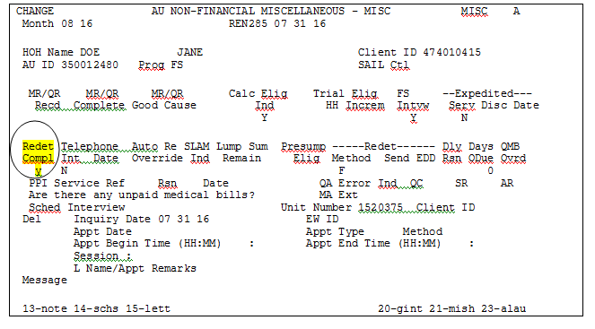

5. On the ELIG screen enter ‘Y’ in the ‘Confirm’ field, then press Enter.

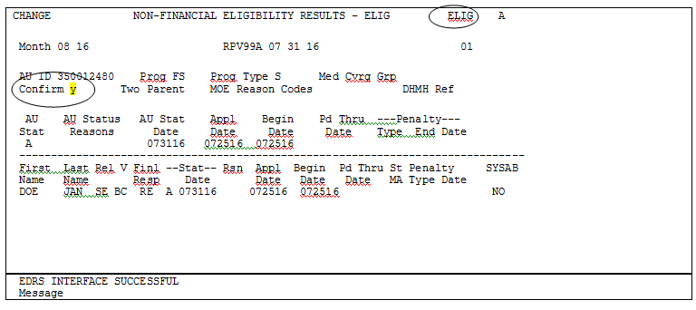

6. On the FSFI screen enter ‘Y’ in the ‘Bnft Confirm’ field and ‘Y’ in ‘Notice Override’
field, then press Enter. The ‘Redet End Date’ will now show an additional six months.The ‘Redet Begin Date’ will show the ongoing month as the redet is being done in the ongoing month.

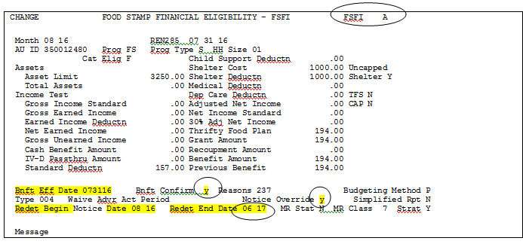

7. Repeat actions #3 to #6 four more times until the Redet End Date value indicates a
36-month certification. After the fifth and final ‘Interim/Hist Change’ process, the
FSFI screen will show the 36-month, 3-year, cert period.

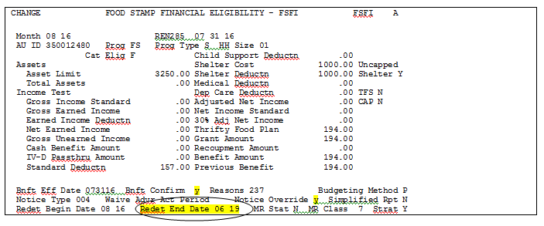

B. For cases where the initial certification period starts at 12 months, as is for FSP/SSI
customers, follow these steps to create the 36-month extension:

1. After finalizing the case, immediately initiate a Redet by selecting option “N” (Initiate
Redet) from the AMEN screen.

2. In the REDE (Initiate Redetermination) screen, type ‘Y’ to the left of the AU
information and press Enter.

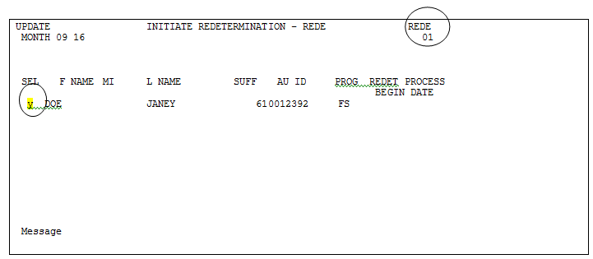

3. From the AMEN screen, select option ‘R’, ‘Interim/Hist Change’, to complete the
Redet.

4. Fast path to the MISC screen and enter a ‘Y’ in the ‘Redet Compl’ field, then press
Enter.

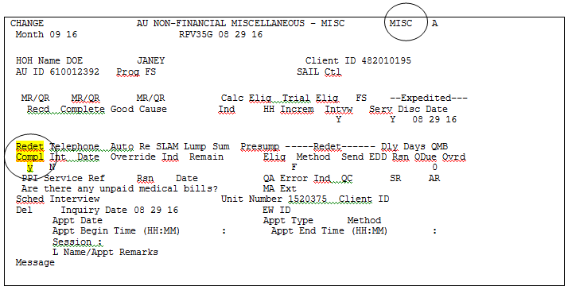

5. In the ELIG screen enter ‘Y’ in the ‘Confirm’ field, then press Enter.
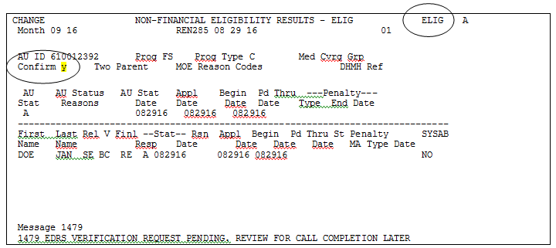

6. On the FSFI screen enter ‘Y’ in the ‘Bnft Confirm’ field and ‘Y’ in ‘Notice Override’ field, then press Enter. The ‘Redet End Date’ will now show an additional 12 months. Note, the ‘Redet Begin Date’ will show the ongoing month as the redet is being done in the ongoing month.

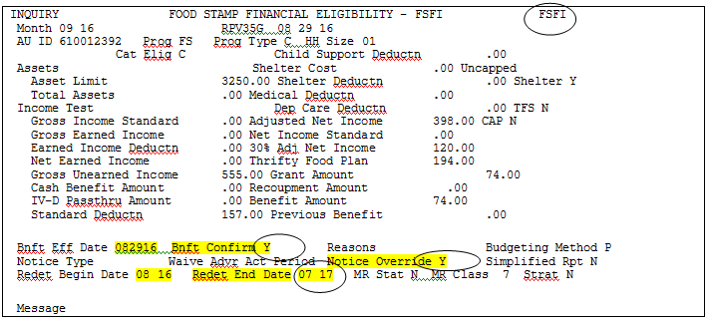

7. Repeat steps #3 to #6 one more time. After completing the second redet, the FSFI
screen will show the 36-month, 3-year, cert period.

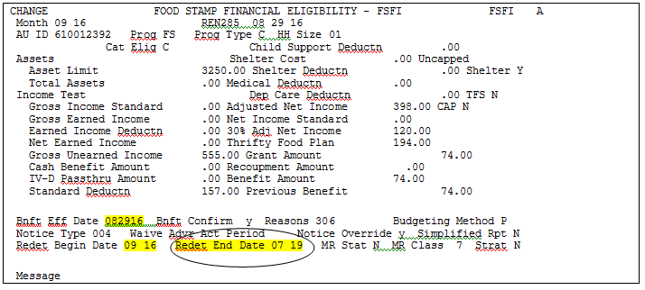

Attachments: ESAP Tool Kit
ESAP Application

INQUIRIES

For policy-related questions, please contact fia.policy@maryland.gov. For CARES-related questions, please contact Maryann Maher at 410-238-1363 or maryann.maher1@maryland.gov.

cc: DHR Executive Staff
FIA Management Staff
Constituent Services
Office of Administrative Hearings
Office of the Inspector General
DHR Help Desk

