  Department of Human Resources  311 West Saratoga Street  Baltimore MD 21201 | Family Investment Administration  ACTION TRANSMITTAL
Control Number: # 17-9 | Effective Date: October 1, 2016
Control Number: # 17-9 | Issuance Date: October 6, 2016

TO: DIRECTORS, LOCAL DEPARTMENTS OF SOCIAL SERVICES
DEPUTY/ASSISTANT DIRECTORS FOR FAMILY INVESTMENT
FAMILY INVESTMENT SUPERVISORS AND ELIGIBILITY STAFF
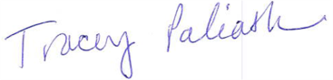
FROM: TRACEY C. PALIATH, EXECUTIVE DIRECTOR

RE: MODIFICATION IN CARES SELF EMPLOYMENT CALCULATION

PROGRAM AFFECTED: FOOD SUPPLEMENT PROGRAM (FSP)

ORIGINATING OFFICE: OFFICE OF POLICY, RESEARCH AND REPORTING

SUMMARY

Previously local departments of social services had to complete manual calculations outside of the CARES system to determine FSP self-employment income. CARES was not programmed to complete a 50 percent disregard of customer’s self-employment income when determining FSP benefits.

This AT provides information on changes to CARES’ programming effective October 1, 2016 for the 50% disregard for self-employment and replaces AT #16-17.

ACTION REQUIRED

Effective October 1, 2016 CARES will apply the deductions (50% and 20%) that self-employed customers are eligible for.

The customer also has the option of providing verification of actual income and deductions to determine self-employment income. The Department recommends the customer submit a minimum of three (3) months of income and deductions for this option. Refer to FSP Manual Section 104.83 for a list of allowable deductions.

CARES PROCEDURES

I. Enter the customer’s Employer Name and the date the Customer began employment with the employer. Enter “SE” in the Income Type Field.
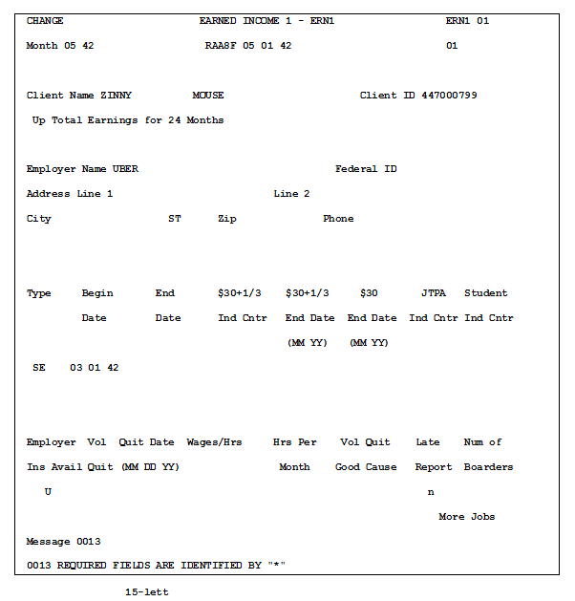

II. Enter the weekly amount the customer receives in Self Employment Income on the ERN2 Screen.
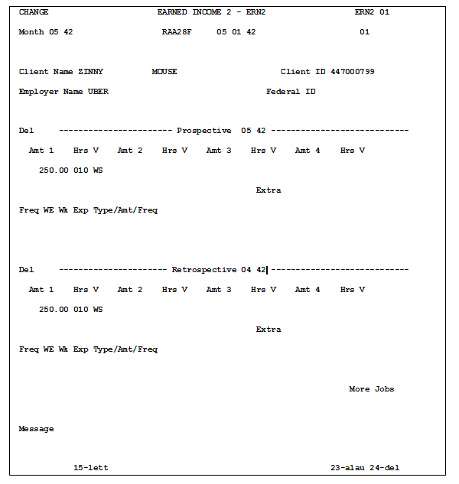

III. The FSFI Screen will reflect the 50% and 20% deductions for the household’s self employment income.

Example:
- $250.00 weekly = $1,000.00 monthly.
- 50% of $1,000.00 (gross self-employment income) = $500.00
- $1,000-$500 (self-employment deduction) =$500
- 20% of $500.00 = $100.00 (earned income deduction)
- $500.00 - $100.00 = $400.00
- $400.00 is reflected as the net income on the FSFI Screen.

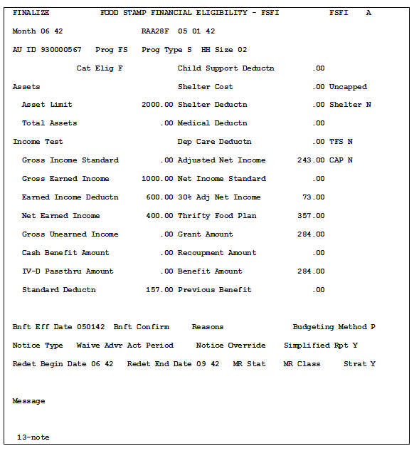

NOTE

For customers choosing to use actual income and expenses, remember that not all business expenses listed on a customer’s federal tax Schedule C are allowable deductions for FSP eligibility. Again, refer to the FSP Manual Section 104.83 to determine which deductions are allowed. Case Managers can use Schedule C, line 1, which is the gross self-employment income.

Attachments: Revised FIA FSP Manual Section 104

INQUIRIES

Please direct all policy questions to the FIA Policy unit at fia.policy@maryland.gov or telephone 410-767- 7953. Please direct CARES questions to La Sherra Ayala at 410-238-1285 or lasherra.ayala@maryland.gov.

DHR Executive Staff
Constituent Services
DHR Help Desk
FIA Management Staff
Office of Administrative Hearings
Office of the Inspector General

