  Department of Human Resources  311 W. Saratoga St.  Baltimore, MD. 21201-3521 | FIA ACTION TRANSMITTAL
Control Number: 16-18 | Effective: Upon Receipt  Issuance Date: June 10, 2016

TO: DIRECTORS, LOCAL DEPARTMENTS OF SOCIAL SERVICES
DEPUTY/ASSISTANT DIRECTORS FOR FAMILY INVESTMENT
FAMILY INVESTMENT SUPERVISORS AND CASE MANAGERS
FROM: ROSEMARY MALONE, EXECUTIVE DIRECTOR

RE: FOOD SUPPLEMENT PROGRAM (FSP) WORK REQUIREMENTS FOR CUSTOMERS WHO ARE HOMELESS

PROGRAM AFFECTED: FOOD SUPPLEMENT PROGRAM

ORIGINATING OFFICE: BUREAU OF POLICYAND RESEARCH

BACKGROUND

Federal policy allows an individual or family to receive a monthly deduction if they have shelter expenses but are without permanent housing. That deduction is based on self-declared expenses and has not changed. Federal policy also allows able-bodied adults without dependents (ABAWDs) to be exempt from work requirements if they are “chronically homeless.” This Action Transmittal provides guidance for that determination.

It is important to note that an individual can be an ABAWD, homeless, subject to the work requirements, and still receive the monthly shelter deduction. A customer is eligible for the shelter deduction when all members of the household are homeless, but do not receive free shelter. Refer to Action Transmittal 16-06 for more information.

A separate AT providing guidance on homelessness policy for the TCA program is forthcoming.

SUMMARY

Definition of Homeless

A household is considered chronically homeless if the individual or family does not have a fixed, regular and adequate nighttime residence. This could include living on the street, a temporary shelter or a different friend or relative’s house each night.

ABAWD - Unfit/Unable to Work due to Chronic Homelessness

If the applicant or recipient checks "homeless" on the application, or indicates homelessness in response to a verbal question, the customer is potentially “unfit for work” and may be exempt from ABAWD requirements. ABAWD policy does not include homelessness alone as an ABAWD exemption. We must, however, determine if the applicant/recipient’s homelessness contributes to his or her inability to work and renders the individual “unfit/unable to work”.

DHR has created a screening tool to determine if an individual is subject to the ABAWD policy or is exempt. The case manager should use this tool to determine whether the customer meets the “chronically homeless/unfit for work” criteria. The screening tool includes the following questions:

- Are you experiencing homelessness?
- Do you have reliable access to a telephone number or email address that a potential employer could use to contact you for an interview?
- Is there an address where we can send you mail and you have reliable access to receive it every day?
- Do you have daily access to a bathroom, shower/bathtub, soap, shampoo and other personal hygiene products?
- Do you have reliable access to affordable transportation?
- Do you have a reliable access to affordable laundry?

If the customer’s response is “no” to question one, the additional questions will not be asked, and the customer will be deemed not chronically homeless/unfit for work.

If the customer’s response is “yes” to question one, and he or she responds “no” to at least one question 2-6, the customer will be deemed chronically homeless/unfit for work.

CARES Procedures for FSP ABAWDS

If the customer is “chronically homeless,” code the Special Circumstances field with HO to indicate homeless and unable to work for FSP. The ADDR screen should indicate homeless, but indicate a valid mailing address, if the customer has one available.

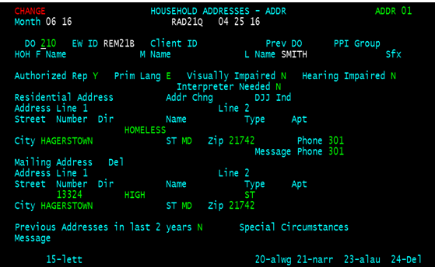
HO

The DEM1 screen should also indicate homeless HL in the Living Arrgmt field.

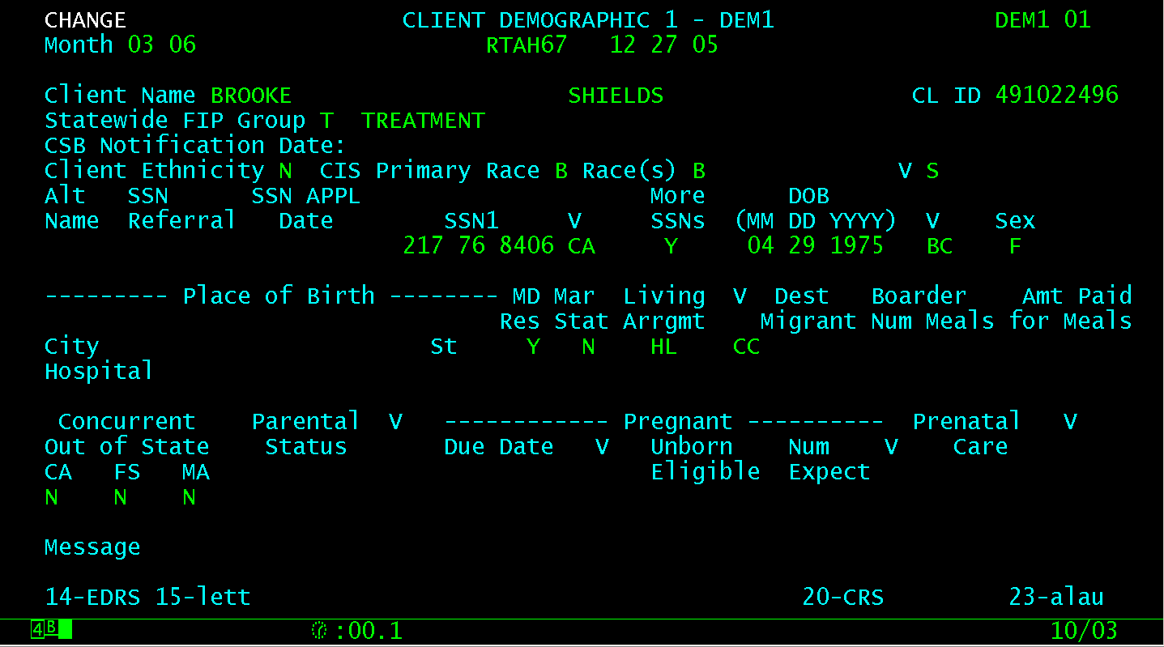

ACTION DUE: Upon receipt.

Note: For previously exempted customers that are listed on the June 2016 ABAWD Generators, who have now been determined not chronically homeless, the case manager needs to declare July 2016 the first month of ABAWD benefit receipt. These customers did not receive prior notification of the work requirement.

INQUIRIES: FSP ABAWD questions should be directed to Taneicsha (Dani) Whittaker at 410-767-5510 or Taneicsha.whittaker@maryland.gov.

