  Department of Human Resources  311 West Saratoga Street  Baltimore MD 21201 | FIA ACTION TRANSMITTAL
Control Number: 16-12 | Effective Date: January 1, 2016
Control Number: 16-12 | Issuance Date: January 29, 2016

TO: DIRECTORS, LOCAL DEPARTMENTS OF SOCIAL SERVICES
DEPUTY/ASSISTANT DIRECTORS FOR FAMILY INVESTMENT
FAMILY INVESTMENT SUPERVISOR AND ELIGIBILITY STAFF
FROM: ROSEMARY MALONE, EXECUTIVE DIRECTOR
FAMILY INVESTMENT ADMINISTRATION
STAFFORD CHIPUNGU, CHIEF FINANCIAL OFFICER
OFFICE OF BUDGET AND FINANCE

RE: CENTRALIZATION OF FISCAL ACTIVITIES FOR INTERIM ASSISTANCE REIMBURSEMENT PROCESSES

PROGRAMS AFFECTED: TEMPORARY CASH ASSISTANCE (TCA) (BEFORE OCTOBER 1st, 2015) AND TEMPORARY DISABILITY ASSISTANCE PROGRAM (TDAP)

ORIGINATING OFFICE: OFFICE OF BUDGET AND FINANCE

SUMMARY:

Applicants for the Temporary Disability Assistance Program (TDAP) must sign Interim Assistance Reimbursement (IAR) forms acknowledging that the State can recover from their lump-sum Supplemental Security Income (SSI) payment the cost of the benefits paid up to that date. Recipients of Temporary Cash Assistance (TCA) who applied before October 1, 2015 also signed the IAR form. In the past, local office Finance and Family Investment staff worked together to ensure the payments were recovered once the customer became eligible for SSI.

In order to improve the collection of the funds, the fiscal-related activities are being centralized at DHR. Fiscal activities performed by Fiscal Officers (or other fiscal personnel) in local Departments of Social Services (LDSS) are being transitioned to the IAR Fiscal Team at DHR on a rolling schedule beginning in February 2016 and ending in June 2016, as noted in Attachment A. Functional responsibilities assigned to LDSS case managers and supervisors will remain unchanged.

New processes are outlined in Attachments B and C. Increasing our reimbursements is the primary driver of the centralization of IAR fiscal functions. Centralization provides additional efficiencies in the fiscal tasks and improves monitoring.

BACKGROUND:

The State provides temporary benefits to eligible disabled customers through the TDAP program. The State is entitled to reimbursement for all TDAP payments, as well as for TCA funds paid prior to October 1, 2015. Reimbursement can occur only if a customer is approved for SSI.

When applying for TDAP, customers must:

- provide evidence of disability (FIA/500 form);
- meet financial eligibility requirements;
- apply for Social Security disability and Supplemental Security Income (SSI) benefits within 60 days of the TDAP application;
- sign and date an Interim Assistance Reimbursement Authorization Form (DHR 340), allowing the Social Security Administration (SSA) to directly reimburse the State for assistance benefits paid to the customer (by deducting the amount equal to the TDAP payments from the individual’s initial “lump sum” payout of SSI); and,
- in the event of a claim denial by Social Security, the customer must file an appeal with SSA within 60 days of the denial in order to continue to receive TDAP benefits.

To ensure the State can obtain full reimbursement, it is important to remember the following:
- A customer must be approved for SSI in order for the State to be reimbursed.
- Closing the TDAP case or removing the individual from the TCA case timely is critical. Benefits paid after the approval of federal benefits cannot be recovered and create an Agency-caused overpayment for the customer.
- The date the customer signed the IAR Form 340 must be entered into CARES on the DEM2 screen in the “IAR Date” field.
  - The customer and the case manager must both sign and date the 340 form or it is not a valid form.
- Do NOT have the customer sign another 340 form at redetermination or if the TDAP case closes and then is re-opened later. The original 340 form is the one we need to match for future reimbursement.
  - A new 340 form is needed only if the SSI application/claim is denied and the customer does not appeal or the appeal is denied. A new signed and dated 340 form is to be obtained when the customer makes a new application for TDAP and SSI benefits.
- The signed and dated IAR Form 340 must be scanned into ECMS (Fiscal folder) so that the centralized unit can locate the form. Ensure the form is scanned properly so that it is legible.

ACTION REQUIRED:
Each local office must identify a primary and back-up IAR Coordinator within the Family Investment staff and enter the contact information in the LDSS Points of Contact Google sheet. The IAR Coordinator is responsible for receiving and distributing communications and requests from the IAR Fiscal Team.

I. FIA Case Managers / Supervisors' role:
- FIA processes related to TDAP, 340 forms will not change.
- CRITICAL: Ensure the 340 is signed/dated properly by the case manager and the customer.
- Do not approve TDAP without confirming a proper 340 is in ECMS
- Ensure scanning of all 340's into ECMS (Fiscal folder).
- NEVER change an existing IAR date in CARES without consulting the IAR Fiscal Team.
- Complete annual redeterminations on TDAP cases.
- Close TDAP case cases timely (with 10 days adverse action) when SSI claims are denied and the customer has not appealed.
- Only adequate adverse (as long as the customer receives the notice before the TDAP benefit would be received) notice is required when the SSI has been approved and the customer has received payment.
- Review the TCA case and determine if the customer can be referred to a work activity and make the appropriate referral.

II. Local Department of Social Services’ Fiscal Officers' role
- Assist IAR Team with their questions.
- Provide 340's to IAR Fiscal Team as requested.
- Send any IAR funds received from SSA to CARES Fiscal (DHR), including Client ID, name, date received, amount, etc.
III. LDSS FIA Assistant Directors' role:
- Assign IAR coordinator to receive / distribute IAR Team emails
- Ensure timely response to IAR Fiscal Team requests
- Educate staff on IAR processes and monitor compliance
INQUIRIES:
For information or questions about the centralized IAR Fiscal Team, please contact Zina Hamlet at zina.hamlet@maryland.gov.

For questions about TDAP or TCA policy or the Family Investment staff’s role, please contact Michelle Green at mgreen@maryland.gov or 410-767-7944.

ATTACHMENTS:
A – Proposed Roll-out Schedule
B – Process Map for Denied SSI Claim
C – Process Map for Approved SSI Claim

Attachment A
Proposed Rollout Schedule for Centralizing Fiscal Activities for IAR

 | Location | Region | Roll-Out Date
1 | Baltimore City | Central | 2/15/2016
2 | Allegany Co | Western | 3/1/2016
3 | Carroll Co | Western | 3/1/2016
4 | Frederick Co | Western | 3/1/2016
5 | Garrett Co | Western | 3/1/2016
6 | Washington Co | Western | 4/1/2016
7 | Anne Arundel Co | Southern | 4/1/2016
8 | Calvert Co | Southern | 4/1/2016
9 | Charles Co | Southern | 4/1/2016
10 | Prince George's Co | Southern | 4/1/2016
11 | St. Mary's Co | Southern | 4/1/2016
12 | Baltimore Co | Central | 5/1/2016
13 | Howard Co | Central | 5/1/2016
14 | Montgomery Co | Central | 5/1/2016
15 | Harford Co | Central | 5/1/2016
16 | Caroline Co | Eastern | 6/1/2016
17 | Cecil Co | Eastern | 6/1/2016
18 | Dorchester Co | Eastern | 6/1/2016
19 | Kent Co | Eastern | 6/1/2016
20 | Queen Anne's Co | Eastern | 6/1/2016
21 | Somerset Co | Eastern | 6/1/2016
22 | Talbot Co | Eastern | 6/1/2016
23 | Wicomico Co | Eastern | 6/1/2016
24 | Worcester Co | Eastern | 6/1/2016

Attachment B
IAR REIMBURSEMENT PROCESS FOR A CUSTOMER WHO IS DENIED SUPPLEMENTAL SECURITY INCOME (SSI)
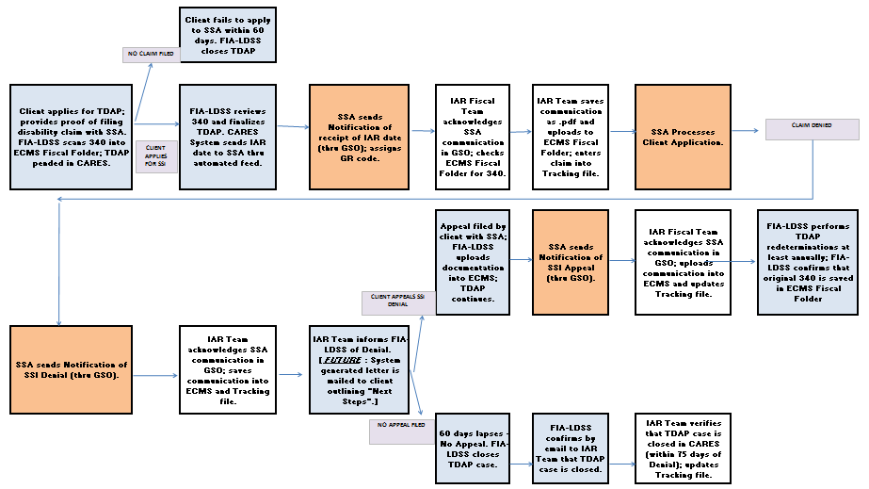

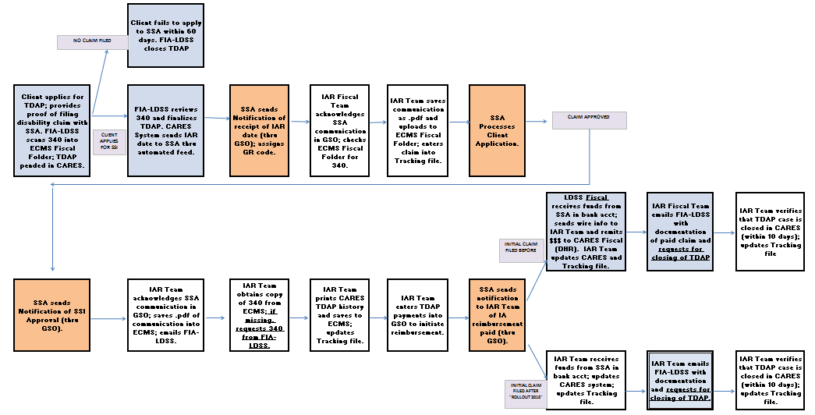
Attachment C
IAR REIMBURSEMENT PROCESS FOR A CUSTOMER WHO IS APPROVED FOR FEDERAL DISABILITY

