  Department of Human Resources  311 West Saratoga Street  Baltimore MD 21201 | FIA ACTION TRANSMITTAL
Control Number: 16-11 | Effective Date: January 1, 2016
Control Number: 16-11 | Issuance Date: December 31, 2015

TO: DIRECTORS, LOCAL DEPARTMENTS OF SOCIAL SERVICES

DEPUTY/ASSISTANT DIRECTORS FOR FAMILY INVESTMENT

FAMILY INVESTMENT SUPERVISORS AND CASE MANAGERS
FROM: ROSEMARY MALONE, EXECUTIVE DIRECTOR, FIA

RE: ABLE-BODIED ADULTS WITHOUT DEPENDENTS (ABAWDS)

PROGRAM AFFECTED: FOOD SUPPLEMENT PROGRAM

ORIGINATING OFFICE: OFFICE OF PROGRAMS AND OFFICE OF OPERATIONS

SUMMARY:

On January 1, 2016, work requirements begin for some of our Food Supplement Program recipients who are considered to be able-bodied adults without dependents (ABAWDs). Able-bodied adults without dependents are individuals between the ages of 18 and 50 who must meet work requirements in order to be eligible for FSP benefits. These individuals can receive FSP benefits for only three months (consecutive or otherwise) in a 36-month period unless they comply with the work requirements. Screening is critical to identify customers who are exempt from ABAWD rules due to age, pregnancy and conditions that render them unfit for work. We provide more details about the policy, CARES functionality and monitoring instructions later in this Action Transmittal (AT).

Maryland obtained approval from the federal Food and Nutrition Service (FNS) to waive implementation of the changes for 12 months in some Local Departments of Social Services. For the 12-month period beginning January 1, 2016, through December 31, 2016, ABAWD policy will be implemented for customers who live in the following six counties only: Anne Arundel, Baltimore County, Carroll, Howard, Montgomery and Prince George’s Counties. The waivers for 12 other LDSS are based on the unemployment rate, employment-to-population ratio or labor surplus conditions. Our waivers are subject to federal review and renewal each year.

In addition to the waivers, Maryland is also able to exempt Kent, Talbot, St. Mary’s, Calvert, Charles, Frederick and Washington Counties through a category of exemption called “the 15% exemptions.” FIA Central will track the 15% exemptions each month to ensure we do not exceed the “allowable” number of ABAWDs who are not working, or participating in work activity, volunteer activity or enrolled in school at least half-time.

In December 2015, DHR sent a flyer to all of the Active FSP customers who have not already been screened out of ABAWD policy, advising them of the changes and what they need to do. A list of those customers who were mailed the flyer will be provided to the six local departments in early January 2016. A copy of the flyer will be provided to use as a handout for FSP applicants and recipients who walk into the offices.

This AT provides policy and procedures for implementing the changes. It is divided into three sections, Policy, CARES and Monitoring. The local departments that need to implement the ABAWD policy will track and manage their customers’ status in an ABAWD GENERATOR file that will be placed in their offices’ PIRAMID/ABAWD folders in early January 2016. Use of the ABAWD GENERATOR is mandatory because CARES functionality is limited, and the notices must be generated manually, not through CARES.

POLICY:

Screening

Individuals identified as ABAWDs are eligible to receive only 3 months of FSP benefits in a 36-month period unless they meet certain work requirements. Screening can identify reasons why an individual is exempt from the ABAWD rules. A CARES query each month will identify FSP ABAWD applicants and recipients. Before January 2016, many of the potential ABAWD customers were already screened; the remaining active recipients will be screened in January.

Screening is critical to the successful implementation of this policy. If FSP benefits are not paid to a customer who is eligible or are paid to a customer who is ineligible due to ABAWD rules, that payment error will count in our Quality Control payment error rate. Identifying customers who are not subject to ABAWD requirements also can help local departments reduce the number of customers who must be tracked every week and monitored for compliance with FSP work requirements.

ABAWD counties must use an automated screening tool to screen each individual identified as a potential ABAWD. When the screening is completed and the result appears, save the file in a .pdf format and upload it into ECMS. Both Quality Control and the Food and Nutrition Service (FNS) will examine the screening file when they complete case reviews or audits.

The screening tool (see Appendix) is available in the PIRAMID/ABAWD folders for the six LDSS that are subject to the ABAWD policy in 2016. A paper copy is available for DHR’s FSP outreach partners and other community partners, who assist us with screening when they complete an application for a customer requesting FSP benefits. Our community partners see customers in different situations and often know more details about their circumstances.

On the screening tool, it is important that staff answer every question for the existing FSP recipients and new applicants based on a thorough review of our systems (CARES, ECMS, MABS, SVES and The Work Number). If the questions cannot be answered using those systems, then the case manager must contact the customer. A telephone interview is the preferred way to contact customers; if an in-office appointment is needed, use the Appointment Letter in the ABAWD GENERATOR.

If the answer to any question is YES, the screening tool will return a result indicating that the customer is “Not an ABAWD.” Regardless of the result, save the file as a .pdf and upload it to ECMS. There is no need to print the result. More information about how to use the screening tool appears at the end of this AT.

Code CARES correctly with the information from the screening tool. Narrate very clearly and thoroughly that the customer was screened, the date of the screening and the result of the screening. More information about CARES screens is included later in this AT. The screening date and result also must be entered in the ABAWD GENERATOR V file. More information about the ABAWD GENERATOR V appears later in this AT.

Certification period

CARES automatically assigns a 6-month certification; however, for ABAWD customers, the case manager must shorten it to a 4-month certification period. This is because by federal law, ABAWDs are eligible for only 3 months of benefits within a fixed 36-month period (January 1, 2016 - December 31, 2018) unless they meet work requirements.

- Shorten the certification period in CARES to ensure only three months of benefits are issued if the customer is not exempt from ABAWD rules.
- Do not count a pro-rated benefit month as one of the 3 in the 36 months.
- At the end of the certification period, the customer must complete a new application and reapply, even if they are meeting the work requirements.
- To be eligible for a new certification period, the ABAWD customer must continue to meet the work requirements or becomes exempt from ABAWD requirements.

Meeting the Work Requirement

Meeting the work requirement means:

- Working at least 80 hours per month, averaged to 20 hours per week.
- If self-employed, working at least 120 hours per month, averaged to 30 hours per week.
- Participating in and complying with a Workforce Investment Act program, Trade Adjustment Assistance Act program, or Employment and Training program (other than job search or job search training program) for 20 hours per week.
- Participating in a work experience program governed by the Fair Labor Standards Act (FLSA) requirements.
- Participating in a Workfare program.
- Volunteering at a non-profit organization for a minimum of 20 hours per week.
- Any combination of the above for a total of 20 hours per week.

Counting the three “free” months

Food Supplement Program policy allows the first three months of FSP benefits an ABAWD receives to be “free” of the work requirement. The customer does not have to work or participate in a work activity in order to receive FSP benefits if otherwise eligible. After those three months, the ABAWD must meet work requirements in addition to eligibility requirements in order to continue to receive FSP benefits. Since ABAWDs are eligible for only three “free” months of benefits during the fixed 36-month period (from January 1, 2016 – December 31, 2018), we must identify those months very carefully. Here are the rules:

- Free months are months during which an ABAWD receives Food Supplement benefits for a full benefit month without meeting the work requirement.
- A prorated month does not count as one of the three free months of eligibility.
- A free month can occur at any time during the fixed 36-month period, that is, the free months do not need to be consecutive.
- If a customer is ineligible to receive FSP due to ABAWD rules, even Expedited FSP is denied.

Example: Mr. C applies for Food Supplement benefits on July 6, 2016 and is screened as an ABAWD who does not work and is not participating in a work activity. The case manager approves his application on July 10, suppresses the CARES approval notice and mails him the special ABAWD Approval notice, located in the office’s PIRAMID/ABAWD folder. The case manager assigns also him a three-month certification period through October 31, 2016. (July does not count as one of the three free months because it is a prorated month.) His case manager informs him about the work requirements and refers him to an activity. He meets the work requirement in August but then does not comply in September. September is counted as his first “free” month.

Regaining Eligibility

When a customer has already received his or her “free” three months of benefits, close the case, using the Closing Letter in the ABAWD GENERATOR. The letter explains how the customer can re-apply to regain eligibility. The customer must work or participate in a work activity or volunteer for a non-profit for an average of 20 hours per week (or 30 hours if self-employed, at the federal minimum wage) for a minimum of 80 hours per month (or 120 hours per month if self-employed) before regaining eligibility. As long as the customer continues to meet the requirements, the customer is eligible for continued FSP benefits.

If the customer stops meeting the work requirements again, he or she is eligible for only three months of benefits, beginning the next month.

Example: Ms. Forrester received her first three “free” months of benefits in January 2016, and then in April 2016, and May 2016. Her FSP case closed on May 31st because she was not meeting FSP work requirements. In July, Ms. Forrester reapplied for FSP benefits. She verified that she worked 40 hours per week in June and is still employed. Ms. Forrester is eligible for FSP benefits. In August, Ms. Forrester is laid off of work and is not eligible for Unemployment Insurance. She is eligible for her second three “free” months of benefits in September 2016, October 2016 and November 2016. She must meet ABAWD work requirements to continue to receive benefits after that time. If she finds a new job and meets the work requirements, those months would not count as “free” ones.

Customers must comply with work requirements before receiving any FSP benefits after receiving the initial “free” three months.

Reporting Changes

ABAWDs are subject to simplified reporting with the exception of reporting when their work hours drop below 20 hours per week. The other requirement is that ABAWDs verify their weekly activity hours.

Good Cause

There are temporary good cause reasons for failing to fulfill work requirements. The individual must have been participating a minimum of 20 hours per week and expect to continue participating except the good cause situation occurred. If a recipient would have participated or worked an average of 20 hours per week, but missed some time for good cause, consider the individual to have met the work requirement if the absence is temporary and the individual keeps the job or continues in the work activity. Case managers must narrate in CARES very thoroughly why good cause was granted. The good cause reason must also be recorded for any month it is relevant in the ABAWD GENERATOR file. Verification is required only if the situation is questionable.

Good cause includes circumstances beyond the customer's control such as, but not limited to:
- Illness,
- Illness of another household member requiring the presence of the member,
- A household emergency, or
- The unavailability of transportation.

Benefits Received in Error

If a customer who is subject to the ABAWD work requirement incorrectly receives Food Supplement benefits, the local department will consider the benefits to have been overpaid. The customer is required to repay the value of any FSP benefits received in error regardless of whether it is the agency’s fault or the customer’s fault. Process the Benefit Error Group (BEG) in CARES.

CARES:

Some functionality in CARES exists for identifying ABAWDs. The functionality is statewide, but it is important that the case manager know if the local department is waived or exempted from the ABAWD policy. Because of the limitations of CARES, each ABAWD office must use the ABAWD GENERATOR as well as CARES.

A description of the ABAWD fields, valid values, and the ABAWD MAINTENANCE screen follows. The fields associated with the WORK and Food Supplement ELIG screens will automatically populate in CARES after the case manager completes data entry. The ABAWD MAINTENANCE screen is also functional.

ABAWD Field on the ELIG Screen

The system derives ABAWD status for each member of the Food Supplement assistance unit and displays it on the ELIG screen in the SYSAB field.

On the ELIG screen, The YE valid value indicates the system has determined an individual to be an ABAWD. A NO valid value indicates the system has determined an individual to be exempt from ABAWD rules. Unfortunately, CARES identifies as ABAWD two categories of customers who are NOT subject to the ABAWD policy -- a customer with a dependent child under the age of 18 and a customer who is providing care to a disabled person. Again, CARES may find these individuals to be ABAWDs when, in fact, they are not. The best way to identify customers who are subject to the ABAWD policy is to use the Screening Tool, as described in the section above.

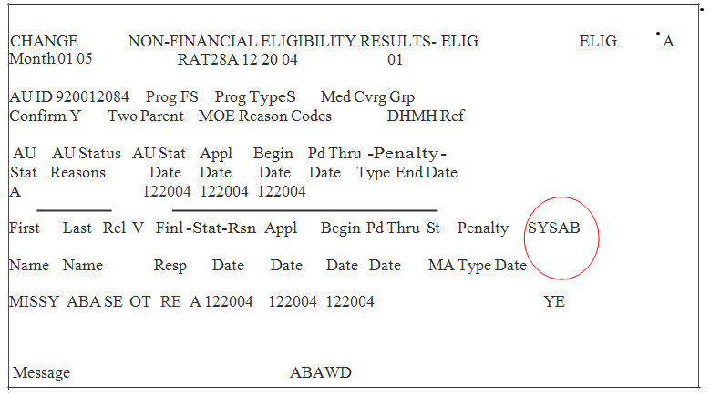

Accessing the ABAWD MAINTENANCE Screen

- From a pending FSP AU:

The ABAWD MAINTENANCE screen appears following the ELIG screen when finalizing an FSP AU with an ABAWD member. When the ELIG screen appears during this process, the message BNFT CTR MUST BE ENTERED WHEN ABAWD STATUS = YE OR OVERRIDE = CY appears. Confirm the case and press ENTER for the ABAWD MAINTENANCE screen to display.
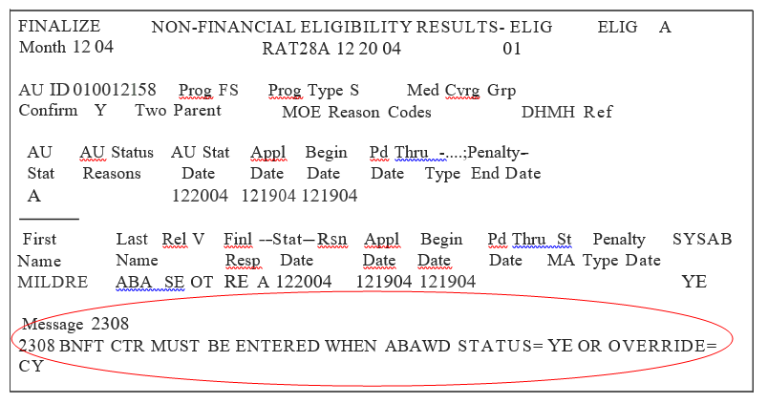

- From an active FSP AUs:

CARES does not automatically update the ABAWD benefit counter for the “free” months. In order to assist the local office in tracking, the case manager must enter the ABAWD MAINTENANCE screen for the ongoing month and manually update the Bnf Ctr field.

The FSP AU is accessed via Option R on the AMEN screen. Fast path to the CARES ELIG screen. Press ENTER if the YE valid value displays in red in the SYSAB field, otherwise, press PF20. The ABAWD MAINTENANCE screen will then display.
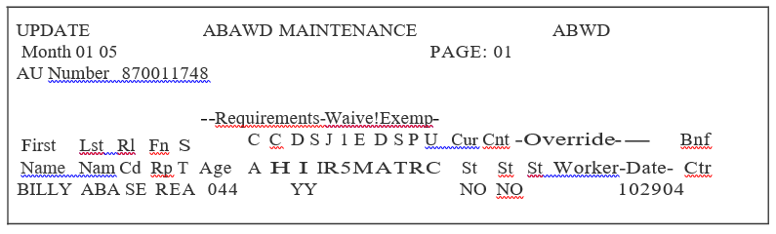

The ABAWD MAINTENANCE screen displays ABAWD identification requirements and ABAWD exemption criteria for each member of the Food Supplement assistance unit. There is one screen per assistance unit. The field definitions for the ABAWD MAINTENANCE screen are as follows:

- The MONTH field indicates the benefit month for which information is displayed.
- The First Name field indicates the first name of each AU member.
- The Last Name field indicates the last name of each AU member.
- The Rl Cd field indicates the relationship code of each AU member.
- The Fn Rp field indicates the financial responsibility of each AU member.
- The ST field indicates the status (Active or Closed) of each AU member.
- The Age field displays the age of each AU member.

Requirements Fields

CARES will populate the Y valid value in each field for which the individual meets the selected exemption criteria.
CA - Cash assistance recipient.
CH - The SE has a child under 18 years of age.
DI - The individual is disabled.
SI - The individual is an applicant or recipient of SSI.

Waiver/Exempt Fields

CARES will populate the Y valid value in each field for which the individual meets the selected criteria.

JR - The individual resides in a jurisdiction that is ABAWD waived.
15 - 15% ABAWD waiver ***NOT CURRENTLY IN USE***.
EM - ABAWD exemption given due to employment.
DA - ABAWD exemption given due to alcohol/drug treatment.
ST - ABAWD exemption given due to full time or half time student status.
PR - Pregnancy.
UC - ABAWD exemption given due to receipt of unemployment compensation.

ABAWD Status Fields

CARES will populate the YE valid value (individual is ABAWD and the benefit month is a “free” month), or the NO valid value (customer is not ABAWD and the benefit month is not a “free” month) in the fields listed below:

Cur St - Individual's current system generated ABAWD status.
Cnt St - Individual's status for the month “free” or not.

If a customer is exempt from ABAWD rules for any part of a benefit month, then that month is considered NOT one of the “free” months. As a result, an individual could have YE for current ABAWD status and NO for the “free” month.

For example:
On March 7, an individual has a Cur St of YE due to meeting the ABAWD definitions. During the month, the individual's child moves into the home. For the March benefit month, the individual would have a Cur St of YE and a Cnt St of NO because the individual was non-ABAWD for part of March.

Override Fields

ST -Override status field.

The valid values associated with the ST field are entered by the case manager to correct the status that CARES determined.
The valid values are as follows:

CN- Case manager changes from a “free” month to a Non-ABAWD status.
CY- Case manager changes from a Non-ABAWD status to a “free” month.
Worker - LOGON ID of the case manager overriding the ABAWD status. This field is automatically populated by CARES.
Date -The date the most recent action was taken to override or change the status.
Bnf Ctr -This field displays the number of "free” ABAWD months received to date. A number from 0 through 6 may be entered in this field. The number in this field is NOT automatic; it must be entered by the case manager.

NOTE: CARES does not automatically update the counter for “free” months. There is no CARES case processing associated with the BNF CTR field.

UPDATE ABAWD MAINTENANCE
Month 12 04 PAGE:01
AU Number 010012158
ABWD

-Requirements--Waive!Exemp-
First Lst Rl Fn S C C D S J 1 E D S P U Cur Cnt - --Override---- Bnf Name Nam Cd Rp T Age A H I I R 5 M AT R C St St St Worker --Date-Ctr MILDRE ABASE REA 048 Y YE YE *

Message 2308
2308 BNFT CTR MUST BE ENTERED WHEN ABAWD STATUS = YE OR OVERRIDE=
CY
PFI-HELP PF3-CANCEL PF7-PG BCK PF8-PG

Processing Data on the ABAWD MAINTENANCE Screen

1. Pending Food Supplement Cases:

The ABAWD MAINTENANCE screen appears following the ELIG screen of an FSP case. During finalization (Option Q) for a pending FS AU, the ELIG screen will display the message BNFT CTR MUST BE ENTERED WHEN ABAWD STATUS = YE OR OVERRIDE = CY will appear. This message will alert the case manager that Bnf Ctr information must be entered on the ABAWD MAINTENANCE screen.

To enter data on the ABAWD MAINTENACE screen:

    - Press ENTER from the ELIG screen and the ABAWD MAINTENANCE screen will display.
    - Review the data to ensure the accuracy of the ABAWD determination.
    - Enter the number of “free" months in the Bnf Ctr field. Press ENTER to return to the ELIG screen.
    - When finalizing subsequent months, review and update the number of “free” months if necessary. Then press PF4 to bypass the warning or to update.
    - Then press ENTER to return to ELIG (Remember: For applications, any prorated month does not count as a “free” ABAWD month.).
    - Press ENTER and the FSFI screen will display.
    - Complete the finalization process.

2. Active Food Supplement Cases:

From Option R on the AMEN screen:
- Enter the FS AU number.
- Press ENTER.
- Fastpath to ELIG.
- Press ENTER if the SYSAB field displays a red YE, otherwise PF20.
- Update the Bnf Ctr field or the Override Status field.
- Press ENTER to return to ELIG.
- Confirm the eligibility and press ENTER to commit the data.
- REMEMBER: ALWAYS NARRATE YOUR ACTIONS

ABAWD Fields on the WORK Screen

Fields are present on the WORK screen to display ABAWD information. None of these fields require data entry by the case manager.

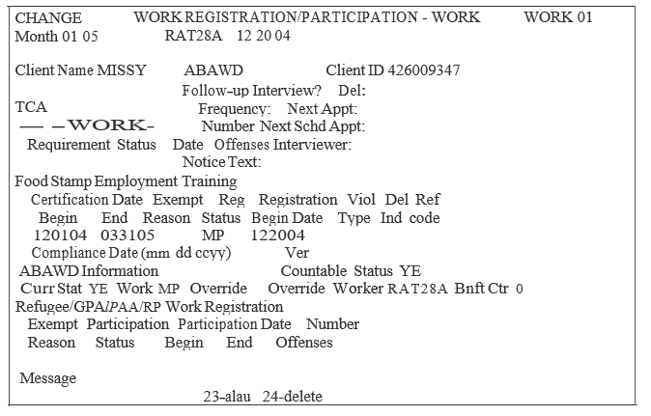

The ABAWD fields appear in the ABAWD information section of the WORK screen. The fields and their valid values are as follows:

Curr Stat – the current ABAWD status. YE indicates the individual is an ABAWD. NO indicates the individual is Non-ABAWD.

Countable Status - indicates whether or not the benefit month is a “free” month. YE displays when the full month is “free”. NO displays when the benefit month is not a “free” month. It will also display NO if the individual is Non-ABAWD for any day of the month.

Work – displays ABAWD work requirement information. The valid values are MP (mandatory), EX (exempt), and WA (waiver or blank if the Curr Stat field is NO).

Override - indicates whether or not the system determined ABAWD status was overridden by the case manager. This field will be blank if an override was not done. CY indicates that the system determined Non-ABAWD status was changed to ABAWD. CN indicates that the system determined ABAWD status was changed to a Non-ABAWD status.

Override Worker – displays the LOGON ID of the case manager entering
the override code or maintaining the benefit counter.

Bnft Ctr – displays the number of "free" ABAWD months.
Potential Error Messages

The following error messages will appear as part of the ABAWD identification process on CARES:

- Error Message #2307 – OVERRIDE IND CANNOT BE THE SAME AS THE ABAWD STATUS. This message appears on the ABAWD MAINTENANCE screen when the incorrect override valid value is entered. For example, the system has determined an individual to have NO as ABAWD status. Should the case manager enter the CN valid value in the St field of the ABAWD MAINTENANCE screen the above error message will display.

- Error Message #2308 – BNFT CTR MUST BE ENTERED WHEN ABAWD STATUS = YE OR OVERRIDE = CY. This message indicates that a value from 0 through 6 must be entered in the Bnf Ctr field on the ABAWD MAINTENANCE screen.

- Error Message #2314 – OVERRIDE IND INVALID – THE CLIENT IS DISABLED OR OUT OF AGE RANGE. This message appears when CY is entered in the St field of the ABAWD MAINTENANCE screen and the individual is disabled or does not meet ABAWD age requirements.

- Error Message #2315 – YOU ARE TURNING A SYSTEM GENERATED ABAWD CLIENT TO NO. This message appears in yellow on the ABAWD MAINTENANCE screen when the CN valid value is entered in the St field and the system has determined an individual to be an ABAWD. Press the PF-4 key to bypass this message.

- Error message #2318 – ABAWD OVERRIDE CLEARED AT REDET, USE PF-20 TO MAINTAIN THE OVERRIDE. This message appears on the ELIG screen when processing an FSP redetermination. The override is maintained by pressing the PF-20 key to access the Bnf Ctr field on the ABAWD MAINTENANCE screen.

- Error message #2334 – ABAWD OVERRIDES CLEARED FOR REDET. This message appears on the ABAWD MAINTENANCE screen and informs the case manager that overrides have been cleared in processing the FSP redetermination.

- Error message #2336 – VERIFY WARNINGS, PRESS PF-4 TO ACCEPT. This message appears on the ABAWD MAINTENANCE screen when finalizing a reapplication. This message prompts the case manager to check the Bnf Ctr field for accuracy. Press the PF-4 key to bypass this message.

- Error message #2337 – PRESS PF-7/PF-8 TO VERIFY WARNINGS ON OTHER PAGES. This message appears when the size of the assistance unit requires more than one ABAWD MAINTENANCE screen for the assistance unit. This message also refers to checking the accuracy of the Bnf Ctr field on the ABAWD MAINTENANCE screen when finalizing an FSP reapplication on CARES.

- Error message #2339 – REVIEW CLIENT'S ABAWD COUNTER. PRESS PF4. This message appears during finalization of subsequent month for a pending food supplement case.

Case Closure Due to Receipt of the Maximum Number of “Free” Months

When closing either an assistance unit or removing an individual customer from an Assistance Unit for receipt of the maximum number of “free” months, use CARES closure code 526 “DID NOT MEET ABAWD REQUIREMENTS” and suppress the notice. Use the ABAWD GENERATOR to generate the closing notice.

If the ineligible ABAWD is in a Food Supplement household with other eligible members, the following action is required:

- Identify the ineligible ABAWD on the STAT screen by entering code 526 in the Rsn field to the right of the individual’s name (Client Level).
- Determine the pro-rated share of income off-line and enter on the appropriate screen(s) for an eligible household member.
- Determine the assets of the ineligible ABAWD household member off-line. Enter the full amount of assets on the appropriate screen(s) for an eligible member(s).
- When the ineligible ABAWD is responsible for shelter costs, determine the prorated amount off-line. Enter the prorated shelter costs on the SHEL 01 screen.
- Use the NARR screen to explain how you prorated income and expense amounts.
- Complete CARES processing as required.

MONITORING:

In order to monitor each and every month of the 36-month ABAWD period (January 1, 2016-December 31, 2018), each office subject to the ABAWD policy must use the ABAWD GENERATOR file, located in the shared drive, in the PIRAMID/ABAWD folder. The file will assist the office in managing, monitoring, tracking and issuing notices to potential ABAWD customers. Training for designated staff in those offices will occur in January 2016 and be recorded for future staff who assume responsibility for the automated file. A manual for using the ABAWD GENERATOR will be located in each office’s PIRAMID/ABAWD folder.
Screening is required before a customer can be coded in the GENERATOR, and the screening date and screening result must be entered.

Here are a few of the features of the ABAWD GENERATOR:
- The ABAWD GENERATOR links the current month of CARES data to the weekly and monthly WORKS system data for any customer who is likely to be an ABAWD.
- Notices can be generated from the GENERATOR, or the case manager can use stand-alone Word templates located in the office’s PIRAMID/ABAWD folder:
  - Approval
  - Denial (if reapplying to regain eligibility after the first 3 “free” months)
  - Notice of Adverse Action to close a case due to ABAWD rules
  - Warning notice for the 1st or 2nd “free” month of benefits.
  - A Change of Status notice for customers who are leaving Exempt status.
- Each month’s new ABAWD customers can be imported into the GENERATOR.
- Appointment letters can be generated for a specific date and time.

This is the ACTIVE ABAWD screen, where the file’s operator manages the cases:
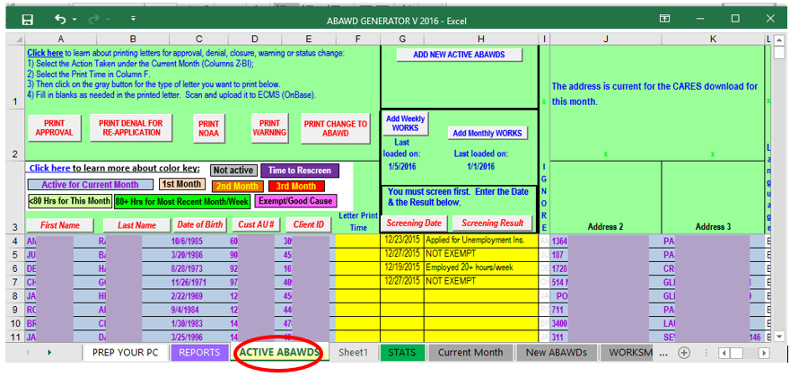
Shown below are the fields for generating an Appointment Letter: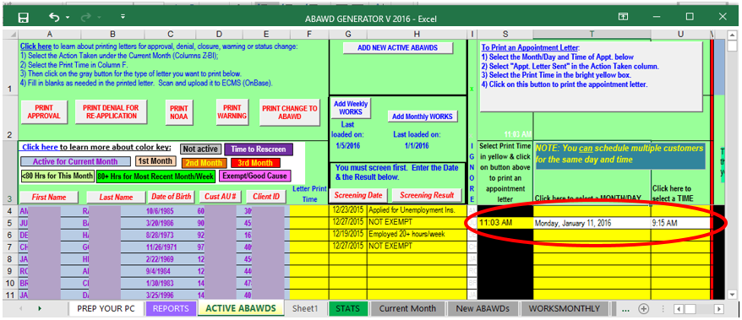

The operator of the ABAWD GENERATOR must code each month for all active customers who appear in the file, as shown below:
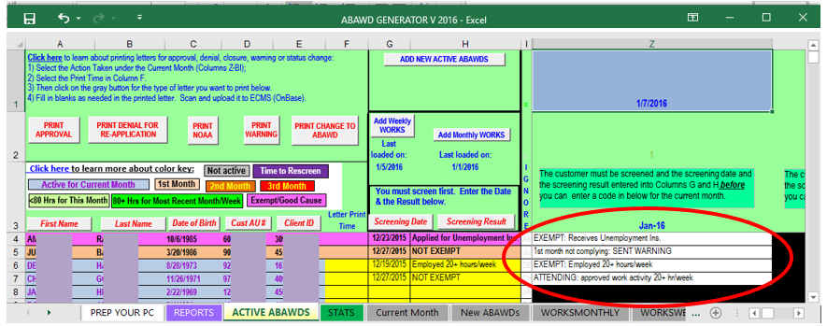

More features will be explained during the training and in the manual.

INQUIRIES:

Please direct ABAWD policy questions to Taneicsha (Dani) Whittaker at 410-767-5510 or taneicsha.whittaker@maryland.gov.

Please direct general Food Supplement Program policy questions to Rick McClendon at 410-767-7307 or rick.mcclendon@maryland.gov.

Please direct all CARES-related ABAWD questions to La Sherra Ayala at (410) 238-1285 or lasherra.ayala@maryland.gov or Randy Graybeal at (410) 767-7683 or randy.graybeal@maryland.gov.

Please direct questions about the ABAWD GENERATOR file to Vesta Kimble at (410) 767-7947 or vesta.kimble@maryland.gov.

cc: DHR Executive Staff
FIA Management Staff
Constituent Services
DHR Help Desk

APPENDIX
How to use the automated Screening Tool for ABAWDs

Fill in the demographic information. The customer’s Client ID field can be left blank if the number is not known at screening, such as when completing the screening for an applicant.
- All other fields must be completed. Code the field for Select which screening this is either “Initial Screening” or “Application.” At any subsequent screening the identifier will be changed.
- Upon entering the customer’s date of birth, a list of questions displays.
- No customer face to face contact is required for screening. If there is not enough information available to make a determination, then a customer interview may be required.
  - Use MABS, CARES, Work Number, SVES, and SDX to assist you in completing the screening.
  - Make sure you check and update the CARES narration.

The next section contains the questions. Most questions are answered YES or NO in a dropdown box and several ask for additional information.

- Customer has a child or children younger than 18 living with him or her.
- The child must live in the household with the ABAWD.
  - Joint custody is considered living in the household, if the child is actually living with the parent and not just visiting.
- The child must be considered part of the FSP household, but is ineligible to receive benefits.
  - The child could be an ineligible alien and ineligible to receive benefits with the other parent or the child is disqualified from receiving FSP benefits.
- The child could be on FSP in another household.
- Enter the age of the youngest child in the yellow box if you check YES to question 1.
- If the child turns 18 during the certification period, the case manager should create a CARES 745 alert as a reminder. The child as well as the parent(s) will be subject to ABAWD rules when the youngest child turns 18.

- Is the customer disabled? Either a long term or short term disability (90 days or
more) will exempt the customer. If the disability is obvious, the case manager does not need verification.

- Is the customer receiving any type of disability payment? What kind?
- Select the type of disability payment from the drop-down box.
- Is the information in CARES?

- Is the customer caring for a disabled person in the home?

- Has the customer applied for or is the customer receiving unemployment?

- Check MABS to see. If the customer filed an out of state claim, contact the customer for verification.

- Is the customer pregnant?
  - The number of weeks or which trimester does not matter.

- Is the customer employed or self-employed - regular employment must be 20 hours per week. Self-employment must be a minimum of 30 hours per week.
  - Enter the number of hours that are verified (remember to look in ECMS, WORKS and/or The Work Number)

- Is the customer participating in drug or alcohol treatment?
- There is no required number of hours.

- Is the customer participating in an approved work activity for at least 20 hours per week?

- Is the customer attending an accredited school at least half time?
- Customers must also meet student status requirements to receive FSP benefits if they are attending school.

The automated Screening Tool makes a suggested determination of ABAWD status based on the information entered.
- Review any screening performed by our community partners to ensure the status is correct. The case manager is responsible for the final determination.

The case manager must review all information on the Screening Tool and code CARES appropriately for any information previously unknown.

If the customer is identified as an ABAWD, the current certification period must be shortened to ensure the individual only receives 3 countable months of benefits. The CARES procedures for this step are included in the CARES section.

INSTRUCTIONS: Screen each individual in the Food Supplement household for potential ABAWD status. You can use CARES, MABS, The Work Number, and SVES to verify status. If you cannot determine the ABAWD status from those systems, then call the customer. Narrate in CARES the date and time of the call and the results of the call.

Screening Tool for Able-bodied Adults Without Dependents (ABAWDs)
Select your District Office:
Customer's Name: |  | This field is a drop down box that identifies the County the customer lives in.
Customer's Client ID:
Cert. Period Begin Date:
Your Name:
Click for Today's Date:
Select which screening this is: |  | A drop down box appears with choice of Initial, Application, Redetermination, or Interim Change.
Enter customer's Date of Birth:
Enter the information above. The next step will appear here.
Screening Tool for Able-bodied Adults Without Dependents (ABAWDs)
Select your District Office: | Glen Burnie
Customer's Name: | John Doe
Customer's Client ID: |  |  | You can leave this field blank and continue with the screening.
Cert. Period Begin Date: | Nov-15
Your Name: | John Smith
Click for Today's Date: | 11/17/2015 |  | 11/17/2015
Select which screening this is: | Initial Screening
Enter customer's Date of Birth: | 10/1/1988

Click in the yellow boxes below to indicate 'Yes' or 'No' for each of the conditions.
1. |  | There is a child in the household who is less than 18 years old.
 |  | These two boxes contain drop down boxes. The first is Yes or No and the second is a choice of disability payments.
2. |  | The customer is disabled.
3. |  | The customer receives a disability payment.
4. |  | The customer is caring for a disabled person.
5. |  | The customer applied for or is receiving Unemployment Insurance.
6. |  | The customer is pregnant.
7. |  | The customer is employed or self-employed with proof of hours.
8. |  | The customer is participating in a drug or alcohol treatment program.
9. |  | The customer participates in an approved work activity.
10. |  | The customer attends an accredited school at least part time.
This customer is an ABAWD and is complying with the required rules for employment or participation in an approved activity. Process the application or keep the case open. Save this file as a .PDF and upload it to OnBase.
A message will be in this box indicating that based on the information provided for the screening tool, the customer is or is not an ABAWD.

