  Department of Human Resources  311 West Saratoga Street  Baltimore MD 21201 | FIA ACTION TRANSMITTAL
Control Number 15- 11 | Effective Date: October 1, 2014
Control Number 15- 11 | Issuance Date: November 5, 2014

TO: DIRECTORS, LOCAL DEPARTMENTS OF SOCIAL SERVICES
DEPUTY/ASSISTANT DIRECTORS FOR FAMILY INVESTMENT
FAMILY INVESTMENT SUPERVISORS AND ELIGIBILITY STAFF
FROM: ROSEMARY MALONE, EXECUTIVE DIRECTOR

RE: NEW REQUIREMENTS FOR ELECTRONIC BENEFITS TRANSFERS (EBT)

PROGRAM AFFECTED: TEMPORARY CASH ASSISTANCE (TCA)

ORIGINATING OFFICE: OFFICE OF PROGRAMS

Summary:

The Middle Class Tax Relief and Job Creation Act enacted on February 22, 2012, contains provisions requiring states to block the use of EBT cards containing Federal Temporary Assistance to Needy Families (TANF, our TCA program) funds at establishments whose primary purpose is gambling (casinos), selling liquor (liquor or package good stores) or where adults take their clothes off to entertain (strip clubs). In this action transmittal we provide the steps we must take to prevent the use of EBT cards in these prohibited establishments.

Action Required:

Beginning October 1, 2014, customers receiving cash assistance must sign a statement agreeing not to use their EBT card with TCA on it at the prohibited locations. The statement also provides the penalties for using the card at the prohibited locations.

The prohibition of use of the card with TCA funds on it in casinos extends to the automated teller machines (ATMs on site), point of sale purchases such as in the gift shops, restaurants and clothing stores, etc. located at the casino. Customers may not make any purchases at liquor stores or package good stores even to make purchase such as sodas or candy or chips. No purchases may be made at an adult entertainment establishment.

[NOTE: Xerox, FIA and EBT staff will complete a random sample of the EBT cash files to determine if customers used their EBT card at a prohibited location.

If a “hit” is found, we will notify the local department to send a warning notice to the customer. The warning notice advises the customer that the access to their cash

benefits is in danger of being revoked. The discovery of a subsequent use at a prohibited establishment will result in the access to cash benefits being revoked for one year. A third instance will result in the EBT access to cash benefits being revoked permanently.

Customers whose access to cash benefits has been revoked must provide the case manager or EBT checking or savings account information for direct deposit. Any customer not providing bank account information will be mailed a paper check.]

Local Department Responsibilities

1. At application or redetermination, advise the customer of the prohibition against using their EBT card with TCA benefits on it at one of the prohibited locations. Have them sign the acknowledgement form (DHR/FIA EBT 7001-A).

2. Scan the signed form into ECMS

3. If the customer is found to have used their EBT card to access cash at one of the prohibited locations, the first time, send the customer a warning letter (DHR/FIA EBT 7001-B).

4. The second time a customer is non-compliant with the prohibition:

- Follow the EBT/CARES steps below. The cash access by EBT card is revoked for one year.
- Send the customer the second notice.
- Request bank information from the customer to put the customer on direct deposit into their bank account.
- If bank information is not received, code CARES so the customer receives a paper check.

Food Supplement Benefits are not affected by the prohibition. Do not make any changes to the FSP EBT access.

The third time the customer is in violation, the cash access for EBT is revoked permanently.

- Follow the EBT/CARES steps below. The cash access on the EBT card is revoked permanently.
- Send the customer the third notice.
- Request bank information to put the customer on direct deposit into their bank account.
- If bank information is not received, code CARES so the customer receives a paper check.

CARES and EBT procedures

The CARES steps are as follows:

For the first violation, there is no change to CARES.

For a second violation, on the head of household CARES STAT screen change BEBT to BCHK.

If there is a third violation, change BEBT to BCHK and EBT staff will turn off cash access in EPPIC.

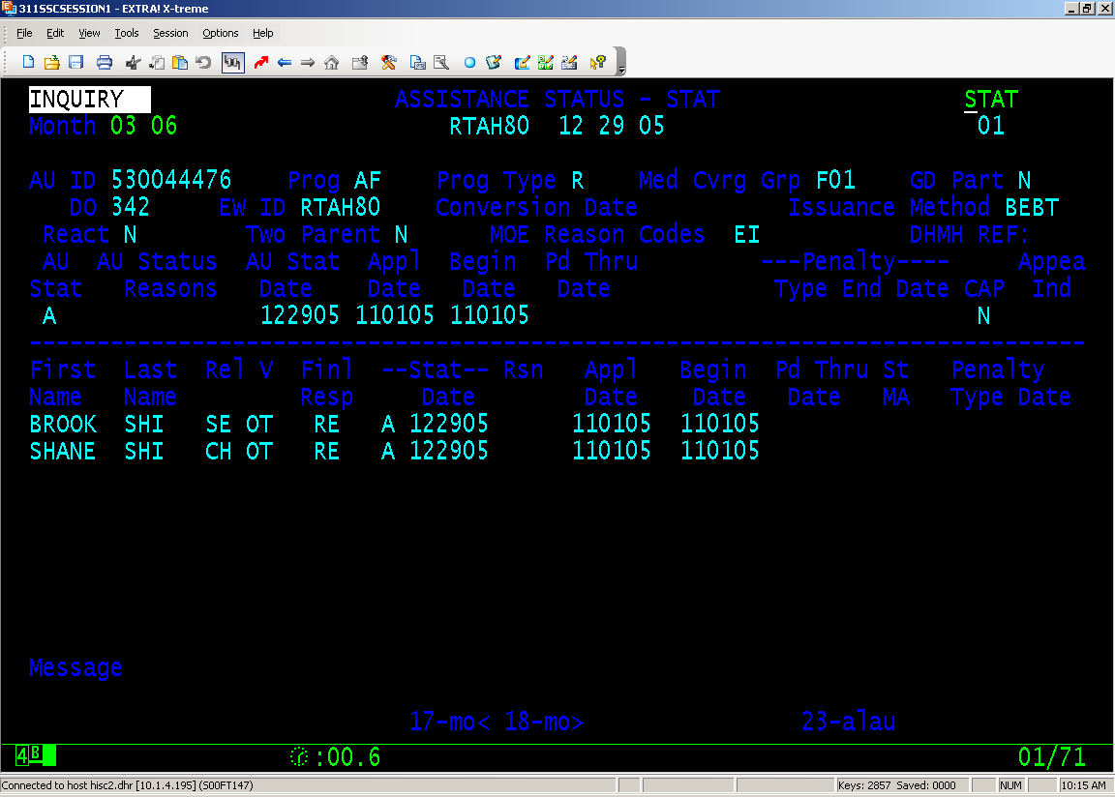
Change this field to BCHK when the customer has 2 or more violations.

Lost or stolen TCA benefits when TCA benefit access is revoked.

Cash benefits on direct deposit may not be replaced if the customer reports a loss or theft.

Paper checks reported lost or stolen may be replaced one time. If the customer reports that the check was not received or it was stolen, the customer must report the theft to the police department and provide a police report to the case manager before replacement can be made.

Forms:

A sample of the Electronic Benefits Card (EBT) Prohibited Uses form (DHR/FIA7001A) and the Notification of EBT Access Violation (DHR/FIA 7001B) are attached and will be available on FIPNET under On-line Forms. Local Departments will be able to order it through their normal ordering procedures within a few weeks.

Attachments:
EBT Prohibited Uses Form (DHR/FIA7001A)
Notification of EBT Access Violation (DHR/FIA 7001B)

Inquiries:

Please direct TCA policy questions to Fatmata Khella, at 410-767-7956 or fatmata.khella@maryland.gov.

cc: DHR Executive Staff FIA Management Staff
Policy, Research and Training Staff Constituent Services
DHR Help Desk

