  Department of Human Resources  311 West Saratoga Street  Baltimore MD 21201 | Family Investment Administration  ACTION TRANSMITTAL
Control Number: 15-01 | Effective Date: September 1, 2014
Control Number: 15-01 | Issuance Date: August 18, 2014

TO: DIRECTORS, LOCAL DEPARTMENTS OF SOCIAL SERVICES
DEPUTY / ASSISTANT DIRECTORS FOR FAMILY INVESTMENT
FAMILY INVESTMENT SUPERVISORS AND ELIGIBILITY STAFF

FROM: ROSEMARY MALONE, EXECUTIVE DIRECTOR, FIA

RE: PROCEDURES FOR IMPLEMENTATION OF THE NEW ELECTRONIC DISQUALIFIED RECIPIENT SYSTEM (eDRS) REGULATIONS

PROGRAM AFFECTED: FOOD SUPPLEMENT PROGRAM (FSP)

ORIGINATING OFFICE: OFFICE OF PROGRAMS

SUMMARY:

The Electronic Disqualified Recipient System (eDRS) is a United States Department of Agriculture, Food and Nutrition Service (USDA/FNS) nationwide database that tracks customers who have been disqualified from receiving Supplemental Nutrition Assistance Program (SNAP) benefits for violating SNAP rules.

Previously, FIA used a manual verification process whereby only authorized staff in the local departments of social services (LDSS) logged into the eDRS website and used the online query (OLQ) function to determine whether or not an applicant or recipient was subject to a disqualification penalty. Additionally, DHR’s Office of the Inspector General (OIG) received a quarterly data file of national SNAP disqualifications directly from FNS. The disqualification information contained in the quarterly data file was subsequently communicated from OIG to LDSS offices throughout the state.

Recently, USDA/FNS passed new regulations which require states to check the eDRS on all applicants or recipients applying for or receiving SNAP benefits. These checks will now be automated via a built-in web services call interface between the Clients’ Automated Resource and Eligibility System (CARES) and eDRS. CARES users with Update capabilities will now be able to initiate and/or view the eDRS web services call or corresponding interface results. CARES users with Inquiry only capabilities will now be able to view interface results. This Action Transmittal will discuss the CARES procedures required to successfully navigate the new automated interface between CARES and eDRS.

The new eDRS Web Services Call Interface and accompanying new CARES procedures outlined below are not changing the existing procedures for the imposition of SNAP/FSP disqualifications nor the existing functionality on the DEM2 screen as it relates to entering disqualification information. Staff must still follow existing DHR verification and documentation procedures as well as any local department SOPs prior to any entry of a disqualification penalty. Only the method by which DHR staff acquire the disqualification information is changing. These changes will be effective September 1, 2014.

CARES PROCEDURES:
- CARES will automatically initiate the eDRS web services call interface from the DEM1 screen when the Enter key is pressed for each:
- Applicant at the time of:
  - Application (Option O),
  - Add a Person (Option K), and
  - Add a Program (Option L)
Recipient at the time of:
  - Redetermination (Option N),
  - Reactivation (Option Y), and
  - Reinstatement (Option M)
Note: eDRS will not be called for customers who are coded with the financial responsibility code of non-member (NM) on the STAT screen or customers who do not have a social security number on their DEM1 screen.

- An eDRS Web Services Call Interface can be manually initiated by a CARES user during an Interim Change (Option “R”) by pressing the PF14 key (shift PF2) on the DEM1 screen. Once the call has been manually initiated, the user will receive an informational message from CARES stating, “EDRS MANUAL WEB SERVICE CALL INVOKED.”
CHANGE CLIENT DEMOGRAPHIC 1 - DEM1 DEM1 01
Month 05 23 xxxxxx 03 01 23

Client Name XXXXXXXX XXXXXXXX XXXXXXXXXX CL ID xxxxxxxxx
Statewide FIP Group T TREATMENT
CSB Notification Date:
Client Ethnicity N CIS Primary Race C Race(s) C V O
Alt SSN SSN APPL More DOB
Name Referral Date SSN1 V SSNs (MM DD YYYY) V Sex
XXX XX XXXX CA XX XX XXXX BC F

--------- Place of Birth -------- MD Mar Living V Dest Boarder Amt Paid
Res Stat Arrgmt Migrant Num Meals for Meals
City St Y S AH RR
Hospital
Concurrent Parental V ------------ Pregnant ---------- Prenatal V
Out of State Status Due Date V Unborn Num V Care
CA FS MA Eligible Expect
N N N
EDRS MANUAL WEB SERVICE CALL INVOKED
Message

14-EDRS 15-lett 20-CRS 23-alau

3. Features of the new EDRS Screen in CARES:

- Once CARES receives the eDRS data for an individual, CARES will automatically populate the eDRS data to the new EDRS screen in CARES. This screen will verify that each FSP household member has passed through the eDRS web services verification process. The new EDRS screen will include a PF1 key for Screen Level Help.
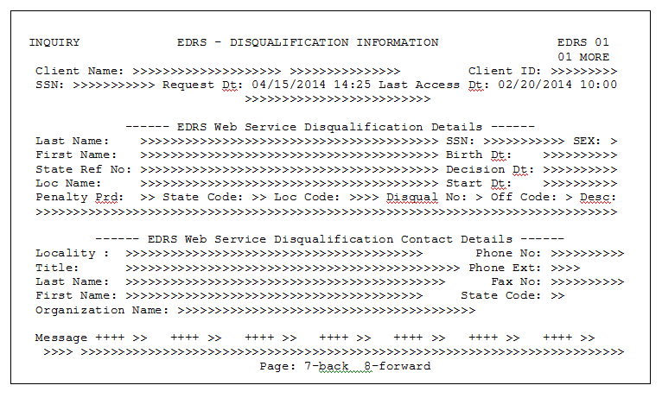
EDRS Screen Detail

Definitions of the new eDRS screen fields are as follows:
- Client Name - Last Name and First Name.
- Client ID – CARES Client ID.
- SSN – The individuals SSN.
- Request Date & Time – The Date and time the eDRS verification Search was sent to eDRS.
- Last eDRS access Date – Is the last date eDRS was accessed for the individual.
- Message - A message will show if no disqualification found for the individual.

eDRS Web Service Disqualification Details
- Last Name – The screen shows the disqualified recipient’s Last Name.
- SSN – The screen shows the disqualified recipient’s SSN.
- First Name – The screen shows the disqualified recipient’s First Name.
- Sex – The screen shows the disqualified recipient’s sex.
- State Ref Num – The screen shows the state’s disqualification reference number.
- Penalty Period – The screen shows a value between 1 thru 99 and each value indicates the individual's penalty period for each disqualification.
- Loc. Code – The screen shows show the state’s code that entered the disqualification.
- Birth Date – The screen shows the disqualified individual’s birth date.
- Loc. Name – The screen shows the state’s location name.
- State Code – The screen shows the state’s abbreviation code.
- Disqual No – The screen shows if this disqualification is the individuals first, second or third disqualification period.
- Decision Date – The screen shows the date the state made the disqualification decision.
- Start Date – The screen shows the date the disqualification began.
- Offense Code – The screen shows a single identifier to indicate the type of offense that caused the disqualification.
- Offense Desc – The screen shows the offense code description.

eDRS Web Service Disqualification Contact Details
- Locality – The screen shows the name of the contact’s location.
- Phone Ext - The screen shows the contact’s phone extension.
- Title - The screen shows the contact’s title.
- State Code - The screen shows the contact’s state code.
- Last Name - The screen shows the contact’s last name.
- Fax Num - The screen shows the contact’s fax number.
- Org. Name - The screen shows the name of the contact’s organization.
- Phone Num - The screen shows the contact’s phone number.

For individuals who have no disqualification penalty through eDRS, the screen will show only Name, Client Identification, Social Security Number, Request Date and Time and the Last eDRS Access Date.

- The screen stores previous eDRS disqualification history for each individual.
- The screen will allow the household member number to be changed (e.g., EDRS 01 can be changed to EDRS 03 etc.) so that the CARES user can navigate directly to a specific household member.

- The EDRS screen can be accessed by pressing the PF14 key from the STAT, DEM2 and ELIG screens

INQUIRY ASSISTANCE STATUS - STAT STAT
Month 05 23 xxxxxx 12 29 22 01

AU ID xxxxxxxxx Prog FS Prog Type C Med Cvrg Grp GD Part
DO 333 EW ID xxxxxx Conversion Date Issuance Method BEBT
React N Two Parent MOE Reason Codes DHMH REF:
AU AU Status AU Stat Appl Begin Pd Thru 14 Day ---Penalty---- Appea
Stat Reasons Date Date Date Date Override Type End Date CAP Ind
A 122922 122922 122922 N
------------------------------------------------------------------------------
First Last Rel V Finl --Stat-- Rsn Appl Begin Pd Thru St Penalty
Name Name Resp Date Date Date Date MA Type Date
XXXXXX XXX SE BC RE A 122922 122922 122922
XXXXXX XXX CH BC RE A 122922 122922 122922

Message 14-EDRS 17-mo< 18-mo> 23-alau

CHANGE CLIENT DEMOGRAPHIC 2 - DEM2 DEM2 01
Month 05 23 xxxxxx 03 01 23

Client Name XXXXXXXX X XXXXXXXXXX Client ID xxxxxxxxx

Citiz V Student V Striker -----------Penalties----------- ----Death-----
Status Stat Org Viol --Dec Date Type-- Del Date State
C BC FS CS N AF
FS
------------- Disability/Incapacity -------------
Disab/ GA SW Approval Begin Date End Date Loan Date IAR Date
Incap Type CTR Coop Source (MM YY) (MM YY) (MM YY) (MM DD YY) (MM DD YY)

Med Rev Treatmt Hlth -----PSH---- OTO Medical Entitle Joint Vet POC
Recd part V Insu Ind V Date Date V Med A SSI/FS Stat

Vote-Reg N Pres@Int Y TCA Ctr 005 TLEX-Rsn MPEXE DMVIOL
HMO Mang Care Insur Dropped Premium OK BUYIN TPL Liab

Message

14-EDRS 15-lett 20-MOE HIST 22-TPL 23-alau 24-del

INQUIRY NON-FINANCIAL ELIGIBILITY RESULTS - ELIG ELIG
Month 05 23 xxxxxx 02 28 23 01

AU ID xxxxxxxxx Prog FS Prog Type S Med Cvrg Grp
Confirm Two Parent MOE Reason Codes DHMH Ref

AU AU Status AU Stat Appl Begin Pd Thru ---Penalty---
Stat Reasons Date Date Date Date Type End Date
P 090921 090921
-------------------------------------------------------------------------------
First Last Rel V Finl --Stat-- Rsn Appl Begin Pd Thru St Penalty SYSAB
Name Name Resp Date Date Date Date MA Type Date
XXXXXX XXX SE P 090921 090921 NO
XXXXX XXX CH P 022823 090921 NO

Message 14-EDRS 17-MO< 18-MO> 20-ABAWD

When accessing the EDRS screen from the DEM2 screen, the user will not be able to view the EDRS screen for other household member numbers (e.g., when the user is on DEM2 02 the user can access only the EDRS screen for household member ’02’).

Quick Review of PF14 Key Functionality by Screen

- DEM1 Screen - Will allow manual initiation of the eDRS Web Services Call Interface during an Interim Change (Option “R”).

- DEM2 Screen – Will allow an individual household member’s eDRS screen to be viewed.

- STAT and ELIG Screens – Will allow the user to navigate between and view the eDRS screens of all household members.

4. Potential Messages resulting from the eDRS Web Services Call Interface

- When a SNAP/FSP disqualification has been found, CARES will display Soft Edit Error Message 1457 on the ELIG screen stating, “EDRS DISQUALIFICATION PENALTY HAS BEEN FOUND. SECONDARY VERIFICATION REQ.” The ELIG screen will display the first and last name of the penalized individual(s) highlighted in yellow.

INQUIRY NON-FINANCIAL ELIGIBILITY RESULTS - ELIG ELIG
Month 05 23 xxxxxx 04 03 23 01

AU ID xxxxxxxxx Prog FS Prog Type S Med Cvrg Grp
Confirm Two Parent MOE Reason Codes DHMH Ref

AU AU Status AU Stat Appl Begin Pd Thru ---Penalty---
Stat Reasons Date Date Date Date Type End Date
P 040323 030123
-------------------------------------------------------------------------------
First Last Rel V Finl --Stat-- Rsn Appl Begin Pd Thru St Penalty SYSAB
Name Name Resp Date Date Date Date MA Type Date
XXXXX XXX SE BC PN P 040323 030123 NO
XXXXX XXX SP BC PN P 040323 030123 NO

Message 1457
1457 eDRS DISQUALIFICATION PENALTY HAS BEEN FOUND. SECONDARY VERIFICATION REQ.
14-EDRS 17-MO< 18-MO> 20-ABAWD

- When the eDRS Web Services Call Interface has failed for one or more FSP household members, CARES will display Soft Edit Error Message 1455 on the ELIG screen stating, “EDRS INTERFACE UNSUCCESSFUL – TRY AGAIN.” The ELIG screen will display the first and last name of the individual(s) in red.

INQUIRY NON-FINANCIAL ELIGIBILITY RESULTS - ELIG ELIG
Month 05 23 xxxxxx 04 03 23 01

AU ID xxxxxxxxx Prog FS Prog Type S Med Cvrg Grp
Confirm Two Parent MOE Reason Codes DHMH Ref

AU AU Status AU Stat Appl Begin Pd Thru ---Penalty---
Stat Reasons Date Date Date Date Type End Date
P 040323 020123
-------------------------------------------------------------------------------
First Last Rel V Finl --Stat-- Rsn Appl Begin Pd Thru St Penalty SYSAB
Name Name Resp Date Date Date Date MA Type Date
XXXXXX XXX SE BC PN P 040323 020123 NO
XXXX XXX SS BC PN P 040323 020123 NO

Message 1455
1455 eDRS INTERFACE UNSUCCESSFUL - TRY AGAIN
14-EDRS 17-MO< 18-MO> 20-ABAWD

*NOTE: Staff should make every reasonable effort to address a disqualification penalty or failed call interface prior to finalizing an Application or updating a Redetermination.

- When the interface has been successfully completed for all household members, CARES will display an informational message on the ELIG screen stating, “EDRS INTERFACE SUCCESSFUL.”

INQUIRY NON-FINANCIAL ELIGIBILITY RESULTS - ELIG ELIG
Month 05 23 xxxxxx 03 24 23 01

AU ID xxxxxxxxx Prog FS Prog Type S Med Cvrg Grp
Confirm Two Parent MOE Reason Codes DHMH Ref

AU AU Status AU Stat Appl Begin Pd Thru ---Penalty---
Stat Reasons Date Date Date Date Type End Date
P 032423 030123
-------------------------------------------------------------------------------
First Last Rel V Finl --Stat-- Rsn Appl Begin Pd Thru St Penalty SYSAB
Name Name Resp Date Date Date Date MA Type Date
XXXXX XXX SE BC PN P 032423 030123 NO
XXXXX XXX CH BC PN P 032423 030123 NO

EDRS INTERFACE SUCCESSFUL
Message

14-EDRS 17-MO< 18-MO> 20-ABAWD

5. Available Reports in DataWatch (Detail Level and Summary Level)

- A monthly ‘eDRS Disqualification Report’ is available in DataWatch. This detailed report lists individuals who were found to have an eDRS disqualification via the eDRS web services call interface. The report displays the LDSS offices first and then a District Office (DO) breakdown for those jurisdictions with multiple DOs. The end of the report displays the total number of disqualifications statewide.

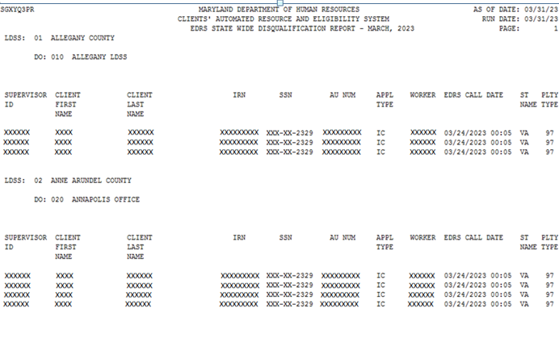
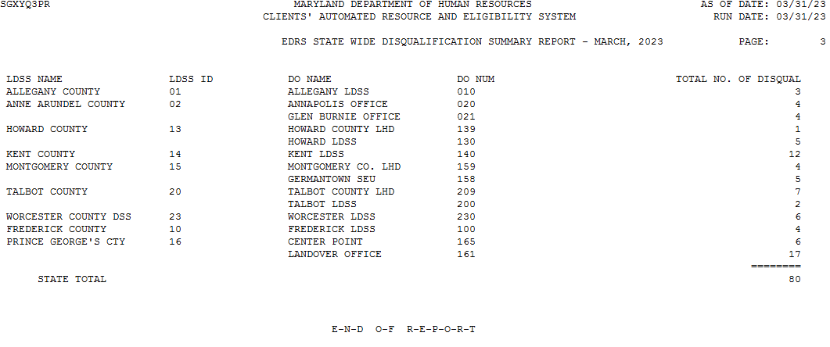

- A monthly ‘eDRS Web Service Call Report’ is likewise available in DataWatch. This detailed report shows the number of calls made to the eDRS web service. The type of eDRS call is listed and shows if the call to eDRS was an Automatic Call, a Manual Call or a Failed Call and the number of calls for each category. The report additionally shows the number of calls with disqualification information and the number of calls with no disqualification information. This report similarly displays the LDSS offices first, a DO breakdown and then statewide totals.

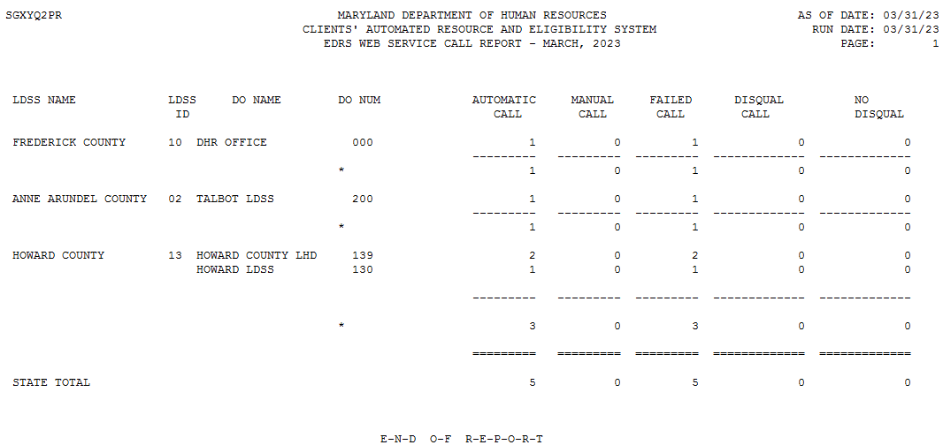

ACTION DUE: Implement the above procedures September 1, 2014.

INQUIRIES: Please direct FSP policy questions to Jeffrey Peterson at (410) 767-7889 or jeffrey.peterson1@maryland.gov and CARES questions to Randy E. Graybeal at (410) 767-7683 or randy.graybeal@maryland.gov

c: DHR Executive Staff
FIA Management Staff
Constituent Services
OTHS Help Desk
FIA Policy and Training Staff
FIA BSDM

