  Department of Human Resources  311 West Saratoga Street  Baltimore MD 21201 | FIA ACTION TRANSMITTAL
Control Number: # 13-15 | Effective Date: Immediately Upon Receipt
Control Number: # 13-15 | Issuance Date: September 19, 2013

TO: DIRECTORS, LOCAL DEPARTMENTS OF SOCIAL SERVICES
DEPUTY/ASSISTANT DIRECTORS FOR FAMILY INVESTMENT
FAMILY INVESTMENT SUPERVISOR AND ELIGIBILITY STAFF LOCAL HEALTH DEPARTMENTS, HEALTH OFFICERS,
LHD SUPERVISORS, MCHP SUPERVISORS

FROM: ROSEMARY MALONE, EXECUTIVE DIRECTOR
DEBBIE RUPPERT, EXECUTIVE DIRECTOR, DHMH/OES

RE: AUTOGOV ASSET VERIFICATION SYSTEM
FOR LONG TERM CARE MEDICAL ASSISTANCE CASES

PROGRAM AFFECTED: LONG TERM CARE (LTC)

ORIGINATING OFFICE: OFFICE OF PROGRAMS

SUMMARY:

At last, a long-awaited enhancement to the clearance process for LTC applications and redeterminations is here! The AutoGov Asset Verification System, or AVS, provides a valuable check on client assets, much like we use MABS or The Work Number to check employment income for non-LTC applications. The AVS is included in the AutoGov Scoring Tool in SAIL Admin and it ensures that the State meets the Federal asset verification requirements in Section 1940 of the Social Security Act.

ACTION REQUIRED:

The LTC Bureau recently created Standard Operating Procedures (SOPs) for using AutoGov and they are attached to this Action Transmittal. To repeat the message, the AutoGov asset check must be used for new applications and when the redetermination forms are received.

To access the SAIL Administration site, enter the URL address https://www.marylandsail.org/SailAdmin into the web browser on your computer. Log into the site using your current SAIL logon ID and password. Please contact a security monitor if you have difficulty accessing the site.
INQUIRIES:

Please direct AutoGov system issues to the HELP Desk at 410-767-7002. Please direct AutoGov/AVS inquiry issues to Mazie Johnson at 410-455-7511 or mazie.johnson@maryland.gov. Please direct Medical Assistance policy questions to DHMH Division of Eligibility Policy at 410-767-1463 or 1-800-492-5231 (select option 2 and request extension 1463).
c: DHR Executive Staff DHMH Executive Staff
DHMH Management Staff DHMH Policy and Training Staff
FIA Management Staff Constituent Services
DHR Help Desk
Family Investment Administration
Standard Operation Procedures (SOPs)
For
AutoGov Asset Verification System

Effective Date: Upon Receipt of the AVS Action Transmittal

Background

AutoGov is a tool that provides risk scores that improves case managers’ workflow by identifying the cases that are ready for processing. AutoGov CaseVue generates a score that provides information about a client’s risk level for becoming eligible for Long Term Care (LTC).

Recently, AutoGov was enhanced to present banking information for many of the major financial institutions. The Asset Verification System (AVS) ensures that the State meets recently added Federal asset verification requirements in Section 1940 of the Social Security Act.

Policy

Case managers who process Long Term Care applications and redeterminations are now required to access AVS data using the AutoGov Scoring Tool in SAIL Admin.

- To access the SAIL Administration site, enter the URL address: https://www.marylandsail.org/SailAdmin into the web browser on your computer.

- Log into the site using your current SAIL logon ID and password.

- The AutoGov application should be used for new applications and when the redetermination is received.

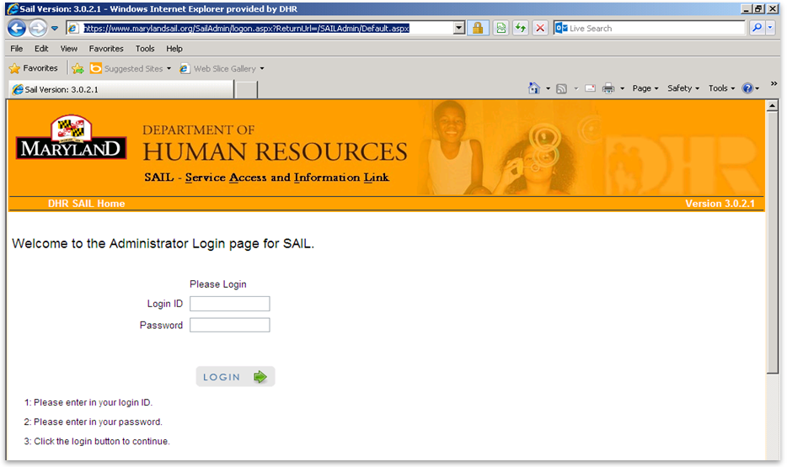
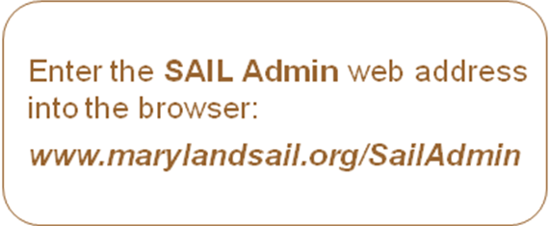
From the DHR SAIL Home page click on “AutoGov Scores”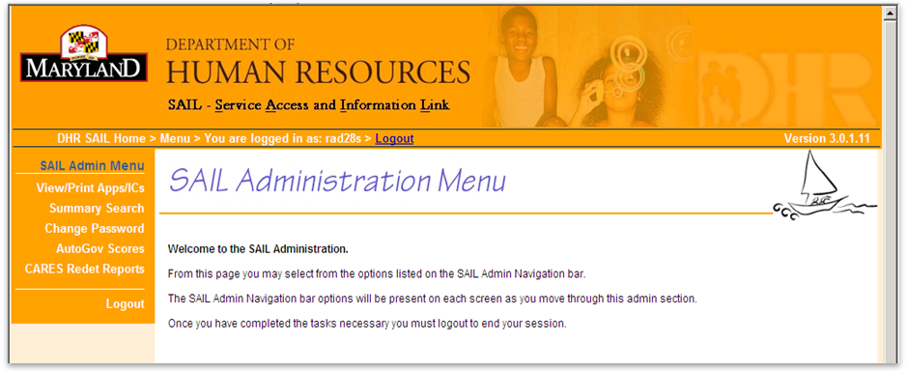


The following screens will guide you in accessing your customer’s information using the IRN (Customer ID), AU (Assistance Unit ID), Name or Social Security Number (SSN).

AU or IRN are the preferred methods of accessing case data.
Enter Number

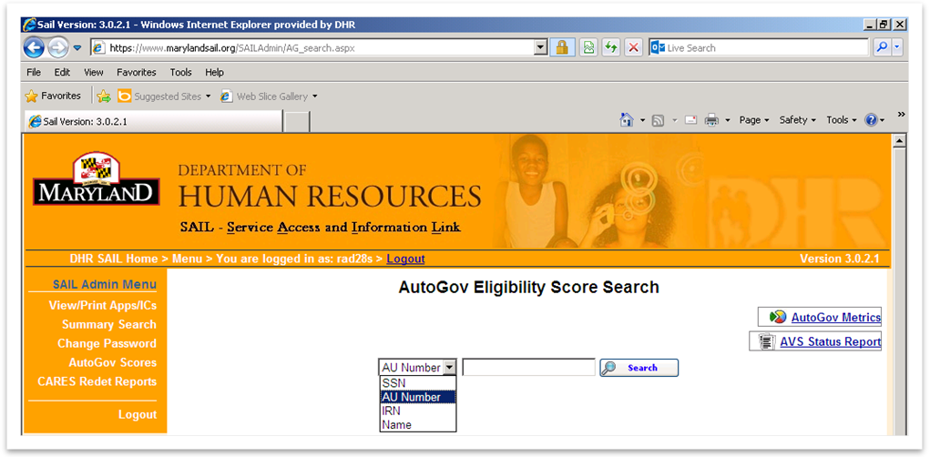

Choose how you are going to search here. Click Search here.

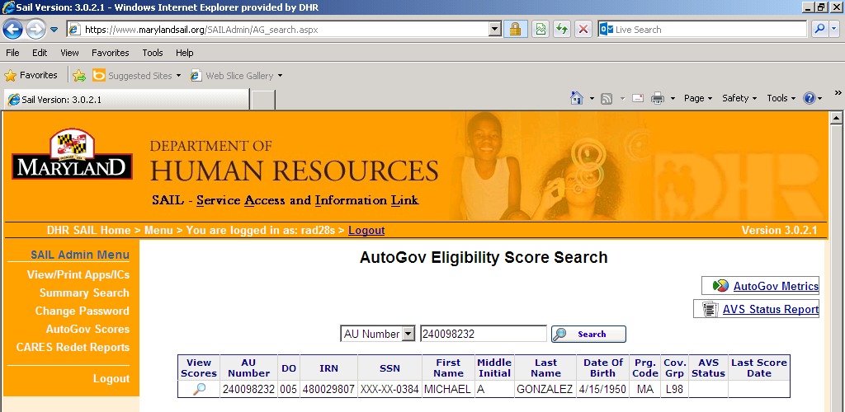
Click Here
AutoGov Score Page with AVS Status

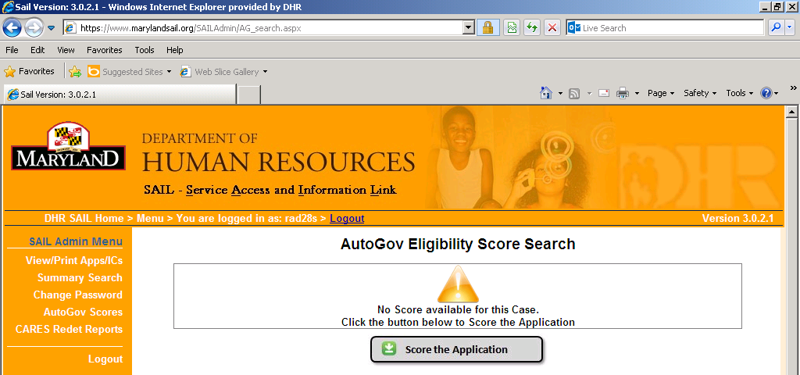
Click Here

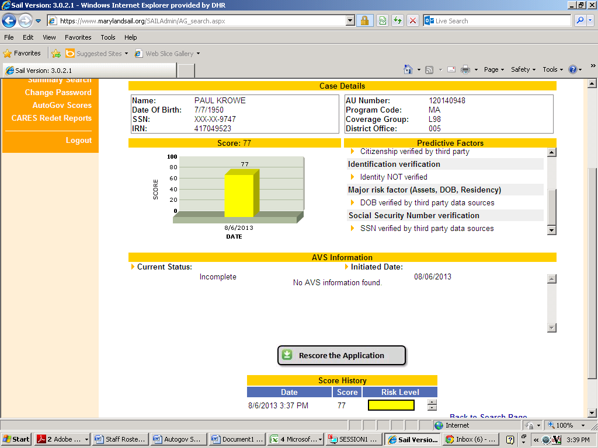
AVS data requested but not acknowledged
This is the initial request therefore, no data will be available
AutoGov score
Determining Factors

The application will need to be re-scored when new information is received

Note: At this point, the score search screen will indicate the demographics for the client. AVS information will include a status of the transaction. Here are the status definitions:
- Incomplete – AVS data requested but not acknowledged
- Pending – AVS data request acknowledged waiting on response from financial institutions
- Partial – AVS data available, at least one financial institution has responded
- Complete – AVS data complete, as the 32 days financial institution response time has expired

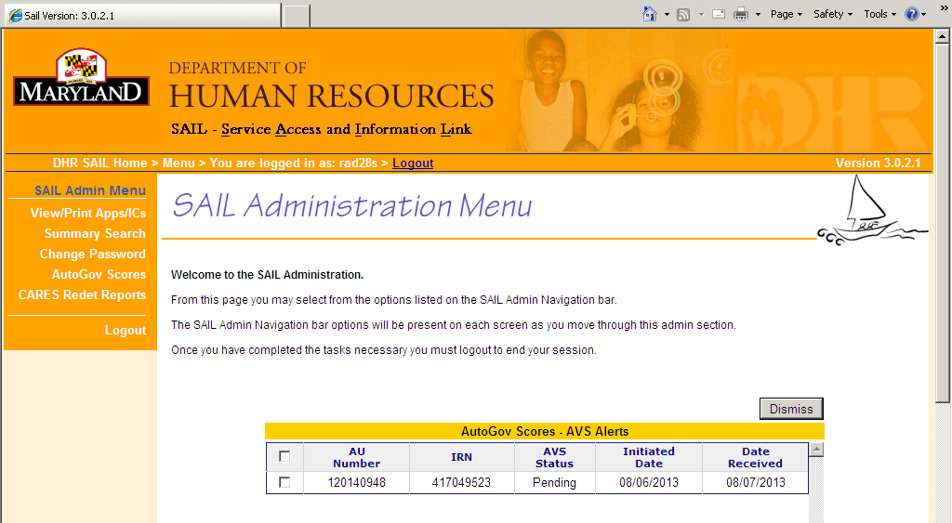
This alerts page will appear each time you log in AutoGov

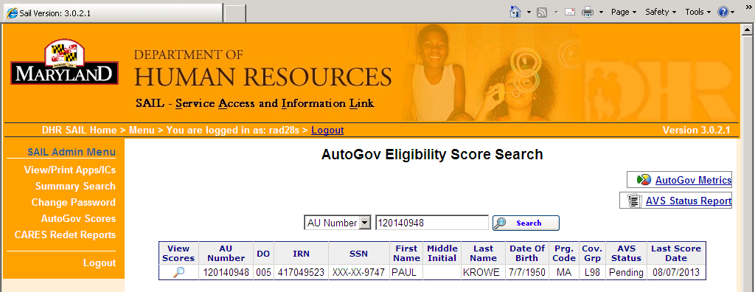
AutoGov Score Page with a filled AVS Status
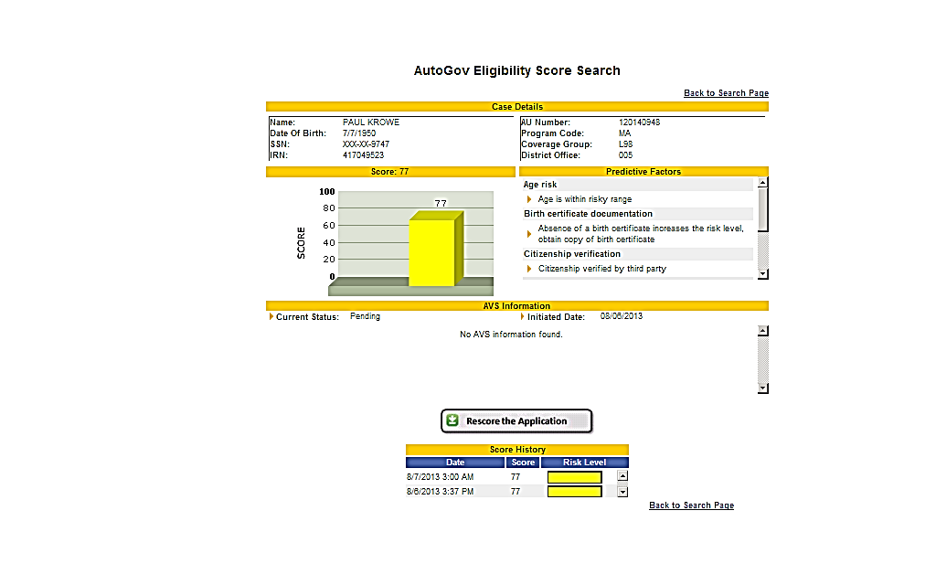
AVS data request acknowledged waiting on response from financial institutions
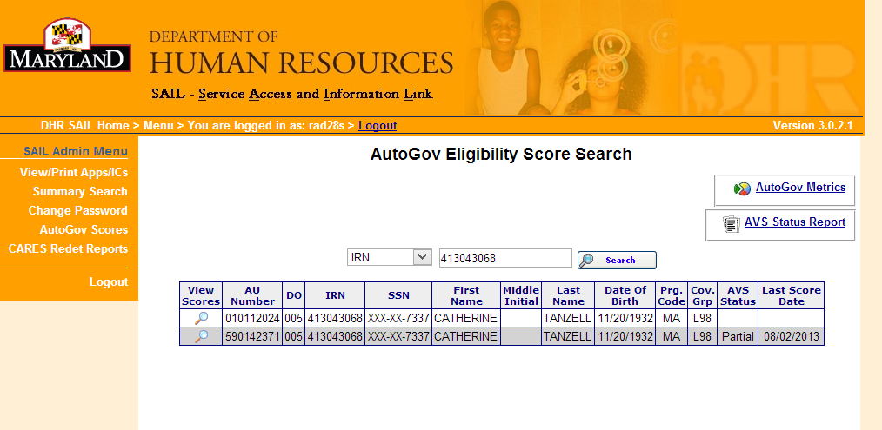
AVS information is available
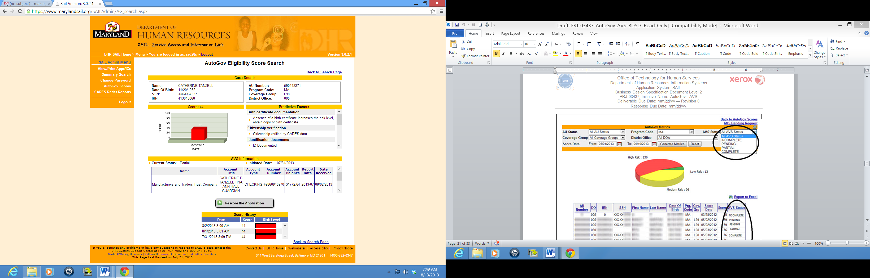
AutoGov View Score Page with AVS Information

AU Num | IRN | AVS Status | Initiated Date | Transaction Date
211101014 | 156893711 | Completed | 5/10/13 12:00 AM | 5/14/13 12:00 AM
31201015 | 156789163 | Completed | 5/11/13 12:00 AM | 5/14/13 12:00 AM

AVS will continue to update AutoGov up to 32 days, then the status will change to Completed

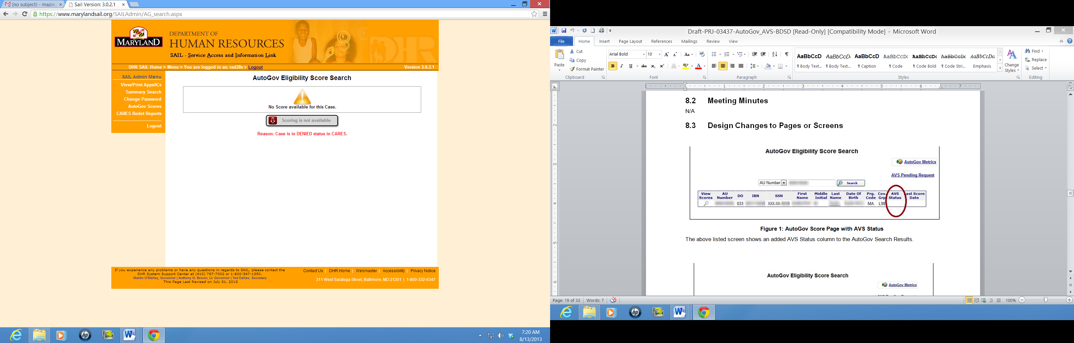
Once the case is denied, the AVS scoring will not be available

