  Department of Human Resources  311 West Saratoga Street  Baltimore MD 21201 | Family Investment Administration  ACTION TRANSMITTAL
Control Number: 12-19 | Effective Date: Upon Receipt
Control Number: 12-19 | Issuance Date: 3-28-12

TO: DIRECTORS, LOCAL DEPARTMENTS OF SOCIAL SERVICES
DEPUTY/ASSISTANT DIRECTORS FOR FAMILY INVESTMENT
FAMILY INVESTMENT SUPERVISORS AND ELIGIBILITY STAFF

FROM: ROSEMARY MALONE, EXECUTIVE DIRECTOR

RE: SKILLS2COMPETE UPDATES FOR WORKS

PROGRAM AFFECTED: TEMPORARY CASH ASSISTANCE (TCA)

ORIGINATING OFFICE: OFFICE OF PROGRAMS

SUMMARY:

MD RISE provides customers with skills training and other opportunities to attain employment and self-sufficiency. We have aligned MD RISE with Skills2Compete Maryland (Skills2Compete), which is the broader, statewide effort to increase the skills of the State’s workforce.

We updated WORKS to support the new alignment through measuring and monitoring customers’ participation in education and training programs. Skills2Compete is focused on occupational skills training, which includes the categories of BEV (vocational education) and IST (job skills training). We created two new reports and modified existing reports. This action transmittal provides information to local department staff about these changes.

New Terms

Bureau of Labor Statistics (BLS) – The principal fact-finding agency for the Federal government in the broad field of labor economics and statistics.

Maryland Higher Education Commission (MHEC) – The State agency responsible for establishing policies and requirements for Maryland public and private colleges and universities and for-profit career schools.

North American Industry Classification System (NAICS) – These codes represent the standard created and used by BLS to classify business establishments for the purpose of collecting, analyzing, and publishing statistical data related to the U.S. economy. FIA will make annual updates to WORKS to reflect changes to NAICS codes. Use the NAICS codes when classifying a job title or profession for the customer’s current employment or work history.

Classification of Instructional Programs (CIP) – These codes represent the classification system developed by the US Department of Education to track and assess fields of study and program completion activity. We will update the CIP codes in WORKS quarterly. Use the CIP codes when classifying training or education (BEV/IST) program activities for customers.

ACTION REQUIRED:

To Record Work History in WORKS:

Search for the customer in the WORKS database by Social Security Number (SSN) or Client Identification (Cl ID).

Select the TCA recipient program on the Search Results page.

Click on the Work History link to record the customer’s work history.

Click the Add New Work History button to record work history data.

Complete the following fields:

- Employer Name: Enter the name of the customer’s past or current employer.
- Job Title: Enter the past or current occupation of the customer.
- NAICS (new field): Select the industry classification under which the customer’s job title is classified. To do this type in either the name of the customer’s profession or the first 3 digits of the classification code of the job title.
- Link to BEV/IST Activity (new field): Select the BEV or IST activity as either currently enrolled in or was previously enrolled in, if this activity led to the customer’s employment history being recorded.
- Certificate awarded? (new field): Select the appropriate response.
- Start Date: Enter the date the customer began the employment.
- End Date: Enter the date the customer’s employment ended if the customer is no longer working. If the customer is still employed, leave this field blank.
- Hourly rate: Enter the customer’s hourly rate of pay.
- Hrs/wk: Enter the number of hours per week the customer is scheduled to work.
- Reason for leaving: Select the reason from the drop down list for why the customer left the job if the customer is no longer working with this particular employer. If the customer is still employed, select “Still Employed”.
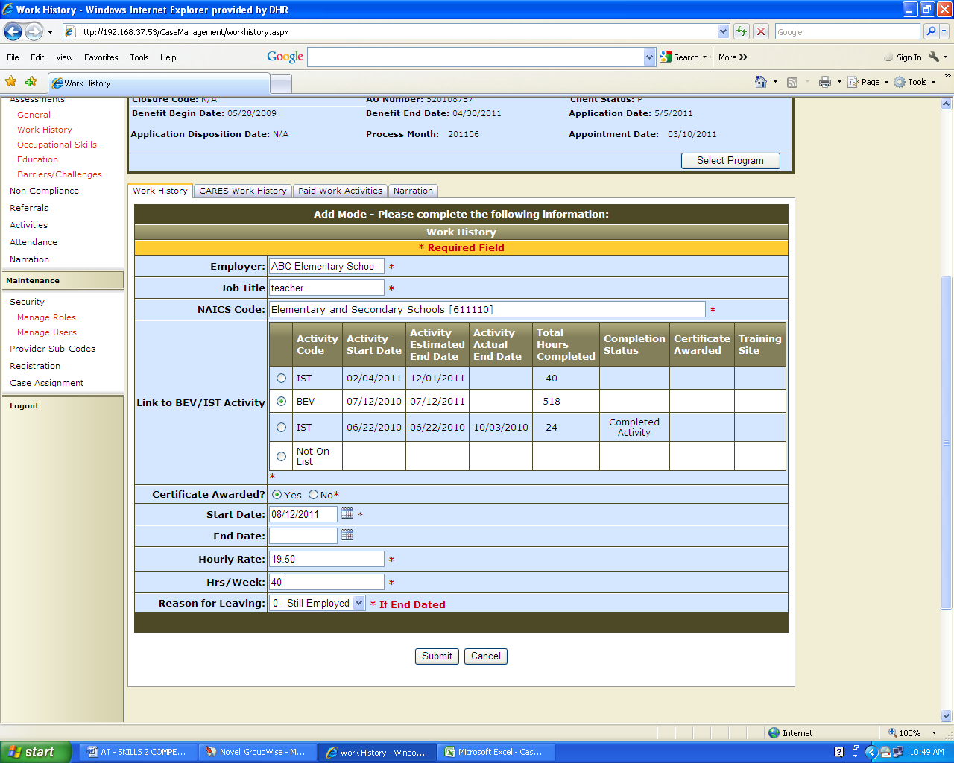

Click the Submit command to enter the data into the database.

REMINDER

If the customer is currently working, remember to add the customer’s employment information to the Activities screen as well.

Recording BEV and IST activities:

Search for the customer in the WORKS database by SSN or Cl ID. Select the TCA recipient program on the Search Results page.

Click on the Activities link to record the customer’s work activity.

Click either Add New Activity or the Edit command next to the BEV or IST activity code already displayed in the customer’s activity list.

Enter BEV in the Activity Code field to allow the screen to extend.

Complete all of the highlighted fields:

- The Start Date: Enter the date the customer began the activity.
- The Estimated End Date: Enter the date the customer is likely to complete the activity.
- The Length of Training (new field): Enter the number of months or weeks the customer is scheduled to be in the activity. If the program is expected to last for 24 months enter 24 months and 0 weeks. Example: If the program is expected to last for 3 weeks, enter 0 months and 3 weeks.
- The Provider Sub code: Select the appropriate provider sub code. Each local jurisdiction has sub codes specifically loaded in WORKS for their jurisdiction.
- Scheduled Hrs per week: Enter the number of hours the customer is scheduled to attend this activity.

Training Site Information

- Job title: Enter the job title, if appropriate. The field can be left blank, since it is not highlighted with a red asterisk.
- CIP category (new field): Click the drop down arrow and select the appropriate CIP category.
- CIP Intermediate (new field): Click the drop down arrow and select the appropriate CIP intermediate category.
- CIP program (new field): Click the drop down arrow and select the appropriate CIP program.
- Training site list (new field): When the 3 previous fields are completed, a list of training sites will appear. Select the appropriate training site for your customer. Once you have selected the training site, the rest of the training site information should automatically populate such as the training site name, address, contact person and phone number.
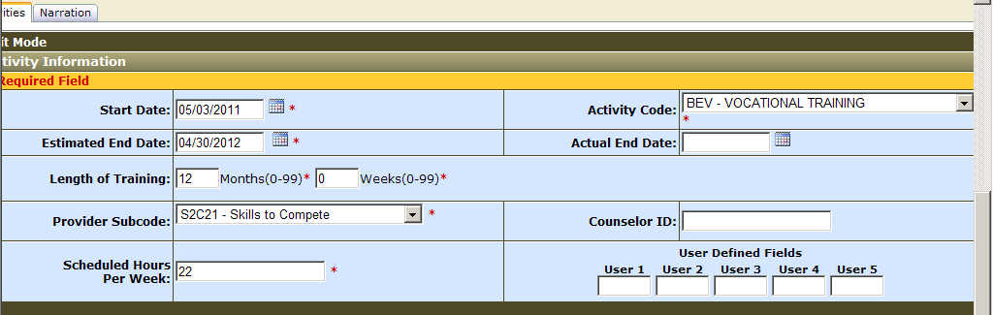

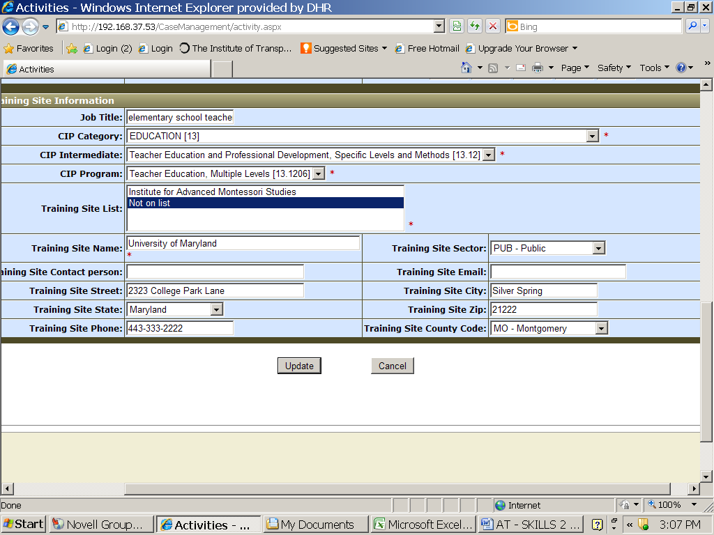

If your customer receives their training or education program at a site that does not appear in the drop down box, select, “Not on the List” and manually enter the training site address and contact information.

Click the Submit or Update command and enter the data into the database.

Adding Employment Activities:

Click on the Activities link to record the customer’s employment activity.

Click the Add New Activity button.

Enter the appropriate employment code (WEJ, WSP, WSU) in the Activity Code field to allow the screen to extend. Complete all of the highlighted fields:

- Start Date: Enter the date the customer began the job.
- Estimated End Date: If known, enter the scheduled date the customer will complete the job. Project an end date if the employment appears to be permanent, such as the end of the calendar year.
- Provider Sub code: Select the appropriate provider sub code. Each local jurisdiction has sub codes specifically loaded in WORKS for their jurisdiction.
- Scheduled Hours Per Week: Enter the customer’s scheduled number of work hours.

Employment Information Section

- Job Title: Enter the name of the customer’s occupation/job title.
- NAICS code (new field): Select the appropriate NAICS code for the customer’s occupation.
- Employer Name: Enter the employer’s name.
- Hourly Wages: Enter the customer’s hourly earnings.
- Work Sector: Select the appropriate employment sector from the drop down list.
- Employer’s Street Name: Enter the employer’s address.
- City: Enter the city.
- State: Select the appropriate state code from the drop down selection.
- Zip: Enter the zip code.
- Medical Benefits: Select the appropriate medical benefits information that applies.
- Leave Benefits: Select any leave benefits the customer may be getting from the employer.
- State Contractors: Select the appropriate state contractor. If the employer is not a state contractor, select “Not a State Contractor”.
- Hiring Agreements: Select the hiring agreement used to employ the customer, if appropriate.

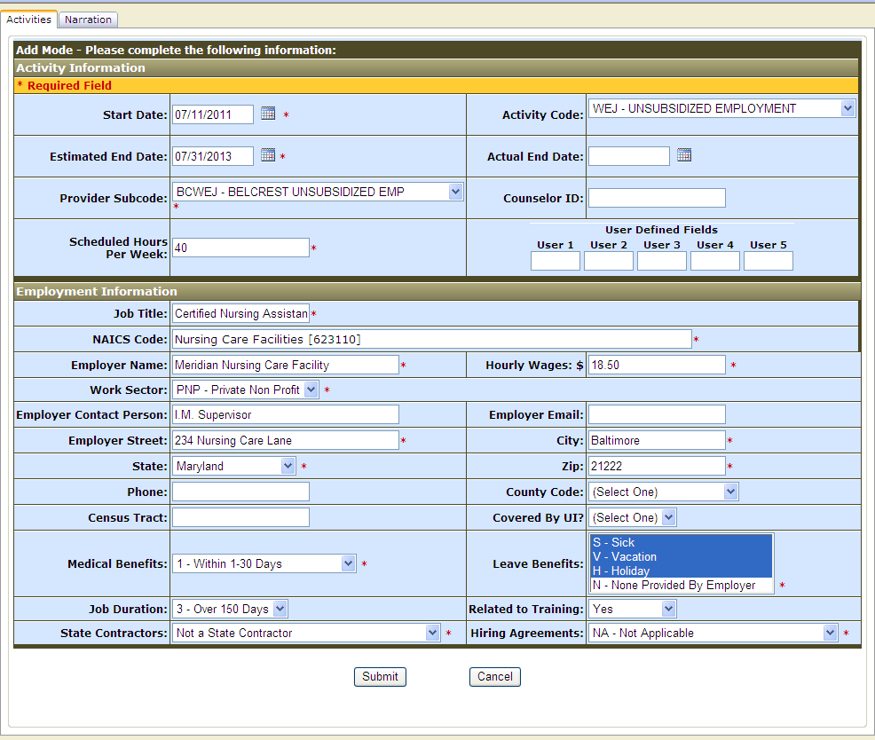

Changes to Reports:

We added CIP or NAICS code fields to 6 existing reports. They are:
- Client Activity Record Report
- Client Activity Status Report
- District Office Status Change Report
- Work Sector Activity Report
- Employment Discrepancy Work Programs Data Report
- Work Opportunity Statistical Report

WORKS has two new Skills2Compete reports to track the number of customers enrolled in BEV/IST activities at the local level and statewide.

Accessing Skills2Compete Local Reports

Go to the Reports section of the Navigation area and click on the Local link.
Click on the Skills2Compete report link on the Local Reports menu.
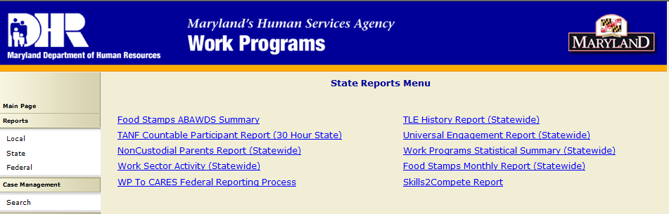

Complete the following:

- LDSS Code: Select either All or a specific LDSS.
- District Office: Click on either All District Offices or Select District Office(s).
- Start Date: Click on the date calendar to enter the appropriate start date.
- End Date: Click on the date calendar to enter the appropriate end date.
- Provider Sub-code: Select a specific Provider Sub-code or bypass the field.
- Activity Code: Select the desired activity code.
- CIP code: Click on Launch CIP Wizard.

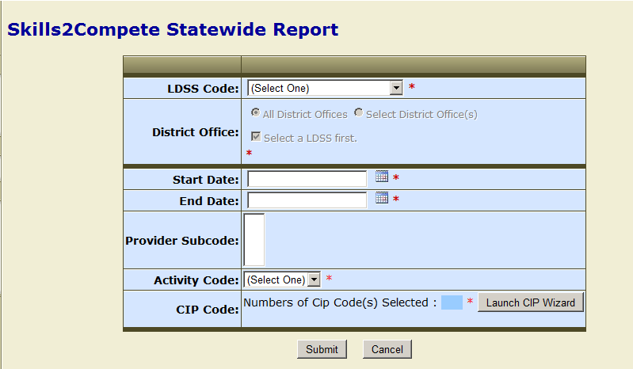

- Launch the CIP Wizard by doing the following:
- Click on Expand All to get all of the CIP code categories.
- Click on Check All if you want to launch all of the CIP codes or for specific codes simply click the CIP code(s) you want.
- Click on Save Selection. You will go back to the report input screen.
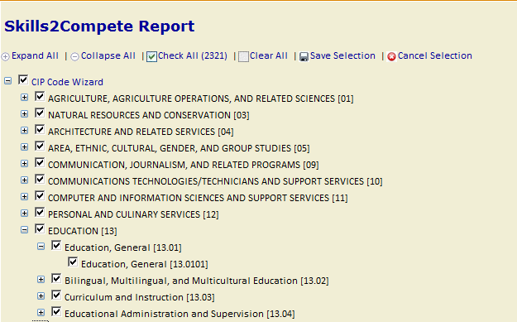

- Click Submit to enter the report data.

WORKS will generate a report, which you can export to Excel or PDF. The report tallies the totals and percentages for Customers in Training, BEV/IST Activities Total, BEV/IST Overall Count, BEV/IST Completed, BEV/IST Certificate Awarded Count and BEV/IST Industry Recognized Training.

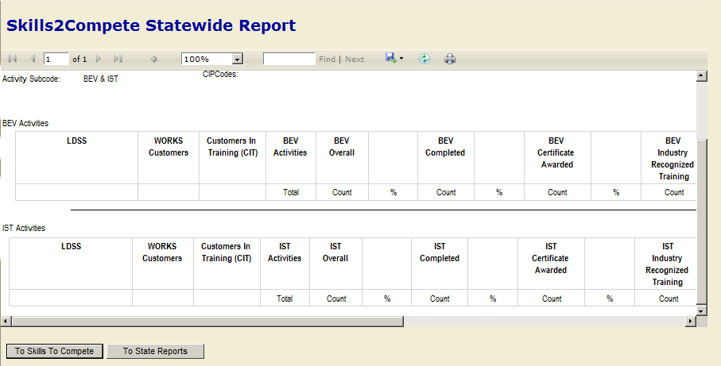

Accessing Skills2Compete Local Reports:

Go to the Reports section of the Navigation area and click on the Local link. On the Local Reports menu, click on the Skills2Compete report link.

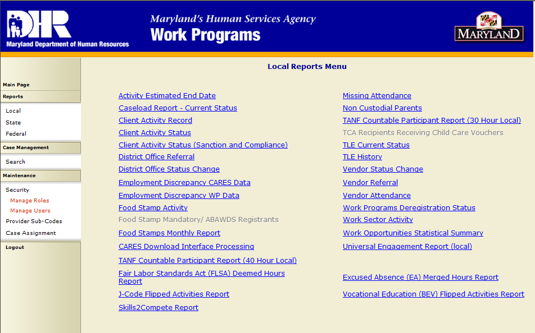

Complete the following fields:

  - LDSS Code: Select the appropriate local department.
  - Start Date: Select the desired start date by clicking on the calendar next to the field.
  - End Date: Select the desired end date by clicking on the calendar next to the field.
  - Activity Code: Select the desired activity code.
  - CIP Code: Click on Launch CIP Wizard (see illustration on page 8)
  - Launch the CIP Wizard by doing the following:
      - Click on Expand All to get all of the CIP code categories.
      - Click on Check All and CIP Code Wizard if you want to launch all of the CIP codes. For specific codes, simply click the CIP code(s) you want.
      - Click on Save Selection. You will go back to the report input screen.
  - All Opened Activities or New Only: Select either all opened activities or new only.
  - Output Options: Select the desired output options.
  - Click Submit to enter the report data.

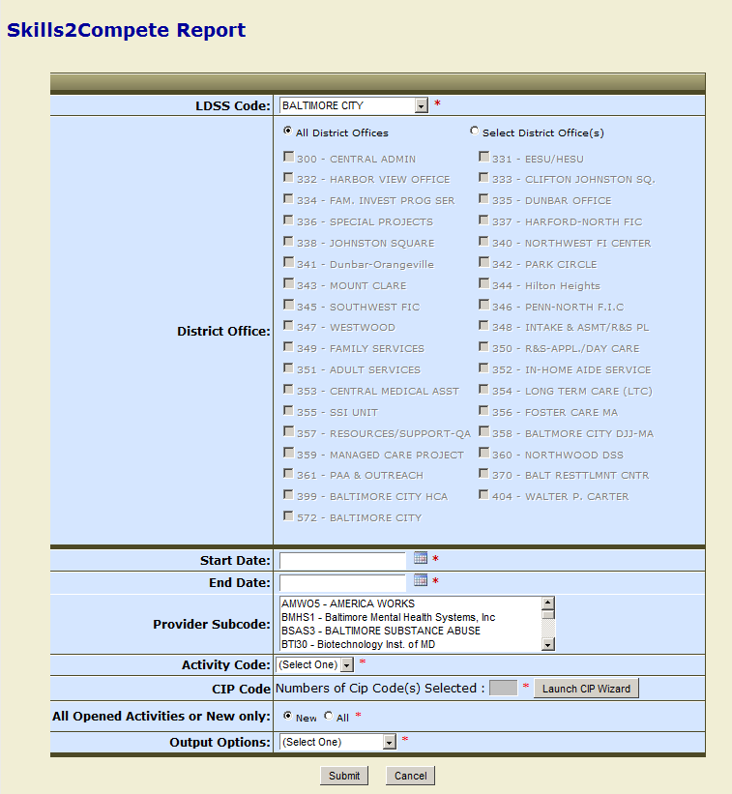

A report will generate, which you can export to Excel or PDF formats, tracking local department activity for BEV/IST placements as well as other related activities.

Attachments:

We are providing the following attachments to assist local department staff in entering the NAICS codes into WORKS.

Attachment 1 contains the NAICS code sector and the description of each sector.
Attachment 2 contains the NAICS code sector with some of the general categories of codes under each sector. This document does not contain all of the NAICS codes developed by BLS. If you need additional NAICS codes, go to www.bls.gov.

INQUIRIES:
For TCA policy questions, please contact Gretchen Simpson at 410-767-7937 or gsimpson@dhr.state.md.us. For questions concerning WORKS or the TCA Work Participation Rate (WPR), contact Faith Freeman at 410-767-7696 or ffreeman@dhr.state.md.us.

Attachment 1

NAICS CODES SECTORS AND DESCRIPTIONS

SECTOR | DESCRIPTION
11 | Agriculture, Forestry, Fishing and Hunting
21 | Mining, Quarrying and Oil and Gas Extraction
22 | Utilities
23 | Construction
31-33 | Manufacturing
42 | Wholesale Trade
44-45 | Retail Trade
48-49 | Transportation and Warehousing
51 | Information
52 | Finance and Insurance
53 | Real Estate and Rental and Leasing
54 | Professional, Scientific and Technical Services
55 | Management of Companies and Enterprises
56 | Administrative and Support and Waste Management and Remediation
61 | Educational Services
62 | Health Care and Social Assistance
71 | Arts, Entertainment and Recreation
72 | Accommodation and Food Services
81 | Other Services ( except Public Administration)
92 | Public Administration

Attachment 2

NAICS CODE LOOKUP GUIDE

11 Agriculture, Forestry, Fishing and Hunting
- 111110 – Soybean Farming
- 11119 – Other Grain Farming
- 112310 – Chicken Egg Production
- 11411 – Fishing
- 115115 – Farm Labor Contractors
21 Mining, Quarry and Oil and Gas Extraction
- 21111 – Oil and Gas Extraction
- 21211 – Coal Mining
- 21311 – Support Activities for Mining
22 Utilities
- 22111 – Electric Power Generation
- 221210 – Natural Gas Distribution
- 221310 – Water Supply Systems
23 Construction
- 236115 – New Single Family Home Construction
- 236118 – Home Renovation
- 236118 – Remodeling and Renovation (General Contractor)
31 Manufacturing
- 31111 – Animal Food Manufacturing
- 31121 – Flour Milling and Malt Manufacturing
- 311615 – Poultry Processing
- 31181 – Bread and Bakery Product Manufacturing
32 Manufacturing
- 32111 – Sawmills and Wood Preservation
- 32199 – All Other Wood Product Manufacturing
33 Manufacturing
- 33131 – Aluminum Production and Processing
- 331511 – Iron Foundries
- 331513 – Steel Foundries
- 336111 – Automobile Manufacturing
42 Wholesale Trade
- 423110 – Automobile and Other Mobile Vehicle Merchant Wholesalers
- 423210 – Furniture Merchant Wholesalers (Other)
- 423220 – Home Furnishing Merchant Wholesalers
- 423410 – Photographic Equipment and Supplies Merchant Wholesalers
- 423440 – Other Commercial Equipment Merchant Wholesalers
- 423850 – Hair Preparations, Professional, Merchant Wholesalers
44 Retail Trade
- 443112 – Cellular Telephone Stores
- 443120 – Computer Stores
- 44619 – Other Health and Personal Care Stores
- 448190 – Bridal Gown Shops
- 448310 – Jewelry Stores
45 Retail Trade
- 451110 – Sporting Goods Stores
- 451211 – Book Stores
- 45291 – Warehouse Clubs and Supercenters
- 453220 – Gift Shops
- 453910 – Pet and Pet Supplies Stores
- 45399 – All Other Miscellaneous Store Retailers
48 Transportation Services
- 485310 – Taxi Service
- 485320 – Limousine Service
- 485991 – Senior Citizens Transportation Services
- 488111 – Air Traffic Control
- 488510 – Freight Forwarding
49 Warehousing
- 491110 – Postal Service
- 492110 – Couriers
- 493110 – Warehousing and Storage
51 Information
- 511110 – Newspaper Publishers
- 512110 – Video Production
- 517210 – Wireless Telecommunications Carriers
- 518210 – Web Hosting/Data Entry Service
- 519120 – Libraries and Archives
52 Finance
- 522110 – Commercial Banking
- 522130 – Credit Unions
- 522291 – Consumer Lending
- 52399 – All Other Financial Investment Activities
- 52411 – Direct Life, Health and Medical Insurance Carriers
53 Real Estate and Rental and Leasing
- 531110 – Building, Apartment, Rental and Leasing
- 531210 – Real Estate Agencies
- 531311 – Property Managers
- 53229 – Other Consumer Goods Rental
- 53241 – Equipment Leasing
54 Professional, Scientific and Technical Services
- 541110 – Law Practices
- 54119 – Other Legal Services
- 541213 – Tax Preparation Services
- 541219 – Bookkeeping
- 541511 – Computer Software Services
- 514519 – Computer Related Services
55 Management of Companies and Enterprises
- 55111 – Management of Companies and Enterprises
56 Administrative and Support and Waste Management and Remediation
- 561110 – Business/Office Management
- 561210 – Facilities Support Services
- 561310 – Employment Placement Services
- 561320 – Temporary Help Services
- 561422 – Telemarketing Bureaus
- 561440 – Debt Collections Services
- 561612 – Security Guards and Patrol Services
- 561720 – Janitorial Services
- 561730 – Landscape Contractors
- 561740 – Carpet Cleaning Services
- 56211 – Waste Collection
- 56291 – Hazardous Material Removal Contractors
61 Educational Services
- 611110 – Elementary and Secondary Schools
- 611210 – Junior Colleges
- 611310 – Colleges, Universities, and Professional Schools
- 61151 – Technical and Trade Schools
- 611710 – Educational Support Services
62 Health Care and Social Assistance
- 62111 – Offices of Physicians
- 621210 – Family Dentists’ Offices
- 621310 – Chiropractor’s Offices
- 621320 – Optometrist’s Offices
- 621330 – Social Worker’s Offices
- 621390 – Other Health Practitioner’s Offices
- 621399 – Registered Nurse’s Offices
- 62151 – Medical and Diagnostic Labs
- 623110 – Nursing Care Facilities
- 62331 – Community Care Facilities
- 624120 – Day Care Centers, Adult
- 62422 – Community Housing Services
- 624410 – Child Day Care Services
71 Arts, Entertainment and Recreation
- 711110 – Theater Companies and Dinner Theaters
- 711120 – Dance Companies
- 711410 – Modeling Agencies
- 712110 – Museums
- 713210 – Gambling Industry
- 713940 – Fitness Centers
72 Accommodation and Food Services
- 721110 – Hotels and Motels
- 722110 – Restaurants, Full Service
- 722211 – Restaurants, Fast Food
- 722212 – Cafeterias
- 722320 – Caterers
81 Other Services
- 81111 – Automotive Mechanical and Electrical Repair and Maintenance
- 81112 – Automotive Body, Paint
- 811192 – Car Washes
- 81211 – Hair, Nail and Skin Care Services
- 81219 – Other Personal Care Services
- 812310 – Laundromats
- 81331 – Social Advocacy Organizations
92 Public Administration
- 921110 – Executive Offices
- 921120 – Legislative Offices
- 921130 – Public Finance Activities
- 922110 – Courts
- 922140 – Correctional Institutions
- 923110 – Administration of Education Programs

