  Department of Human Resources  311 West Saratoga Street  Baltimore MD 21201 | FIA ACTION TRANSMITTAL
Control Number: # 11-14 | Effective Date: January 1, 2011
Control Number: # 11-14 | Issuance Date: December 21, 2010

TO: DIRECTORS, LOCAL DEPARTMENTS OF SOCIAL SERVICES
DEPUTY/ASSISTANT DIRECTORS FOR FAMILY INVESTMENT
FAMILY INVESTMENT SUPERVISORS AND ELIGIBILITY STAFF

FROM: KEVIN M. MCGUIRE, EXECUTIVE DIRECTOR

RE: TRANSITIONAL FOOD SUPPLEMENT BENEFIT CHANGE

PROGRAM AFFECTED: FOOD SUPPLEMENT PROGRAM (FSP)

ORIGINATING OFFICE: OFFICE OF PROGRAMS

SUMMARY

Transitional Food Supplement (TFS) benefit policy was implemented effective January 1, 2003 with Action Transmittal 03-29. This policy was permitted under the Farm Security and Rural Investment Act of 2002. The final rule for this act was published on January 29, 2010. It contained several changes to how we operate TFS. Since some of the changes require system modifications, we have requested a waiver; however, we will implement one provision effective January 1, 2011.

ACTION DUE

Effective January 1, 2011, if a TFS household returns to Temporary Cash Assistance during the 5- month TFS period, we must end the TFS period and recertify the household under normal requirements. If the household reapplies for TCA, complete the TCA application process. Do not break the TFS freeze until the TCA case has been approved.

Be sure to explain to the customer during the TCA application process that the TFS benefit will end upon approval of the TCA grant and that they will be recertified for regular Food Supplement Program (FSP) benefits.

CARES

RECERTIFICATION

If a household begins to receive TCA during the transitional period, it is necessary to recertify the household for regular FSP benefits. This will end the TFS “freeze period.” To ensure that case managers do not break the freeze in error the following prompts were put into place.

If a case manager accesses Option N (Initiate Redetermination) to initiate a recertification, warning message “3001 ATTENTION – MORE TIME REMAINS IN THE TRANSITIONAL FOOD STAMP PERIOD” will appear on the REDE screen.

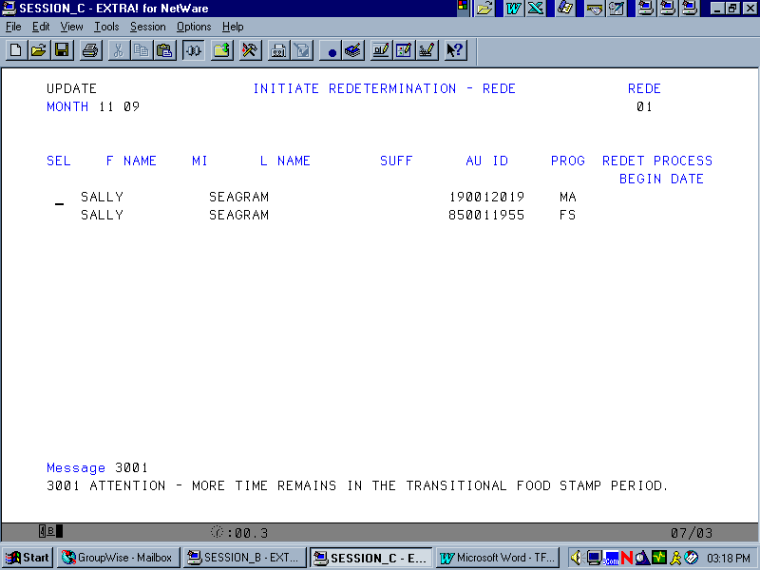

If a second attempt is made to recertify Food Stamps during the “freeze” period, warning message “3002 ARE YOU SURE YOU WANT TO DO THIS?” will appear on the REDE screen.

A further attempt by the case manager to initiate a redetermination will be allowed. Once the redetermination is initiated, the TFS indicator will change to “N”.
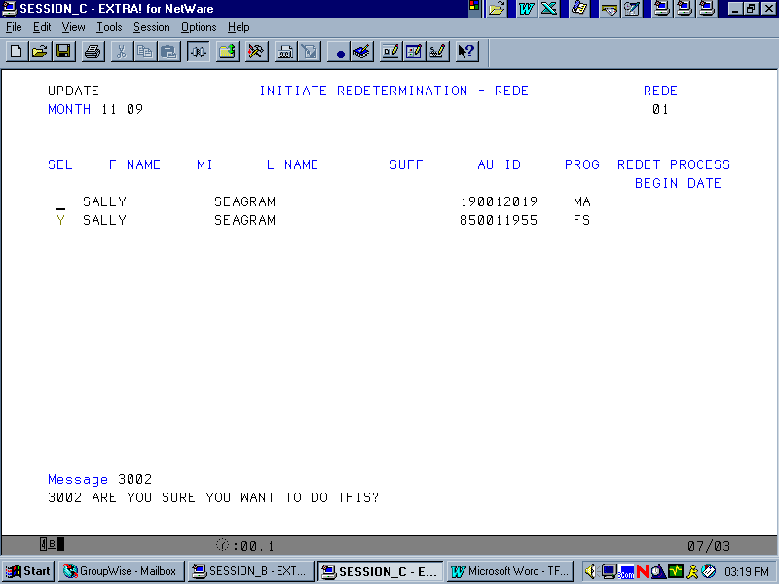

Important Note: CARES will establish the new certification period for 6 months from the date the TFS period ends. This may result in a certification period in excess of 6 months. To prevent this from happening, upon completion of the redetermination, the case manager must pull back the Redet End Date on the FSFI screen so the certification period end date is 6 months from the date of the new certification period.

INQUIRIES
Please direct policy questions to Rick McClendon at 410-767-7307 and systems questions to Joyce Westbrook at 410-238-1299.

cc: DHR Executive Staff
FIA Management Staff
Constituent Services
DHR Help Desk

