  Department of Human Resources  311 West Saratoga Street  Baltimore MD 21201 | Family Investment Administration  ACTION TRANSMITTAL
Control Number: 10-05 | Effective Date: UPON RECEIPT
Control Number: 10-05 | Issuance Date: September 9, 2009

TO: DIRECTORS, LOCAL DEPARTMENTS OF SOCIAL SERVICES
DEPUTY/ASSISTANT DIRECTORS FOR FAMILY INVESTMENT
FAMILY INVESTMENT SUPERVISORS AND ELIGIBILITY STAFF
HEALTH OFFICERS, LOCAL HEALTH DEPARTMENTS
LOCAL HEALTH DEPARTMENT ELIGIBILITY STAFF

FROM: KEVIN M. MCGUIRE, EXECUTIVE DIRECTOR
JILL SPECTOR, ACTING EXECUTIVE DIRECTOR, DHMH/OES

RE: WEB ENHANCEMENTS FOR THE SYSTEMATIC ALIEN VERIFICATION FOR ENTITLEMENT (SAVE) PROGRAM SYSTEM

PROGRAM AFFECTED: TEMPORARY CASH ASSISTANCE (TCA), FOOD SUPPLEMENT PROGRAM (FSP), MEDICAL ASSISTANCE

ORIGINATING OFFICE: OFFICE OF PROGRAMS

SUMMARY:

The Systematic Alien Verification for Entitlement (SAVE) Program is an intergovernmental information sharing partnership developed to help case managers determine immigration status for eligibility for federal benefits. SAVE is an online system which allows case managers to directly access and verify information on a customer’s citizenship and immigration status. Effective July 12, 2009, the United States Department of Homeland Security (DHS) implemented enhancements to the SAVE program. These enhancements improve the speed and efficiency of the SAVE system and provide additional data sources that case managers can use. The conversion will transfer all data entered by the user and retain active and historical case data. This action transmittal informs local departments about the enhancements and provides a guide to accessing the system.

OVERVIEW OF NEW SYSTEM:

Advantages and Features of the New System

- Initial Verification – The initial verification process is now document driven. Case managers will select the document presented by the applicant and input the data based on that document. Additionally, there is now a requirement to submit additional biographic information (name, date of birth, etc.) about the immigrant which ensures a better matching probability. Also, DHS has included an “echo screen” to assists in correcting data entry errors prior to submitting an initial query.

- Re-try Initial Verification Option – If the initial verification results in a data mismatch, the system will display the mismatched data fields and a “Retry” button. Case managers then have the option to correct the mismatched data fields and resend the query as an initial verification or to continue with additional verification without making any changes to the information.

- Additional Data Sources – Case managers have access to six additional data sources. This helps increase the number of successful initial verifications.

- Sponsorship and Work History Data – Case managers still have the ability to access Affidavit of Sponsorship (sponsorship) data or Employment Authorization Document (EAD) work history data. However, the ability to access additional verification and to skip initial verification is no longer an option. The initial verification request must be made first.

ACTION REQUIRED:
The SAVE system has a new website address. To access VIS logon to: www.vis-dhs.gov/WebThree. Use the attached instruction guide for logging on and navigating through the new system features.

INQUIRIES:
Please direct all SAVE inquiries to Marilyn Lorenzo at 410-767-7333 or mlorenzo@dhr.state.md.us or Gretchen Simpson at 410-767-7937 or gsimpson@dhr.state.md.us.

cc: DHR Executive Staff
FIA Management Staff
Constituent Services
DHR Help Desk

The Systematic Alien Verification for Entitlements (SAVE)
Web Enhancements and Features Guide

Introduction
The Systematic Alien Verification for Entitlements (SAVE) Program has added several enhancements to the Web access method to increase the success rate of initial verifications and improve operational effectiveness.

This guide provides you with step-by-step instructions demonstrating the Web access enhancements for the following:

- What’s New
- Verification Process AFTER the Web Access Enhancements
- Initial Verification
- Additional Verification
- Customer Service and Support Options

What’s New

The following enhancements are now part of your Web access features and functions:
Initial Verification  To ensure a higher matching probability, the initial verification request now includes:  - Additional Data Sources – There are now six additional data sources.  - Document-Driven Selection – You can now input the applicant’s document information and biographic information (Last/First Name, Date of Birth) when submitting an initial verification request.  - Confirmation Page – The system returns a confirmation page after you submit the initial verification information. You may review this information and make any necessary corrections before submitting the initial verification request. | Re-Try Initial Verification Option  - If the initial verification request results in a data mismatch, the system will display any mismatched data fields plus a Retry Initial Verification button. You have the option to correct the data and retry the query, or you can proceed with a request for additional verification.  Additional Verification  - The Navigation Menu no longer contains a direct link to the Additional Verification screen. You must first submit an initial verification request followed by an additional verification.

Verification AFTER the Web Access Enhancements

Logging Into VIS
To obtain Web Access to the Verification Information System you must enter
www.vis-dhs.gov/WebThree into the agency’s Web browser.
User Agreement  - Read the Agreement  - Check the “I Agree” box  - Click the “Continue” button  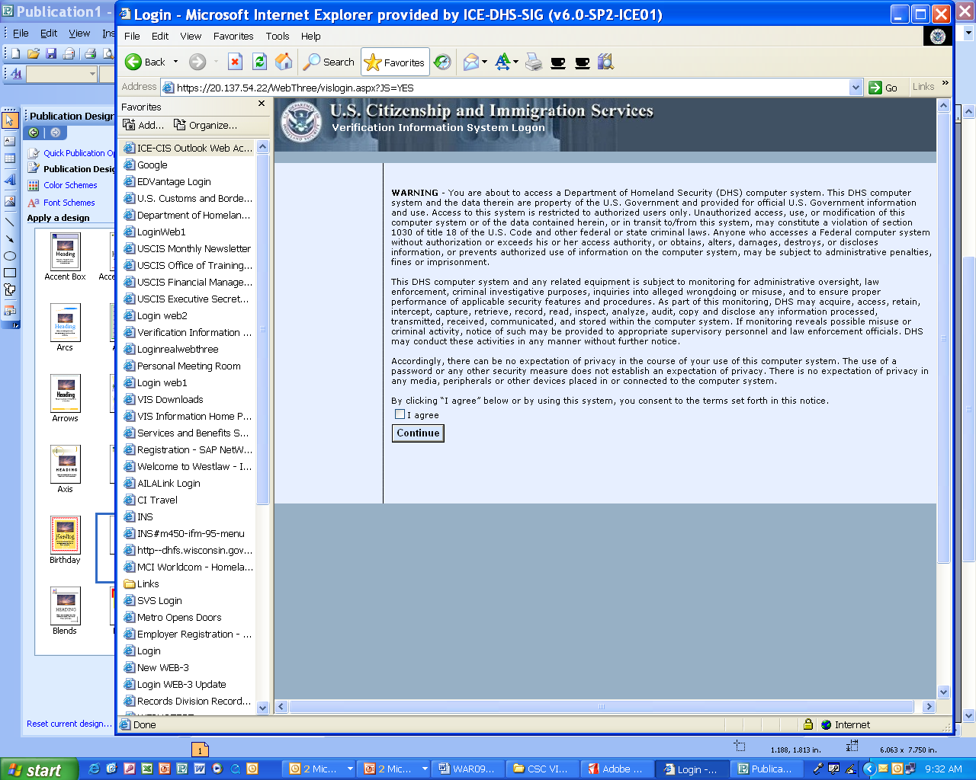 |  | User ID’s and Passwords  Enter:  - Current User Id  - Current Password  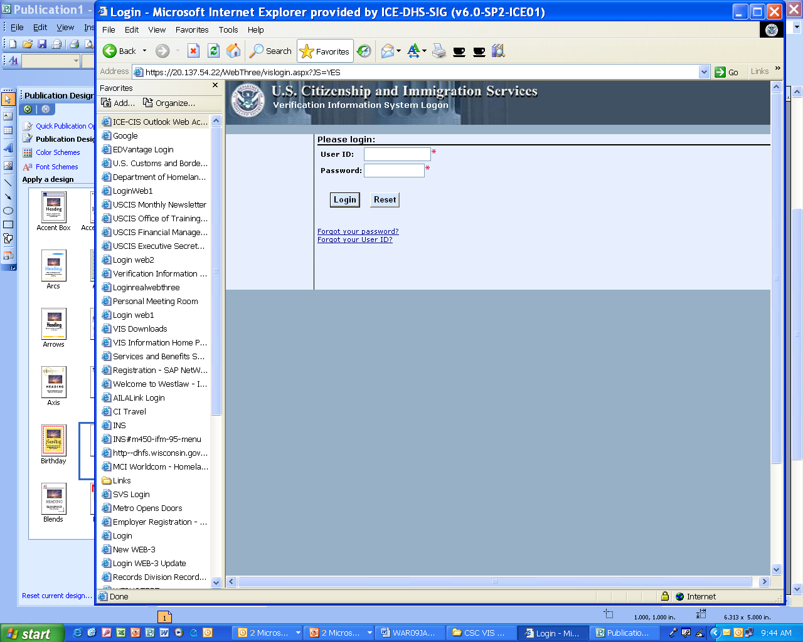

Initial Verification Features and Steps
Select Initial Verification link from the Navigation Menu
1. Enter Applicant Information – contains a list of evidentiary documents (tailored to the Agency
verification requirements)
- Select Document –use the radio buttons to select the document presented by the applicant – only one document per query  - Select “Other” when document is not listed, and provide the Alien Number  - Click Next button to continue the verification process | 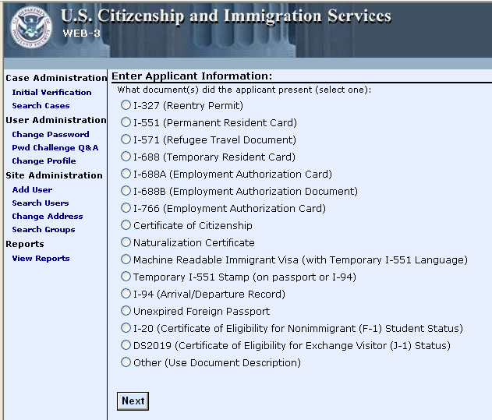

Initial Verification Features and Steps, continued

2. Enter Applicant Information  Based upon the document selected, the system will return the required data fields for you to complete.  - Enter the applicant’s evidentiary document information data (Alien Number, Card Number) and personal information (Last Name, First Name, and Date of Birth) into the required data fields.  - If there are data entry errors when the Next button is pressed, the system returns an error message in a red box at the top of the page with directions to correct the error before proceeding.  - Select the Back button to return to the previous page. | 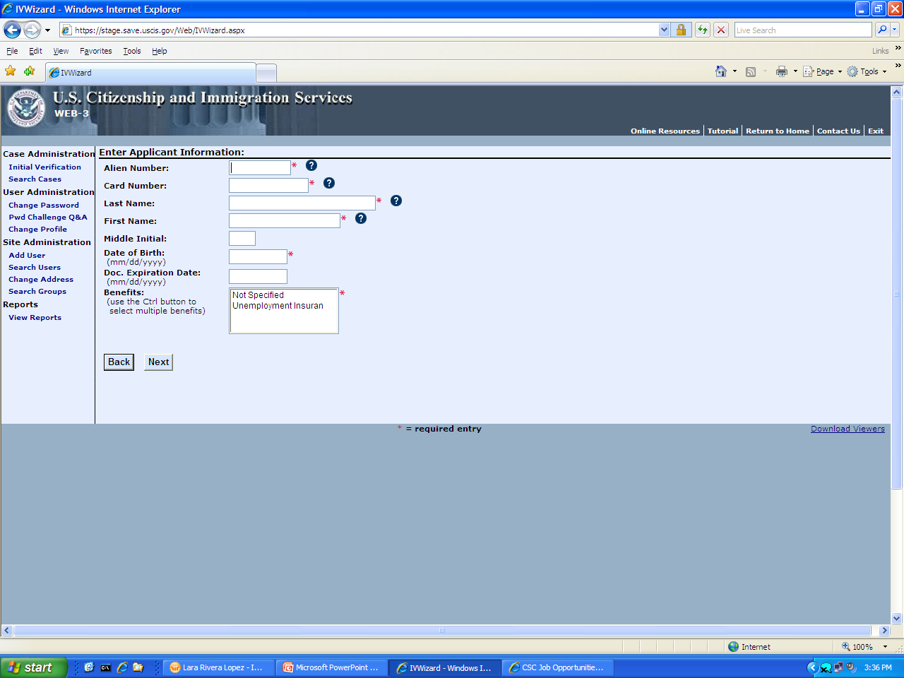  - Helper Text – If you are unsure where the document information is located, just click on the question mark for an explanation of the data field.  - Required Data – All data fields marked with a RED asterisk must be completed to proceed with the initial verification request.

3. Confirm Applicant Information  - This page allows you to confirm all data entered against the document presented by the applicant before submitting the request for initial verification.  - Use the Back button to return to the previous page to correct or modify the data entered.  - Click Next button to submit query. | 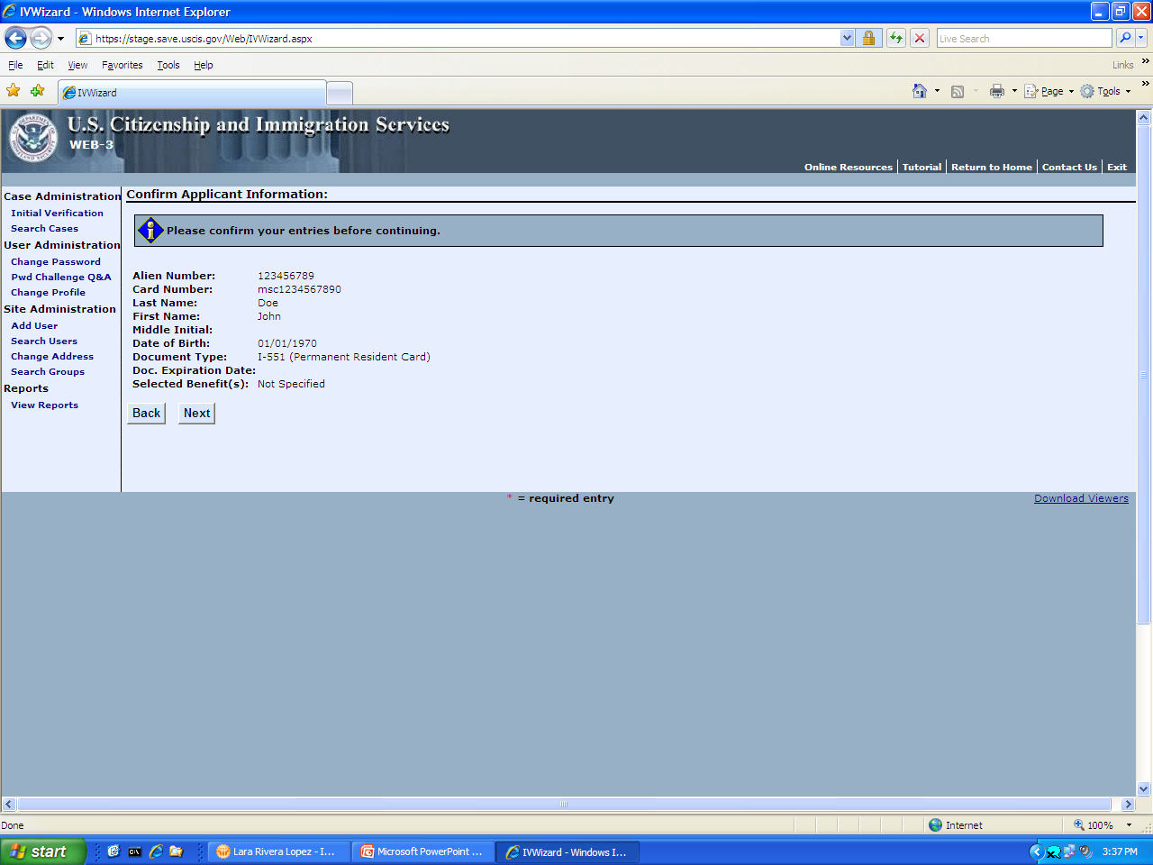  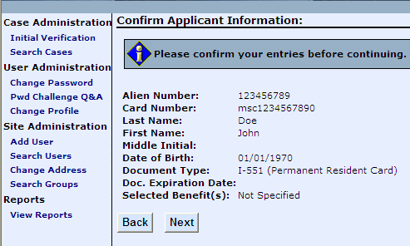  Note: Once you click the Next button, the Agency is charged for the query.

Initial Verification Features and Steps continued

Retry Initial Verification Option
If there is a mismatch in the data entered, the system returns a page with the following information:
- Case Verification Number  - System instruction message in box at the top of the page  - Mismatched data field(s)  - Applicant information submitted  - Selected benefit(s)  User Options:  - Correct the mismatched data field(s) and then click the Retry Initial Verification button  OR  - Click the Request Additional Verification button to proceed with the verification process  OR  - Click Complete and Close Case button to close the case | 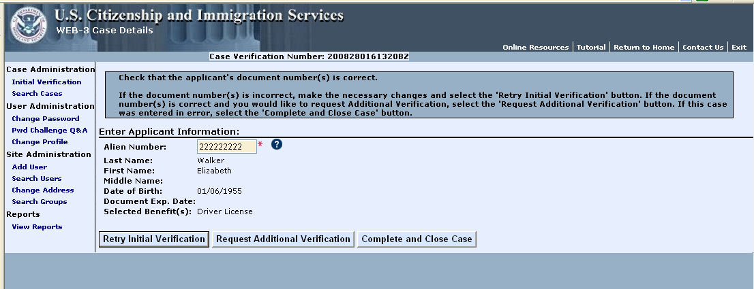  - Helper Text – If you are not sure what the data field requires, just click on the question mark for an explanation of what should be entered in the data field.

Initial Verification Results and Options
The Case Detail Page returns within seconds displaying:

- Case Verification Number  - Initial Verification Case Details  - Initial Verification Results  User Options:  - Click Print Case Details to print a copy of the case  - Click Request Additional Information to input additional information for verification  - Click the Complete and Close Case button to close the case  - Click the Keep Case Open button to keep the case open until further information is available | 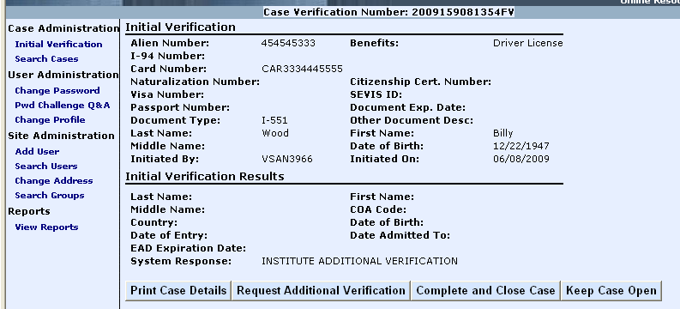  Note: The System Response will display either the applicant’s current immigration status or a system message requesting you to “Institute Additional Verification.”

Additional Verification Steps
Upon receiving the Initial Verification results, you must click the Request Additional Verification button to continue the verification process.
Enter the necessary additional information, such as:  - Case Number  - A.K.A. (“Also Known As” – an alias the applicant may use)  I-94 Number  - Special Comments – additional information that may help resolve the case  - Request Affidavit of Support Data box (available to authorized agencies only)  - Request Employment Authorization Document History Data box (available to authorized agencies only)  Click on the Submit Additional Verification button, and your case will begin processing. | 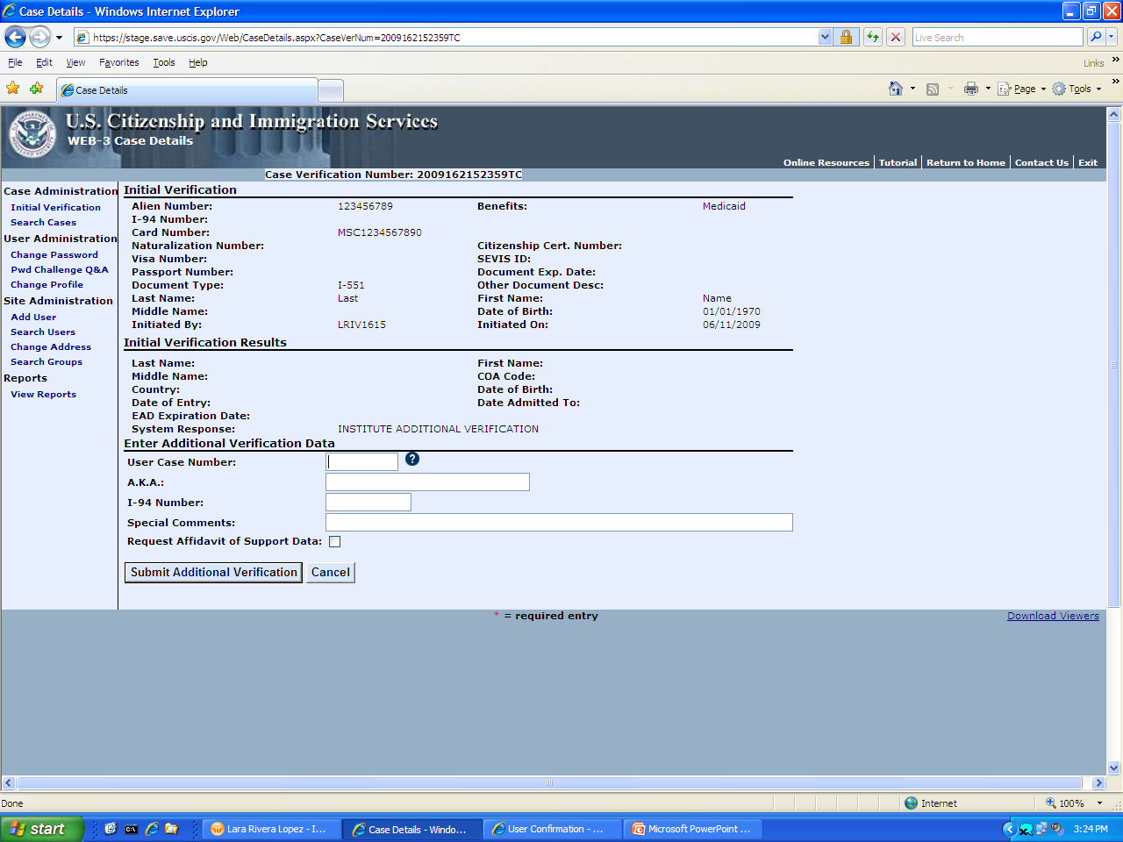  Note: The system returns the results of the additional verification on the Case Summary Page within 3 to 5 federal working days.

Customer Service and Support Options
Customer Service and Support  If you have any questions regarding the Web access enhancements and features, or general questions regarding the SAVE Program, please contact us at (888) 464-4218, or  E-mail: SAVE.Help@dhs.gov  General Information on the Web:  - SAVE Website: www.uscis.gov/save  - USCIS Website: www.uscis.gov |  | Case Status Inquiries  SAVE Customers may call (877) 469-2563  (Please provide the Case Verification Number)  Use this number to check the status for:  R Electronic verification requests pending over 5  federal working days  R G-845 request pending over 20 federal working  days (from USCIS Receipt)  R DHS Case in “Continuance” and pending over 20  days (from USCIS Receipt)  R Congressional Inquiry Cases

