  Department of Human Resources  311 West Saratoga Street  Baltimore MD 21201 | Family Investment Administration  ACTION TRANSMITTAL
Control Number: 15-24 | Effective Date: April 1, 2015
Control Number: 15-24 | Issuance Date: March 31, 2015

TO: DIRECTORS, LOCAL DEPARTMENTS OF SOCIAL SERVICES
DEPUTY / ASSISTANT DIRECTORS FOR FAMILY INVESTMENT
FAMILY INVESTMENT SUPERVISORS AND ELIGIBILITY STAFF
HEALTH OFFICERS, LOCAL HEALTH DEPARTMENTS
MCHP SUPERVISORS AND ELIGIBILITY STAFF
DEPARTMENT OF HEALTH AND MENTAL HYGIENE ELIGIBILITY
OFFICES AND STAFF


FROM: ROSEMARY MALONE, EXECUTIVE DIRECTOR, FIA
DEBBIE RUPPERT, EXECUTIVE DIRECTOR, OES, DHMH

RE: CARES MODIFICATIONS TO SUPPORT HBX

PROGRAM AFFECTED: MEDICAL ASSISTANCE (MA) AND TEMPORARY CASH ASSISTANCE (TCA)

ORIGINATING OFFICE: OFFICE OF PROGRAMS

SUMMARY:

In November 2014, the Health Benefit Exchange (HBX) became the main healthcare platform for Medicaid (MA) customers, and customers applying for subsidized health insurance. Modified Adjusted Gross Income (MAGI) MA households, (F-Track, P-Track and S98 Childless Adult assistance units) now use the HBX system to apply for Medical Assistance, receive eligibility determinations and recertify eligibility for Medical Assistance. Customers have the option of visiting a Local Health Department (LHD) office, Local Department of Social Services (LDSS) office, Regional Connector Entity, or to apply online at www.marylandhealthconnection.gov, to enroll for benefits.

Effective April 1, 2015, the following modifications will occur in CARES to support the HBX system:
- F01 Medical Assistance will no longer be linked to TCA assistance units.

CARES notices will instruct customers how to apply for and receive Medical Assistance using the HBX.

New error messages will remind case managers to process MAGI eligibility in the HBX.

This transmittal provides details of the changes that will occur for MAGI assistance units. Case processing for non-MAGI assistance units (S-Track, G-Track, L-Track, X-Track, T-Track, E-Track and H-Track) will not change.

CARES CHANGES:
Effective April 1, 2015 case managers must process all MAGI (F-Track, P-Track and S98 Childless Adult) assistance units in the HBX. Following are the CARES changes:

- Delinking of F01 Coverage
- For new TCA applications with a benefit month of April 1, 2015 and beyond, TCA AUs will have an AU number with no Medical Assistance coverage (F01) attached.

- TCA assistance units that were active and pended in CARES prior to April 1, 2015 will continue to have F01 tag-a-long coverage until a scheduled or unscheduled redetermination is completed. When redeterminations are completed, the F01 coverage will automatically close, and case managers will need to assist customers to apply for medical coverage in the HBX.

- TCA applications processed in CARES April 1, 2015 and beyond will not display the F01 coverage group on the INCH screen during screening.

- TCA application dates of April 1, 2015 and beyond will not display F01 coverage group on the following screens:

- APP1 Process Appl Months
- APP2 Finalize Application
- CAFI Cash/MA Financial Eligibility
- DONE Session Summary
- ELIG Non-Financial Eligibility Results
- PART Client Participation History
- REIN Reinstatement
- SAIS SAIL Application Inquiry Screen
- SARA Select AU Numbers for Re-Use
- STAT Assistance Status
- VERF Outstanding Verifications

- Sprouting of an F-Track or P-Track MA coverage group will not occur in CARES as of April 1, 2015.

- Existing MAGI assistance units in CARES will continue to trickle.

- If a case manager attempts to process a MAGI assistance unit in CARES on or after April 1, 2015 a soft edit that states: “2713 PROCESS MAGI MA FOR 2015 AND BEYOND VIA HBX” will appear on the following screens:

- INCH
- REIN
- REDE
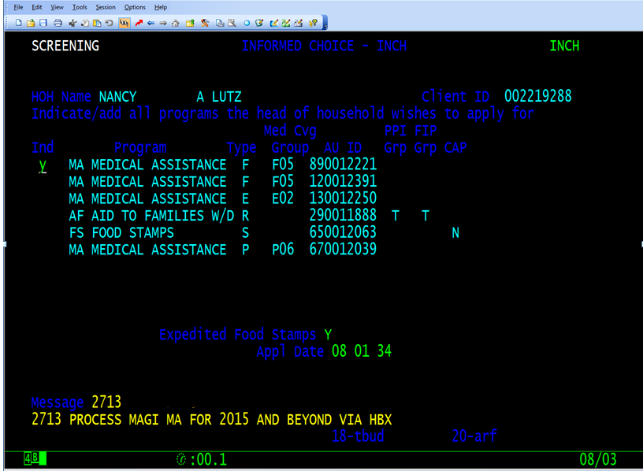
- ELIG
- APP2

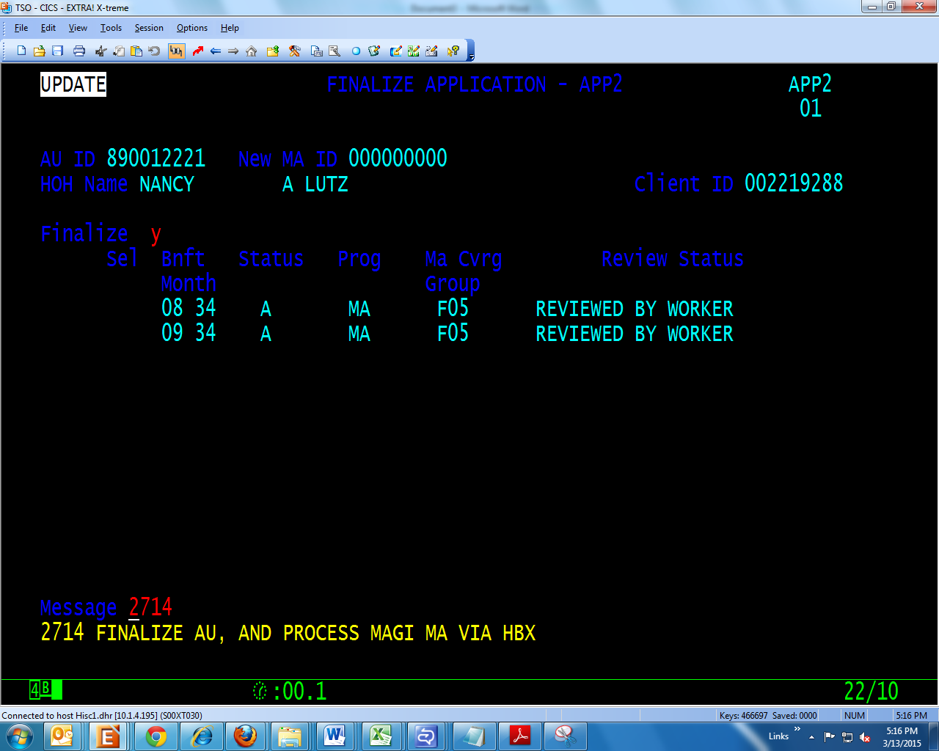

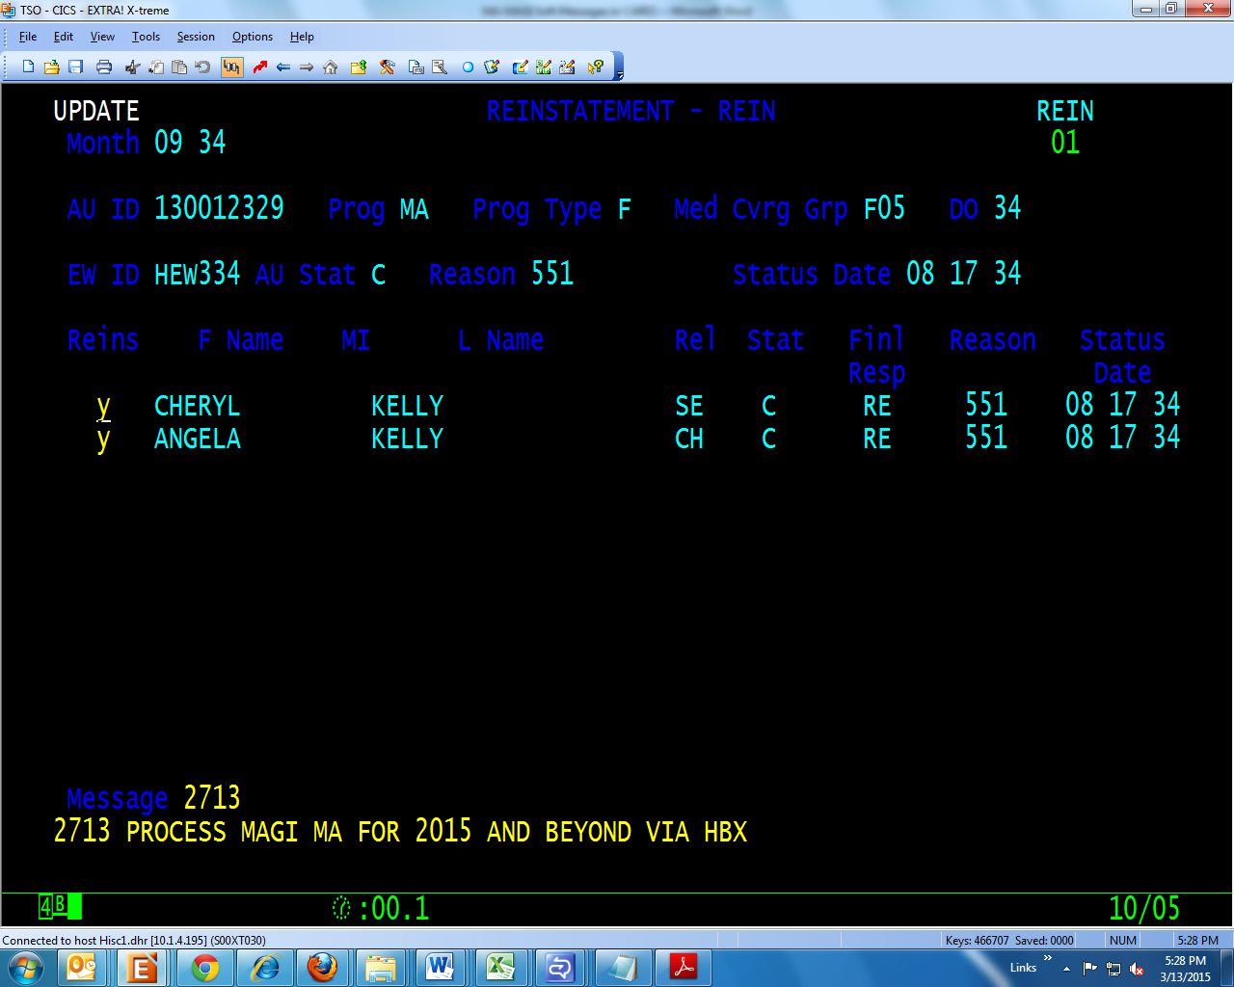

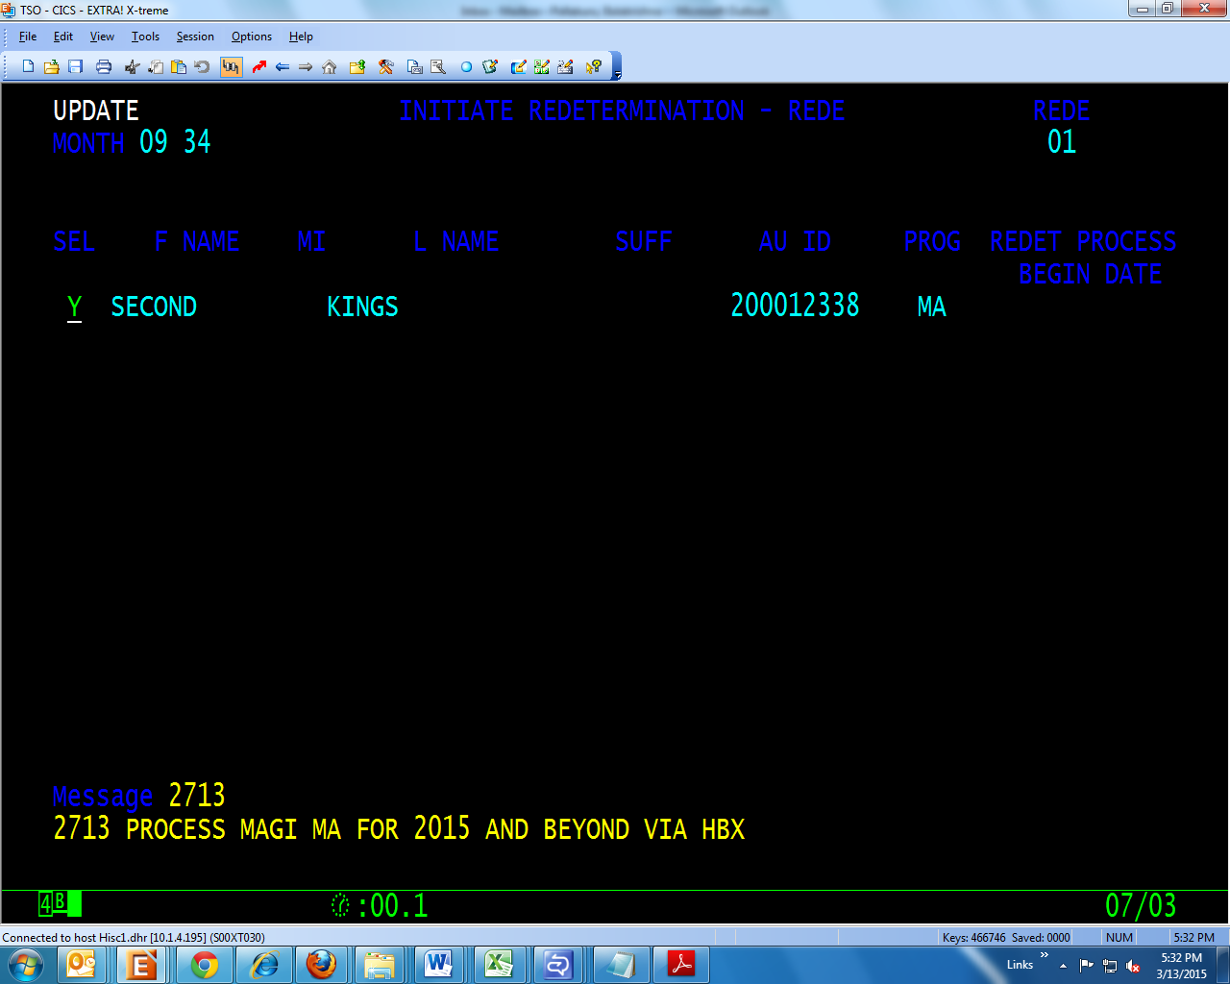

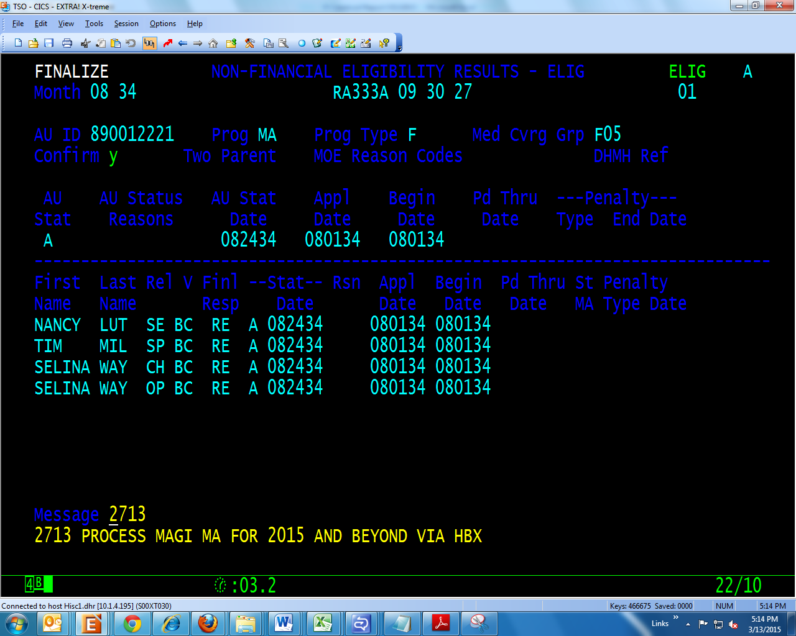

- Effective April 1, 2015 and beyond, a dual participation edit will display in CARES only on MAGI cases (F/P tracks) when a customer is actively receiving Medical Assistance in the HBX system.

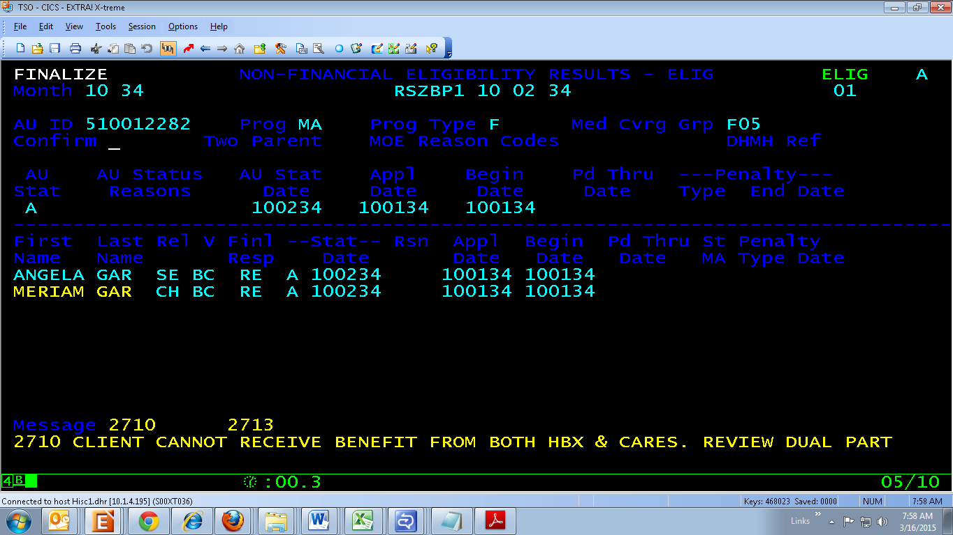

- Notice Changes
The following notices will now instruct customers how to apply for Medical Assistance in the HBX, instead of CARES. Each notice will also contain a list of Maryland Health Connection Connector Entities, Local Department of Social Services (LDSS) and Local Health Department offices.

Notice 4 – Approval

CAROLINE COUNTY District: CAROLINE LDSS
DEPARTMENT OF SOCIAL SERVICES Customer ID: #########
300 MARKET STREET Case Manager: MS. J DOE
DENTON,MARYLAND MD 21629-1229 Telephone: (410) 238-1303
Date: 04/23/15

Insert in Return Envelope with
the Address Below Showing

MS. First Last Name CAROLINE COUNTY
1 WHY ST DEPARTMENT OF SOCIAL SERVICES
ELLICOTT CITY MD 21043 300 MARKET STREET
DENTON, MARYLAND MD 21629

Dear MS. Last Name

APPROVAL FOR TCA

Accepting Cash Assistance is a temporary means of supporting
your family. Our goal for you is Independence.

Based on your application dated ##/##/##, you are eligible for
Temporary Cash Assistance (TCA) effective ##/##/##. Your period of
eligibility is through ##/##. This means you will receive benefits
during this period unless there is a change in your situation.
Before the end of this period, we will contact you to review your
eligibility.

You will get your benefits as part of the Electronic Benefits
Transfer (EBT) System. You will receive your EBT card in the
mail. You will also receive directions for how to set your
personal identification number (PIN). YOU WILL NOT BE ABLE TO
ACCESS YOUR BENEFITS UNTIL YOU RECEIVE YOUR CARD AND SET YOUR PIN.

If you already have an EBT card, you can continue to use that card
and PIN.

If you had an EBT card and cannot find it, call the Customer
Service Call Center at 1-800-997-2222 and request a replacement
card.

Based on information we now have, you are eligible for the
following benefits:

06/24 $ 372.00

07/24 $ 372.00
You will receive benefits for the people listed below:

GIRL
ROSE
IMPORTANT INFORMATION ABOUT APPLYING FOR MEDICAID
To apply for Medicaid you must file an application through Maryland Health Connection (www.marylandhealthconnection.gov), the State’s health insurance marketplace.

You can file a Maryland Health Connection application in the following ways:

- Online at www.marylandhealthconnection.gov. You’ll first need to create a user account then go to “Start New Application” from the Quick Links on the Account Home page.

- By calling the Call Center at 1-855-642-8572 (TTY): 1-855-642-8573).
- In person at your local Health Department, local Department of Social Services or regional Connector Entity.
- By mailing a paper application. You can request a paper application by contacting the Call Center.

If you have any questions or need assistance with submitting an application, contact the Maryland Health Connection Call Center at 1-855-642-8572 (TTY): 1-855-642-8573).

Language services are available to assist you. If you need assistance, call 1-855-642-8572 (TTY): 1-855-642-8573). Servicios de idiomas están disponibles para ayudarle. Si necesita ayuda, llame al 1-855-642-8572 (TTY): 1-855-642-8573)

Notice 7 – Reinstatement

CAROLINE COUNTY District: CAROLINE LDSS
DEPARTMENT OF SOCIAL SERVICES Customer ID: #########
300 MARKET STREET Case Manager: MS. J DOE
DENTON,MARYLAND MD 21629-1229 Telephone: (410) 238-1303
Date: 04/23/15

Insert in Return Envelope with
the Address Below Showing
MS. First Last Name CAROLINE COUNTY
1 WHY ST DEPARTMENT OF SOCIAL SERVICES
ELLICOTT CITY MD 21043 300 MARKET STREET
DENTON, MARYLAND MD 21629

Dear MS. Last Name
REINSTATEMENT

Based on a review of your case, you will receive Temporary Cash
Assistance (TCA) for ##/##. Your TCA benefit will be $620.00.

You will receive assistance for the following people:

Name
Name
IMPORTANT INFORMATION ABOUT APPLYING FOR MEDICAID
To apply for Medicaid you must file an application through Maryland Health Connection (www.marylandhealthconnection.gov), the State’s health insurance marketplace.

You can file a Maryland Health Connection application in the following ways:

- Online at www.marylandhealthconnection.gov. You will first need to create a user account then go to “Start New Application” from the Quick Links on the Account Home page.
- By calling the Call Center at 1-855-642-8572 (TTY): 1-855-642-8573).
- In person at your local Health Department, local Department of Social Services or regional Connector Entity.
- By mailing a paper application. You can request a paper application by contacting the Call Center.

If you have any questions or need assistance with submitting an application, contact the Maryland Health Connection Call Center at 1-855-642-8572 (TTY): 1-855-642-8573).

Language services are available to assist you. If you need assistance, call 1-855-642-8572 (TTY): 1-855-642-8573). Servicios de idiomas están disponibles para ayudarle. Si necesita ayuda, llame al 1-855-642-8572 (TTY): 1-855-642-8573)

Notice 10 - Deny an Individual

CAROLINE COUNTY District: CAROLINE LDSS
DEPARTMENT OF SOCIAL SERVICES Customer ID: #########
300 MARKET STREET Case Manager: MS. J DOE
DENTON,MARYLAND MD 21629-1229 Telephone: (410) 238-1303
Date: 04/23/15

Insert in Return Envelope with
the Address Below Showing

MS. First Last Name CAROLINE COUNTY
1 WHY ST DEPARTMENT OF SOCIAL SERVICES
ELLICOTT CITY MD 21043 300 MARKET STREET
DENTON, MARYLAND MD 21629

Dear MS. Last Name
DENY AN INDIVIDUAL

Based on your application dated ##/##/##, the following people in
your household are not eligible for TCA for the following months:

JANUARY, 2018

Individual reason(s):
For: Name
THE PEOPLE LISTED CANNOT GET BENEFITS BECAUSE THEY
GET SSI. ACCORDING TO CODE OF MARYLAND REGULATIONS

AF 07.03.03.09 00.00.00.00 00.00.00.00

COMAR Explanation:
A PERSON WHO GETS SSI CANNOT GET TCA BENEFITS.

This action only affects the people listed above.

IMPORTANT INFORMATION ABOUT APPLYING FOR MEDICAID

To apply for Medicaid you must file an application through Maryland Health Connection (www.marylandhealthconnection.gov), the State’s health insurance marketplace.

You can file a Maryland Health Connection application in the following ways:

- Online at www.marylandhealthconnection.gov. You will first need to create a user account then go to “Start New Application” from the Quick Links on the Account Home page.
- By calling the Call Center at 1-855-642-8572 (TTY): 1-855-642-8573).
- In person at your local Health Department, local Department of Social Services or regional Connector Entity.
- By mailing a paper application. You can request a paper application by contacting the Call Center.

If you have any questions or need assistance with submitting an application, contact the Maryland Health Connection Call Center at 1-855-642-8572 (TTY): 1-855-642-8573).

Language services are available to assist you. If you need assistance, call 1-855-642-8572 (TTY): 1-855-642-8573). Servicios de idiomas están disponibles para ayudarle. Si necesita ayuda, llame al 1-855-642-8572 (TTY): 1-855-642-8573

Notice 16 – Closing Notice for TCA, P-Track and F-Track MA

CAROLINE COUNTY District: CAROLINE LDSS
DEPARTMENT OF SOCIAL SERVICES Customer ID: #########
300 MARKET STREET Case Manager: MS. J DOE
DENTON,MARYLAND MD 21629-1229 Telephone: (410) 238-1303
Date: 04/23/15

Insert in Return Envelope with
the Address Below Showing

MS. First Last Name CAROLINE COUNTY
1 WHY ST DEPARTMENT OF SOCIAL SERVICES
ELLICOTT CITY MD 21043 300 MARKET STREET
DENTON, MARYLAND MD 21629

Dear MS. Last Name Client ID #########
CLOSING
Your Medical Assistance will end on ##/##/##.

Reason(s):

NO ONE IN YOUR FAMILY IS ELIGIBLE FOR BENEFITS. ACCORDING
TO CODE OF MARYLAND REGULATIONS
MA 10.09.24.05 00.00.00.00 00.00.00.00

This closure affects the following people:
Name
Individual reason(s):
For:
Name

THE MEMBERS LISTED ABOVE DO NOT MEET PROGRAM AGE
REQUIREMENTS.
MA 10.09.24.03 00.00.00.00 00.00.00.00
IMPORTANT INFORMATION ABOUT APPLYING FOR HEALTH COVERAGE

To apply for Medicaid, Maryland Children's Health Program (MCHP), MCHP Premium and Qualified Health Plans (QHPs) with or without financial assistance that includes advanced premium tax credits and cost-sharing reductions, you must file an application through Maryland Health Connection (www.marylandhealthconnection.gov), the State’s health insurance marketplace.

You can apply through Maryland Health Connection in the following ways:

- Online at www.marylandhealthconnection.gov. You’ll first need to create a user account then go to “Start New Application” from the Quick Links on the Account Home page.
- By calling the Call Center at 1-855-642-8572 (TTY: 1-855-642-8573).
- In person at your local Health Department, local Department of Social Services or regional Connector Entity.
- By mailing a paper application. You can request a paper application by contacting the Call Center.

Medicaid and MCHP enrollment is open year-round. Enrollment in a QHP is only available during Open Enrollment unless you have a life event that qualifies you for a Special Enrollment Period (SEP). If you are no longer eligible for Medicaid for a reason other than failure to renew or have a qualifying life event, you may qualify for an SEP. To see if you qualify, complete the questions in the Special Enrollment Section of the application when you apply.

If you have any questions or need assistance with submitting an application, contact the Maryland Health Connection Call Center at 1-855-642-8572 (TTY: 1-855-642-8573).

Language services are available to assist you. If you need assistance, call 1-855-642-8572 (TTY: 1-855-642-8573). Servicios de idiomas están disponibles para ayudarle. Si necesita ayuda, llame al 1-855-642-8572 (TTY: 1-855-642-8573).

Notice 28 - Redetermination

CAROLINE COUNTY District: CAROLINE LDSS
DEPARTMENT OF SOCIAL SERVICES Customer ID: #########
300 MARKET STREET MS. J DOE
DENTON, MARYLAND MD 21629-1229 Telephone: (410) 238-1303 Date: 07/23/32

Insert in Return Envelope with
the Address Below Showing

MS. First Last Name CAROLINE COUNTY
1 WHY ST DEPARTMENT OF SOCIAL SERVICES ELLICOTT CITY MD 21043 300 MARKET STREET
DENTON, MARYLAND MD 21629

Dear Ms. Last Name:

REDETERMINATION/RECERTIFICATION RESULTS

Based on your redetermination/recertification, you are still
eligible for Temporary Cash Assistance (TCA).
Your period of eligibility is from ##/## through
##/##. This means you will receive TCA during this
period unless there is a change in your situation.
Before the end of this period, we will contact you to review your
eligibility.

You will receive a TCA Benefit of $ 199.00 monthly until there
is a change in your circumstance.

You will receive benefits for the people listed below:

Name

IMPORTANT
It is very important that you notify your case manager if you
move. If your case manager does not have your current address
at all times you will not receive important letters about continuing
eligibility. You must also report changes in income, insurance
and household members within ten days of such changes. If you do
not report these changes eligibility may be canceled.

You will receive a separate notice from the Maryland Health Connection regarding your household’s eligibility for Medicaid, Maryland Children’s Health Program (MCHP), MCHP Premium, and Qualified Health Plans (QHPs) with or without financial assistance that includes advanced premium tax credits and cost-sharing reductions.

Maryland Health Connection Connector Entities

Region | Counties Served | Entity Name | Address and Phone Number
Central | Baltimore City, Baltimore, and Anne Arundel | HealthCare Access Maryland | 201 E. Baltimore Street, 15th Fl.  Baltimore, MD 21202  (877) 223-5201
Capital | Montgomery and Prince George’s | Montgomery County Department of Health & Human Services | 8818 Georgia Avenue  Silver Spring, MD 20910  (240) 773-8250
Lower Eastern Shore | Wicomico, Somerset, and Worcester | Worcester County Health Department | 424 West Market Street  Suite A  Snow Hill, MD 21863  (855) 445-5540
Southern | Calvert, Charles, and St. Mary’s | Calvert Healthcare Solutions | 234 Merrimac Court  Prince Frederick, MD 20678  (855) 339-3007
Upper Eastern Shore | Harford, Cecil, Kent, Queen Anne’s, Talbot, Caroline, and Dorchester | Seedco | 216 E. Pulaski Highway  Suite 212  Elkton, MD 21921  (410) 996-4839
Western | Garrett, Allegany, Washington, Frederick, Carroll, and Howard | The Door to Healthcare Western Maryland, Healthy Howard | 8930 Stanford Blvd.  Columbia, MD 21045  (855) 288-3667

Local Department of Social Services (LDSS) and Local Health Department (LHD) Offices

Locality | LDSS Office Address and Phone Number | LHD Office Address and Phone Number
Allegany Co | 1 Frederick St  Cumberland, MD 21502  (301) 784-7000 | 12501 Willowbrook Rd  Cumberland, MD 21502  (301) 759-5000
Anne Arundel Co | Annapolis  80 West St  Annapolis, MD 21401  (410) 269-4500  Glen Burnie  7500 Ritchie Hwy  Glen Burnie, MD 21061  (410) 269-4500 | 1 Harry S. Truman Pkwy, Suite 200  Annapolis, MD 21401  (410) 222-7095
Baltimore Co. | Catonsville  746 Frederick Rd  Catonsville, MD 21228  (410) 853-3450  Dundalk  1400 Merritt Boulevard, Suite C,  Baltimore, MD 21222  (410) 853-3400  Essex  439 Eastern Ave  Essex, MD 21221  (410) 853-3800  Reisterstown  130 Chartley Dr  Reisterstown, MD 21136  (410) 853-3010  Towson  6401 York Rd  Baltimore, MD 21212  (410) 853-3340 | 6401 York Rd 3rd Fl  Towson, MD 21212  (410) 887-2773
Calvert County | 200 Duke St  Prince Frederick, MD 20678  (443) 550-6900 | 280 Stratford Rd  Barstow, MD 20610  (410) 535-5400

Locality | LDSS Office Address and Phone Number | LHD Office Address and Phone Number
Caroline County | 207 South Third St  Denton, MD 21629  (410) 819-4500 | 403 S. 7th Street  Denton, MD 21629  (410) 479-8000
Carroll County | 1232 Tech Ct, Ste. 1 Westminster, MD 21157  (410) 386-3300 | 290 S Center St  Westminster, MD 21158  (410) 876-2152
Cecil County | 170 East Main St  Elkton, MD 21921  (410) 996-0100 | 401 Bow St  Elkton, MD 21921  (410) 996-5100
Charles County | 200 Kent Ave  LaPlata, MD 20646  (301) 392-6400 | 200 Kent Ave  LaPlata, MD 20646  (301) 392-6400
Dorchester County | 627 Race St  Cambridge, MD 21613  (410) 901-4100 | 3 Cedar St  Cambridge, MD 21613  (410) 228-3294
Frederick County | 100 East All Saints St  Frederick, MD 21701  (301) 600-4555 | 350 Montevue Lane  Frederick, MD 21702  (301) 600-1029
Garrett County | 12578 Garrett Hwy  Oakland, MD 21550  (301) 533-3000 | 1025 Memorial Dr  Oakland, MD 21550  (301) 334-7720
Harford County | 2 South Bond St Ste 300  Bel Air, MD 21014  (410) 836-4700 | 120 S Hays St  Bel Air, MD 21014  (410) 638-8415
Howard County | 7121 Columbia Gateway Dr Columbia, MD 21046  (410) 872-8700 | 8930 Stanford Blvd  Columbia, MD 21045  (410) 313-5845
Kent County | 350 High St  Chestertown, MD 21620  (410) 810-7600 | 125 S Lynchburg St  Chestertown, MD 21620  (410) 778-1350
Montgomery County | Rockville  1301 Piccard Dr. 2nd Fl  Rockville, MD 20850  (240) 777-4600  Silver Spring  8818 Georgia Ave  Silver Spring, MD 20910  (240) 777-3100 | Rockville LHD  1335 Piccard Dr, 2nd Fl  Rockville, MD 20850  (240) 777-3075  Silver Spring LHD  8630 Fenton St. 10th Fl  Silver Spring, MD 20910  (240) 777-3066

Locality | LDSS Office Address and Phone Number | LHD Office Address and Phone Number
Montgomery County | Germantown  12900 Middlebrook Rd.  Germantown, MD 20874  (240) 777-3420 | Germantown LHD  12900 Middlebrook Rd  Germantown, MD 20874  (240) 777-4448
Prince George’s County | Hyattsville  6505 Belcrest Rd. Gr Fl  Hyattsville, MD 20782  (301) 209-5000  Landover  425 Brightseat Road, Suite 242  Landover, MD 20785  (301) 909-6000  South County MSC  4235 28th Ave, Suite 101  Temple Hills, MD 20748  (301) 316-7700 | 425 Brightseat Road #101  Landover, MD 20785  (401) 324-2933
Queen Anne’s County | 125 Cornet Dr  Centreville, MD 21617  (410) 758-8000 | 206 N Commerce St #1  Centreville, MD 21617  (410) 758-0720
Somerset County | 30397 Mt. Vernon Rd  Princess Anne, MD 21853  (410) 677-4200 | 7920 Crisfield Hwy  Westover, MD 21871  (443) 523-1761
St. Mary’s County | 12110 Leonard Hall Dr Leonardtown, MD 20650  (240) 895-7000 | 21580 Peabody St  Leonardtown, MD 20650  (301) 475-4330
Talbot County | 301 Bay St  Easton, MD 21601  (410) 770-4848 | 100 S Hanson St  Easton, MD 21601  (410) 819-5600
Washington County | 122 North Potomac St Hagerstown, MD 21740  (240) 420-2100 | 1302 Pennsylvania Ave  Hagerstown, MD 21742  (240) 313-3200
Wicomico County | 201 Baptist St Ste 27  Salisbury, MD 21801  (410) 713-3900 | 108 E Main St  Salisbury, MD 21801  (410) 749-1244
Worcester County | 299 Commerce St  Snow Hill, MD 21863  (410) 677-6800 | 9730 Healthway Dr  Berlin, MD 21811  (410) 629-0164

Locality | LDSS Office Address and Phone Number | LHD Office Address and Phone Number
Baltimore City | Harbor View  18 Reedbird Ave  Baltimore, MD 21225  (443) 423-4700  Northeast Regional Office  2000 N. Broadway  Baltimore, MD 21213  (443) 423-6100  Northwest Family Investment Center  5818 Reisterstown Road  Baltimore, MD 21215  (443) 378-4400  Dunbar-Orangeville  2919 E. Biddle Street  Baltimore, MD 21213  (443) 423-5200  Hilton Heights  500 N. Hilton Street  Baltimore, MD 21229  (443) 423-4800  Southwest  1223 W. Pratt Street  Baltimore, MD 21223  (443) 423-7800  Penn-North  2500 Pennsylvania Ave  Baltimore, MD 21217  (443) 423-7600 | 201 E. Baltimore Street, Suite 920  Baltimore, MD 21202  (410) 649-0512

ACTIONS:
Case Managers should take the following actions:

- Remember: Effective April 1, 2015 process all MAGI MA in the HBX.
- Continue to follow the procedures in Action Transmittal 15-13, Health Care Application Procedures.
- Make every attempt to finalize all existing MAGI MA applications initiated in CARES by 3/31/15.
- Review the Client Database Participation History (CDBP) in CARES and MMIS to see if MA already exists in the HBX prior to establishing a new MAGI MA application.
- After finalizing MAGI MA applications, check MMIS three business days after the finalization date to verify active coverage prior to creating C-TADs.

INQUIRIES:
Please direct TCA policy questions to Marilyn Lorenzo at (410) 767-3333 or marilyn.lorenzo@maryland.gov, and CARES questions to La Sherra Ayala at (410) 767-7288 or lasherra.ayala@maryland.gov. For questions about MA policy, please contact the DHMH Division of Eligibility Policy and MCHP at (410) 767-1463 or 1-800-492-5231 (select option 2 and request extension 1463).

cc: DHR Executive Staff
FIA Management Staff
DHMH Executive Staff
DHMH Management Staff
Constituent Services
FIA BSDM

