ATTACHMENT 1

CONSENT FOR THE RELEASE OF

CONFIDENTIAL ALCOHOL AND DRUG TREATMENT INFORMATION

by Substance Abuse Assessment and Treatment Providers to Departments of Social Services

Head of Household ____________________________ DSS Office ____________________________

MA#_______________________ AU ID#_______________________ SS#_______________________

I, ______________________________________________, authorize the substance abuse assessment or
^{Print name}
treatment provider that I am referred to for assessment or treatment, or that is treating me, to report to the Department of Social Services (DSS) office named above the information listed below, if it has this information about me:

- That the substance abuse treatment provider has received my consent form and referral for treatment from the Addictions Specialist;

- That I did not keep an appointment for a comprehensive substance abuse assessment ordered by the Addictions Specialist in the DSS office;

- That a comprehensive substance abuse assessment indicates that I am not in need of substance abuse treatment;

- That I have been referred for substance abuse treatment;

- That I did not schedule and appear for my first appointment for substance abuse treatment within 30 days of referral or as soon as I could get an appointment;

- That I am waiting for room for me in the kind of substance abuse treatment program I was referred to;

- That I am enrolled in a substance abuse treatment program;

- That I am not maintaining active attendance or participation in the treatment program;

- That I have been discharged from a treatment program for noncompliance;

- That I successfully completed the substance abuse treatment that I was referred to;

- That I was referred to another substance abuse treatment program, and the name of that program.

- That I have been tested for drug use and results of the test. (FOR PERSONS CONVICTED OF A DRUG FELONY)

This release is necessary to comply with State law which requires that this information has to be reported to your local DSS office if you are going to receive Temporary Cash Assistance (TCA) benefits, and to receive TCA and Food Stamps if you have been convicted of a drug felony.

I understand that my records are protected under the federal regulations governing Confidentiality of Alcohol and Drug Abuse Patient Records, 42 CFR Part 2, and cannot be reported to anyone without my written consent unless those regulations provide otherwise. I also understand that I can cancel this consent at any time, but the cancellation will not apply to the past acts someone who was covered by this consent at the time and relied on it; if I do cancel this consent, I could lose my TCA or Food Stamp benefits. In any case, this consent will automatically be canceled when my TCA and Food Stamp benefits end.

______________________________________________________________ ________________________
^{Signature} ^{Date}
PROHIBITION OF REDISCLOSURE
This information has been disclosed to you from records protected by Federal confidentiality rules (42 CFR part 2). The federal rules prohibit any further disclosure of this information unless expressly permitted by the written consent of the person to whom it pertains or as otherwise permitted by 42 CFR Part 2. A general authorization for the release of medical or other information is not sufficient for this purpose. The Federal rules restrict any use of the information to criminally investigate or prosecute any alcohol or drug abuse treatment patient.

DHR/FIA 1176 (Revised 10/05) Previous editions obsolete
WHITE – Addictions Specialist Copy YELLOW – Assessor/Treatment Provider PINK – DSS Case Record Copy

SUBSTANCE ABUSE
ATTACHMENT 2

SCREENING REFERRAL FORM

Date ____________________

DSS Office __________________________________________ MA No. __________________

Head of Household __________________________________ AU No. ___________________

Applicant/Recipient Name _____________________________ SS No. ____________________

Address ____________________________________________ Telephone No. ( ) -

_________________________ Zip ___________ □ Drug Felon

DOB _______________ MCO (if applicable) _________________________________

LDSS Case Manager _________________________________ Telephone No. ( ) -

Addictions Specialist Completes

1. □ Customer failed to appear for screening.
2 □ Customer refused to be screened and/or assessed.
3. □ Customer’s screen was negative.
4. □ Customer failed to sign 1176 when substance abuse screen was positive.
5. □ Customer’s screen was positive. (Forward Independence Plan to Addiction Specialist)
6. □ Customer acknowledged a substance abuse problem. (Forward Independence Plan to AS)
7. □ Customer referred for assessment/treatment to: ___________________________ on __________
(Name of Provider) (Date)
8. □ Customer failed to appear for referred assessment/treatment by ___________________
^{( Date)}
9. □ Customer currently in treatment at __________________________________________

Verified by ____________________________ ( ) - _____________
(Contact person at provider) (Telephone No.) ^{(Date)}
10. □ Service Referral made on ______________
^{(Date)}
11. □ Comments: ____________________________________________________________________

______________________________________________________________________________

______________________________________________________________________________

For persons convicted of a drug felony

12. □ Referred for drug testing/assessment to ___________________________on _________________
(Name of Provider) (Date)
13. □ Results □ Positive □ Negative _________________________ □ No Show
^{(Date)}

Addictions Specialist ______________________________ Telephone No. ( ) -

DHR/FIA 1177 (Revised 10/05) Previous editions obsolete

WHITE–Addictions Specialist Copy PINK– DSS Case Record Copy
ATTACHMENT 3
SUBSTANCE ABUSE IDENTIFICATION AND TREATMENT NOTIFICATION

Enrollee Name _________________________________________ AU No.____________________________
MA No.___________________________
Address___________________________________Zip__________ SS No. ____________________________
DOB __________________ Telephone No. ( ) - MCO ____________________________

Addiction Specialist/DSS Office __________________________________________________________________
Address ___________________________________________________ Telephone No. ( ) -
Treatment Provider ____________________________________________________________________________
Address ___________________________________________________ Telephone No. ( ) -
SAMIS Identification No._______________________________ Provider No._____________________________

Part I. Comprehensive Substance Abuse Assessment □ or Drug Test □ (Check one)
- Date provider received consent form and referral _____/_____/_____
- Date of appointment _____/_____/_____
3. Results of drug test: Positive □ Negative □
4. □ Patient failed to keep appointment for comprehensive substance abuse assessment or drug test.
5. □ Comprehensive assessment indicates patient not in need of substance abuse treatment.
6. □ Patient referred for treatment to: __________________________________ on _____/_____/_____.

Signature of addictions specialist ______________________________ Telephone No. ( ) -

Print or type name ______________________________________________ Date ___________________

Part II. Treatment Compliance Notification
Level of Care Provided _________________________________________________________________________
1. Date provider received consent form and referral _____/_____/_____
2. □ Patient failed to appear for initial appointment within 30 days of referral or if no appointment available within 30 days of referral, patient failed to schedule and appear for first available appointment.
3. □ Awaiting available vacancy.
4. □ Enrolled in treatment program
5. □ Not maintaining active attendance/participation.
6. □ Discharged for noncompliance.
7. □ Successfully completed program.
8. □ Referred to _____________________________ on _____/_____/_____.
New Program Date

Admission date: _____/_____/_____ Discharge date: _____/_____/_____

Discharged to (provider) _________________________ Level of Care ____________________________________

New Provider’s Address ________________________ Zip ____________ Telephone No. ( ) -

Signature of addictions specialist _____________________________________ Date _____/_____/_____

Print or type name ____________________________________________ Telephone No. ( ) -

Part III. Work Readiness
- □ Not able to work
- □ Not ready to work but could participate in job readiness/training/education
- □ Able to work.
- □ Other__________________________________________________________________

Signature of addictions specialist ____________________________________ Date _____/_____/_____

Part IV. Case Manager Action Taken Case Manager Name______________________________
- □ Conciliation _____/_____/_____ date began.
- □ Sanction _____/_____/_____ effective date.
- Active Service case □ YES □ NO Comments:_________________________________________________________________

DHR/FIA 1178 (Revised 10/05) Previous editions obsolete
White-Addictions Specialist Copy YELLOW-Assessor/Treatment Provider PINK-DSS Case Record Copy

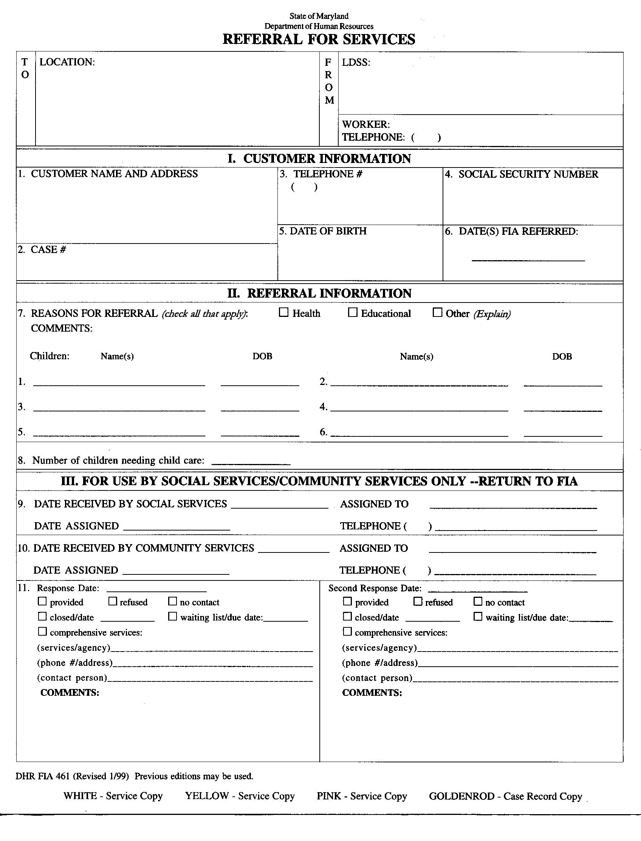
ATTACHMENT 4

