  Department of Human Resources  311 West Saratoga Street  Baltimore MD 21201 | Family Investment Administration  ACTION TRANSMITTAL
Control Number: #08-29 | Effective Date: March 1, 2008
Control Number: #08-29 | Issuance Date: April 17, 2008

TO: DIRECTORS, LOCAL DEPARTMENTS OF SOCIAL SERVICES
DEPUTY/ASSISTANT DIRECTORS FOR FAMILY INVESTMENT
FAMILY INVESTMENT SUPERVISORS AND CASE MANAGERS
HEALTH OFFICERS, LOCAL HEALTH DEPARTMENTS
LOCAL HEALTH DEPARTMENT ELIGIBILITY STAFF

FROM: KEVIN M. MCGUIRE, EXECUTIVE DIRECTOR
CHERYL A. CAMILLO, EXECUTIVE DIRECTOR, DHMH/OES

RE: COLLECTION OF RACE AND ETHNICITY DATA

PROGRAM AFFECTED: ALL PROGRAMS

ORIGINATING OFFICE: OFFICE OF PROGRAMS

SUMMARY:

In October 1997, the federal Office of Management and Budget issued a notice - Revision to the Standards for the Classification of Federal Data on Race and Ethnicity. CARES was recently changed to reflect these federal requirements for collecting information about race and ethnicity. This action transmittal is to inform you of the changes in CARES for collecting information about the race and ethnicity of applicants and recipients.

These changes are in no way meant to single people out based on race or ethnicity.

Note: Prior to this change, the collection of racial and ethnic data was by single race category, only. With the new format customers can choose more than one race.

Beginning March 1, 2008, CARES began to collect this data for all programs under a new two-question format for all new applications and re-certifications.

The first racial/ethnic question asks customers for their ethnicity. The second question asks for their race. Case managers must allow customers to identify themselves as being of more than one race by choosing multiple racial categories.

The customer can select:

- One of two ethnic categories:
- Hispanic or Latino
- Not Hispanic or Latino

- One or more of the following race categories:
- American Indian or Alaska Native
- Asian
- Black or African American
- Native Hawaiian or Other Pacific Islander
- White

See the attachment 2 for definitions of the categories.

ACTION REQUIRED:

Case managers must continue to tell customers that:
- This information is voluntary
- It will not affect eligibility or benefit levels, and
- The reason for the information is to assure that program benefits are distributed without regard to race, color, or national origin.

Case managers must give applicants and recipients the opportunity to self-identify their race and ethnicity. However, if the applicant or recipient chooses not to self-identify, the caseworker is to record ethnicity and one race based on observation.

If the applicant or recipient does not provide the information and if the caseworker is unable to observe the applicant’s race and ethnicity (for example during a telephone interview), leave the race and ethnicity fields in CARES blank.

CARES PROCEDURES:
Effective February 25, 2008 the following changes were made to the CARES DEM1 screen (See attachment 1 below):
- Client Ethnicity Field was added
- The existing Race field was changed to: “CIS Primary Race”
- Five new race codes were added
- New verification valid values were added to both race and ethnicity fields

The Race and Ethnicity Verification field is a required field for all members of a CARES Assistance Unit with a financial responsibility code other than “NM”, including current recipients. This field can be entered during any edit or update CARES function (i.e., interview, process application months, interim change, historical case change, and redetermination).

Client Ethnicity
The codes for this field are:
- H – Hispanic or Latino
- N – Not Hispanic or Latino

Race
The customer can select up to five of the following race codes. The selections are:
- A – Asian
- B – Black or African American
- C – White
- N – American Indian or Alaska Native
- P – Native Hawaiian or other Pacific Islander

Verification Valid Values
The case manager can enter one of the following valid values into the verification field following the race and ethnicity code fields:
- S – Self-disclosed. Race is stated by customer in face-to-face interview
- O – Observed. Race is observed by caseworker in face-to-face interview and customer declines to state race.
- M – Mail-in or telephone interview. The ethnicity and race code fields default to “blank” when M is entered. Blank ethnicity and race fields are not accepted unless the verification code is M.

Error Messages
Case managers cannot exit the DEM1 screen if values are missing or incorrect during the Interview, Process Application Months, Interim Change, Historical Case Change, and Redetermination process.

Hard Error Message Matrix

Field | Invalid Action | Error Code | Error Message Text
Verification | No Value is entered | 3592 | Race and Ethnicity must be updated for this AU member
Verification | Value other than S, M or O is entered | 3593 | Valid Values are S, M or O

Field | Invalid Action | Error Code | Error Message Text
Client Ethnicity | No value is entered and Verification Code is not M | 3598 | Ethnicity must be entered for this AU member
Client Ethnicity | Value entered is not H or N | 3594 | Valid Values are H (Hispanic) or N (Not Hispanic)
Client Race | No valid value entered and Verification Code is not M | 3595 | At least one race code must be selected for this AU member
Client Race | A value other than A, B, C, N or P is entered in any race field | 3596 | Valid Values for Race are A, B, C, N, or P
Client Race | The same valid value for race is entered more than one time | 3597 | A race code can be used only once. Review valid values for race

Case managers will receive a soft/warning edit (yellow asterisk) for the following reason when the customer’s financial responsibility is a value other than NM (Non-member). Case managers can use the PF4 key to exit the DEM1 screen during the Interview, Process, Application Months, Interim Change, Historical Case Change, and Redetermination process.

Soft Error Message Matrix

Field | Action | Warning Code | Warning Message Text
Race/Ethnicity Verification | Race and Ethnicity are blank and the verification field contains an M. M denotes that the data was entered as a result of a mail-in application or phone interview and the customer did not disclose the required information. | 3591 | Can you determine Race/Ethnicity At this time?

Case managers will not be allowed to commit data when there are unresolved errors in the following fields. These edits apply to the CARES functions of Interview, Process Application Months, Interim Change, Historical Case Change, and Redetermination.

Final Edits Error Messages

Field | Invalid Action | Error Code | Error Message Text
Verification | No value entered | 3592 | Race and Ethnicity verification field must be updated for this AU member
Client Ethnicity | No code entered and no M in verification field | 3598 | Ethnicity code must be entered for this AU member
Client Race | No code entered and no M in verification field | 3595 | At least one race code must be selected for this AU member

The race codes in SAIL, CIF and EDD have been modified to match the coding in CARES.

ACTION DUE:

This is policy was effective March 1, 2008.

INQUIRIES:

For questions regarding the CARES procedures please call Gerald Conaway at 410-767-7546.

cc: FIA Management Staff
Constituent Services
OTHS System Support

Attachment 1

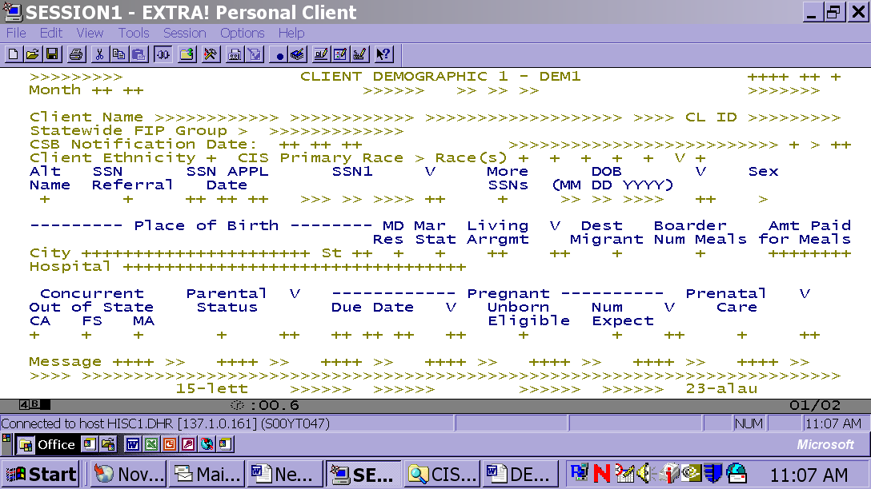

Attachment 2

Racial/Ethnic Categories and Definitions

Ethnicity
Hispanic or Latino. A person of Cuban, Mexican, Puerto Rican, South or Central American, or other Spanish culture or origin, regardless of race.

Race
American Indian or Alaska Native. A person having origins in any of the original peoples of North and South America (including Central America), and who maintains tribal affiliation or community attachment.

Asian. A person having origins in any of the original peoples of the Far East, Southeast Asia, or the Indian subcontinent including, for example, Cambodia, China, India, Japan, Korea, Malaysia, Pakistan, the Philippine Islands, Thailand, and Vietnam.

Black or African American. A person having origins in any of the black racial groups of Africa.

Native Hawaiian or Other Pacific Islander. A person having origins in any of the original peoples of Hawaii, Guam, Samoa, or other Pacific Islands.

White. A person having origins in any of the original peoples of Europe, the Middle East, or North Africa.

