``  Department of Human Resources  311 West Saratoga Street  Baltimore MD 21201 | FIA ACTION TRANSMITTAL
Control Number # 07-20 | Effective Date: Immediately
Control Number # 07-20 | Issuance Date: March 27, 2007

TO: DIRECTORS, LOCAL DEPARTMENTS OF SOCIAL SERVICES
DEPUTY/ASSISTANT DIRECTORS FOR FAMILY INVESTMENT
FAMILY INVESTMENT SUPERVISORS/CASE MANAGERS

FROM: KEVIN M. MCGUIRE, EXECUTIVE DIRECTOR

RE: NATIONAL DIRECTORY OF NEW HIRES (NDNH)

PROGRAM AFFECTED: TEMPORARY CASH ASSISTANCE and Food Stamps

ORIGINATING OFFICE: OFFICE OF PROGRAMS

SUMMARY

The State New Hires process does not include information on federal government employees, people who have jobs in other states or people who work in Maryland for employers with home offices in other states. In Federal Fiscal Year 2005, states participated in a match against the National Directory of New Hires (NDNH). Recently, the United States Department of Health and Human Services, Administration for Children and Families (DHHS, ACF) enhanced the NDNH. Now included are: W-4 (new employment), Quarterly Wage (QW), and Unemployment Insurance (UI). Use of NDNH information helps local departments reduce the number of incorrect payments caused by unreported income and provides information that may help increase work participation rates.

On December 23, 2006, we completed a CARES system migration for the NDNH and NDNH was added to CARES effective January 1, 2007. A NDNH match tells CARES to send the customer a notice, along with employment verification and child care forms. CARES sends new alert 992 to the case manager for all NDNH matches. The alert displays NDNH employment information including the Federal ID number and any current employment as recorded in CARES from the ERN1 screen. You can access management reports through Datawatch.

Case managers must follow local department procedures for establishing potential overpayments and Intentional Program Violations (IPVs).

Example 1: Dawn Johnson receives TCA for herself and her children. Dawn lives in Hagerstown in Washington County. A New Hires match shows that Dawn is employed at Wal-Mart in Martinsburg, W. VA. She has never reported the employment. The Family Investment CARES team reviews the NDNH matches and sends a manual letter to Dawn, requesting verification of the employment and explaining she has 10 days to submit the verification to the case manager. Dawn does not return the requested information. The case manager sends Dawn an adverse action notice and then closes Dawn’s TCA case when the 10-day adverse action period expires and the information was not submitted.

Example 2: Mary Smith receives TCA and FS for herself and her children. An NDNH report shows Mary has been receiving unemployment benefits from Delaware. The case manager contacts Mary and asks her about the information. Mary states she didn’t think the case manager would find out. The case manager takes action on the unreported income for both the TCA and the FS programs including overpayments and a possible Intentional Program Violation (IPV).

NOTE: The NDNH processes unemployment benefit matches on a quarterly basis.

When the customer submits the necessary verification (pay stubs, employer statement, wage form, child care statement), the case manager must review the employment information and determine whether an overpayment exists for unreported or under-reported income. The case manager sends a 10-day adverse action notice for a reduction or termination of benefits.

Do not close the TCA or FS case because the customer did not verify child care. Do not allow the child care deduction for the period of time it was not verified.

REMINDER TO CASE MANAGERS:

Take the necessary steps to obtain verification from the customer or if the customer is uncooperative or unable to provide the information, obtain the information from a secondary source such as the employer or day care provider.

Case managers should use all resources available to attempt to obtain the verification. Use the Maryland Automated Benefits System (MABS) and the Work Number to attempt to verify employment. Follow normal MABS procedures to obtain information through MABS.

Use either the website address or phone number to obtain employment information from the WORK NUMBER. The website is www.theworknumber.com. The telephone number is 1-800-660-3399. The Work Number is free, but your agency must have a registered fax number to use it.

When you use The Work Number website:

1) From the site's home page, click on "Enter Social Services Section"

2) From next screen, select "Social Services Login"

3) The next screen that appears is “Permissible Purpose”. Click on the first option, where it states, “we are a governmental agency using the site to determine employee's eligibility” Click on Submit.

4) The next screen is where you enter Employer, SSN, etc.

NOTE: Do not allow TCA Customers who have unreported earned income the earned income deduction for the portion of the income that is unreported. Do not allow the earned income deduction in the income calculation from the time it should have been reported to the time it was reported. Do not allow the dependent care deduction for any period of time dependent care was unreported.

When a NDNH match indicates federal employment, case managers should forward the information to the:

Office of Inspector General
Program Fraud Unit
100 South Charles Street
Baltimore Maryland 21201

Example 2: Terry Thompson lives in Prince George’s County. She receives TCA and FS. The NDNH indicates that Terry works in Washington D.C. for a federal agency. The case manager must refer the information to the Office of the Inspector General (OIG) Fraud Unit.

CARES Procedures

When employment and child care verification is received the case manager must follow these steps:

- Access the CARES AMEN screen from option “R”. Type in the Client ID and press enter.

- Fast path to the ERN1 screen. Enter employment information not already on the ERN1 and ERN 2 screens. SEE SCREEN A

- Enter the employment information exactly as it appears on the customer’s pay stubs, W2 form, or wage verification form. Enter the address of the employer and the employer’s Federal ID number, if it is available.

- Complete the CARE screen when the customer provides dependent care information.

- On the MISC screen enter a “Y” in the Calculate Eligibility field to confirm eligibility. SEE SCREEN B

- The new benefit amount will show on the CAFI or FSFI screen. SEE SCREEN C

- Go back and complete any overpayments because of the unreported income.

If the customer does not return requested earned income information, follow the same procedures used for the State New Hires.

CARES New Hires Alert Disposition Codes

All New Hire disposition codes are numeric in CARES. Case managers must not disposition alerts before taking action on the case. The codes are:

1-No change due to New Hire employment-already reported
2-Case closed /denied as a result of New Hire information
3-Case closed /denied for reason other than New Hire
4-Benefits decreased as a result of New Hire information
5-Benefits increased as a result of New Hire information
6-No change as a result of new Hire information-Income excluded
7-Incorrect match

Screen A
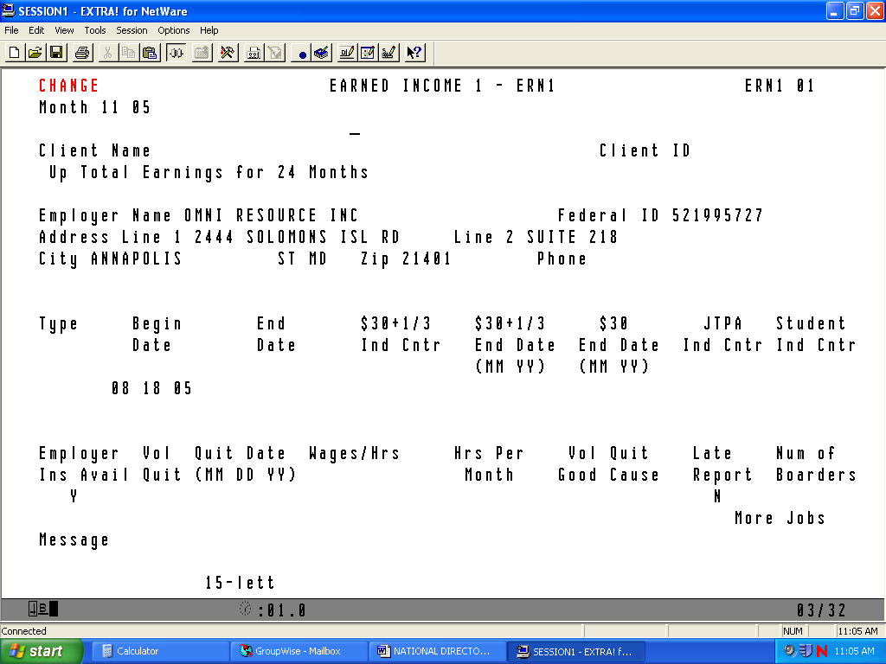

Screen B
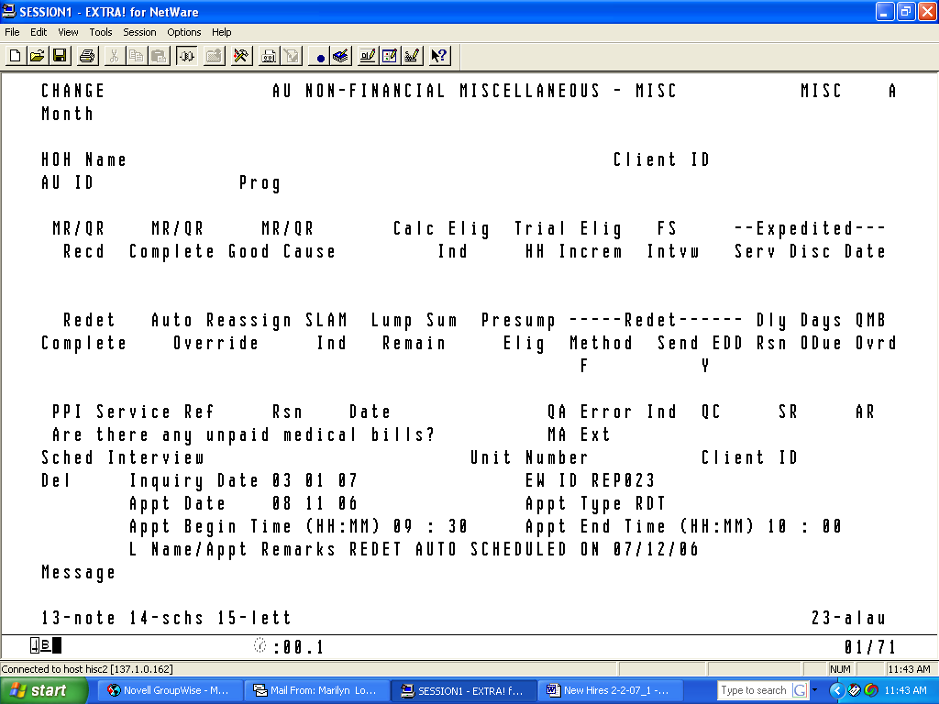

Screen C
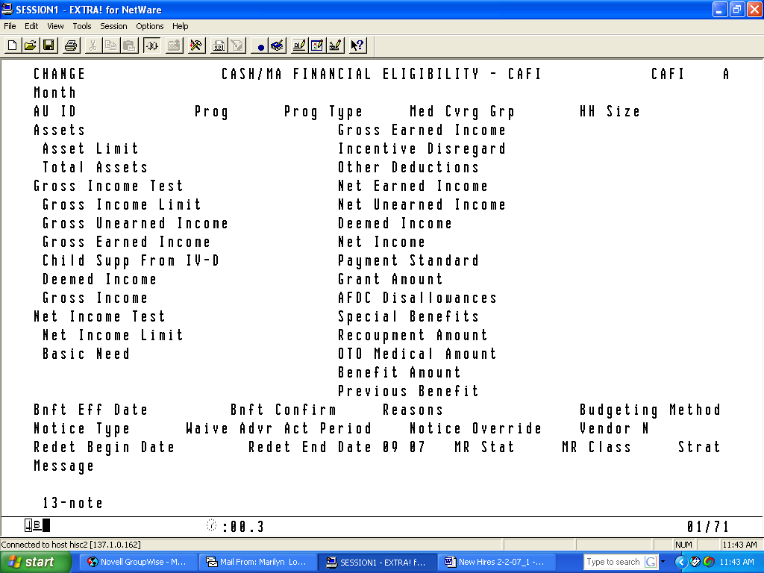

Transitional Food Stamps

TCA customers are entitled to Transitional Food Stamps (TFS) when the TCA closes for any reason except:

- Failure to cooperate with a Quality Control (QC) review;
- Non-cooperation with a TCA work requirement;
- Non-cooperation with a Child Support requirement;
- A FS Intentional Program Violation (IPV);
- The customer is included in another FS household; or the
- Customer moved out of State.

When the customer fails to respond to a request for information, close the TCA on CARES by entering code 500- BECAME EMPLOYED AND DID NOT PURSUE APPLICATION on the STAT screen or by entering NO for verification on the CARES ERN2 for the wage earner. Using either of these CARES procedures permits the food stamps to go into TFS.

CARES Reports

Eight Management Reports have been added to Datawatch. They are as follows:

- Active clients with New Possible Employment
- Clients with Unreported Employment
- Head of Households whose cases close with codes other than 301
- SSN Exceptions
- Quarterly Wage match (QW) (This match is done quarterly)
- Unemployment Insurance match (UI) (This match is done quarterly)
- National Directory of New Hires Disposition Report
- National Directory of New Hires Outstanding Alerts Report

Work Programs

Review NDNH reported employment history and update WORKS with any previously undiscovered work participation information. Follow local department procedures for data entering information in the system. Enter work history information following procedures listed in the WORKS USERS’ Manual. If you do not have a WORKS Users Manual, please call Jackie Knight at 410-767-7343.

INQUIRIES:

Please direct TCA questions to Marilyn Lorenzo at 410-767-7333, or Gretchen Simpson at 410-767-7937. Direct Food Stamp questions to Kay Finegan at 410-767-7939 or Rick McClendon at 410- 767-7307; and CARES questions to Kim Butler at 410-767-7950.

cc: FIA Management Staff Constituent Services Help Desk

