  Department of Human Resources  311 West Saratoga Street  Baltimore MD 21201 | Family Investment Administration  ACTION TRANSMITTAL
Control Number: 07-04 | Effective Date: Immediately
Control Number: 07-04 | Issuance Date: August 10, 2006

TO: DIRECTORS, LOCAL DEPARTMENTS OF SOCIAL SERVICES
DEPUTY/ASSISTANT DIRECTORS FOR FAMILY INVESTMENT
FAMILY INVESTMENT SUPERVISORS AND CASE MANAGERS

FROM: KEVIN M. MCGUIRE, EXECUTIVE DIRECTOR

RE: INTERVIEW FOR EXPEDITED SERVICE CASES AND THE NOTICE OF MISSED INTERVIEW

PROGRAM AFFECTED: FOOD STAMP PROGRAM

ORIGINATING OFFICE: OFFICE OF PROGRAMS

SUMMARY

Recently, the Food and Nutrition Service (FNS) notified us of the following two changes that affect the Food Stamp Program immediately:

- Interview before approval of benefits for all cases - The local department must interview all households before issuing benefits. We can no longer issue expedited food stamps without an interview. See section E below for policy about interviews.

- Scheduling an Interview and Notice of Missed Interview - The Quality Control review of denials now must look at whether the local department scheduled an interview for a particular date and time and sent the household a notice of missed interview if the customer did not keep the appointment and was not interviewed. The requirement for local departments to schedule interviews and to send notices of missed interview is current and ongoing policy. The inclusion of these requirements as part of the QC negative review is new. See Section C for policy about scheduling an interview and the notice of missed interview.

Note: CARES supports both of these activities.

This action transmittal provides the new policy and an overview of current application processing policy. The transmittal also clarifies application processing timeliness.

Expedited Service Criteria

  - If otherwise eligible, Federal law requires states to make benefits available to certain households right away, but no later than seven calendar days after the date the household files the application. Maryland policy states that that these households must receive food stamp benefits right away. This means that local departments must process the case and issue benefits the day of the application if the customer appears at the local office. The following households are entitled to expedited service:

- Households with less than $150 gross monthly income and who have $100 or less in liquid resources.
- Households whose combined gross income and liquid resources are less than the household’s monthly rent or mortgage and utilities, including entitlement to SUA or LUA, as appropriate.
- Migrant or seasonal farm worker households who are destitute, and have liquid resources that do not exceed $100.

Screening for Expedited Service

- Federal rules require local departments to screen all food stamp applications for expedited service on the day of application. Local offices should already have procedures in place for screening all food stamp applications.

- Local departments must screen applications filed in person (including applications that are dropped off), by mail or fax, or electronically. This includes households applying for food stamps only, as well as households applying for several programs.

- For dropped off applications or when the applicant cannot be seen on the same day he or she applies, the person screening applications for expedited service must examine the application to ensure that information about income, deductions and assets is included and that the application is signed.

- The person screening for expedited processing should also check to make sure there is a contact phone number for the applicant. This is important if the case manager needs to do a telephone interview in order to meet expedited timeliness requirements. It is also needed when the household is eligible for expedited food stamps so the case manager can notify the customer that benefits are available. For a household that does not already have an independence card the case manager may need to tell the customer how to get the card. If there is no phone and a case manager cannot interview the customer on the date of application, the local department must schedule an interview (See section C). The case manager must include this information in the case narrative.

Scheduling an Interview and the Notice of Missed Interview.

- Federal rules require local departments to schedule an interview appointment for all applicant households who are not interviewed on the date of application.

Note: The interview appointment must be for a specific date and a specific time.

- If the customer does not appear for the interview, the local department must notify the household that it missed the appointment and that the household is responsible for rescheduling the appointment.

- If the screening process indicates the household meets expedited criteria, the local department must make every effort to interview the household that day if the customer is in the office. If the customer is not in the office, then the local department must schedule the interview so that the household has access to benefits within the expedited time frame. The only exception to this is if the case manager cannot contact the applicant quickly enough to conduct the interview within the expedited time frame. In this case, the case manager will issue benefits as quickly as possible after the interview takes place.

Note: When scheduling an interview on CARES for a household that dropped off or mailed in an application, the local department must take into consideration the mailing time for getting the scheduled interview notice to the customer. Mailing time may add up to three days to the application processing time.

Reminder: The case manager should offer a telephone interview for any hardship reason. Hardship reasons include, but are not limited to: disability of the applicant, transportation or childcare problems and work hours. A telephone interview can help local departments meet application timeliness requirements.

- If the household does not keep the interview, the household is not eligible for expedited benefits. This is a valid denial for Quality Control purposes as long as the agency had scheduled an interview on a specific date and time and has sent a notice of missed interview.

- CARES Procedures for scheduling an appointment so that CARES generates a notice of missed interview are included in the CARES Action Required Section of this transmittal. Since the case manager will not initiate Option O in CARES without interviewing the customer, the case manager should make every effort to schedule the interview on the SCDI screen in option J and allow CARES-to generate a Notice of Missed Interview if the customer misses the interview.

- In instances where the local department gives the customer a manual appointment letter, it must give a specific date and time for the appointment. If the household does not keep the appointment, the case manager will have to go into CARES in order to issue a manual Notice of Missed Interview letter. A new Notice of Missed Interview Letter #0014 is in the letters submenu. It is important to place a copy of both the appointment letter and the Notice of Missed Interview letter in the case record and narrate if the household did not keep the appointment.

Examples:
Scenario: Ms. C applied for food stamps on April 14th. She could not stay for the interview because she had gotten a ride to the agency and the ride could not wait. The agency screened Ms. C for expedited service. Ms. C met the expedited criteria and had a library card to prove identity. The screener set up an interview with a case manager on CARES for April 18th and CARES generated the appointment notice. The screener gave Ms. C a screen print of the notice and placed a copy in the case record. Ms. C did not keep the appointment. Since option O was not initiated, CARES automatically sent a notice of missed interview.

Example 1: Ms. C called on April 20th and said she could not get to the office for her appointment because she has no transportation. The case manager completed a telephone interview at the time of the call and processed and finalized the case on the same day. The case manager also called Ms. C to tell her she is eligible so that she has access to her benefits within the 7-day expedited period. The case manager narrated that she had conducted the telephone interview and the hardship reason for the telephone interview.

Example 2: Ms. C does not come for the interview and never called. Because she did not keep the interview appointment, the case manager can deny the case, but no earlier than the 30th day after the date Ms. C filed the application. The case manager may also let CARES deny the application with a 365 code after 60 days.

Example 3: Ms. C calls and reschedules an interview within 60 days of the date she filed the application. The 7-day expedited processing period begins at the time the case manager interviews her. If Ms, C is interviewed more than 30 days after the date of application and it is a customer delay, the case manager must deny and repend the case from the date of the interview.

Note: The Expedited Service Discovery Date field on the MISC screen documents the date the case manager discovers that the household is entitled to expedited service when the date of discovery is different from the date of application. Datawatch and Quality Control will use the date of application to determine timeliness.

Quality Control Invalid Negative Findings:
Either the local department’s failure to schedule a specific date and time for an appointment for households that are not interviewed on the date the application is filed, or its failure to send a “notice of missed interview” will cause a Quality Control invalid negative error finding.

Application Timeliness and the “Opportunity to Participate”

- Policy states that local departments must give eligible households the “opportunity to participate” on or before the 7th day for expedited cases or the 30th day for normal processing. “Opportunity to participate” means the household has access to benefits.

- According to federal guidance, the household is considered to have the opportunity to participate 24 hours after the case manager notifies the customer by phone, or in person, or 3 days after the customer is notified by mail. It is important to narrate when a case manger notifies a customer of his or her eligibility at the interview or by phone.

Quality Control reviews application timeliness according to the federal guidance, not according to the coding of “CD” or “AD” on the MISC screen.

Reminder: If the case is not processed within 30 days after the date of application the case manager must code the reason for the delay when the 102 alert appears shortly before day 30.

Interviews

- The interview that is now required before expedited benefits can be issued is more than an expedited screening interview.
- As part of the interview, the interviewer must explore and resolve with the household any unclear or questionable information. The interviewer must conduct the interview as an official and confidential discussion of household circumstances and protect the applicant’s privacy.
- Unless waived for a hardship reason, households must have a face-to-face interview with a case manager at initial certification and at least every 12 months after that. If waived for a hardship reason, the case manager must conduct a telephone interview.

Note: The case manager must complete Option O (Interview) during or shortly after the interview to prevent CARES from sending an inappropriate notice of missed interview.

Verification

- The case manager will use the applicant’s statement as to the amount of income, assets and deductions in determining the benefit amount if verification is not available.

- The only required verification for expedited food stamps is identity. This does not have to be a photo ID. If necessary, the local department may make a collateral contact to verify identity. (Example: For a customer who states that he stayed the previous night in a particular homeless shelter or hospital but does not have any proof of identity, the case manager must make every effort to contact the shelter or hospital in an attempt to verify his identity.)

Reminder: If the customer is applying for food stamps and has an ongoing associated case the case manager may have to enter program specific verification codes to prevent the closure of the ongoing case when food stamp verification is pending.

CARES PROCEDURES FOR SCHEDULING AN INTERVIEW AND THE NOTICE OF MISSED INTERVIEW:

Automated CARES process (Recommended method):

In Option J:
- Before scheduling an interview appointment, the local department staff person screening the application (“screener”) must first check the appointment schedule for the assigned case manager or designated staff member (such as lead worker).
- On the SCDI screen:
  - Press PF14 to display the appointment schedule for the case manager or designated staff member.
  - Once an available appointment date and time is found, go to the SCDI screen and enter this information under APPT Date and Time.
  - If no date and time is available, the person scheduling the appointment must search for another staff member’s schedule for an available date and time.

Note: If the screener does not check for an available appointment date/time and schedules an appointment that conflicts with an appointment previously scheduled, then the case returns to the AMEN screen, and the AU Number appears with the following error message “SCREENING COMPLETE BUT SCHEDULING CONFLICTS EXISTS, RESCHEDULE VIA “MISC.” At this point, the screener must schedule a manual appointment for an interview, and if no interview occurs, the local department must go into CARES and send the manual Notice of Missed Interview letter (Letter 0014).

The local department should make a screen print of the SCDI screen and give it to the customer. CARES will generate the appointment notice (Notice 20) to the customer in overnight batch.

To examine Notice 20, the case manager must enter Customer ID, or the Case Assistance Unit Number and enter a “Y” next to the date of the notice they wish to view.

Following is a screen print of Notice 20:
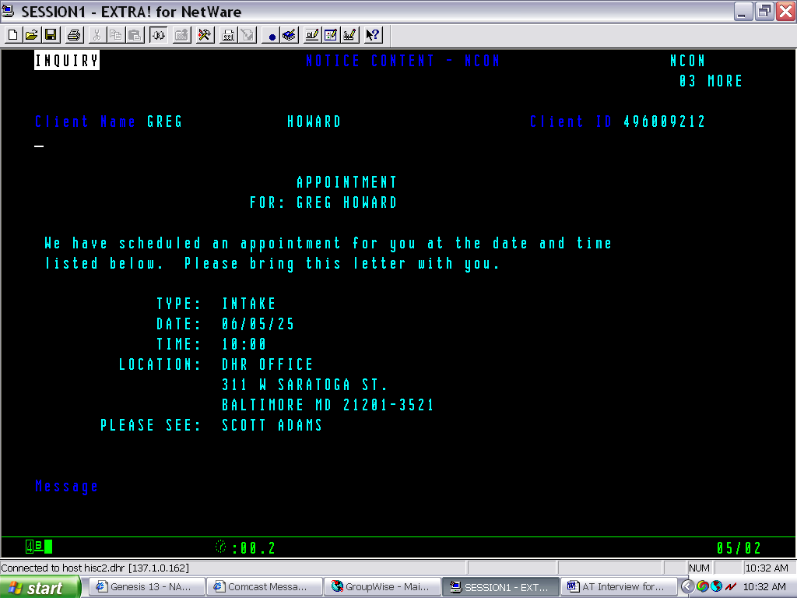

CARES will automatically generate Notice 49 – Notice of Missed Interview – when an applicant household fails to appear for a schedule interview, because if Option “O” has not been initiated, CARES understands that no interview has occurred.

To use new CARES Letter 0014 if the appointment letter was issued manually:

To access the CARES letter submenu either:
- On the ADDR screen, press PF15

OR

- On the Welcome screen:
- Enter F (Letters) in the Selection field
- Press Enter

On the FMEN screen:
- Enter A (Letter Generation) in the Selection field
- Enter the AU number in the AU ID field
- Enter 0014 in the Letter Type field
- Press Enter

On the LDTL screen:
- Enter the customer’s name in the Regards Name field
- Review the Worker Name field and update the Case Manager’s name if you choose
- Press PF13 to go to the body of the letter

On the LETT screen:
- Enter the customer’s name on the first line after “Dear” (i.e. Ms. Jones)
- Enter the date the missed interview date on the 6th line
- Enter additional text, if needed on lines 12 - 15
- Enter the Case Manager name under “Sincerely”
- Press Enter

Narrate the date the CARES letter was generated.

A screen print of the Notice of Missed Interview letter is attached to this Action Transmittal.

ACTION DUE:

The policy requiring a Notice of Missed Interview is not new policy. Quality Control will begin reviewing denials and closings under this policy for August applications that are denied in October 2006 and expedited cases that are closed on September 30, 2006.

Local departments must interview households prior to any food stamp issuances effective with new applications received in the local department on or after October 1, 2006.

INQUIRIES

Please direct policy questions to Kay Finegan at (410) 767-7939 or Rick McClendon at 410-767-7307. Direct CARES questions to Joyce Westbrook at 410-238-1299.

cc: FIA Management Staff
Constituent Services
DHR Help Desk
Attachment

