

WEB-1 Access Method Reference

Version 1.1

for

Customer Processing System
(CPS 1.0)

February 27, 2004

Table Of Contents

Document Conventions 1
Introduction 2
Agency Hierarchy 2
User Privileges 3
Logon 5
Logging onto the system for the first time Su, Sv, GU 5
Logging onto the system after the first time Su, Sv, GU 6
After you have logged on… 7
Screen Layout 7
Section 1: Title Frame 7
Section 2: Navigation Menu 8
Section 3: Main Display Frame 10
Section 4: System Message Frame 10
System Modules 11
Verification Processes 11
Initial Verification Sv, GU 11
Complete and Close Case Sv, GU 12
Additional Verification Sv, GU 13
Additional Verification (I-94 number) Sv, GU) 15
View Case/ Checking Case Status 18
Printing a Case 21
User Administration 21
Change Password Su, Sv, GU 21
Change Profile Su, Sv, GU 22
Site Administration 23
Add User Su, Sv 23
Viewing User Information Su, Sv 25
Modifying User Information Su, Sv 27
Resetting Another User’s Password Su, Sv 28
Unlocking Another User’s Account Su, Sv 29
View Departments Su 29
Add Department Su 30
Edit Department Su 31
View Groups Su, Sv 32
Add Group Su, Sv 34
Edit Group Su, Sv 34
Delete Group Su, Sv 35
Reports 35
Run Report Su, Sv, GU 36

Document Conventions

Document Conventions

This document uses the convention that certain font types and font colors represent particular screen objects or data types. The table below defines these conventions by giving examples.

Convention | Description
View Cases | Menu option in the Navigation frame
Next, Go | Screen button
First Name | Field Name in a form or display page
Case Details | Name or label for a page
Su | Indicates the function is available to a Superuser
Sv | Indicates the function is available to a Supervisor
GU | Indicates the function is available to a General User

Introduction

Introduction

This document is a reference guide for the WEB-1 Access Method, which is one of several access methods used to access the Verification Information System (VIS), Customer Processing System (CPS). CPS is provided by the Department of Homeland Security (DHS) to verify the immigration status of non-citizens applying for various benefits and for work authorization. The WEB-1 Access Method is designed to assist government agencies that issue federal, state, and/or local public benefits. The intent for this document is only to introduce the user to the Web-1 Access Method; it is not intended to serve as a guide for performing immigration status verifications or for other parts of the verification process.

This document outlines the structure and layout of the WEB-1 Access Method and the functions available to the various user roles within this access method.

Agency Hierarchy

The WEB-1 application has several levels of hierarchy established, including Agency, Department, Group, and User. The application also has several user roles, including Superuser, Supervisor, and four types of General User. Each role has specific privileges and responsibilities and operates primarily at one particular level of the hierarchy. Some roles have other privileges and responsibilities at other hierarchy levels.

The Agency is the top level of the hierarchy and is the domain of the Superuser role. Superusers have the ability to manage the entire agency hierarchy structure, including all users within the Agency. Superusers have the ability to view all verification queries performed within their agency but do not have the privilege to initiate verification queries of their own.

The next lower level in the hierarchy is Department, followed by Group, and then User. The Superuser for the Agency is responsible for setting up the Agency’s Departments and Groups. Non-Superuser roles must be assigned to a Group within a Department, so a Superuser must create at least one Department within the Agency, and at least one Group within the Department before user IDs can be created for Supervisors and General Users.

The Supervisor role has management privileges for a Department, and everything under that Department, including the Department’s users. Supervisors have the ability to view and continue to work cases assigned to other users in their Department, and can also perform and view their own initial and additional verifications queries.

The General User 1 role is similar to the Supervisor role in that it has the ability to view and continue to work cases assigned to all users in its Department, and can also perform and view its own initial and additional verification queries. However, the General User 1 role has no management privileges for its Department.

The General User 2 role has the ability to view and continue to work cases assigned to other users in its Group, and can also perform and view its own initial and additional verification queries.

The General User 3 role can perform and view its own initial and additional verification queries. This role does not have the privilege to view or continue to work cases assigned to other users in its Department or Group.

The General User 4 role can perform and view its own initial verification queries, and initiate additional verification queries. This role does not have the privilege to view additional verification queries.

WEB-1 Hierarchy Example

User Privileges

User privileges are divided into two distinct categories: Verification privileges and Administration privileges. The following table lists the privileges within each category and show which of those privileges are granted to each user role.

 | USER ROLE
 | Superuser | Supervisor | General User 1 | General User 2 | General User 3 | General User 4
Verification Privileges
Request Initial Verifications | N | Y | Y | Y | Y | Y
View Initial Verifications initiated by Self | N | Y | Y | Y | Y | Y
View Initial Verifications initiated by Users within their Group | N | Y | Y | Y | N | N
View Initial Verifications initiated by Users within their Department | N | Y | Y | N | N | N
View Initial Verifications initiated by all Users within their Agency | Y | N | N | N | N | N
Request Additional Verifications | N | Y | Y | Y | Y | Y
View Additional Verifications initiated by Self | N | Y | Y | Y | Y | N
View Additional Verifications initiated by Users within their Group | N | Y | Y | Y | N | N
View Additional Verifications initiated by Users within their Department | N | Y | Y | N | N | N
View Additional Verifications initiated by all Users within their Agency | Y | N | N | N | N | N
Administration Privileges
Modify their own User Data | Y | Y | Y | Y | Y | Y
Change their own Password | Y | Y | Y | Y | Y | Y
Assign User Roles | Y | Y | N | N | N | N
Create Users | Y | Y | N | N | N | N
Modify Users | Y | Y | N | N | N | N
Delete Users | Y | Y | N | N | N | N
Reset Passwords | Y | Y | N | N | N | N
Create Groups | Y | Y | N | N | N | N
Modify Groups | Y | Y | N | N | N | N
Delete Groups | Y | Y | N | N | N | N
Create Departments | Y | N | N | N | N | N
Modify Departments | Y | N | N | N | N | N
Delete Departments | Y | N | N | N | N | N

Logon

Logon

Logging onto the system for the first time Su, Sv, GU
- Enter the web address, also known as a Uniform Resource Locator (URL), for the CPS Web-1 Access Method in the address line of your web browser (Internet Explorer or Netscape).
- Enter your CPS login information.
  - Enter your user ID.
  - Enter your password. The password is case-sensitive, so enter it exactly as it is provided to you.

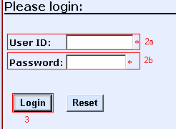

- Click Login to continue.
- Change your password. You are required to do this when you log onto the system for the first time.
  - Enter the password you just used to log on in the Old Password field.
  - Enter a new password in the New Password field. Your new password must contain at least three of the four following password characteristics:
    - Uppercase letter
    - Lowercase letter
    - Number
    - Special character ($, !, #, etc.)
- To ensure that you have entered the correct password, re-enter the password in the Re-type New Password field.

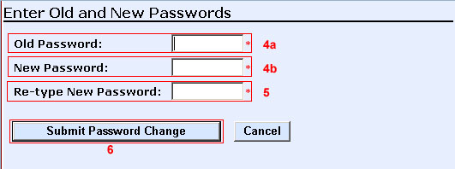

- Once you have entered the passwords, click the Submit Password Change button.

Once you have completed the password change, you will be allowed into the system.

Logging onto the system after the first time Su, Sv, GU
- Enter the CPS Web-1 URL in the browser’s address line
- Enter your CPS login information.
  - Enter your user ID.
  - Enter your password. The password is case-sensitive, so enter it exactly as you have set it or as it is provided to you.

- Click Login to continue.

After you have logged on…

After you have logged on…

Screen Layout

There are four major sections in the main screen layout:
- Title Frame
- Navigation Menu
- Main Display Frame
- System Message Frame

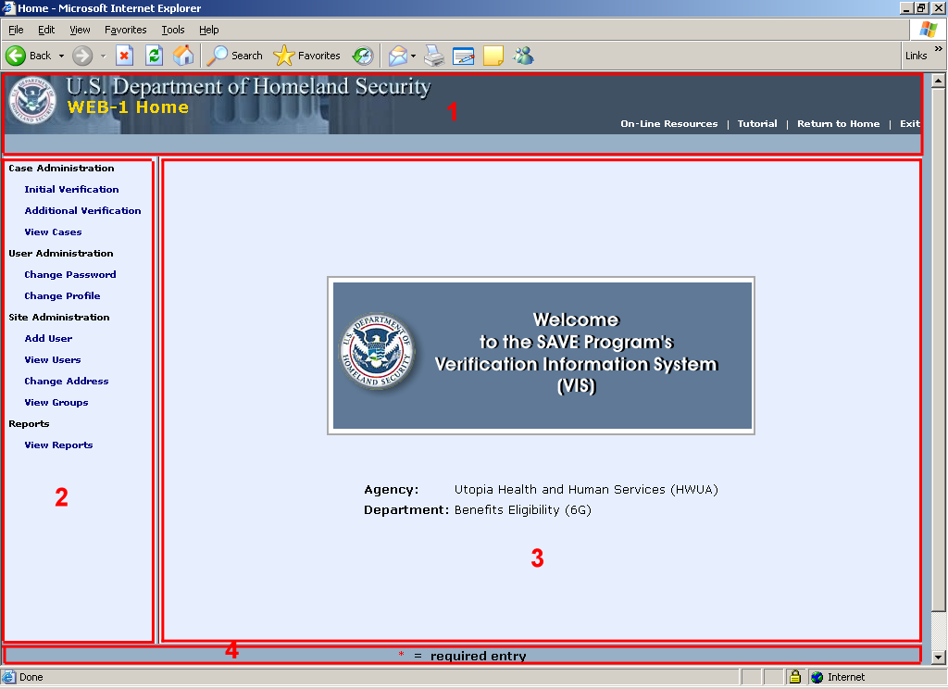

Section 1: Title Frame
The title frame has three components to it: the title bar, title navigation links, and the status message bar.

Title Bar
The title bar is used to show the application name and page name.

In this example, the page name field for the Web-1 application says “WEB-1 HOME” in yellow.

Title Navigation Links
The title navigation links bar, shown below, provides links to useful resources.

On-Line Resources: Helpful documents for the SAVE Program, and non-citizen documentation.
Tutorial: A web-based, self-paced, role-sensitive tutorial. It is divided into lessons focused on each major section of the navigation menu. Each lesson is composed of topics that focus on each of the functions that can be performed in CPS.
Return to Home: Return to the Home Page.
Exit: Log out of CPS

Status Message Bar
The Status Message Bar, located below the Title Navigation Links bar, displays any messages resulting from an action performed by a user.

Section 2: Navigation Menu
The Navigation Menu shows all of the functions available to the user. The menu is role-sensitive so no options will be displayed that the user does not have privilege to use.

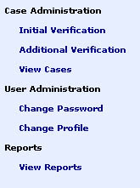
General User Navigation Menu
The General User has three major categories available: Case Administration, User Administration, and Reports.
Case Administration has three selections available for queries of Alien numbers and viewing the results of those queries: Initial Verification, Additional Verification (for I-94 numbers), and View Cases.
User Administration contains those functions that allow users to maintain their own account information. This includes Change Password and Change Profile.
The Reports category contains the link to the report launcher. The link is labeled View Reports.

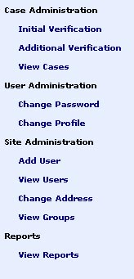
Supervisor Navigation Menu
The Supervisor has four major categories available: Case Administration, User Administration, Site Administration, and Reports.
Case Administration has three selections available for queries of Alien numbers and viewing the results of those queries: Initial Verification, Additional Verification (for I-94 numbers), and View Cases. Supervisors have the ability to view and continue to work cases assigned to other users in their department, as well as perform their own verifications.
User Administration contains those functions that allow users to maintain their own account information. This includes Change Password and Change Profile.
The Site Administration menu for a Supervisor displays the functions for managing a Department: Add User, View Users, Change Address, and View Groups.
The Reports category contains the link to the report launcher. The link is labeled View Reports.

Superuser Navigation Menu
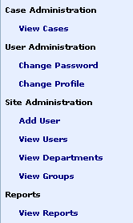The Superuser has four major categories available: Case Administration, User Administration, Site Administration, and Reports
The Superuser does not have the verification privileges so the Case Administration menu is shorter than the one displayed to other users. The Superuser only has the View Cases privilege.
User Administration contains those functions that allow users to maintain their own account information. This includes Change Password and Change Profile.
The Site Administration menu for a Superuser displays the functions for managing an Agency: Add User, View Users, View Departments, and View Groups. The View Users function can also be used to modify a user’s profile, such as resetting the user’s password.
The Reports category contains the link to the report launcher. The link is labeled View Reports.

Section 3: Main Display Frame
The Main Display Frame is the primary display area for data forms, search screens, summary lists, and information details. On the home page, this area displays the Welcome splash screen with the name of the current Agency assigned to the user. Supervisors and General Users will also have their Department name displayed.

Section 4: System Message Frame
The System Message Frame displays system-wide standards and messages. It currently says:
“* = required entry”

System Modules

System Modules

Verification Processes

Initial Verification Sv, GU
- Select the Initial Verification function in the Case Administration section of the Navigation frame.
- Enter the Alien number to be queried in the Alien Number field.
- Select one or more benefits from the Benefits list by clicking on the benefit name. A verification query can be performed for one or all benefits in the available list. To select more than one benefit, after selecting the first benefit hold down the Control or Shift key while clicking on the additional benefits.
- Click the Submit Initial Verification button to submit your query.

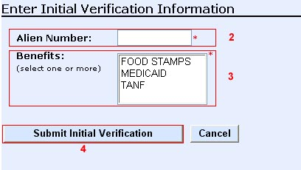

The system will return the Case Details page with the initial verification parameters at the top, followed by a section with the results of your initial verification query.

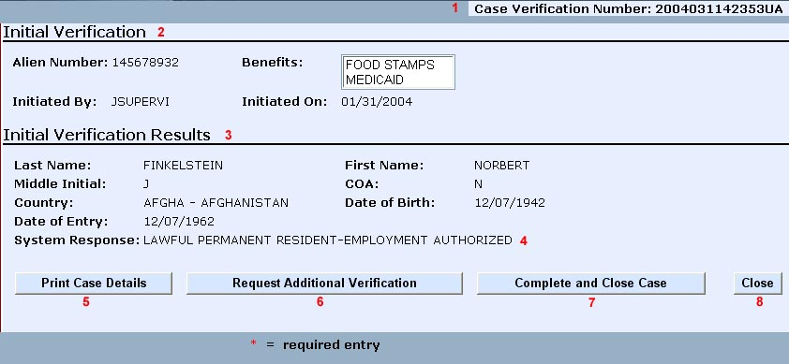

Some things to note on the Case Details page:
The Verification Number. This is a unique number assigned to case. This number will always remain associated with the case. This number can also be used retrieve the case in the future.
The Initial Verification block. This displays the information that was entered in the Initial Verification Information form. This is the start of the Case Details page.
The Initial Verification Results block contains the information returned by the system based on the information entered on the Initial Verification Information form.
System Response. This is the result returned by the system.
Print Case Details button. This displays a printer-friendly version of the Case Details page, which can then be printed using the browser’s print function.
Request Additional Verification button. This button allows the user to start an additional verification query. (See “Additional Verification”“Additional Verification”)
Complete and Close Case button. This button allows the user to remove the case from the case load. (See “Complete and Close Case” “Close Case”)
The Close button returns the user to the Web-1 home page without closing the case.

Complete and Close Case Sv, GU
It is important to close a case to eliminate the completed work from your case load. On the Case Details page, click the Complete and Close Case button.

NOTE: This is not the same as clicking the Close button. The Close button only removes the Case Details Page from the screen. It does NOT close the case, nor does it remove the case from the user workload.

Additional Verification Sv, GU
There are several reasons for submitting an Additional Verification request, including:
    - The Initial System Response was “Institute Additional Verification.”
    - The information in the Initial Results section did not match the information on the immigration documentation provided by the non-citizen.

The following are the steps for submitting an additional verification request:
- While the Case Details page is on the screen, click the Request Additional Verification button. The Case Details page will be redisplayed with the Additional Verification Data Request form at the bottom of the page. The entry fields will be populated by the known data from the initial verification.

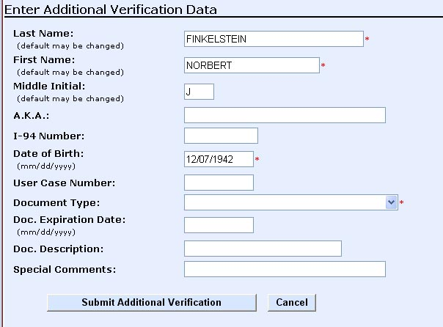

- Complete the form using information from the non-citizen’s immigration document, including optional fields like A.K.A. or any Special Comments for the Status Verifier.
- Click the Submit Additional Verification button at the bottom of the page.

The system will return the Case Details page with the initial verification parameters, the initial results, the additional verification parameters, and the status of the Additional Verification. The system will immediately return the status of “DHS Verification in Process.” The Additional Verification request is then sent to an Immigration Status Verifier to be processed. The response time for an Additional Verification is 3 to 5 days. Return to the system to check the status verifier’s response. (See “View Case/ Checking Case Status”)

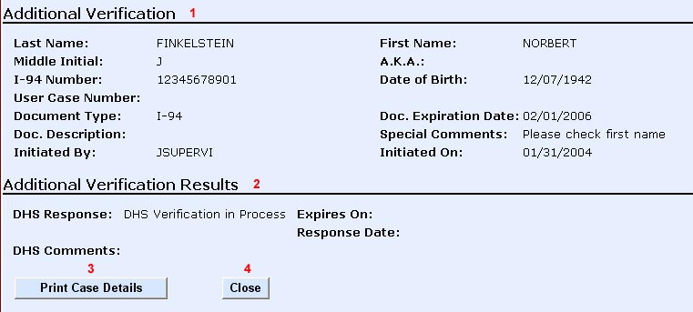

Some things to note on the Case Details page:
The Additional Verification section lists the information entered on the form
The Additional Verification Results section displays the result returned by the system.
The Print Case Details button displays a printer-friendly version of the Case Details page, which can then be printed using the browser’s print function.
The Close button returns to the home page.

When the Status Verifier does return a response, the DHS Response message will change and the Response Date will be populated. If the non-citizen’s immigration status expires, the Expires On will be populated with the expiration date. Any comments from the Status Verifier will be displayed in DHS Comments. In addition to the Print Case Details and Close buttons, the Complete and Close Case button will also be available. (See “Complete and Close Case”)

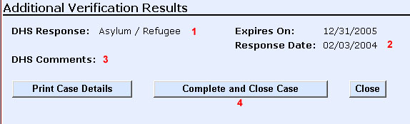

Some things to note on the Case Details page after the Status Verifier has responded:
DHS Response. This is the result entered by the Status Verifier and returned by the system.
Expires On. If applicable, this is the date the non-citizen’s immigration status expires.
Response Date. The date the Status Verifier resolved the case.
DHS Comments. Any information the Status Verifier wishes to convey back.
DHS Response. This is the result entered by the Status Verifier and returned by the system.
Response Date. The date the Status Verifier resolved the case.
DHS Comments. Any information the Status Verifier wishes to convey back.
Complete and Close Case button. This button allows the user to remove the case from the case load. (See “Complete and Close Case” See “Close Case”)

Additional Verification (I-94 number) Sv, GU)
The Additional Verification function link allows users to perform Additional Verification Requests when only the I-94 number is known.
- Select the Additional Verification function in the Case Administration section of the Navigation frame.
- Enter the required fields for the Additional Verification:
  - I-94 Number
  - Last Name
  - First Name
  - Birth Date
  - Document Expiration Date
- Enter any optional fields, like A.K.A. or any Special Comments for the Status Verifier.
- Select a benefit or benefits from the Benefits list. A verification query can be performed for one or more benefits in the available list. To select more than one benefit, after selecting the first benefit hold down the Control or Shift key while clicking on the additional benefits.
- Click the Submit Additional Verification button to submit your query.

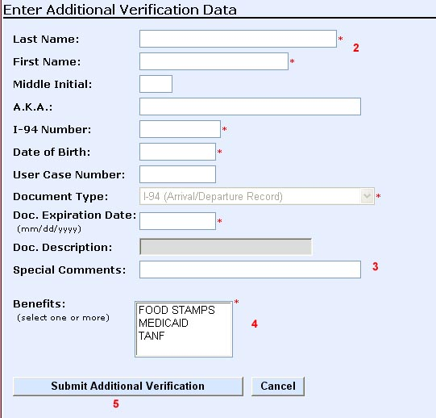

The system will return the Case Details page with the additional verification parameters and the status of the Additional Verification request.

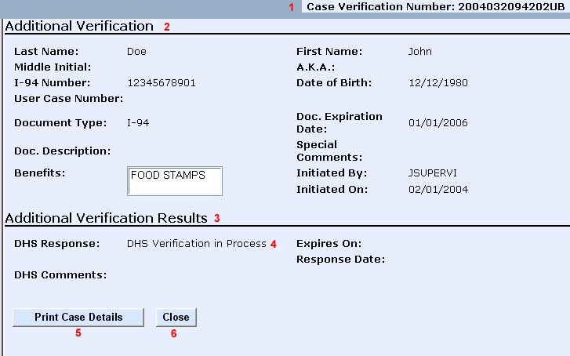

Some things to note on the Case Details page:
- The Verification Number. This is a unique number assigned to a case. This number will always remain associated with the case. This number can also be used to retrieve the case in the future.
- The Additional Verification block. This displays the information that was entered in the Additional Verification Information form. This is the start of the Case Details page.
- The Additional Verification Results block contains the information returned by the system based on the information entered on the Additional Verification Information form.
- DHS Response. This is the result returned by the system.
- Print Case Details button displays a printer-friendly version of the Case Details page, which can then be printed using the browser’s print function.
- The Close button returns the user to the Web-1 home page without closing the case.

The Additional Verification request is sent to an Immigration Status Verifier to be processed. The response time for an Additional Verification is 3 to 5 days. Return to the system to check the status verifier’s response. (See “View Case/ Checking Case Status”)
The Additional Verification Results section will be updated with the Status Verifier’s response.

Some things to note on the Case Details page after the Status Verifier has responded:
DHS Response. This is the result returned by the system.
Expires On. If applicable, this is the date the non-citizen’s immigration status expires.
Response Date. This is the date on which the Immigration Status Verifier posted the response.
DHS Comments. This field contains any information the Status Verifier wishes to convey back to the requester.
Complete and Close Case button. This button allows the user to remove the case from the case load. (See “Complete and Close Case”See “Close Case”)

View Case/ Checking Case Status
- Click the View Cases link in the Case Administration section of the Navigation frame.
- Enter the parameters in the Search Criteria page to produce the results you want to be returned.
- Click the Display Case Summary List button.

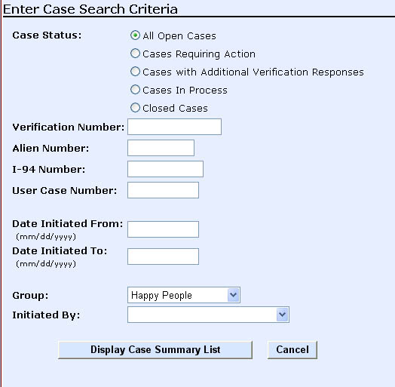

- Locate the desired case in the Case Summary List. Use the Next and Previous buttons to page through the cases, if necessary.
- Once the case has been located, click the Verification number to display the Case Detail page.
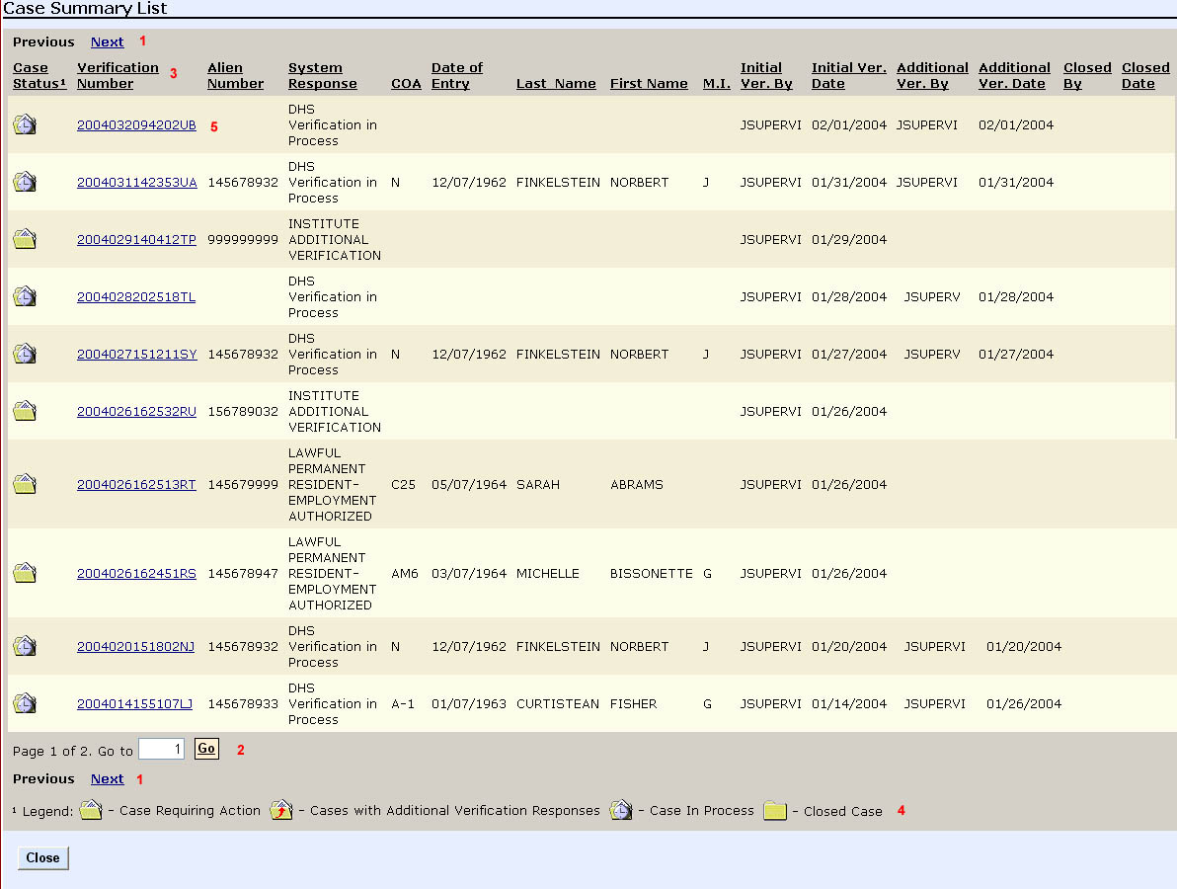

Some things to note on the Case Summary List:
Next and Previous buttons. Ten records are displayed in the Summary List at one time. If there are more than ten records returned, these buttons are used to move through the records.
Direct Page navigation. To jump to a specific page, enter the page number and click Go.
Column headers. Clicking on any column header changes the sort order of the list to that column. Clicking the column header displays the list in ascending (or alphabetical) order. Clicking the same header again sorts the list in descending order.
Status Icons and Legend. Icons are used as visual cues to quickly identify case status.

Click the Verification Number to view the Case Details page.

Printing a Case
- Follow the steps in “View Case/ Checking Case Status” to view the Case Details page.
- Click the Print Case Details button.
- Select “Print…” from the “File” menu at the top of the browser.

Below is an example of a printed version of the Case Details page.

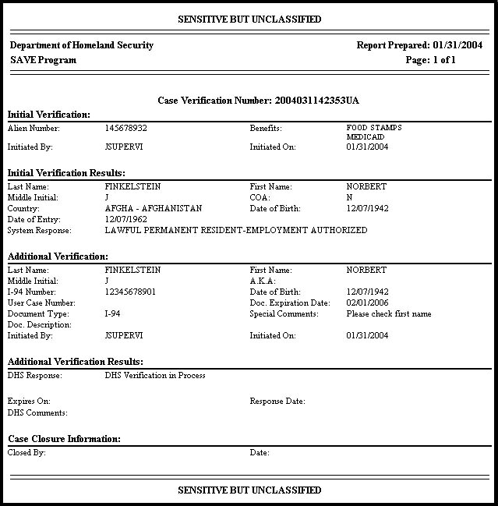

NOTE: Not all sections may be populated. The amount of data is determined by the steps taken with the case to that point.

User Administration

The User Administration section contains tools available to all users to help them maintain their account information. This includes changing their password and contact information.

Change Password Su, Sv, GU
- Click the Change Password link in the User Administration section of the Navigation frame.
- Enter the password you just used to log on in the Old Password field.
- Enter a new password in the New Password field. Your new password must contain at least three of the four following password characteristics:
  - Uppercase letter
  - Lowercase letter
  - Number
  - Special character ($, !, #, etc.)
- To ensure that you have entered the correct password, re-enter the password in the Re-type New Password field.
- Click the Submit Password Change button.

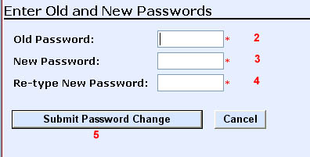

Change Profile Su, Sv, GU
- Click the Change Profile link in the User Administration section of the Navigation frame.
- Make any changes to the data in the fields in the User Profile form.
- Click the Submit Profile Changes button to save the changes.

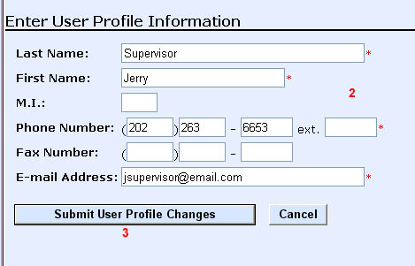

Site Administration

This section is available to Supervisors and Superusers.

Add User Su, Sv
The Add User module walks the user through a series of simple screens to create a new user.
- Click the Add User link in the Site Administration section of the Navigation frame.
- Select the User Role for the user to be created and click the Next button.
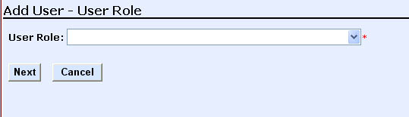

- Select the Department (this function is available only to a Superuser) and click the Next button.
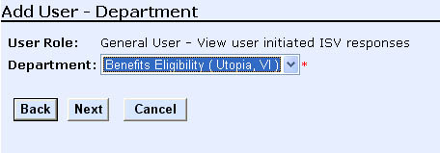

- Select the Group and click the Next button.
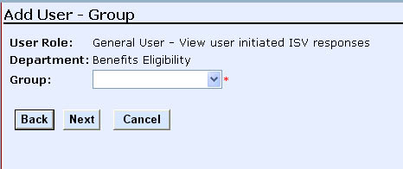

- Enter the information about the user and click the Next button. Required fields are last name, first name, phone number and e-mail address.
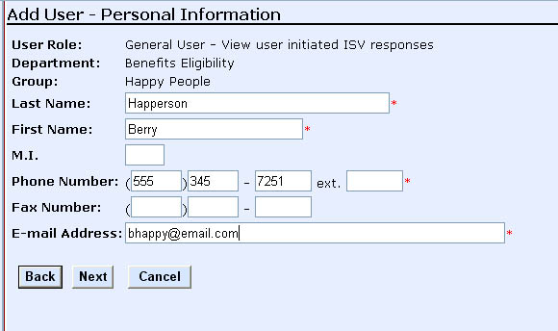

The system will generate a default user ID based on the first letter of the first name, the first three letters of the last name, and a four-digit number.

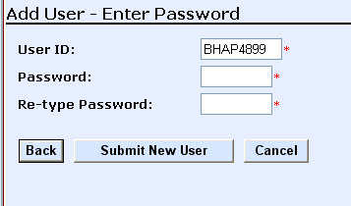
- Alter the user ID, if desired. The user ID must be eight characters and unique in the system.
- Enter a password in the New Password field. The password must contain at least three of the four following password characteristics:
  - Uppercase letter
  - Lowercase letter
  - Number
  - Special character ($, !, #, etc.)
- To ensure that you have entered the correct password, re-enter the password in the Re-type Password field.
- Click the Submit New User button to save the user ID and associated information.

Once the user ID is submitted, the system will return a “Success adding user…” message.

A confirmation page with the user’s information is also displayed.
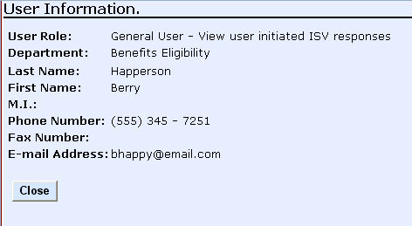

Viewing User Information Su, Sv
- Click the View Users link in the Site Administration section of the Navigation frame .
- Enter the parameters in the Search Criteria page to produce the results you want to be returned.
- Click the Display User Summary List button.
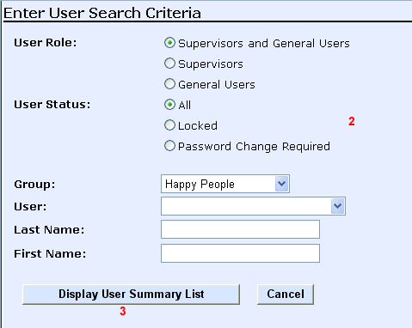

- Locate the desired case in the User Summary List. Use the Next and Previous buttons to page through the list, if necessary.
- Once the user ID has been located, click the User ID to display the User View/Modify Information page. (See “Modifying User Information”)

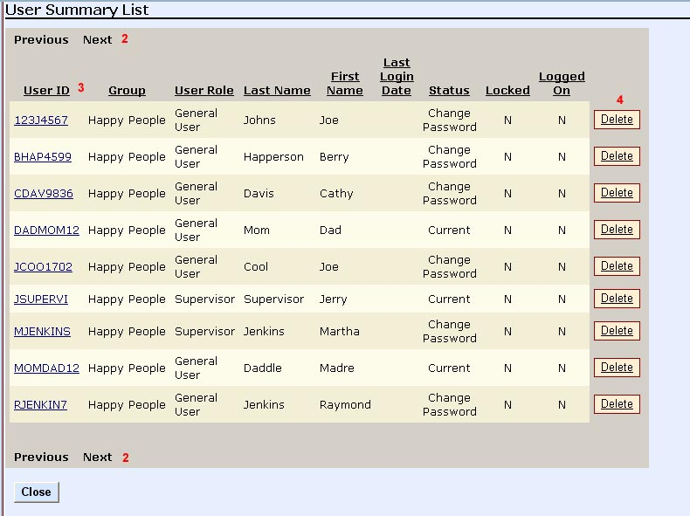

Some things to note on the User Summary List page:
Record count on Status Message Bar. The total records returned and the records are displayed in the message Message bar Bar (not shown in partial screen shot above).
Next and Previous buttons. Ten records are displayed in the Summary List at one time. If there are more than ten records returned, these buttons are used to move through the records.
Column headers. Clicking on any column header changes the sort order of the list to that column. Clicking the column header displays the list in ascending (or alphabetical) order. Clicking the same header again sorts the list in descending order.
Delete button. This button terminates the associated user’s access. The user is removed from the visible list, but is not deleted entirely from the system. A “deleted” user cannot be re-activated through the web-based application. If a user ID must be re-activated, please contact the Help Desk.

Modifying User Information Su, Sv
Before you can modify a user’s information, you must locate the user ID in the View Users module. (See “Viewing User Information”) Superusers and Supervisors can modify any information about a user except the user ID.
- Follow steps 1 through 5 in “Viewing User information” to display the Modify/View User Information page.
- Change the data in the fields available.
- Click the Submit User Modifications button.
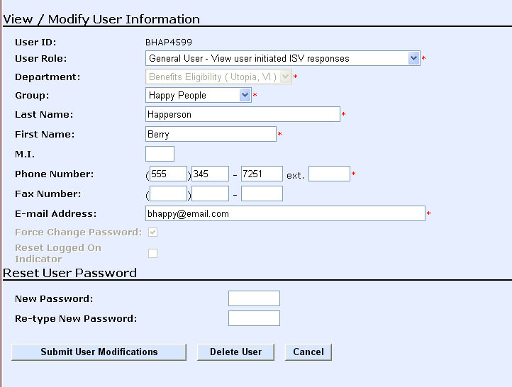

Resetting Another User’s Password Su, Sv
Before you can modify a user’s password, you must locate the user ID in the View Users module. (See “Viewing User Information”) Superusers and Supervisors can modify any information about a user except the user ID.
- Follow steps 1 through 5 in “Viewing User information” to display the Modify/View User Information page.
- Enter a new password in the New Password field. The new password must contain at least three of the four following password characteristics:
  - Uppercase letter
  - Lowercase letter
  - Number
  - Special character ($, !, #, etc.)
- To ensure that you have entered the correct password, re-enter the password in the Re-type New Password.
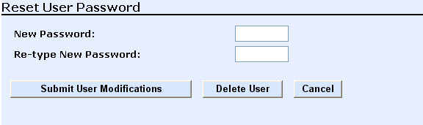

- Click the Submit User Modifications button to save the new password.
- Pass the temporary password to the user. When they log on, they will be asked to change it to something else.

Unlocking Another User’s Account Su, Sv
A locked user account is unlocked by changing the user’s password. Before you can unlock a user’s account, you must locate the user ID in the View Users module. (See “Viewing User Information”) You can confirm the user’s lockout by noting a ‘Y’ in the Locked column.
- Follow steps 1 through 5 in “Viewing User information” to display the Modify/View User Information page.
- Click the Force Change Password checkbox.
- Enter your new password in the New Password field. Your new password must contain three of the four following password characteristics:
- Uppercase letter
- Lowercase letter
- Number
- Special character ($, !, #, etc.)
- To ensure that you have entered the correct password, re-enter the password in the Re-type Password.
- Click the Submit User Modifications button to save the user information.
- Pass the temporary password to the user. When they log on, they will be asked to change it to something else.

View Departments Su
Click the View Departments link in the Site Administration section of the Navigation frame. This will open the Department Summary List.
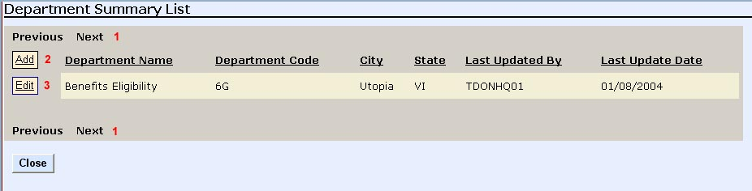

Some things to note on the Department Summary List:
- Next and Previous buttons. Ten records are displayed in the Summary List at one time. If there are more than ten records returned, these buttons are used to move through the records.
- Add button. This button is used to add a new department.
- Edit button. This button is used to alter an existing department.

Add Department Su
- Click the View Departments link in the Site Administration section of the Navigation frame. This will open the Department Summary List.
- Click the Add button on the upper left of the Department Summary List.
- Enter the new Department Name.
- Enter the address of the department.
- (Optional) Enter an alternate address for the department. This is mandatory if the primary address is a P.O. Box or some other post office delivery. This is because most major shipping companies do not deliver to P.O. boxes.
- Click the Next button.

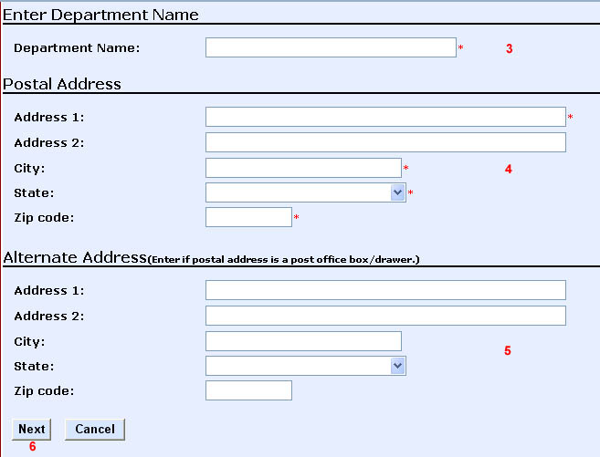

Edit Department Su
- Click the View Departments link in the Site Administration section of the Navigation frame. This will open the Department Summary List.
- Click the Edit button next to the desired department in the Department Summary List. This will display the Department Summary page.
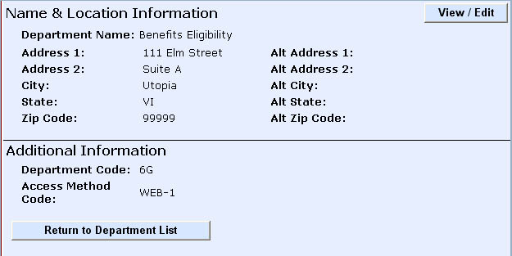

- Click the View/Edit button in the upper right of the main display area. This will display the Department Address page.
- Alter the information as desired.
- Click the Submit Department Information button when done.
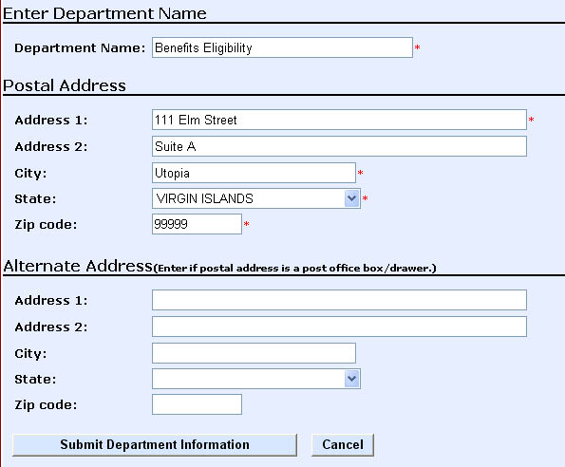

View Groups Su, Sv
- Click the View Groups link in the Site Administration section of the Navigation frame. This will open the Group Search Criteria page.
- Select the search parameters.
  - Superusers select a Department and, optionally, a Group from the list. Leave the Group field blank to retrieve all groups for the selected Department.
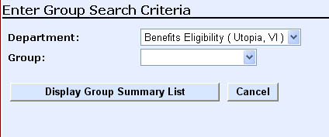

  - Supervisors select a Group from the list. Leave the Group field blank to retrieve all groups.
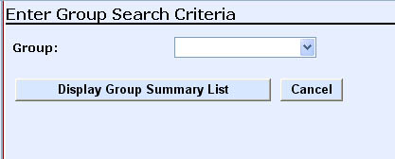

- Click the Display Group Summary List button. This will open the Group Summary List.
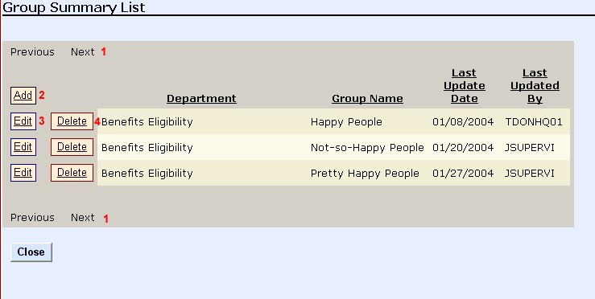

Some things to note on the Group Summary List:
Next and Previous buttons. Ten records are displayed in the Summary List at one time. If there are more than ten records returned, these buttons are used to move through the records.
Add button. This button is used add a new group. (See “Add Group”)
Edit button. This button is used alter the existing group. (See “Edit Group”“Edit Group”)
Delete button. This button is used delete the existing group. (See “Edit Group”“Edit Group”)

Add Group Su, Sv
- Follow the steps for displaying the list of Groups (See “View Groups”)
- Click the Add button on the upper left of the Group Summary List. A Group Summary List will appear showing blank fields for the group being added.
- Select the Department from the available list.
- Enter the name of the group in the Group field.
- Click the Update button.
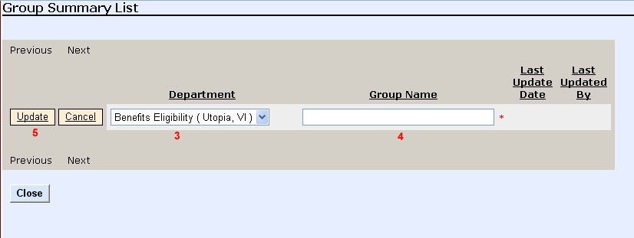

Edit Group Su, Sv
- Follow the steps for displaying the list of Groups (See “View Groups”)
- Click the Edit button next to the group in the Group Summary List.
- Alter the group name as desired.
- Click the Update button when done.

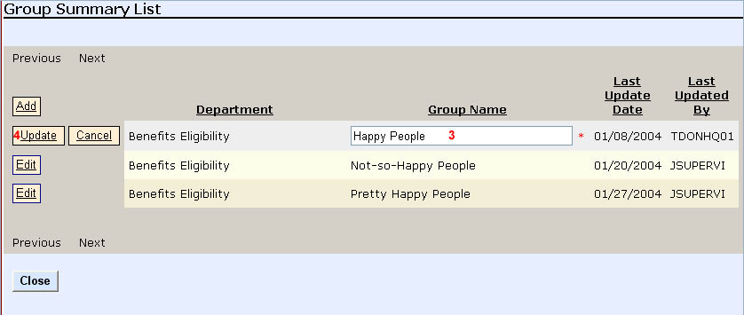

Delete Group Su, Sv
- Follow the steps for displaying the list of Groups (See “View Groups”)
- Click the Delete button next to the group in the Group Summary List.
- Click the Delete Group button to confirm the deletion.
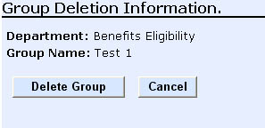

NOTE: If there are users in the group to be deleted, a message similar to the one below will be displayed. Continuing with the group deletion will delete all of the users in that group.

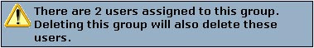

Reports

The View Reports module allows a user to run several different reports against the verifications performed. The reports are role-sensitive. In other words, the user can only see information in the reports that they can see through the View Cases screen. Adobe Acrobat Reader 5.05 or newer is required to view reports.

Run Report Su, Sv, GU
- Click the View Reports button in the Reports navigation section to display the list of reports available.
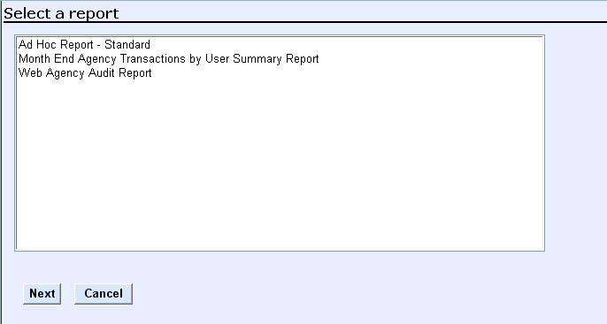

- Select the report by clicking on the report name in the list. A brief description of the report will appear at the bottom of the selection box.
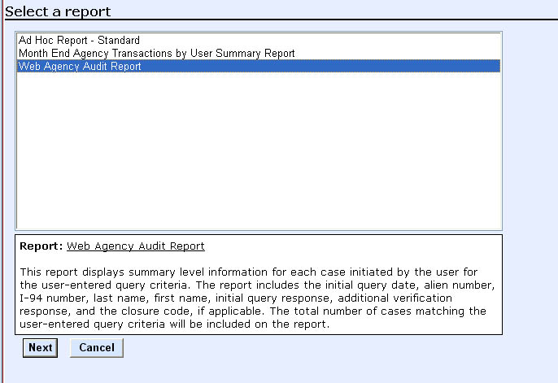

- Click the Next button. This will display the Report Parameter form.
- Enter the appropriate parameters for the report. Remember that the * indicates the required fields.
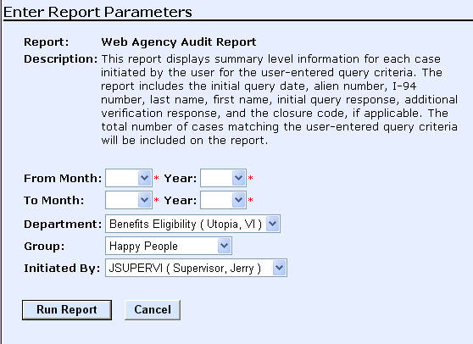

- Click Run Report button to execute the report. The application will open a new browser window with an Adobe Acrobat file. Below is an example of a report output.

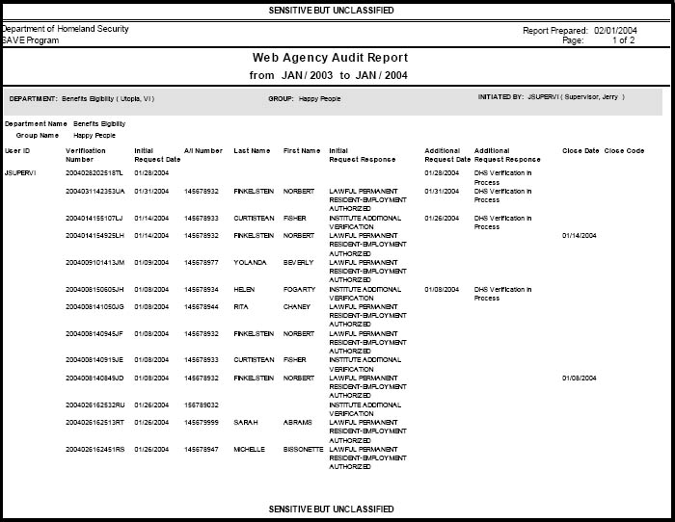

Index

A.K.A. 13, 15
Access Method 2, 5
Account Unlock 29
Acrobat Reader 35
Add
Department 30
Group 34
User 9, 23
Additional Verification 3, 8, 9, 13, 15, 17, 18
I-94 Number 15
Additional Verification Data Request form 13
Additional Verification Results section 18
Address Change 9
Administration
Case 8, 9, 11, 15, 18
Privileges 3, 4
Site 9, 23
User 8, 9, 21, 22
Adobe Acrobat Reader 35
Agency Hierarchy 2
Alien Number 11
Benefits 11, 15
Buttons
Add Department 30
Add Group 34
Close 14
Complete and Close Case 12, 14
Delete Group 35
Display Case Summary List 18
Display Group Summary List 33
Display User Summary List 25
Edit Department 31
Edit Group 34
Next 19, 23, 24, 26, 36
Previous 19, 26
Print Case Details 14, 21
Request Additional Verification 13
Run Report 37
Submit Additional Verification 13, 15
Submit Department Information 32
Submit Initial Verification 11
Submit New User 25
Submit Password Change 6, 22
Submit Profile Changes 22
Update 34
View Reports 36
View/Edit Department 32
Case
Administration 8, 9, 11, 15, 18
Check Status 18
Complete and Close Case button 12, 14
Display Case Summary List 18
Print 20
View 8, 9, 35
Case Details Page 17
Change
Address 9
Password 4, 9, 21
Profile 9, 22
Check Case Status 18
Close Case 12, 14
Comments
DHS 14
Special 13, 15
Complete and Close Case 12
Create
Department 4, 30
Group 4
User 4
Delete
Department 4
Group 4, 35
User 4
Delete Group Button 35
Department
Add 30
Create 4, 30
Delete 4
Edit 31
Modify 4, 31
Summary List 29, 30, 31
View 9, 29, 30, 31
DHS Comments 14
DHS Response Code 14
DHS Verification in Process 13
Edit
Departments 31
Group 34
User 27
Force Password Change 29
Frame
Main Display 10
System Message 10
Title 7
General User Navigation Menu 8
Group
Add 34
Create 4
Delete 4, 35
Display Group Summary List button 33
Edit 34
Modify 4
Summary List 34, 35
View 9, 32
Helpful documents 8
Hierarchy 2, 3
I-94 number 8, 9, 15
Initial Results section 13
Initial Verification 8, 9, 11, 15
Institute Additional Verification 13, 15
Logging on
After first time 6
For first time 5
Main Display Frame 10
Menu
Navigation
General User 8
Superuser 9
Supervisor 9
Site Administration
Superuser 9
Supervisor 9
Modify
Department 4, 31
Group 4
User 4
User Profile Information 27
Navigation Menu 8
Next Button 23, 24, 36
On-Line Resources 8
Password
Change 4, 9, 21
Characteristics 5, 22, 25, 28, 29
Creating or changing 5, 22, 25, 28, 29
Force Change 29
Resetting Another User’s 28
Print Case 20
Print Case Details Button 21
Privileges
Administration 3
Verification 3
Profile
Change 9, 22
Report Parameter form 36
Reports 9, 35
Adobe Acrobat Reader 35
Run 36
View 9, 35, 36
Resetting Another User’s Password 28
Response Code 14
Response Date 14
Role, User 4, 23
Run Report 36
Run Report Button 37
Screen Layout 7
Search Criteria 18, 25, 32
Site Administration 9, 23
Special Comments 13, 15
Status Message Bar 8
Superuser Navigation Menu 9
Supervisor Navigation Menu 9
System Message Frame 10
Title Bar 7
Title Frame 7
Title Navigation Links 8
Tutorial 8
Unlock an Account 29
Update button 34
User
Edit 27
User
Add 9, 23
Administration 8, 9, 21, 22
Administration Privileges by Role 4
Change Password 21
Create 4
Delete 4
Display User Summary List button 25
Hierarchy 2, 3
Modify 4
Modify profile information 27
Privileges 3
Role 4, 23
Verification Privileges by Role 3
View 9, 25
View/Modify Profile Information 25
User
Unlock 29
User ID
Changing Default 24
Default 24
User Summary List 25, 27
Verification
Additional 3, 8, 9, 13, 15, 17, 18
Initial 3, 8, 9, 11, 15
Institute Additional 13, 15
Privileges 3
View
Cases 8, 9, 18, 35
Departments 9, 29, 30, 31
Groups 9, 32
Reports 9, 35, 36
User Profile Information 25
Users 9, 25
View Cases Link 18
View Reports Button 36

Document prepared by:

Computer Sciences Corporation
2001 L. Street, NW, Suite 1000
Washington, DC 20036

Founded in 1959, Computer Sciences Corporation is a leading global information technology (IT) services company. CSC’s mission is to provide customers in industry and government with solutions crafted to meet their specific challenges and enable them to profit from the advanced use of technology.
With more than 92,000 employees, CSC provides innovative solutions for customers around the world by applying leading technologies and CSC’s own advanced capabilities. These include systems design and integration; IT and business process outsourcing; applications software development; Web and application hosting; and management consulting. Headquartered in El Segundo, Calif., CSC reported revenue of $13 billion for the 12 months ended Oct. 3, 2003. For more information, visit the company’s Web site at www.csc.com.

