  Department of Human Resources  311 West Saratoga Street  Baltimore MD 21201 | FIA INFORMATION MEMO
Control Number: 04-33 | Effective Date: April 12, 2004
Control Number: 04-33 | Issuance Date: April 12, 2004

TO: DIRECTORS, LOCAL DEPARTMENT OF SOCIAL SERVICES

DEPUTY/ASSISTANT DIRECTORS FOR FAMILY INVESTMENT
FAMILY INVESTMENT SUPERVISORS/ELIGIBILITY STAFF

FROM: KEVIN McGUIRE, EXECUTIVE DIRECTOR, FIA

RE: MEDICARE PHARMACY DISCOUNT PROGRAM

PROGRAMS AFFECTED: MEDICAL ASSISTANCE

ORIGINATING OFFICE: OFFICE OF POLICY, RESEARCH AND SYSTEMS

SUMMARY: The Medicare Prescription Drug Improvement and Modernization Act of 2003 authorizes the implementation of the Medicare-Approved Drug Discount Card Program. The drug discount card program is effective June 1, 2004 through December 31, 2005. The program is designed to help Medicare recipients with the cost of prescription drugs.

Federal law prohibits recipients that currently receive benefits from Medicaid, Maryland Pharmacy Assistance, or the current Maryland Discount Drug Program to receive the new Medicare-Approved Drug Discount Card. During the week of April 5, 2004 the Department of Health and Mental Hygiene (DHMH) will mail notification to recipients receiving benefits from these programs not to apply for the new discount card program (Attachment I). Approximately 79,000 customers require notification not to apply for this program.

The Local Department of Social Services, Family Investment Administration (FIA) staff will not determine eligibility for the Medicare-Approved Drug Discount Card Program. FIA staff will provide information and referral assistance to customers:

- Refer customers wishing to apply for Medicare to the Social Security Administration (SSA). SSA will inform the customer about the new discount drug card program.

- For customers that receive Medicare who apply for and are determined not eligible for Medicaid, refer them to SSA and instruct them to call 1-800-Medicare regarding eligibility for the new discount drug card program.

DHMH will forward to FIA additional information to provide customers regarding the Medicare-Approved Drug Discount Drug Program. No date has been set for FIA to receive this information.

INQUIRES:

Please direct inquires to Cynthia Carpenter at 410-767-7495

.cc: DHR Executive Staff FIA Management Staff RESI
Constituent Services OIM HELP Desk

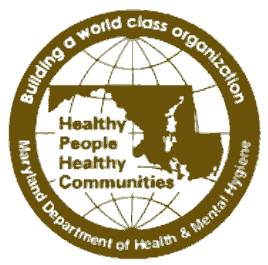
STATE OF MARYLAND
ATTACHMENT I

DHMH

Maryland Department of Health and Mental Hygiene

201 W. Preston Street • Baltimore, Maryland 21201
Robert L. Ehrlich, Jr., Governor - Michael S. Steele, Lt. Governor - Nelson J. Sabatini, Secretary

Office of Operations, Eligibility & Pharmacy Joseph E. Davis
Medical Care Programs Executive Director

April, 2004

Important Notice
Your State Prescription Coverage Offers Better Benefits

Than the Federal Medicare Discount Drug Card

You are getting this notice because you are in the Maryland Medical Assistance Program, Maryland Pharmacy Assistance Program or the Maryland Pharmacy Discount Program and are receiving Federal Medicare Benefits.

Congress Added Prescription Benefits to the Federal Medicare Program
- As a first step, beginning in June 2004, Medicare will offer a temporary drug discount card program.
- This discount drug card program will only last until December 31, 2005.

You Already Have Prescription Benefits Under the State Programs
- You have drug coverage under the Maryland Medical Assistance Program, the Maryland Pharmacy Assistance Program or the Maryland Pharmacy Discount Program.
- Federal Medicare law says that if you have prescription benefits from the State, you are NOT eligible for the Medicare prescription drug card.
- However, you will be eligible for the full Medicare prescription drug program when it begins January 1, 2006.

Discount Drug Company Ads Will Ask You to Apply
- Many prescription discount card companies will try to enroll you in the Medicare drug discount card program.
- Do NOT sign-up for the Medicare discount prescription card.
- You already receive higher savings with your State pharmacy benefit.
- If you have any questions about this letter, you can call 1-800-492-5231.

