  Department of Human Resources  311 West Saratoga Street  Baltimore MD 21201 | Family Investment Administration  ACTION TRANSMITTAL
Control Number: #03-29 | Effective Date: January 1, 2003
Control Number: #03-29 | Issuance Date: December 2, 2002

TO: DIRECTORS, LOCAL DEPARTMENTS OF SOCIAL SERVICES
DEPUTY/ASSISTANT DIRECTORS FOR FAMILY INVESTMENT
FAMILY INVESTMENT SUPERVISORS AND ELIGIBILITY STAFF

FROM: CHARLES E. HENRY, EXECUTIVE DIRECTOR

RE: TRANSITIONAL FOOD STAMP BENEFITS

PROGRAM AFFECTED: FOOD STAMP PROGRAM

ORIGINATING OFFICE: OFFICE OF POLICY, RESEARCH AND SYSTEMS

SUMMARY:
The Farm Bill allows states to extend a household’s food stamp benefits when their Temporary Cash Assistance (TCA) case closes. Food stamp benefits are “frozen” for five months following the TCA case closing. Transitional food stamps ease the transition from welfare and bring federal dollars into Maryland’s economy.

Transitional food stamps (TFS) are issued to a TCA assistance unit when the TCA closes. The amount of the benefit is frozen at the same level for five months unless the household requests recertification. When the TCA case closes, households, including mixed households, will receive transitional food stamps, unless:
- The household did not receive a TCA benefit for at least one month prior to the month the TCA benefit ended.
- The household moves out of State.
- The household lost TCA eligibility because of:
- Failure to comply with work requirements,
- Failure to comply with child support requirements, or
- Intentional program violations (IPV)
- The entire household is ineligible for FS because of:
- IPV,
- Failure to comply with work requirements,
- Failure to cooperate with Quality Control,
- Ineligible immigrant status
- Status as a fleeing felon, or
- Transfer of assets.

A guide to implementing transitional food stamps follows.

Note: CARES supports this policy.

GUIDE TO TRANSITIONAL FOOD STAMPS

NEW POLICY:

What are transitional food stamps?

- Transitional benefits are food stamp benefits that are issued to a TCA assistance unit when the TCA case closes.

- The amount of the benefit is frozen at the same level for five months unless the household requests recertification.

Who will get transitional food stamps?

- With a few exceptions, TCA households that have received at least two months of TCA benefits will receive transitional food stamps (TFS) for five months after the TCA case closes.

- Mixed Households, which include both TCA members and non-TCA members, will also receive TFS when the TCA case closes.

Example 1: Ms. B lives with her 20-year old daughter (Ms. C) and her two grandchildren. Ms. C receives TCA for herself and the two children. Ms. B receives SSI. They are all included in the same food stamp case. When Ms. C’s TCA case closes, the household will get TFS.

Example 2: Ms. K’s FS household includes her 20-year old daughter and child and her 19-year old daughter and child. Each of the daughters receives TCA. The 20-year old daughter reports new employment and requests to have her TCA case closed. This household will not get TFS since there is still an open TCA case associated with the food stamp household.

Example 3: Ms. G receives TCA and food stamps for herself and one child. Her only income is TCA. In September she reported to her case manager that she had gotten married and her husband was employed. She wants her TCA case closed. Her case is closed effective October 1. She will get TFS from October through February. The benefit is based on a 2-person household with no income.

Who will not get TFS?

- A household will not get TFS if:

- The household did not receive a TCA benefit for at least one month prior to the month the TCA benefit ended.

- The household moves out of State.

- The household loses TCA eligibility because of:

- Failure to comply with work requirements,
- Failure to comply with child support requirements, or
- Intentional program violations (IPV)

Example 4: Mr. G receives TCA for himself, his wife and two children. Mr. G did not comply with TCA work requirements, so his TCA case was closed. This household cannot get TFS. Reminder: If this household is still eligible for food stamps the case manager will include phantom TCA income in the calculation of the FS benefit.

- The entire household is ineligible for FS because of:
- IPV,
- Failure to comply with work requirements,
- Failure to cooperate with Quality Control,
- Ineligible immigrant status
- Status as a fleeing felon, or
- Transfer of assets.

Reminder: A food stamp disqualification is usually an individual sanction. Most TCA sanctions result in full family ineligibility. When there are remaining eligible members of the food stamp or TCA case, the household is potentially eligible for TFS.

Example 5: Ms. J and her two children receive TCA and food stamps. The local department determined that last year she had committed a FS IPV, before she applied for TCA. She signed a waiver of the disqualification hearing. Ms. J was disqualified from food stamps for one year beginning in October but continued to receive food stamps for her two children. In January she reported a new job. Her TCA case is closed effective February. She will get 5 months of transitional food stamp benefits for the two eligible household members.

What is the amount of the transitional food stamp benefit?

- The TFS amount is based on the amount of food stamps the household received in the month before the TCA case closes, adjusted for the loss of the TCA benefit.

- The TFS amount stays the same for five months, regardless of changes in the family’s circumstances, unless the household requests recertification.

- CARES will count the income, deductions and household size in the month before the TCA case closes and subtract out the TCA grant received in that month.

Example 6: Mr. A and his two children receive a TCA grant in the amount of $172. He also receives $300 in social security benefits for the two children. On January 27, 2003 Mr. A reported that he got a job and requested closure of his

TCA case. The TCA benefits will end effective March 1. Transitional food stamps are calculated using only the social security income of $300. Neither his new earnings nor the TCA benefit will count for the five-month transitional benefit period.

Example 7: Ms. B lives with her 20-year old daughter (Ms. C) and her two grandchildren. Ms. C receives TCA for herself and the two children in the amount of $472. Ms. B receives SSI in the amount of $545. They are all included in the same food stamp case. Ms. C got a job in August and reported the information to her case manager on September 5, after receiving her first pay. Her earnings are over the income level for TCA and her TCA case closes effective October 1st. The FS household is entitled to five months of TFS. The TFS benefit is based on the September food stamps adjusted for the loss of the TCA benefit. Ms. B’s SSI is the only countable income.

Note: After the recertification at the end of the 5-month transitional food stamp period, the household will be in the simplified reporting group.

What if there are less than 5 months remaining in the household’s current certification period?

- CARES will extend the household’s certification period beyond the current period in order to meet the 5-month transitional period.

Example 8: Ms. E receives food stamps and TCA based on no income. She was certified for food stamps from January 1 through June 30. On May 10, she reported a job that makes her TCA over scale. She is entitled to TFS beginning June 1 through October 31.

What if there are more than 5 months left in a household’s certification period?

- CARES will shorten the certification period to correspond to the end of the TFS period.

- The TFS period will never extend past five months.

Example 9: Mr. M receives food stamps for himself and his daughter, Ms. M, and her two sons. The household was certified from November through October. Ms. M receives TCA. In December she requests that the agency close her case because of receipt of social security survivor’s benefits. The case manager closes Ms. M’s TCA effective January. The TFS period is January through May. The household will have to complete a recertification to get benefits after May.

What changes do households have to report during the transitional benefit period?

- During the transitional benefit period the household is not required to report any changes for food stamps.

What if there is a change in the household’s circumstances?

- The household’s benefit remains frozen during the TFS benefit period unless the household requests recertification.

- If the household is recertified TFS stop and all regular food stamp rules apply.

Example 10: Ms. P receives food stamps and TCA for herself and child. She has no income other than TCA. She was certified for food stamps from January 1 through June 30. On May 10, she reported a job that makes her TCA over scale. Her TCA case closes effective June 1. She is entitled to TFS beginning June 1 through October 31. In August she reports that she moved to a household with higher shelter costs and that her 10-year old nephew had moved into her home. She requests recertification. The case manager will recertify the household and will use the updated information.

What if the customer does not want to recertify, but wants to report a change that affects medical assistance?

The agency will act on the reported changes for MA (or any other program). The change will not affect the TFS benefit unless the case manager initiates a recertification period.

What if the household reapplies for TCA during the transitional food stamp period?

The household will continue to get TFS until the end of the five-month period unless it requests recertification. At the end of the transitional food stamp period, the household will have to recertify in order to get additional food stamps.

How should the local department handle situations in which a household member moves out of a transitional food stamp household and either reapplies as a new household or is reported as a new member of another household?

Food stamp policy does not allow duplicate participation. In this situation, the case manager will remove the individual from the household receiving TFS and add the individual to the other household.

Note: Do not change the food stamp household composition during the transitional benefit period unless the household member reapplies as a new household, is reported as member of another food stamp household or requests recertification.

What if the case manager becomes aware of an error in the TCA or food stamp benefit, either at the time of calculating the transitional benefit or later? Should we adjust the transitional benefit to correct the error?

- The case manager would not adjust the TFS benefit. Both the local department and household will be held harmless for TFS inaccuracies that are due to prior errors in the food stamp benefit if the transitional benefit was based on the benefit issued during the final month of TCA. Errors may occur if the transitional benefit amount is incorrectly calculated.

- The agency or household may be liable for errors that occurred in the regular issuance (before the transitional benefit period). The case manager would refer the case for overpayment when an error is identified in the regular food stamp benefit.

ACTION REQUIRED:
- Transitional benefit procedures are CARES supported.

- When the TCA closes, CARES generates the following notice

Transitional Benefit Conditional Notice Text:

Old amount: New amount:

Reason: Your household’s Temporary Cash Assistance (TCA) case closed and you are eligible for transitional food stamps.
According to Code of Maryland Regulation:
FS 07.03.17.47

You will get this fixed amount for five months after your TCA case closes, unless someone in your household applies in another Food Stamp (FS) case. We based this benefit amount on the food stamps you got the month before your TCA case closed. We did not count the closed TCA grant when we calculated your food stamps. You do not have to report any changes until the end of this 5-month period. If you want to get food stamps after this 5-month period, you will have to complete a redetermination.

You can ask for a redetermination at any time during this 5-month period.

ACTION DUE:
This policy will be effective January 1, 2003.

INQUIRIES:
Direct food stamp policy questions to Kay Finegan at 410-767-7939 or Marilyn Lorenzo at 410-767-7333. Questions concerning CARES procedures can be directed to
Fern Parson at 410-767-7064 or Scott Adams at 410-767-3964.

cc: FIA Management Staff DHR Help Desk
Constituent Services RESI

CARES SYSTEM PROCEDURES:

When initiating Transitional Food Stamp (TFS) benefits, case managers must keep in mind that the household must have received at least two months of TCA and Food Stamp benefits.

INITIATING TFS

- Follow normal TCA closing procedures, confirm the TCA closure on ELIG and CAFI, and proceed to the Food Stamp ELIG screen.

- The existing Food Stamp AU will remain active. Reason code 362 (TCA Case Closed – Eligible for Transitional Food Stamps) will appear on the Food Stamp ELIG and STAT screens if the customer is eligible for TFS in the month immediately following the TCA closure (i.e., no adverse action). This code will not appear if the TCA AU closed in adverse action. Place a “Y” in the Food Stamp ELIG field and proceed to FSFI.

- If the TCA closure occurs within an adverse action period, the TFS indicator on FSFI will be set to “P” (pending). Once the adverse action period has passed, the TFS indicator will change to “Y” (Yes). CARES eligibility will “freeze” the last regular issuance of Food Stamp benefits, disregarding the countable cash grant amount from the closed TCA when the TFS indicator on FSFI has a “P” or a “Y”.

“pending” on FSFI

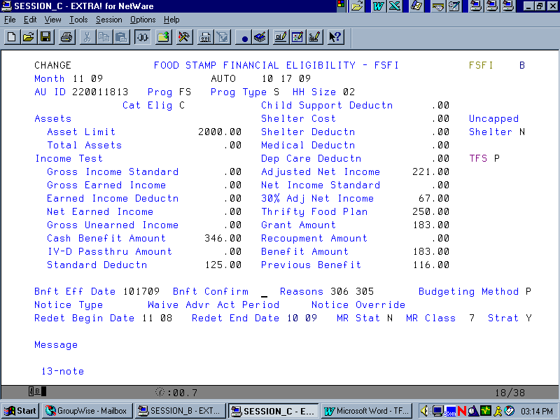

“Yes” on FSFI

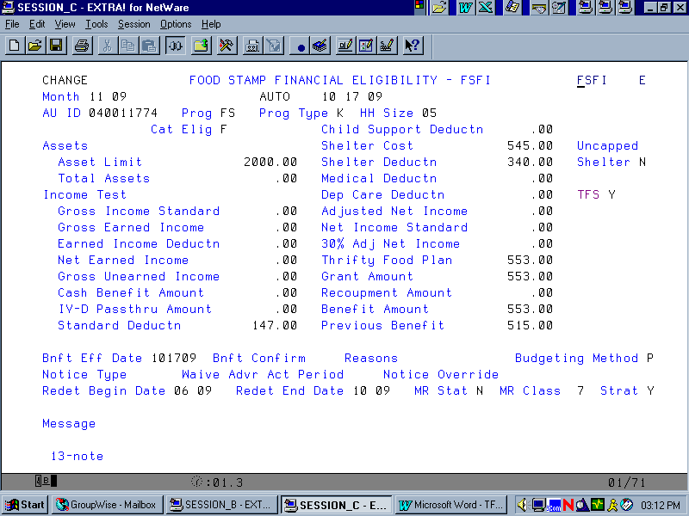
- The Food Stamp certification period will be extended for 5 months beyond the date of the TCA closure.

- Prior to the end of the TFS “freeze” period, case managers will receive normal recertification alerts, appointments and notices. TFS cases will follow the normal redetermination cycle and will close in batch processing with a 235 (Failed to Reapply for Benefits) when the certification period expires.

FSET Changes

A new FSET Exempt Reason code of “TB” (Transitional Benefit) has been created on the WORK screen.

Closings with 500 Level Reason Codes:

Food Stamp customers receiving TFS are exempt from FSET. Case managers must take the following actions when closing TCA with a 500 level reason code:

- Prior to finalization of the TCA closure, case managers will receive an edit requesting that they return to the WORK screen. Once on the WORK screen error message “2295 EXEMPT RSN CA IS NOT VALID, CLIENT IS NOT ACTIVE OR PENDING ON A CASH AU” will appear. If an attempt is made by the case manager to change the Exempt Reason code to “TB” error message “2479 TB EXEMPTION NOT VALID; FS AU DOES NOT HAVE TFS INDICATOR = Y OR P” will display. To resolve this error message, case managers must temporarily change the existing “EX” registration status to “MP”, and delete the Exemption Reason, prior to completing the finalization process.

- Once the Food Stamp AU is accessed through Option “B” or “R”, the FSET Exempt Reason code on the WORK screen will default to “TB”.

Closings with System Generated Reason Codes:

No additional steps need to be taken because system generated closures will not cause a WORK screen edit.
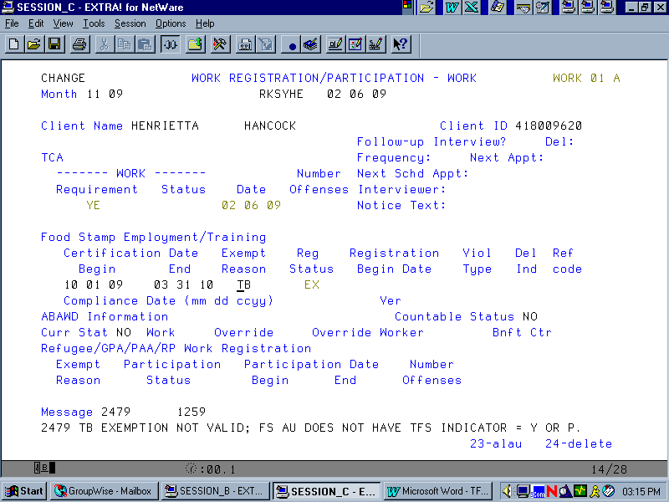

RECERTIFICATION

A customer may recertify for Food Stamps at any time during the five-month “freeze” period. However, case managers must remember that by doing so, this will end the TFS “freeze period”. To ensure that case managers do not break the freeze in error the following prompts have been put into place.

- If a case manager accesses Option N (Initiate Redetermination) to initiate a recertification, warning message “3001 ATTENTION – MORE TIME REMAINS IN THE TRANSITIONAL FOOD STAMP PERIOD” will appear on the REDE screen.
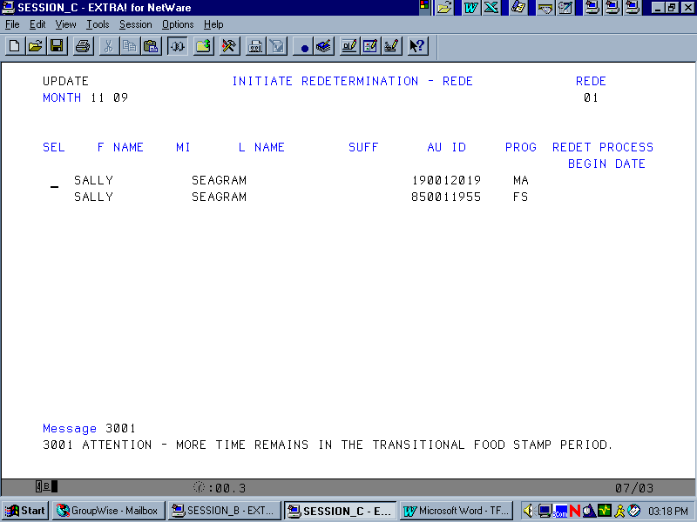

- If a second attempt is made to recertify Food Stamps during the “freeze” period, warning message “3002 ARE YOU SURE YOU WANT TO DO THIS?” will appear on the REDE screen.

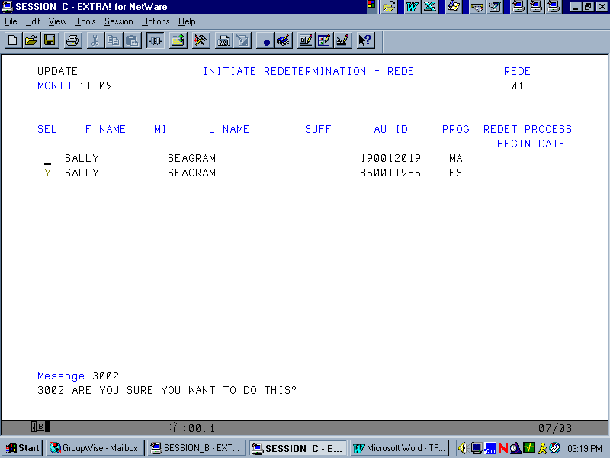
- A further attempt by the case manager to initiate a redetermination will be allowed. Once the redetermination is initiated, the TFS indicator will change to “N”.

CHANGES DURING THE TFS PERIOD

If a customer reports a change in household composition during the TFS “freeze” period, the case manager must carefully review with the customer their option to remain in the “freeze” period, or to recertify their Food Stamps.

- If a household member leaves the home during the TFS “freeze” period, the remaining members will continue to receive the “frozen” benefit allotment for the remainder of the TFS period if the customer chooses. The same will apply if a new household member moves into the home.

- Important Exception: If the household member that is leaving the Food Stamp AU during the TFS “freeze” period applies for their own Food Stamp AU, the existing TFS period will have to be broken to prevent dual participation.

- To end a TFS “freeze” (at the customer’s request), case managers must initiate a redetermination (Option N on AMEN), PF4 past warning messages 3001 and 3002 on the REDE screen, and select the FS AU.

- Attempting to add a new member to an existing Food Stamp AU during the TFS “freeze” period (Option K on AMEN) will generate error message “3003 HOUSEHOLD IN TFS – YOU MUST RE-CERTIFY TO ADD OR REMOVE MEMBERS”, if the Food Stamp AU is entered in the AU ID. This same message will appear on the STAT screen when an attempt is made to remove an individual, and on INCH when the FS AU is selected when attempting to add an individual to an existing Food Stamp AU in TFS.

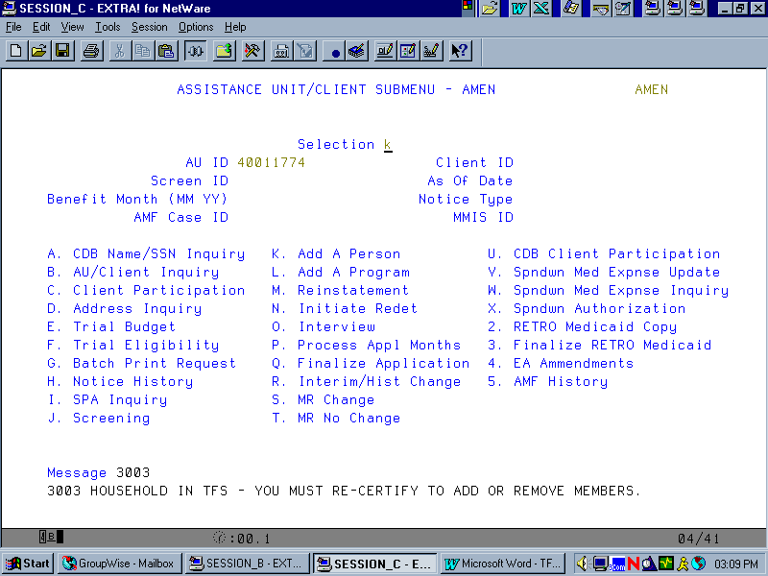
AMEN

STAT

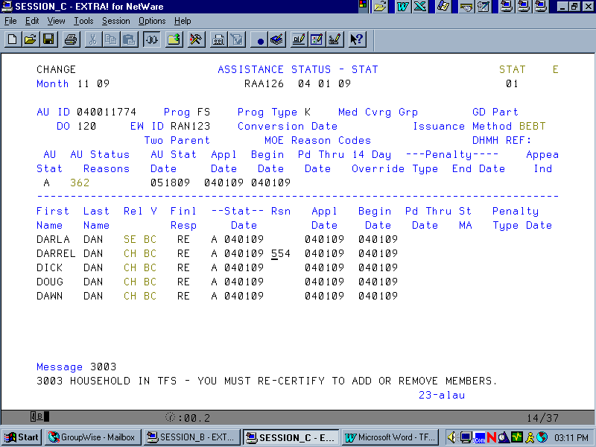

INCH
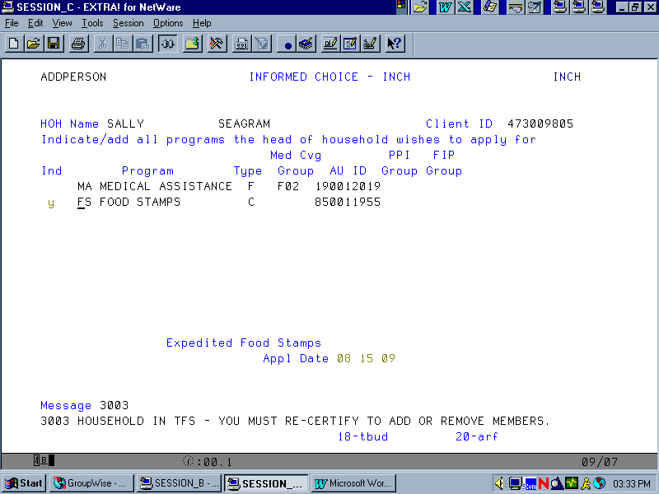

ELIG

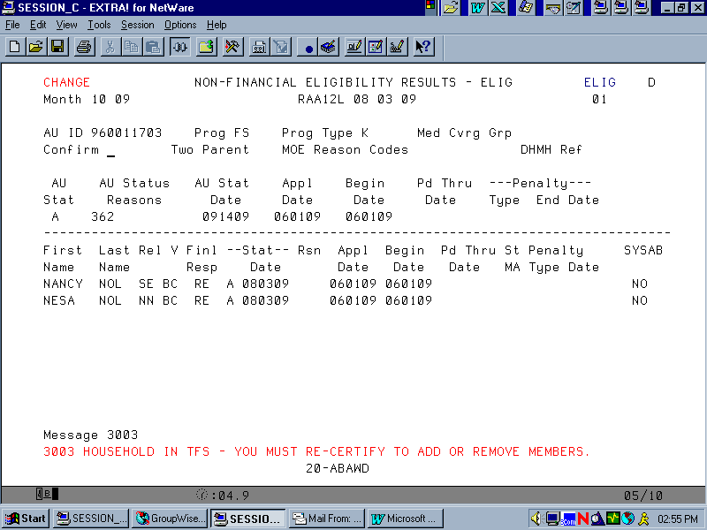

FOOD STAMP AU’S IN RECOUPMENT

Food Stamp overpayments that were in recoupment during the regular certification period will remain unaffected by the TFS “freeze”. That is, overpayments will continue to be recouped from the allotment.

- FS AU’s scheduled to satisfy one overpayment and begin another during the “freeze” period will be recalculated and applied to the remaining months of the TFS period.

- Initiating an overpayment while an AU is in TFS will affect the TFS AU in the same manner as a regular Food Stamp household. Underpayments will also function in the same manner as a regular FS household.

CUSTOMER DECLINES TFS

If a customer chooses not to receive TFS Benefits, case managers should enter closing code: 581 (CUSTOMER DECLINED TFS) in the first AU level reason code field on the Food Stamp STAT screen.

Note: Entry of the 581 reason code in the second AU level reason code field on STAT will give warning message 2481 –The Only Valid AU Status Reasons for FS Cases in TFS are 362 and 581. Entering the 581 reason code in the Client level reason code field will produce warning message 3003 – Household in TFS – You Must Re-certify to Add or Remove Members.

