NEW CARES PROCESSING:

New/Modified Parameters
CARES has been modified to include the poverty level parameters applicable to the MCHP Expansion Program. The pregnant woman (P11) parameter has been increased to 250% of the Federal Poverty Level (FPL). A new MCHP income parameter has been created and set to 300% FPL for determining P14 eligibility for potential coverage under the Expansion program.

- DHMH Referral Indicator
Modifications have been made to the Assistance Status (STAT) and Non-Financial Eligibility Results (ELIG) screens. One new field has been added to both screens. The field is labeled ‘DHMH REF’. This field is unavailable for user entry. CARES will display a ’Y’ in the ongoing month for all customers who have been closed or denied for Medical Assistance (F and P track) and are found potentially eligible for the MCHP Expansion Program. A blank space in the this field indicates that a referral was not made to DHMH for the Expansion program.
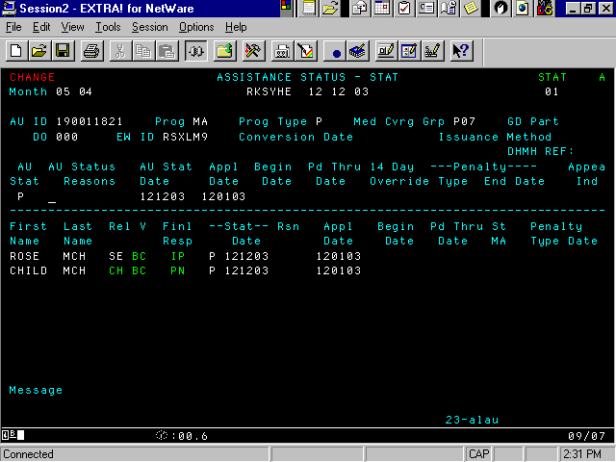

- CARES To MMIS II Interface
A new DHMH auxiliary file has been created to capture federal reporting requirements associated with the MCHP and MCHP Expansion programs. This file will also contain the required data for customers who are potentially
eligible under MCHP Expansion. CARES will electronically transmit this data daily to MMIS II.
- Health Insurance Coverage – Application, Reopen or Redetermination
The Medical Coverage Statement and corresponding verification fields for the P14 coverage group on the Client Demographic 1 (DEM1) screen are obsolete for benefit months beginning July 2001. However, these fields will be available for data entry for benefit months prior to July 1, 2001.

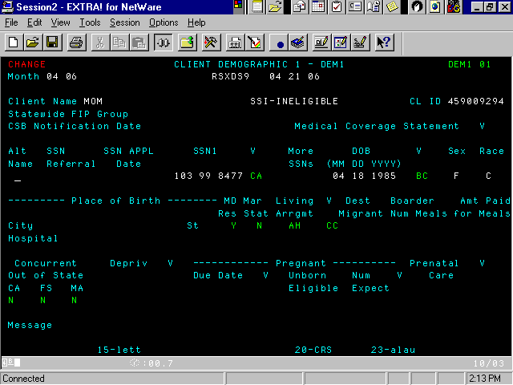
DEM1 Screen

Customers that have health insurance coverage or voluntarily drop health insurance in the past 6 months remain ineligible for P14 coverage. The following denial and closing reason codes are for children found ineligible for the P14 coverage group.

359 (Previously 344) – You have indicated that you have health insurance.
360 – You have indicated on your application that you have dropped
health insurance in the past 6 months.

Two new fields have been added to the Client Demographic 2 (DEM2) screen. These fields are labeled ‘Insur Dropped’ and ‘Premium OK’. This data is mandatory for all TCA and MA (F and P track) AUs that include children under the age of 19. The combination of the valid values entered is used to determine P14 eligibility.

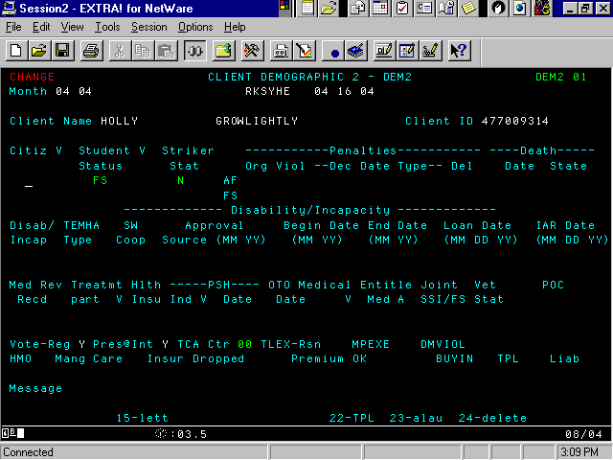
DEM2 Screen (Effective July 1, 2001)

Processing a TCA or MA (F and P track) AU will require the use of accurate valid values on the DEM2 screen.

Health Insurance – Enter the appropriate valid value in the ‘Hlth Insu’ field:
Y – Yes, customer has health insurance
N – No, customer does not have health insurance
P – Customer potentially has health insurance

Reason Dropped – Enter the appropriate valid value in the ‘Insur Dropped’ field:

A – Did Not Drop Insurance In The Six Months Prior to Application
B – Change to New Employer
C – Moved Out of Service Area for All Employer Health Plans
D – Employer Dropped Coverage
E – Involuntary Loss of Employment
F – Expiration of COBRA Coverage Period
G – Limited Benefit Insurance – No Inpatient Hospital Coverage
H – Insurance Was No Longer Needed
I – Voluntary Loss of Employment
J – Dropped Insurance Due to Cost
K – Other

Premium OK – Enter the appropriate valid value:

Y – Yes, customer is willing to pay a premium
N – No, customer is not willing to pay a premium
U – Unknown if customer is willing to pay a premium

The Medical Care Operations Administration Insurance Recoveries Unit will automatically code the ‘Hlth Insu’ field on the Client Demographic 2 (DEM2) screen with ‘C’ (confirm) when health insurance coverage is discovered for the customer. Alert code 991 (MMIS Reports: Client Has Other Health Insurance) is generated to the Case Manager indicating an unscheduled redetermination is needed. The local department of social services or the local health department is then required to establish continued eligibility.

Use the following procedure to process the unscheduled redetermination:

- Delete the ‘C’ from the ‘Hlth Insu’ field on the DEM2 screen by pressing the delete or end of field key. Do not use the spacebar to delete the code.

- Enter the appropriate valid value (‘Y’, ‘N’ or ‘P’) in the Hlth Insu field.

- Update the narrative indicating the action taken on the case.

Note: Failure to update this field will prompt the following edit message to
display on the Final Edits screen.

2327 – Health insurance = ‘Y’, ‘N’, or ‘P’ for Appl, Reopen, or
Redet

The Earned Income 1 (ERN1) screen has a new field labeled ‘Employer Ins Avail’. This information is mandatory for all employed adults in TCA and MA (F and P track) AUs where a valid parental relationship exists.

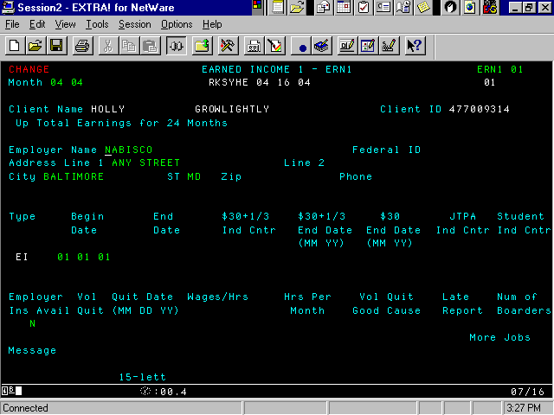
ERN1 Screen (Effective July 1, 2001)

Enter the appropriate valid value on the ERN1 screen in the Employer Ins Avail field:

Y – Yes, employer insurance is available
N – No, employer insurance is not available
U – Unknown if employer insurance is available

- Eligibility Determination Document
The Eligibility Determination Document (EDD) has been modified to include three new detail lines. This information will be printed (in the client level Medical Information section) for all TCA and MA (F and P track) AUs.

Example Extract:

MEDICAL INFORMATION
******************************

IS THIS PERSON COVERED BY ANY MEDICAL INSURANCE? X

WAS INSURANCE COVERAGE DROPPED DURING 6 MONTHS PRIOR TO APPLICATION? X

IS THE FAMILY WILLING TO PAY A PREMIUM? X

IS HEALTH INSURANCE AVAILABLE THROUGH THE CUSTODIAL PARENT’S EMPLOYER? X
- Notices

Denial and closing notices have been revised to include referral text (in bold) for the MCHP Premium Program. (See Attachment A and B)

- MCHP (P track) AUs – Medical Support Processing
The Valid Value Help Text screen for the Client Demographic 1 (DEM1) has
been modified.

- Enter the valid value ‘N’ (Deprivation is not required) in the ‘Depriv’ field on the Client Demographic 1 (DEM1) screen.

CARES will not automatically display the Absent Parent Information (APID) screens.

Pregnant Woman (P02 and P11) Processing
The Valid Values Help Text screen for the Client Demographic 1 (DEM1)
has been modified.

Enter DS – Declaratory Statement in the ‘Expected Date of Delivery’ verification field and ‘Num Expect’ verification fields.

- Enter Y – Yes, receiving prenatal care in the ‘Prenatal Care’ field.

- Enter YE – Yes, verified receiving prenatal care in the Prenatal Care ‘V’ – verification field.

Note: Valid values OT – Other Medical Professional and NO – Not
Verified are not applicable for benefit months beginning July 2001.
However, these valid values are appropriate for benefit months prior
to July 1, 2001.

TCA and MA (F track) AUs - Application, Reopen or Redet
Case managers are required to appropriately complete the DEM1 and
APID screens.

ATTACHMENT A

NOTICE OF DENIAL

Your application dated 08/05/01 for Medical Assistance has been
denied. If your situation changes, you may reapply at anytime.

AUGUST, 2001
SEPTEMBER, 2001

Reason(s) for Denial:

NO ONE IN YOUR FAMILY IS ELIGIBLE FOR BENEFITS.
ACCORDING TO CODE OF MARYLAND REGULATIONS

MA 10.09.24.05 00.00.00.00 00.00.00.00

NAME: JANE DOE

This child may be eligible for the MCHP Premium Program. For a small monthly premium, this program provides health insurance through an employer's health plan or a managed care organization. Someone from the Department of Health and Mental Hygiene will call you to help you apply for the program. If you have any questions about the Premium Program, please call 1-800-456-8900.

The information below helped us make our decision:

MEDICAL ASSISTANCE
Assistance Unit Number XXXXXXXXX
Household Size 1
Earned Income $ 1,412.98
Unearned Income
Housing Costs
Utility Costs
Dependent Care Costs
Medical Costs
Assets

If you think the information we used is wrong, please call your
Case Manager at the number listed above. Please remember to
Report all changes within (10) ten days.

You may ask for a Fair Hearing if you think our decision is wrong.
The Fair Hearing rules are on the other side of this notice.

ATTACHMENT B

CLOSING

Your Medical Assistance will end on 12/31/01.

REASON(S):

NO ONE IN YOUR FAMILY IS ELIGIBLE FOR BENEFITS.
ACCORDING TO CODE OF MARYLAND REGULATIONS
MA 10.09.24.05 00.00.00.00 00.00.00.00

This closure affects the following people:
JOHN DOE

This child may be eligible for the MCHP Premium Program. For a small monthly premium, this program provides health insurance through an employer’s health plan or a managed care organization. Someone from the Department of Health and Mental Hygiene will call you to help you apply for the program. If you have questions about the Premium Program, please call 1-800-456-8900.

The information below helped us make our decision:

MEDICAL
ASSISTANCE
Assistance Unit Number XXXXXXXXX
Household Size 1
Earned Income $ 1,927.47
Unearned Income
Housing Costs $ 12.50
Utility Costs $ 315.47
Dependent Care Costs $ 215.00
Medical Costs
Assets

If you think the information we used is wrong, please call your
Case Manager at the number listed above. Please remember to
report all changes within ten (10) days.

You may ask for a Fair Hearing if you think our decision is wrong.
The Fair Hearing rules are on the other side of this notice.

ATTACHMENT C

PWC Track, Trickle Sprout

PWC TRACK

1.  Program  Code | 2.  Coverage Group | 3.  Is Application Allowed? | 4.  Can It Trickle In? From Where? | 5.  Can It Trickle Down? To Where?
MA | P02  Pregnant Women  185% Poverty Level | Yes | No | Yes,  P11
MA | P03  Cat. Needy Newborns | Yes | No | Yes  P06 if Mom is not actively receiving MA at time of application or P07 if age
MA | P06  Children < 1 185% of Poverty | Yes | Yes  P03 | Yes  P07 (if over age)  P08 (if overscale income)
MA | P07  Children > 1 < 6  133 % of Poverty | Yes | Yes  P03 or P06 | Yes  P08 (if over age)  P13 (if overscale income)
MA | P08  Children > 6 100 % of Poverty * | Yes | Yes  P07 | Yes  benefit month < 7/98 - P09  benefit month >= 7/98 - P13
MA | P09  Children > 1  185 % Poverty * | No | Yes  P08 | No

Track, Trickle, Sprout

PWC TRACK

1.  Program  Code | 2.  Coverage Group | 3.  Is Application Allowed? | 4.  Can It Trickle In? From Where? | 5.  Can It Trickle Down? To Where?

MA | P11  Pregnant Women  200% Poverty Level | No | Yes,  P02 |  | No
MA | P12  Newborns born to P11 and P14 mothers | Yes | No | Yes  P06 age < 1,  P07 age > 1
MA | P13  Children  185% Poverty Level * | No | Yes,  P06,  P07,  P08 | Yes,  P14
MA | P14  Children  200% Poverty Level | No | Yes,  P13 | Yes, if overscale income - Test for MCHP Expansion
MA | MCHP Expansion  Program | No | Yes,  P14 | No (Referred to  DHMH)

* Child must be born after 9/30/83

