  Department of Human Resources  311 West Saratoga Street  Baltimore MD 21201 | FIA ACTION TRANSMITTAL
Control Number: #01-31 | Effective Date: March 1, 2001
Control Number: #01-31 | Issuance Date: February 12, 2001

TO: DIRECTORS, LOCAL DEPARTMENTS OF SOCIAL SERVICES
DEPUTY/ASSISTANT DIRECTORS FOR FAMILY INVESTMENT
FAMILY INVESTMENT SUPERVISORS AND ELIGIBILITY STAFF

FROM: CHARLES E. HENRY, ACTING EXECUTIVE DIRECTOR

RE: VEHICLE EXCLUSION

PROGRAM AFFECTED: FOOD STAMP PROGRAM

ORIGINATING OFFICE: OFFICE OF POLICY, RESEARCH AND SYSTEMS

SUMMARY

This action transmittal provides information about changes in how we treat vehicles.

OLD POLICY

- We did not count toward the resource limit any vehicle used primarily for income producing purposes. To qualify for the exemption, the household had to use the vehicle for income producing purposes at least 50 percent of the time.

- We did not count any vehicle with an equity value (fair market value less debt) of less than half of the appropriate resource limit for the household. For households that did not include an elderly member, we excluded a vehicle with an equity value of less than $1,000.

- The following nonexcluded vehicles were exempt from the equity test (subject to the fair market test only):

- One vehicle for household use.

- Any vehicle used for employment, training or seeking employment.

NEW POLICY

- Do not count toward the resource limit any vehicle used for income producing purposes.

The word “primarily” has been removed. Case managers no longer need to verify the relative amount of mileage traveled for income producing purposes.

Examples of excluded vehicles:
- A car a delivery person uses for a job,
- A motor vehicle used by a courier,
- A car a household member uses to call on clients or customers, even though the household member does not use the vehicle for long distance travel, or
- Any vehicle a household member uses to perform a job that was advertised as requiring a personally owned motor vehicle.

- Do not count any vehicle that has an equity value (fair market value less debt) of $1500 or less. This limit applies to all households.

- If a vehicle is countable, it is subject to the fair market test (fair market value minus $4,650) and/or the equity test. The following vehicles are exempt from the equity test. They are subject to the fair market test only:

- One licensed vehicle per adult household member regardless of the use of the vehicle. If the fair market value exceeds $4650, the amount over $4650 is counted as a resource.

- Any other vehicle a household member under age 18 drives to commute to and from employment or training, to seek employment, or to pursue an education that is preparatory to employment (including high school). This includes periods of temporary unemployment. The amount of fair market value that exceeds $4650 must be counted as a resource.

NOTE: The equity exemption also applies to any ineligible person whose resources are considered available to the food stamp household. (Example: Someone disqualified for an IPV)

ACTION DUE

This policy is effective March 1, 2001. Adjust ongoing cases at the next recertification, at household request or interim change, whichever is first.

INQUIRIES

Please direct policy questions to Kay Finegan at (410) 767-7939 and CARES questions to David Holland at (410) 238-1295. Thank you.

cc: DHR Executive Staff
FIA Management Staff
Constituent Services
DHR Help Desk

CARES PROCEDURES:

Code an excluded income-producing vehicle in the following manner:

- On the AST2 screen, enter the appropriate code for the type of vehicle in the Motor Vehicle Type field.
- Enter IP (income producing) in the Motor Vehicle Use field for Food Stamps.
- Enter the remaining fields as usual entering the appropriate FMV and verification along with the year, make, and model of the vehicle as seen below.

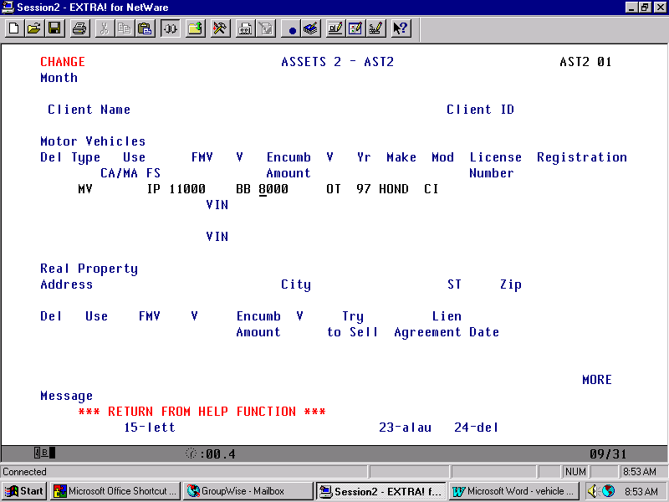

Code any vehicle that is exempt because the equity value is $1500 or less in the following manner:

- On the AST2 screen enter the appropriate code for the type of vehicle in the Motor Vehicle Type field.
- Enter HF (hunting/fishing) in the Motor Vehicle Use field for Food Stamps.
- Enter the remaining fields as usual including the appropriate FMV of the vehicle along with the amount owed on the vehicle and the corresponding verification codes.

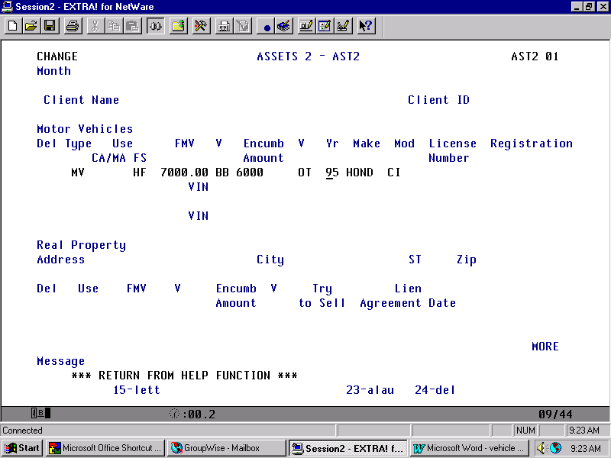

Code any vehicle that is fair market tested only in the following manner:

- On the AST2 screen, enter the appropriate code for the type of vehicle in the Motor Vehicle Type field.
- Enter FV (primary family vehicle) in the Motor Vehicle Use field for Food Stamps.
- Enter the remaining fields as usual including the FMV of the vehicle along with the corresponding verifications.

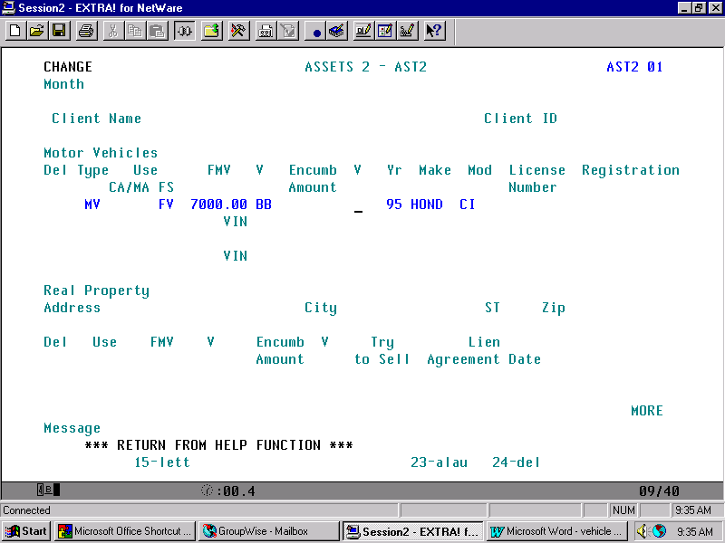

Code any vehicle whose greater of the fair market value and equity test is used towards the resource limit in the following manner:

- On the AST2 screen, enter the appropriate code for the type of vehicle in the Motor Vehicle Type field.
- Enter OT (other) or UN if it’s an untagged vehicle, in the Motor Vehicle Use field for Food Stamps.
- Enter the remaining fields as you would any other, including the FMV of the vehicle and the amount owed on the vehicle along with the corresponding verifications.

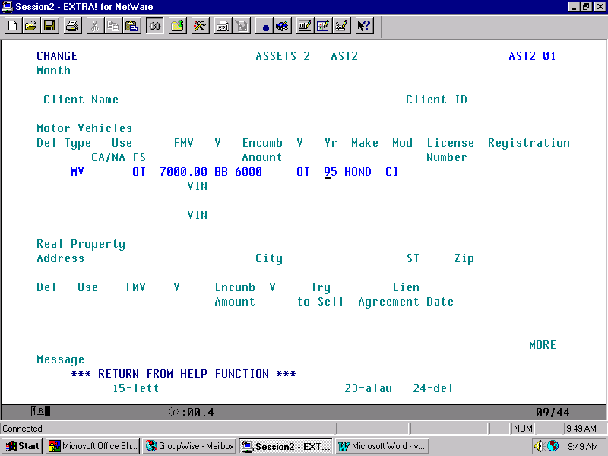

Remember to thoroughly narrate why you used specific tests for each vehicle.

